Programming Guide of libgw: an Object-Oriented Library to Develop OpenGL Applicaitons

Teng-Yok Lee
leeten@cse.ohio-state.edu

8/16/2008

Abstract
This file is the programming guide for the library libgw. The main purpose of this library is to provide a quick and organized solution to create an application of multiple GLUT windows. It also supports user controls defined in another library GLUI. This file provides suggested procedures to create GLUT window with GLUI control and illustrative sample codes.

Table of Contents
Programming Guide of libgw: an Object-Oriented Library to Develop OpenGL Applicaitons 1
Abstract 1
Table of Contents 2
Table of Figures 4
Introduction to OpenGL, GLUT and GLUI 5
Usage of CGlutWin 7
Creating a GLUT Window via CGlutWin 7
The Built-in User Interface 10
Registering Timer Events 10
Suggested Coding Template 11
Member Methods 11
Callbacks related to mouse coordinate 11
_ReshapeFunc 12
Usage of CGlutWin with GLUI 13
Creating GLUI window/subwindow 13
Handling GLUI callbacks 14
Summary 15
Quick Reference 17
Constructor/destructor 17
CGlutWin() 17
virtual ~CGlutWin() 17
Initialization 17
static void _Init(int *argcp, char **argv, unsigned int mode) 17
Window Initialization 17
virtual void _InitFunc() 17
int ICreate(char *szTitle, bool bUseDefault = true, int x = 0, int y = 0, int w = 128, int h = 128) 17
GLUI Window and Subwindow 17
void _AddGluiWin() 17
GLUI *PCGetGluiWin() 17
void _AddGluiSubwin(int iPosition = 0) 18
GLUI *PCGetGluiSubwin() 18
Callbacks end with Func 18
virtual void _DisplayFunc() 18
virtual void _ReshapeFunc(int width, int height) 18
virtual void _KeyboardFunc(unsigned char key, int x, int y) 18
virtual void _SpecialFunc(int skey, int x, int y) 18
virtual void _IdleFunc() 18
virtual void _TimerFunc(unsigned short value) 18
virtual void _GluiFunc(unsigned short usValue) 18
Callbacks end with CB 18
virtual void _DisplayCB() 18
virtual void _ReshapeCB(int w, int h) 18
virtual void _KeyboardCB(unsigned char key, int x, int y) 18
virtual void _SpecialCB(int skey, int x, int y) 18
virtual void _MotionCB(int x, int y) 18
virtual void _MouseCB(int button, int state, int x, int y) 18
Timer Registration 18
void _AddTimer(unsigned int msecs, unsigned short value = 0) 18
GLUT Equivalent Methods 19
void _Redisplay() 19
void _Reshape(int w, int h) 19
void _Push() 19
void _Pop() 19
int IGetId() 19
void _Set() 19
GLUI Control 19
int IAddWid(unsigned short usValue) 19
static void _GluiCB_static(int iIdValue) 19
Beginning/Ending of Methods 19
void _Begin() 19
void _End() 19
FPS 20
void _DisplayFpsOn() 20
void _DisplayFpsOff() 20
float fGetFps(); 20
String 20
char *SZSprintf(const char *szFormat, ...) 20
void _DrawString(char *szString, int iX = 0, int iY = 0, bool bAlignToRight = false) 20
void _AddToLog(char *szString, FILE* fpOutput = stderr) 20
Mouse Coordinate 20
void _UpdateWinCoord(int *px, int *py, bool bFlipY = true) 20
Frame Updating 20
void _KeepUpdateOn() 20
void _KeepUpdateOff() 20
Appendix 22
Design Decisions 22
Known issues 22

Table of Figures
Figure 1. a sample code of OpenGL/GLUT. 6
Figure 2: the procedure to create a GLUT window via CGlutWin. 8
Figure 3: a sample class CTestWin. 9
Figure 4: a sample code that use libgw to create an application with 3 windows. 10
Figure 5: A demo of the code in Figure 4. 10
Figure 6: the steps to define a sub class of CGlutWin that can play animation. 11
Figure 7: the suggested template for the methods of CGlutWin. 12
Figure 8: the suggested template for methods with mouse coordinate. 13
Figure 9: the suggested template to reset the viewport in the method _ReshapeCB(). 13
Figure 10: a code segment to create a window with a GLUI window. 14
Figure 11: a code segment to create a window with a GLUI sub-window. 14
Figure 12: a code segment to create a window with both GLUI window and sub-window. 15
Figure 13: a snapshot of the modified application. 15
Figure 14: a code segment to register a button event. 16
Figure 15: the procedure to create a window with GLUI controls. 17

Introduction to OpenGL, GLUT and GLUI

OpenGL is a library for rendering graphical primitives, but it does not define the interface between OpenGL and the window system. For instance, in Win32 environment, before using OpenGL commands, the user must allocate and configure the Device Context before, which is tedious. Besides, setting up windows system is different from one system to another.

GLUT is one of the libraries that wrap the setting of window system for OpenGL application. First, the user should initial the GLUT and create windows. OpenGL command can be then applied to the created windows. To handle the event from windows systems, GLUT provides API to register function as callbacks for various events.
Next, the application enters a loop to bypass window event to the registered callbacks.
An example is below.

#include <GL/glut.h>

// the function for rendering event
void _DisplayCB();

int
main(int argn, char* argv[])
{
// initialize OpenGL
glutInit(&argn, argv);
glutInitDisplayMode(GLUT_RGBA);

// create the window
glutCreateWindow("Window title");

// ... after the window has been created,
// OpenGL command can be applied

// register the callback.
// At least the display function should be registerd
// in order to render the created window.
glutDisplayFunc(_DisplayCB);

glutMainLoop();
return 0;
}

// the function for rendering event
void
_DisplayCB()
{
// ... apply OpenGL command here
}

Figure 1. a sample code of OpenGL/GLUT.

While using GLUT is much simpler than using MFC or Win32 SDK to develop OpenGL applications, it only provides very preliminary user interfaces. Besides, the coding of GLUT programs is often routine and redundant on implementing the GLUT callbacks. Even though GLUT supports multiple windows, the managing of windows can be very complicated.
As a result, I define libgw, an object-oriented library to quickly and organized create OpenGL applications with basic user interface and multiple windows. In libfw, I define a class called CGlutWin that wraps variables and functions for each GLUT window into a single object. Each GLUT window contains a 3D object coordinate that can be manipulated controlled by the mouse and keyboard. Since it is object-oriented, users can redefine new interface by overloading related methods. Besides, the class CGlutWin also supports user controls not defined by GLUT. Those user controls are mainly defined by GLUI, another GLUT based library for user interface.

This document is a programming guide to learn the programming with libgw. This guide provides suggested procedures and illustrative sample codes to create GLUT window with GLUI controls. More detail about this library should be in another document, the manual of the libgw.

In the following sections, first, the usage of the class CGlutWin is described. The usage of GLUI user control via CGlutWin is then proposed. Next, a simple reference of useful methods in CGlutWin is listed. The design decision and know issues are listed in the Appendix.

Usage of CGlutWin

Creating a GLUT Window via CGlutWin

- Define a class for the a new window
  - Overload the constructor. At this point, however, the GLUT window hasn’t been created. Thus it is recommended to only initialize values for member variable in the constructor.
  - Overload the method _InitFunc(). When this method is invoked, the GLUT window and GLUI window/subwindow has been created. Therefore OpenGL commands can be applied now.
  - Overload the method _DisplayFunc() or _DisplayCB() to execute OpenGL commands. If _DisplayFunc() is overloaded, a default 3D object coordinate is already defined in the window, and thus ther is no need to set up the object coordinates. On the other hand, if _DisplayCB() is overloaded, the user must define command to setup the viewpoint and object coordinate.
  - Overload the destructor to release allocated resources
  - Overload other methods
    - Overloading functions that end in Func. (_IdleFunc(), _KeyboardFunc(),_SpecialFunc() and _ReshapeFunc() and _TimerFunc()) can add new functionality to the default UI
    - Overloading functions that end in CB. (_IdleCB(),_KeyboardCB(),_SpecialCB(), _ReshapeCB() and _TimerCB()) can redefine the UI
  - Of course, define new methods if necessary.
- Declare an object belong to this class to represent a window, say win.
- Launch OpenGL via a static method CGlutWin::_Init(). This method should be called only once. It is highly recommended to call it at the beginning of the function main() because it will parse the command line arguments to setup GLUT.
- Call win.ICreate(title, x, y, width, height) to create a window of size width by height, in location (x, y) and with a tile title.
- (optional) Call win._AddTimer(msecs, event_index) to create timers in this window.
- Call glutMainLoop() to enter the event loop.

Figure 2: the procedure to create a GLUT window via CGlutWin.

Note it takes a slightly different process to register and handle of timer event. This process will explain in more detail later.

A simple example is in Figure 3 and Figure 4. As listed in Figure 3, a new class called CTestWin is created by inheriting the class CGluWin. Inside a CTestWin, there is a wired cube whose color is specified via the constructor. Figure 4 is a sample code that employs CTestWin to create a multiple window application. A snapshot of the create application is listed in Figure 5. As can be seen, a application with three windows can be created in a very short code segment in Figure 4. It is worthy to note that the cubes in the three windows can be manipulated via mouse, but we don’t need to implement this functionality since it has been defined in CGlutWin already. (The white dog is just my desktop. Never mind.)
#include "GlutWin.h"

class CTestWin:public CGlutWin {
void _DisplayFunc()
{
glClear(GL_COLOR_BUFFER_BIT);

glColor4f(r, g, b, a);
glutWireCube(1.0f);

glutSwapBuffers();
}

public:
// the colors
float r, g, b, a;

CTestWin() {};
CTestWin(float r, float g, float b, float a)
{
this->r = r;
this->g = g;
this->b = b;
this->a = a;
}
};
Figure 3: a sample class CTestWin.
#include "..\include\TestWin.h"

CTestWin
cGreenWin(0.0, 1.0, 0.0, 1.0),
cRedWin(1.0, 0.0, 0.0, 1.0),
cBlueWin(0.0, 0.0, 1.0, 1.0);

int
main(int argn, char *argv[])
{
CGlutWin::_Init(
&argn, argv,
GLUT_DEPTH | GLUT_DOUBLE | GLUT_RGBA | GLUT_ALPHA | GLUT_STENCIL);

cRedWin.ICreate("RED", false, 100, 100, 256, 256);
cGreenWin.ICreate("GREEN", false, 200, 100, 256, 256);
cBlueWin.ICreate("BLUE", false, 300, 100, 256, 256);

glutMainLoop();
return 0;
}

Figure 4: a sample code that use libgw to create an application with 3 windows.

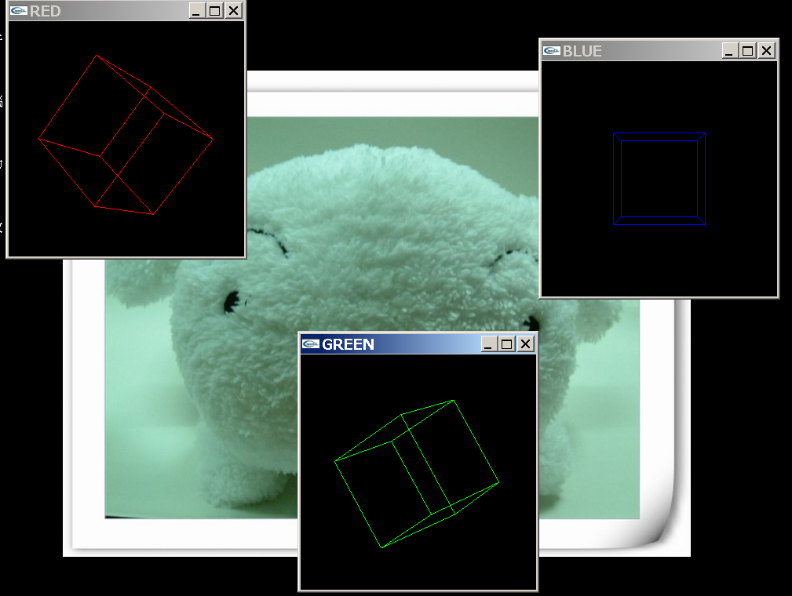
Figure 5: A demo of the code in Figure 4.

The Built-in User Interface
In the class CGlutWin, a simple user interface has already been defined. The main advantage of this interface is that it can manipulate the viewpoint and the object coordinate.

The object coordinate can be manipulated when the left mouse button is pressed. When CTRL key is pressed too, the object coordinate is rotated as a virtual track ball. When SHIFT key is pressed too, the object coordinate is pushed or pulled. When none key is pressed, the object coordinate is moved on the screen.

The object coordinate can be manipulated when the right mouse button is pressed. When CTRL key is pressed too, the viewpoint is rotated. When SHIFT key is pressed too, the viewpoint is zoomed in or out. When none other key is pressed, the object coordinate is panned.

The support hotkeys are listed in Table 1.
Key | Description
ESC | Quit the application
X | View from +X direction
x | View from –X direction
Y | View from +Y direction
Y | View from –Y direction
Z | View from +Z direction
Z | View from –Z direction
R/r | Reset the object coordinate to the initial state
Table 1: hotkeys in the built-in user interface.

Registering Timer Events

If we want to create a timer for a specific window, a method _AddTimer(msecs, value) can be called. After msecs milliseconds, the method _TimerFunc(value) will be invoked. This method can be application-dependently overloaded.

For instance, if we want to create a window that can display animation, the procedure in Figure 6 is suggested:
- Define a new class inheriting from the class CGlutWin.
- Define an unsigned short integer event_animation as the index for this event.
- Add a member variable msecs to record the delay between frames.
- Call _AddTimer(msecs, event_animation) to create a timer event
- Overload the method _TimerFunc(event_index). If the passed value event_index is equal to event_index, display next frame and register next timer event by calling _AddTimer(msecs, event_animation).

Figure 6: the steps to define a sub class of CGlutWin that can play animation.
It is important to know that timer is a global event in GLUT, which means that it is not associated with a certain window. While GlutWin implicitly bypass the event to the associated window, it is still possible to create a timer event to the main application.

Suggested Coding Template

Member Methods
It is highly possible that a sub-class of the class GlutWin need to call methods in another sub-class. Under this circumstance, however, the active window in GLUT might be changed. This will cause issue when the callee executes OpenGL commands since the current window is not the window that the callee belongs to.

Therefore, the coding template in is recommended for the member methods of the subclass inheriting from CGlutWin. In this template, there is a method _Begin() at the beginning of the scope of the method, and another _End() at the end of the scope. The method _Begin() saves the current active GLUT window and the window that this method belongs as the active window. The method _End() restores the original active GLUT window.
class CNewClass:public CGlutWin {
// ...

void _NewMethod()
{
_Begin(); // save current GLUT window and
// set this window as the current GLUT window

// ...

_End(); // restore the GLUT window
}
}

Figure 7: the suggested template for the methods of CGlutWin.
Meanwhile, CGlutWin has another method _Set() to explicitly set this window as the current GLUT window.

Callbacks related to mouse coordinate
When user input like keyboard and mouse event happen, the corresponding callbacks will be invoked with the mouse’s location as the parameters. This location is in the coordinate of the window coordinate. This can cause two problems. One issue is that the origin of the window coordinate is in the left top, but the origin in the OpenGL is in the left bottom. In other words, the y-value is flipped. The other issue is that the size and location of the rendering region can influenced by the GLUI subwindows. As a result, a certain adjustment of the passed coordinate is necessary before further processing.

Thus a member method _UpdateWinCoord(px, py, flip_y = true) is defined. This method can adjust the passed window coordinate (*px, *py) to the actual rendering region, and the adjusted y-coordinate will be flipped if the flag flip_y is true. The suggest template for those callbacks is in Figure 8.

void
CGlutWin::_KeyboardCB(unsigned char key, int x, int y)
{
_UpdateWinCoord(&x, &y);// adjust the coordinate// …
}

Figure 8: the suggested template for methods with mouse coordinate.

_ReshapeFunc
Once the size of display window has been changed, the two methods _ReshapeCB() and then _ReshapeFunc() will be called.

If only _ReshapeFunc() is to be overloaded, note that the viewport has been reseted in the method _ReshapeCB(). As a result, the viewport should be NOT reset again in _ReshapeFunc().The location and size of current viewport is stored in a member variable piViewport[4].

If the method _ReshapeCB() is to be overloaded, on the other hand, it is recommended to reset the viewport as the code in Figure 9.

void
CGlutWin::_ReshapeCB(int w, int h)
{
int tx, ty, tw, th;
GLUI_Master.get_viewport_area( &tx, &ty, &tw, &th );
glViewport(tx, ty, tw, th);
glGetIntegerv(GL_VIEWPORT, piViewport);

// ...
}

Figure 9: the suggested template to reset the viewport in the method _ReshapeCB().

Usage of CGlutWin with GLUI

Creating GLUI window/subwindow

To create a window with a GLUI window, a method _AddGluiWin() is defined. It should be called before the window is created. The pointer to the GLUI window can be then obtained via another method PCGetGluiWin(). GLUI window is a class defined by GLUI. It contains methods to create GLUI user control. Figure 10 shows a code segment to setup a GLUI window. This code modifies the green window in the sample in Figure 4. After the window is created, a spinner is added to the GLUI window to change the green color.
cGreenWin._AddGluiWin();
cGreenWin.ICreate("GREEN", false, 200, 100, 256, 256);
cGreenWin.PCGetGluiWin()->
add_spinner("G:", GLUI_SPINNER_FLOAT, &cGreenWin.g);

Figure 10: a code segment to create a window with a GLUI window.

Similarly, to create a window with a GLUI sub-window, another method _AddGluiSubwin(pos) is defined. It should be called before the window is created. The parameter pos can determine the location of the sub-window inside the window. The value of pos can be GLUI_SUBWINDOW_TOP, GLUI_SUBWINDOW_BOTTOM, GLUI_SUBWINDOW_LEFT or GLUI_SUBWINDOW_RIGHT. Then the pointer to the GLUI sub-window can be obtained via another method PCGetGluiSubwin. Figure 11 shows a code segment to setup a GLUI window. This code modifies the blue window in the sample in Figure 4. After the window is created, a spinner is added to the GLUI window to change the green color.
cBlueWin._AddGluiSubwin(GLUI_SUBWINDOW_RIGHT);
cBlueWin.ICreate("BLUE", false, 300, 100, 256, 256);
cBlueWin.PCGetGluiSubwin()->
add_spinner("B:", GLUI_SPINNER_FLOAT, &cBlueWin.b);

Figure 11: a code segment to create a window with a GLUI sub-window.

Each window can be associated with both a GLUI window and a GLUI sub-window. Figure 12 shows an example. Another object of CTestWin in Figure 4 is created. Before it is created, both _AddGluiWin() and _AddGluiSubwin() are called. After it has been created, two spinners are added to the GLUI sub-window to control the red and green colors, and one spinner is added to the GLUI window to control the blue color.
cWhiteWin._AddGluiWin();
cWhiteWin._AddGluiSubwin(GLUI_SUBWINDOW_LEFT);
cWhiteWin.ICreate("WHITE", false, 400, 100, 256, 256);
cWhiteWin.PCGetGluiSubwin()->add_spinner(
"R:", GLUI_SPINNER_FLOAT, &cWhiteWin.r);
cWhiteWin.PCGetGluiSubwin()->add_spinner(
"G:", GLUI_SPINNER_FLOAT, &cWhiteWin.g);
cWhiteWin.PCGetGluiWin()->add_spinner(
"B:", GLUI_SPINNER_FLOAT, &cWhiteWin.b);

Figure 12: a code segment to create a window with both GLUI window and sub-window.
By adding the modification in Figure 10, Figure 11 and Figure 12 to the sample code in Figure 4, an application with four windows is created. Figure 13 shows a snapshot of the modified application.

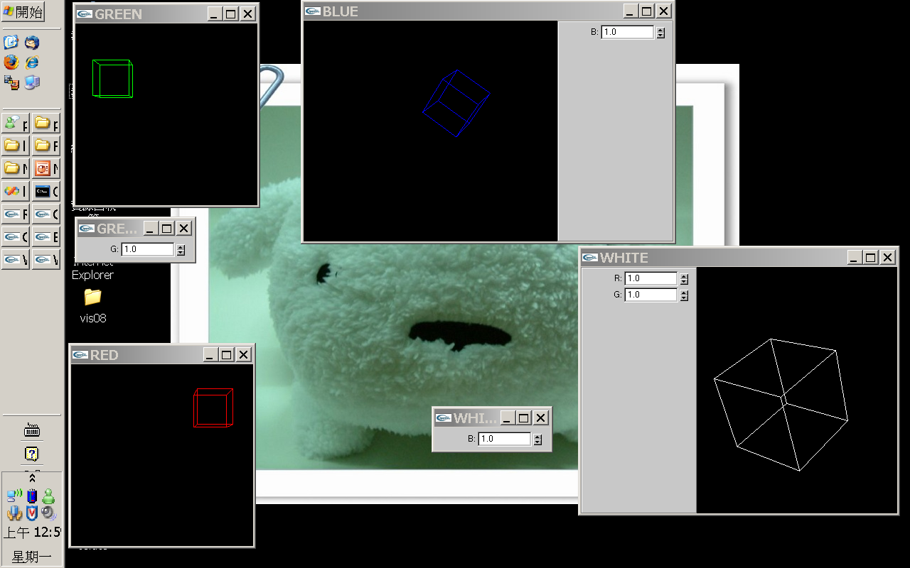
Figure 13: a snapshot of the modified application.

Handling GLUI callbacks

Several GLUI controls need a function to handle the callback. One example is the GLUI button. When a GLUI button is pressed, the event must be processed by a callback function. To register the callback, an integer is often specified to indicate this event; later, when the callback is trigger, this integer will be passed to the callback.

However, the pointer of a class method cannot be passed as function pointer. Therefore, a static method called CGlutWin::_GluiCB_static() is defined as the callback. Besides, since the events from all windows will be process via this static method, a scheme to bypass the event to the corresponding windows is needed. Another method IAddWid () is also defined to convert the integer into a unique ID. Note that the precision of the integer is thus limited to 16 bits.

For example, to register a callback for a button, the code segment in Figure 14 should be used.
CGlutWin *win;
win->PCGetGluiSubwin()->add_button (
“ButtonName”, win->WidValue(value), &CGlutWin::_GluiCB_static);
Figure 14: a code segment to register a button event.

After CGlutWin::_GluiCB_static() has received the event, it passes the event to the corresponding window by calling a method _GluiFunc(). Therefore, this method should be overloaded to process the events according to the application’s purpose.

Summary
By modifying the procedure in Figure 2, the procedure to create a window with GLUI window and/or GLUI subwindow can be summarized in Figure 15. The new steps related to GLUI are marked by underlines.
- Define constants to indicate the GLUI events. Note that those constant’s precision must be limited to less than 16 bits.
- Define a class for the a new window
  - Overload the constructor.
  - Overload the method _InitFunc().
  - Overload the method _DisplayFunc() or _DisplayCB() to execute OpenGL commands.
  - Overload the destructor to release allocated resources
  - Overload the method _GluiFunc(). In _GluiFunc(event), the passed event should be checked against the predefined constants and execute the corresponding actions.
  - Overload other methods that ends with Func or CB.
  - Define new methods if necessary.
- Declare an object belong to this class to represent a window, say win.
- Launch OpenGL via a static method CGlutWin::_Init().
- Call win._AddGluiWin() and/or win._AddGluiSubwin()to GLUI window/subwindow associated with the window win.
- Call win.ICreate(title, x, y, width, height) to create the window.
- Call win._AddTimer(msecs, event_index) to create timers in this window.
- Setup GLUI controls. The GLUI pointers can be obtained via the method PCGetGluiWin() and PCGetGluiSubwin(). If a callback function is need for GLUI controls, use the static method CGlutWin::_GluiCB_static and another method WidValue() to wrap the GLUI events.
- Call glutMainLoop() to enter the event loop.

Figure 15: the procedure to create a window with GLUI controls.

Quick Reference
This section provides a quick description of the methods of the class CGlutWin. Note that only the methods supposed to be useful are listed.

Constructor/destructor

CGlutWin()
// The constructor. When it is involed, neither GLUT nor GLUI windows has been created. Thus it main application is just to assign a initali value to member variables

virtual ~CGlutWin()
// The destructor.

Initialization

static void _Init(int *argcp, char **argv, unsigned int mode)
// Initialize libgw. It is recommned to be executed at the beginning of the programs because it also read the program arguments for configuring GLUT. The mode specify the type of window frames. Note the if the mode is or with the constant GLUT_DOUBLE, the allocate window will contains two buffers, and the function glutSwapBuffers will be implictly executed in _DisplayCB after the method _DisplayFunc has been executed.

Window Initialization

virtual void _InitFunc()
// The method to initialize the window. When it is involed, both GLUT and GLUI windows have been created. Thus it main application is to setup OpenGL environment for this window or add built-in user controls to the GLUI windows

int ICreate(char *szTitle, bool bUseDefault = true, int x = 0, int y = 0, int w = 128, int h = 128)
// Create the window with the specified tile szTitle. If bUseDefault is true, the szie of location of the window will be the fefault values in GLUT; otherwise, the window will be created at location (x, y) with size w x h.

GLUI Window and Subwindow

void _AddGluiWin()
// Add a GLUI window.

GLUI *PCGetGluiWin()
// Return the pointer to the GLUI window.

void _AddGluiSubwin(int iPosition = 0)
// Add a GLUI subwindow in the specified position

GLUI *PCGetGluiSubwin()
// Return the pointer to the GLUI sub-window

Callbacks end with Func

virtual void _DisplayFunc()

virtual void _ReshapeFunc(int width, int height)

virtual void _KeyboardFunc(unsigned char key, int x, int y)

virtual void _SpecialFunc(int skey, int x, int y)

virtual void _IdleFunc()

virtual void _TimerFunc(unsigned short value)

virtual void _GluiFunc(unsigned short usValue)
// Methods ends with _Func. Those functions should be overloaded

Callbacks end with CB

virtual void _DisplayCB()

virtual void _ReshapeCB(int w, int h)

virtual void _KeyboardCB(unsigned char key, int x, int y)

virtual void _SpecialCB(int skey, int x, int y)

virtual void _MotionCB(int x, int y)

virtual void _MouseCB(int button, int state, int x, int y)
// Methods ends with _CB. Those functions could be overloaded, but then it might destroy the orginal user interface.

Timer Registration

void _AddTimer(unsigned int msecs, unsigned short value = 0)
// Add a timer event in time msecs. When the time is up, method _TimerFunc will be invoked with the passed value.

GLUT Equivalent Methods

void _Redisplay()
// Trigger a display event. It is equivalent to glutPostRedisplay() in GLUT.

void _Reshape(int w, int h)
// Resize a display window. It is equivalent to glutRshapeWindow(w, h) in GLUT.

void _Push()
// Push current window. It is equivalent to glutPushWindow() in GLUT.

void _Pop()
// Pop a window. It is equivalent to glutPushWindow() in GLUT.

int IGetId()
// Get the window ID. It is equivalent to glutGetWindow() in GLUT.

void _Set()
// Set this window as the current GLUT window. It is equivalent to glutSetWindow() in GLUT.

GLUI Control

int IAddWid(unsigned short usValue)
// Create an uniqute integer for the passed value among GLUT windows.

static void _GluiCB_static(int iIdValue)
// A static method used as the callback for processing events from GLUI controls

Beginning/Ending of Methods

void _Begin()
// Save current GLUT window and set this window as the current one.

void _End()
// Restore GLUT window.

FPS

void _DisplayFpsOn()
// Enable displaying of FPS on the screen

void _DisplayFpsOff()
// Disable displaying of FPS on the screen

float fGetFps();
// Return the FPS from previous frame

String

char *SZSprintf(const char *szFormat, ...)
// Simialr to sprintf without explictily allocating a buffer for the return string.

void _DrawString(char *szString, int iX = 0, int iY = 0, bool bAlignToRight = false)
// Draw a string on the screen coordinate (x + dx, y). The value of x is iX if iX is nonegative, or (window_width + iX) elsewhere. The value of dx is zero if bAlignRoTight is false, or the length of szString times 9 elsewhere. The value of y is iY if iY is nonegative, or (window_height + iY) elsewhere.

void _DrawString3D(char *szString, float fX = 0.0f, float fY = 0.0f, float fZ = 0.0f)
// Draw a string on the location (fX, fY, fZ) in the object coordinate.

void _AddToLog(char *szString, FILE* fpOutput = stderr)
// Print out a string to the specified file as the log

Mouse Coordinate

void _UpdateWinCoord(int *px, int *py, bool bFlipY = true)
// Thie method can adjust the coordinate of (*px, *py) and flip the value of y after the adjstment to fit the real viewport, not the whole window because the GLUI subwindow inside a GLUT window can influence the renderable screen space for application. If is often used at the beginning of callback with the current coordiante of the mouse pointer, such as _KeyboardFunc, _SpecialFunc, _KeyboardCB, _SpecialCB, _MosueCB and _MotionCB.

Frame Updating

void _KeepUpdateOn()
// Enable automatically updating of the frame

void _KeepUpdateOff()
// Eisable automatically updating of the frame

Appendix

Design Decisions
Q1. Why not just use MFC?
A. Portability. We might need to run our applications on Linux

Q2. Why not other libraries such as FLTK?
A. According to my understanding, different versions of FLTK are not consistent

Q3. Why not use the sub-window in GLUT?
A. If sub-window is desired, a layout for the sub-windows inside the parent window should be specified, but the layout can be frequently changed. Thus I prefer using multiple-windows other than sub-window.

Known issues
- If FBO is used, it might cause segmentation fault on certain chips like NVidia Quadro NVS 100M.

- (2008/08/18) When invoking the method _Reshape(int w, int h), it can cause the children GLUI window lost the display event. NOTE: this has been solved on 2008/08/18. It is because that in my implementation of _ReshapeFunc(w, h), GLUI_Spinner::set_int_val() was called, which cause this issue.

