**Borderline Security with Human Detection System**

1Sanjana B 2Reshma P 3Praveen G 4Prajwal KL 5Jyothi R

*Department of Computer Science and Engineering,*

*Global Academy of Technology, Bangalore-560010, India*

[*sanjanab2197@gmail.com*](mailto:sanjanab2197@gmail.com)*,* [*rechu.824@gmail.com*](mailto:rechu.824@gmail.com)*,* [*praveeng2497@gmail.com*](mailto:praveeng2497@gmail.com)*,*

[*prajwalprism@gmail.com*](mailto:prajwalprism@gmail.com)*,* [*jyothir.gat@gmail.com*](mailto:jyothir.gat@gmail.com)

**ABSTRACT—Presently the arduous task is to monitor International borderareas. The security of the country is very crucial. The border guarding forces are constantly patrolling the border as much as possible, but it’s not an easy task. It is not viable to monitor each and every moment. In order to improve the situation, an intelligent robot can be employed. A trespasser can be automatically detected by the robot and then report this to the security control unit. Most of the military departments in the world use robots to perform risky jobs instead of a solider. In this present work, a Raspbian operating system based spy robot platform which can automatically move around and detect personnel as a solider. Also, we are using gas sensors to detect the hazardous gas and thermal sensors to give a warning to the security control unit that the robot is destroyed. The concept of Internet of Things (IoT) and Machine Learning(ML)has been deployed which will protect the country from enemies, minimize manual error, save human lives. The spy robot comprises of Raspberry Pi, pi camera and few sensors. The detection of obstacles is by IR sensor. The robot moves away automatically if it sense any object present near it avoiding collision. The pi camera captures the faces and checks if the person is a solider. If not, the image is posted inside the web page of the control unit. The commander in control room able to access the image and the commander can take the necessary action such as to fire the trespasser or not. The intelligent spy robot can also be applied and customized for various fields like banks shopping malls and industries.**

***Keywords— Raspbian OS, Machine learning, IoT, Spy Robot, Raspberry Pi, IR sensor, Gas sensor, Thermal sensor, K nearest neighbor.***

1. **INTRODUCTION**

Autonomous robotic system is one of the superlative innovations in the contemporary world. The proposed embedded spy robot detects humans in the borderline areas which is very helpful for army personals to monitor the border carefully. This system reduces the patrolling for border guarding forces. Along with this the robot detects hazardous gases and triggers an alert if the pollution level in the environment is elevated. The robot can also send the temperature of the environment to the control unit. The IR sensor is used to detect any obstacle on the way of robot. This can help the commander in the control unit to check if the robot is spotted and destroyed. Sometimes it is laborious for the army personnel to enter into War-field affected areas. In these scenarios, the spy robot can be deployed to monitor their actions [1].

The proposed system uses camera to detect the motion of human body and capture the image if it is an unknown person. Here we are training the Raspbian operating system by the set of soldier’s images using haar cascade algorithm. The robot does not take any action if it recognizes the image as a solider. The image of the unknown person is sent to the control unit using cloud. The obtained image can be further classified into humans and animals using k-nearest neighbor algorithm. The commander in the control unit can take an action to either fire or not fire the trespasser.

The **embedded autonomous spy robot detects human which** provides a cost effective robot for saving the lives of army persons in the borderline areas. The wireless communication by using cloud between the robot and control unit will help to send the data faster. The surveillance of the borderline will be made easier by deploying this system.

1. **MATERIAL AND METHODS**

Two gear motors are adequate for the mobility of the spy robot. For the Protection of Raspberry-pi module from the damage, the motor driver module is used to supply enough current to drive two gear motors. The advantage of using two gear motors is to reduce the power consumption. The sensing of the obstacle is done by the two IR sensors. IR Sensor can sense any object in front of spy robot. The robot continues to move in a particular direction and when the obstacle or object is found in front, it will revert back in the opposite direction. Similarly, if the obstacle is found in the right, it turns left and visa - versa. The gas sensor is used to detect any hazardous gas in the environment. The information of the abnormality in the air is sent to the commander control unit. The commander can take necessary actions such as alerting the people in the region. If the robot is destroyed by firing, the battery temperature rises drastically and leads to explosion. So, by the use of thermal sensor the commander can know the robot is crashed.

The visual sensor (pi camera) captures the image if a person is detected and sends it to the web server if it is a unknown person. Instead of deploying a gun, stepper motor is placed in this system. The motor rotates if the commander gives the command as fire. The received image from the robot will also be further processed and classified between animals and humans.

Raspberry-pi has been widely used to build projects in various fields like agriculture, industries, medical and defense [2]. The Raspberry-pi 3 module is used which having an inbuilt wireless controller and pi camera support. In spy robot can be used to detect the presence of enemies at the border and the presence of unauthorized people. The commander will be observing this image data received from the robot on the web page at the control room. Control unit communicates with spy robotic unit with the help of a common IP Address [3]. This IoT application is developed by python, Matlab, HTML and Javascript. The proposed system has limitation due to wheeled mechanisms which is more suitable for almost flat surface and is not suitable for rough terrain environments like rocky or hilly terrain. Figure 1 shows the block diagram of the spy robot for examining the borderline areas.

Human and animal classification

DC Power Bank (5V/1A)

Monitoring System (Control Unit)

Raspberry Pi 3

(Mini Computer)

Vision Sensor (Pi Camera)

Wi-Fi Router

Gear Motors

Obstacle Sensors (Left-IR & Right-IR)

Battery (12DC)

Gas Sensor

Thermal Sensor

**Figure 1: The block diagram of the spy robot for examining the borderline areas.**

The Raspberry pi 3 has with a 64-bit 1.2GHz quad-core processor, 1GB RAM and WiFi. It also has 4 x USB 2.0 ports, 10/100 Ethernet, 40 GPIO pins, Full-size HDMI 1.3a port, Camera interface (CSI), Combined 3.5mm analog audio and composite video jack, a Display interface (DSI), MicroSD slot and VideoCore IV multimedia/3D graphics core @ 400MHz/300MHz and the Raspberry pi Camera V1 is 5MP static sensitive type camera [3]. The CSI port of Raspberry pi is connected with pi camera module is connected.

A color image is represented by three components, such as RGB(Red, Green, Blue), XYZ, YIQ, HIS and these will play a significant role in classification of animals and humans. Due to perceptual uniformity of HSV(Hue, Saturation, Value) the feature can be extracted. The Haar Cascade is trained by superimposing the positive image over a set of negative images for detecting face [5]. A simple algorithm called K nearest neighbors classifier can stores all available cases and classifies new cases based on a similarity measure (with respect to distance function). The K nearest neighbors is used for the classification of humans and animals.

K nearest neighbors is interpreted as k-number of points relatively closer to a point in n-dimensional space. The Euclidean distance is calculated between testing and training samples. The k-training samples with lesser distances are termed as knn (K nearest neighbors). So, among k-training samples, the maximum number of samples which are most similar to a test sample, proves out to allocate its class label to the given test sample [6]. The working of the entire spy robot is given in figure 2.

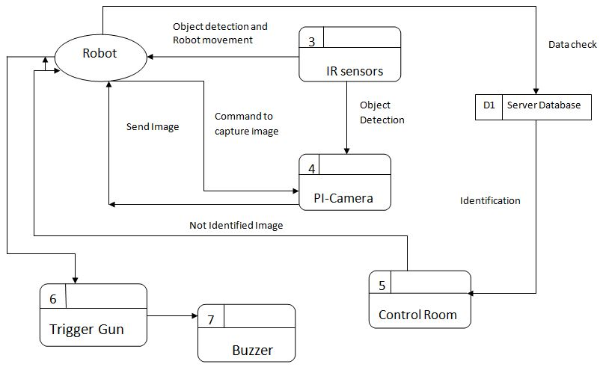

**Figure 2: Working of Spy Robot.**

1. **RESULTS**

The spy robot detects objects using IR sensor. The Pi-camera captures images if it finds any person in front of it. The input image is taken from the Pi-camera and pre-processing is done [4]. Later, Image filtering is applied for sharpening, removing noise, and edge detection. Then the features are extracted by the haar cascade algorithm. Later the data is trained and the knowledge is fed inside the system.

Firstly, the data sets of solider are collected. The model is trained with the collected data. The system captures the photo of the person in the borderline area. The spy robot compares the image with data set and identify whether the person is solder or unknown person [8]. If it is unknown person, image is sent to Commander Room through cloud. Commander has the authority to check the image and take action to shoot the person if he is terrorist or a trespasser.

Figure 3 shows the photograph of the intelligent spy robot for surveillance in the border line areas. The web page where the control unit can take action is shown in figure 4. In figure 4 we can see that the temperature and gas value is give. The temperature of the environment is displayed and if the environment is polluted, it will display that gas is abnormal.

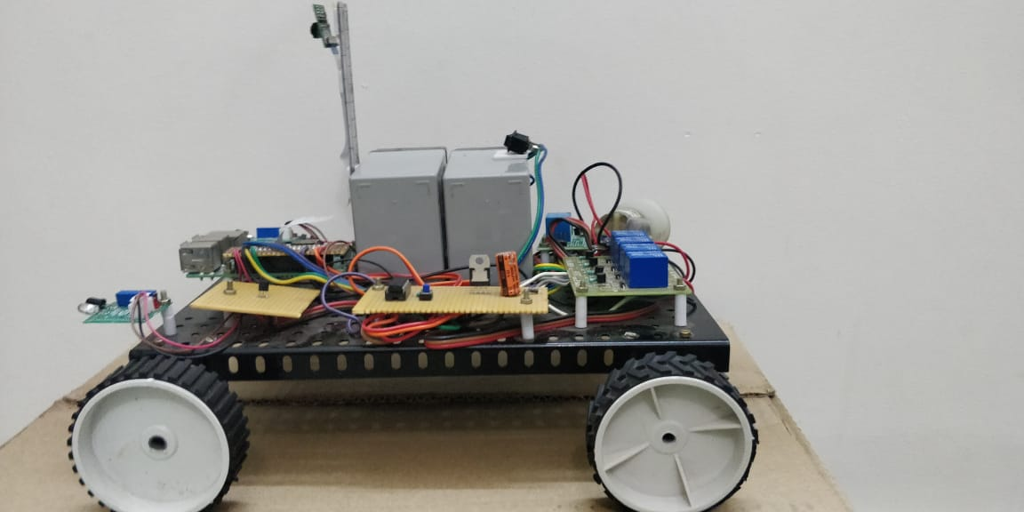

**Figure 3: Photograph of the intelligent spy robot for a surveillance in the border line areas.**

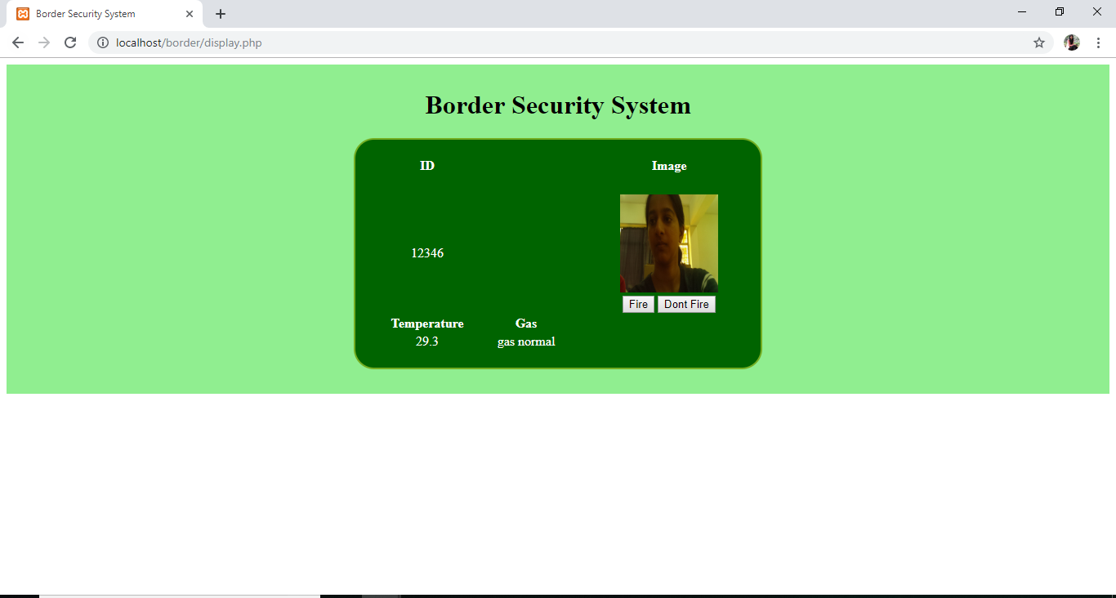

**Figure 4: The web page of the control unit.**

For further analysis of the human and animal classification k-nearest neighbor algorithm is contemplated [7]. The images is firstly converted into grey-scale and later converted into ostu threshold using Matlab as shown in the figure 5 for both human and animal. Figure 6 shows the result of the classification.

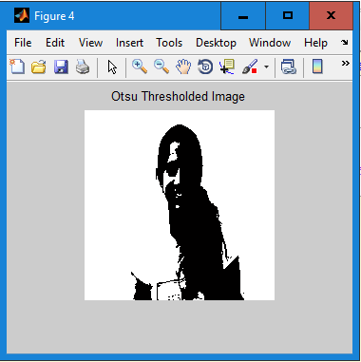 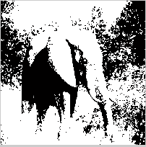

**Figure 5: Otsu threshold for human and animal.**

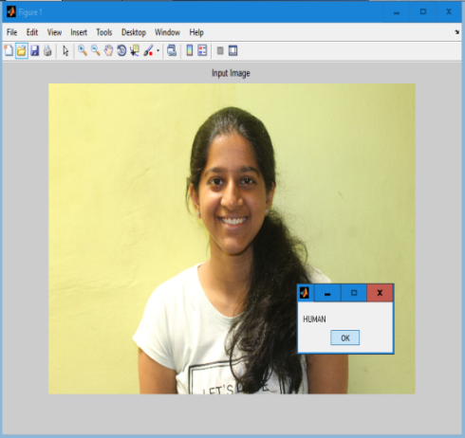 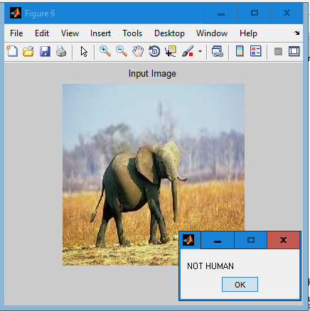

**Figure 6: Classification result of human or animal.**

This spy robot can be used for many applications in military like navigator in forest, detect trespassers, bomb detector with metal detection sensor, etc. It is used to minimize human casualties in terrorist attack. The future work of this system is to add continues track such that the robot can move in any type of surface. The system can also be implemented in drones which can be beneficial in war field, hilly terrain, terrorism and sensitive areas.

1. **DISCUSSION AND CONCLUSION**

The intelligent spy robot is used for the security and can operate efficiently in order to collect various types of information in the borderline areas that required by commander in the control unit. For instance, the presence of unwanted folks in war areas who are restricted to enter the region can be determined by Pi- camera which is triggered and the camera module immediately to captures an image and send it to the web page in a common IP address. Raspberry Pi acts as a brain of the spy robot. The Robot is operated by four modes. Firstly, the Robot navigates freely based on the sensor status. Secondly, Capture the image of an unknown folk and send it to the web page. Thirdly, detect the gas and the thermal values based on the sensor and provide information to the web page. Fourthly, monitor the information present on the web page, and control accordingly with various buttons. Furthermore the analysis between the human and animal is classified.

**REFERENCES**

1. Abhishek Nigam, Nishant Addenki, Girish Juwatkar and Rajesh Toraskar, “Alive Human Body Detection and Rescue Operation”, in International Journal of Electrical and Electronics Research, Vol. 3, Issue 1, pp. (208-212), Month: January - March 2015.
2. A. Imteaj, T. Rahman, M. K. Hossain and S. Zaman, "IoT based autonomous percipient irrigation system using raspberry Pi," 2016 19th International Conference on Computer and Information Technology (ICCIT), Dhaka, 2016, pp. 563-568.

# Md. Maminul Islam, Md. Sharif Uddin Azad, Md. Asfaqul Alam, N. Hassan, "Raspberry Pi and image processing based Electronic Voting Machine (EVM)", in International Journal of Scientific and Engineering Research*,* vol. 5, no. 1, pp. 1506-1510, 2014.

1. R. Ikhankar, V. Kuthe, S. Ulabhaje, S. Balpande and M. Dhadwe, "Pibot: The raspberry pi controlled multi-environment robot for surveillance & live streaming," 2015 International Conference on Industrial Instrumentation and Control (ICIC), Pune, 2015, pp. 1402-1405.
2. [Diajeng Tyas Purwa Hapsari](https://ieeexplore.ieee.org/author/37086531495); [Cindykia Gusti Berliana](https://ieeexplore.ieee.org/author/37086535225); [Putri Winda](https://ieeexplore.ieee.org/author/37086531063); [M. Arief Soeleman](https://ieeexplore.ieee.org/author/37086533822), “[Face Detection Using Haar Cascade in Difference Illumination](https://ieeexplore.ieee.org/document/8549752/)”, [2018 International Seminar on Application for Technology of Information and Communication](https://ieeexplore.ieee.org/xpl/mostRecentIssue.jsp?punumber=8533146), Indonesia, 2018, pp. 555 - 559
3. Shweta Taneja, Charu Gupta, Kratika Goyal, Dharna Gureja, "An Enhanced K-Nearest Neighbor Algorithm Using Information Gain and Clustering", Advanced Computing & Communication Technologies (ACCT) 2014 Fourth International Conference on, pp. 325-329, 2014.
4. Elke Achtert, Christian B'ohm, Peer Kr'oger, Peter Kunath, Alexey Pryakhin, Matthias Renz, "Efficient Reverse k-Nearest Neighbor Estimation", Proceedings of the 12th GI-Fachtagung für Datenbanksysteme in Business, Technologie und Web (BTW 2007), Aachen, Germany, 2007.
5. Wen Xuezhi, Fang Wei, Zheng Yuhui, A Vehicle Identification Algorithm Based on Class Haar Features Improved AdaBoost Classifier, vol. 39, no. 5, pp. 1121-1127, 2011.