1. complete function to implement coin change making problem i.e. finding the minimum

number of coins of certain denominations that add up to given amount of money.

The only available coins are of values 1, 2, 3, 4

Input Format:

Integer input from stdin.

Output Format:

return the minimum number of coins required to meet the given target.

Example Input:

16

Output:

4

Explanation:

We need only 4 coins of value 4 each

Example Input:

25

Output:

7

Explanation:

We need 6 coins of 4 value, and 1 coin of 1 value

**Program:**

def coinChange(n):

coins=[1,2,3,4]

dp=[float('inf')]*(n+1)

dp[0]=0

for i in range(1,n+1):

for coin in coins:

if coin<=i:

dp[i]=min(dp[i],dp[i-coin]+1)

return dp[n]

**Output:**

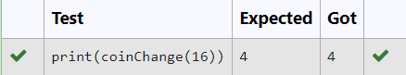

**2.** An automorphic number is a number whose square ends with the number itself.

For example, 5 is an automorphic number because 5*5 =25. The last digit is 5 which same

as the given number.

If the number is not valid, it should display “Invalid input”.

If it is an automorphic number display “Automorphic” else display “Not Automorphic”.

Input Format:

Take a Integer from Stdin Output Format: Print Automorphic if given number is Automorphic number,otherwise Not Automorphic Example input: 5 Output: Automorphic Example input: 25 Output: Automorphic Example input: 7 Output: Not Automorphic

**For example:**

| **Test** | **Result** |
| --- | --- |
| print(automorphic(5)) | Automorphic |

**Program:**

def automorphic(n):

if(n<0):

return "Invalid input"

square = n * n

n_s=str(n)

s_s=str(square)

if s_s.endswith(n_s):

return "Automorphic"

else:

return "Not Automorphic"

**Output:**

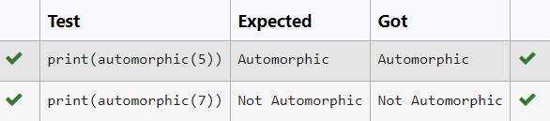

**3.** An abundant number is a number for which the sum of its proper divisors is greater than

the number itself. Proper divisors of the number are those that are strictly lesser than the number.

Input Format:

Take input an integer from stdin

Output Format:

Return Yes if given number is Abundant. Otherwise, print No

Example input:

12

Output:

Yes

Explanation

The proper divisors of 12 are: 1, 2, 3, 4, 6, whose sum is 1 + 2 + 3 + 4 + 6 = 16. Since sum of

proper divisors is greater than the given number, 12 is an abundant number.

Example input:

13

Output:

No

Explanation

The proper divisors of 13 is: 1, whose sum is 1. Since sum of proper divisors is not greater

than the given number, 13 is not an abundant number.

**For example:**

| **Test** | **Result** |
| --- | --- |
| print(abundant(12)) | Yes |
| print(abundant(13)) | No |

**Program:**

def abundant(number):

d_s=sum([divisor for divisor in range(1,number) if number % divisor == 0])

if d_s>number:

return"Yes"

else:

return "No"

**Output:**

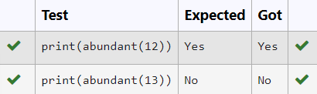

**4.** An e-commerce company plans to give their customers a special discount for Christmas.

They are planning to offer a flat discount. The discount value is calculated as the sum of all

the prime digits in the total bill amount.

Write an algorithm to find the discount value for the given total bill amount.

Constraints

1 <= orderValue< 10e100000

Input

The input consists of an integer orderValue, representing the total bill amount.

Output

Print an integer representing the discount value for the given total bill amount.

Example Input

578

Output

12

**For example:**

| **Test** | **Result** |
| --- | --- |
| print(christmasDiscount(578)) | 12 |

**Program:**

def is_prime_digit(digit):

return digit in [2,3,5,7]

def christmasDiscount(n):

s=discount=0

prime_digitis=[2,3,5,7]

for digit in str(n):

digit=int(digit)

if is_prime_digit(digit):

discount+=digit

return discount

**Output:**

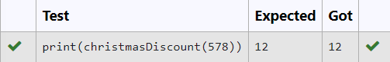

5. A number is considered to be ugly if its only prime factors are 2, 3 or 5.

[1, 2, 3, 4, 5, 6, 8, 9, 10, 12, 15, …] is the sequence of ugly numbers.

Task:

complete the function which takes a number n as input and checks if it's an ugly number.

return ugly if it is ugly, else return not ugly

Hint:

An ugly number U can be expressed as: U = 2^a * 3^b * 5^c, where a, b and c are nonnegative integers.

**For example:**

| **Test** | **Result** |
| --- | --- |
| print(checkUgly(6)) | ugly |
| print(checkUgly(21)) | not ugly |

**Program:**

def checkUgly(n):

if n <= 0:

return "not ugly"

while n % 2 == 0:

n //= 2

while n % 3 == 0:

n //= 3

while n % 5 == 0:

n //= 5

return "ugly" if n == 1 else "not ugly"

**Output:**

