Paper Template for MIR Final Project
Qingyang Xi  Music Technology  NYU Steinhardt  tom.xi@nyu.edu | Sumanth Srinivasan  Electrical and Computer Engineering  NYU Tandon  sumanths@nyu.edu

ABSTRACT
The abstract should be placed at the start of the top left column and should contain about 150–200 words. The abstract should be formatted in italic type (this has already been set in the abstract style).

- INTRODUCTION
Rhythm is an influential character of music both in traditional western and other ethnic cultures. By establishing structure in the form of granular repeating blocks, which is then accentuated by other meter-based features, it informs of the cultural background and in pop-cultures, the genre. Hence, in the fields of music information retrieval and computer music, beat tracking and automated rhythm detection has been an active space of research.

A lot of work has been carried out to detect downbeats in music as they highly characterize the overall rhythm of the track, as well as establish structure to its form. Most beat tracking methods use a recurring workflow of feature extraction, estimation of periodicity in these features and phase estimation [1]. The feature used for this purpose is usually a novelty function.
Beat tracking is a particularly cumbersome task and often inaccurate in case of expressive classical music. A study on Chopin Mazurkas [2] compares the results of different beat tracking methods on each of his pieces, but also considers the consistencies of beat tracking results across a number of performances of the same piece.

- TEMPO ESTIMATION PROBLEM
The onsets tracked in case of most beat detection algorithm is often characterized by sudden increase in energy. While this is more prominent in case of percussive music, pieces entirely based on instruments with soft onset may result in blurring of these novelties. The uncertainty makes it difficult to assign specific time to beat positions. The presence of tempo changes and expressive nuances in the piece may further aggravate this problem. Problems may also arise due to syncopations and rhythms created by silences and negative space in the piece.

Chopin Mazurkas is a great example to study the presence of such problems as it is greatly expressive in nature but also has musical embellishments that subvert general notions of rhythm. This is also supported by the availability of dataset of select performances obtained from the Mazurka Project.
    - What is expected
This should thoroughly present the project and the work completed for the project. This will include sections such as; a literature review of similar work and work that inspired your work, references, the iterative steps taken along the way and how the contributed (or didn't) to the project, a detailed explanation of the project and its individual elements, figures/graphs/images to help show how the project works, etc.
  - Code
All code used to create the project should be submitted. This should include a a readme.txt that explains how to compile and execute the code. Please use comments and make your code clear and readable.
A short demo video explaining the project is expected. This should present the projects significance in the field and for your work, along with presenting a demo of the project. This should be 1-4 minutes.
This can be posted to a service such as youtube/vimeo (please ensure that the link works and has appropriate public settings), google drive (again please ensure appropriate sharing privileges so I can watch/download the videos), or submitted as part of the .zip file submission (in this case please compress the video to an .mp4 or similar).
- WORKFLOW
Since tempo is a metric of periodicity just like pitch, a lot of methods formulated for pitch detection can be modified and applied to obtain tempo information in music with variable tempo.

This project follows the Grosche’s approach [2], but with novelty function as the input – hence allowing adjustments on granularity to look for low frequencies that are perceived as beats. While PLP was computed and an estimation of tempo was obtained per frame, details of variation were greatly missed out. Hence the process of obtaining PLP was modified to take a time-warped function as input, hence using the Fan Chirp Transform [3] instead of STFT. The tempo salience thus obtained is used as an observation in order to estimate instantaneous tempo as a hidden state. This is done using the Viterbi method.
  - Fan Chirp Transform

The Fan Chirp Transform (FChT) provides both time and frequency resolution using a set of fan-geometry as an additional dimension of basis functions and is carried out by time-warping the signal in time domain and then using the FFT. This method allows it to retain the computational efficiency that FFT offers.

A discrete implementation of the FChT as proposed in [3] is used to warp the time domain novelty function. The warping is as follows:

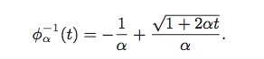

The output of FChT for each frame of the novelty function is a matrix of time-warped signals, each warped at a different alpha value.

The windowing parameters such as window size and hop size affect the choice of α and vice versa. For this project only linear warping was applied. The most optimal parameters were found to be:

<<<<Alpha parameters, window stuff and reasons to pick those values>>>>
  - PLP
Determining the Predominant Local Pulse (PLP) allows restricting the frequency domain analysis to a window of frequencies of basis functions. This allows a focus on frequencies that are relevant to tempo detection.

As explained in [4], PLP is designed to work on noisy novelty curves with a poor pulse structure. It is carried out for every frame on each of the warped time domain signals obtained using FChT. This results in a tempo salience plane as a measure of magnitude across frequencies and warping values of α.

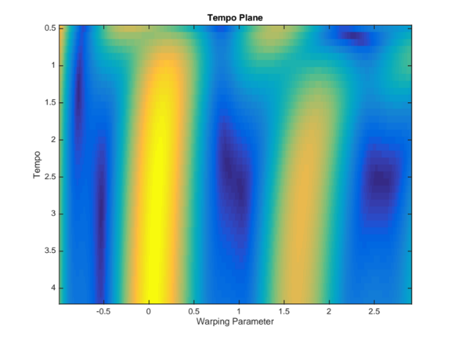
Figure 1: Tempo Plane for one frame

What the tempo-gram thus obtained provides is information on not only the frequencies that contain most energy, but also the change in instantaneous frequency over the course of the window, which improves our prediction when compared to STFT method that assumes stationary input. However, this also means that there are multiple chirp functions in place of each basis functions, calling for one more step towards obtaining the optimal modulated sinusoidal kernel.

One method of obtaining the best basis function for each window was by picking the max kernel from each tempo plane and sequencing the corresponding basis function in time domain for tempo estimation.

<<<<Did it work? Resuts etc>>>>
  - Tempo Estimation Using Viterbi
A more robust method of picking the best kernel estimate was done by considering the tempo as an observation corresponding to a hidden state i.e., the tempo at that instant. The α values are used as a means to build a transition matrix that informs change from one state (tempo) to another.

This allows us to treat the signal with variable tempo as a Markov process and make informed predictions of hidden states.
- Observations
  - Normal or Body Text
Please use a 10pt (point) Times font. Sans-serif or non-proportional fonts can be used only for special purposes, such as distinguishing source code text.
The first paragraph in each section should not be indented, but all other paragraphs should be.
  - Title and Authors
The title is 16pt Times, bold, caps, upper case, centered. Authors’ names are centered. The lead author’s name is to be listed first (left-most), and the co-authors’ names after. If the addresses for all authors are the same, include the address only once, centered. If the authors have different addresses, put the addresses, evenly spaced, under each authors’ name.
  - First Page Copyright Notice
Please include the copyright notice exactly as it appears here in the lower left-hand corner of the page. It is set in 8pt Times, one column in width, and should not descend into the page margins (i.e. it should keep clear of the 1" margin at the bottom of the page).
  - Page Numbering, Headers and Footers
Do not include headers, footers or page numbers in your submission. These will be added electronically at a later stage, when the publications are assembled.
- headings
First level headings are in Times 12pt bold, centered with 1 line of space above the section head, and 1/2 space below it. For a section header immediately followed by a subsection header, the space should be merged.
  - Second Level Headings
Second level headings are in Times 10pt bold, flush left, with 1 line of space above the section head, and 1/2 space below it. The first letter of each significant word is capitalized.
    - Third and Further Level Headings
Third level headings are in Times 10pt italic, flush left, with 1/2 line of space above the section head, and 1/2 space below it. The first letter of each significant word is capitalized.
Using more than three levels of headings is strongly discouraged.
- Floats and equations
  - Equations
Equations should be placed on separated lines and numbered. The number should be on the right side, in parentheses.
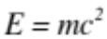 (1)

  - Figures, Tables, and Captions
All artwork must be centered, neat, clean, and legible. All lines should be very dark for purposes of reproduction and artwork should not be hand-drawn. The proceedings will be distributed in electronic form only, therefore color figures are allowed. However, you may want to check that your figures are understandable even if they are printed in black-and-white.

String value | Numeric value
Hello ICMC2016 | 2016
Table 1. Table captions should be placed below the table.
Numbers and captions of figures and tables always ap- pear below the figure/table. Leave 1 line space between the figure or table and the caption. Figure and tables are numbered consecutively. Captions should be Times 10pt. Place tables/figures in text as close to the reference as possible, and preferably at the top of the page.
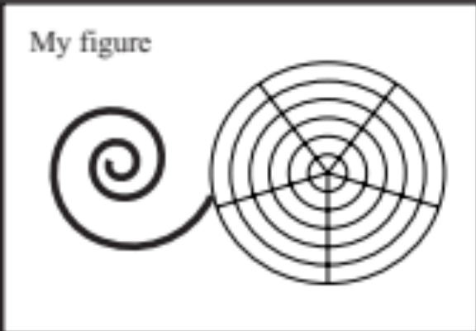
Figure 1. Figure captions should be placed below the figure, exactly like this. Please note that the printed proceedings will be black and white.
Always refer to tables and figures in the main text, for example: see Figure 1 and Table 1. Figures and tables may extend across both columns to a maximum width of 17.2cm.
Vectorial figures are preferred. For example when using Matlab, export using either Postscript or PDF format. Also, in order to optimize readability, the font size of text within a figure should be at list identical to footnote font size. If bitmap figures are used, please make sure that the resolution is enough for print quality.
  - Footnotes
Indicate footnotes with a number in the text. Use 8pt type for footnotes. Place the footnotes at the bottom of the page on which they appear. Precede the footnote with a 0.5pt horizontal rule.

- Citations
All bibliographical references should be listed at the end, inside a section named “REFERENCES”.
References must be numbered in order of appearance. Please avoid listing references that do not appear in the text.
Reference numbers should appear within square brackets, such as in [1] or [2, 3].
The reference format is the standard IEEE one. We rec- ommend using BibTeX to create the reference list.
- CONCLUSIONS
Please, submit full-length papers. Submission is fully electronic and automated through the Conference Management Management System. Do not send papers directly by e-mail.
Acknowledgments
At the end of the Conclusions, acknowledgements to peo- ple, projects, funding agencies, etc. can be included af- ter the second-level heading “Acknowledgments” (with no numbering).
- REFERENCES
- S Böck, M Schedl, Enhanced beat tracking with context-aware neural networks - Proc. Int. Conf. Digital Audio Effects, 2011

- P Grosche, M Müller, CS Sapp, “What Makes Beat Tracking Difficult? A Case Study on Chopin Mazurkas” - ISMIR, 2010

- P Cancela, E Lopez, M Rocamora, “Fan Chirp Transform for Music Representation” - Proc. Int. Conf. Digital Audio Effects, 2010

- P. Grosche and M. Muller. “A mid-level representation for capturing dominant tempo and pulse information in music recordings.” In Proc. of ISMIR, pages 189–194, Kobe, Japan, 2009

- X. Someone and Y. Someone, The Title of the Book. Springer-Verlag, 2004.
- A. Someone, B. Someone, and C. Someone, “The Title of the Conference Paper,” Proceedings of the 2005 International Computer Music Conference, Barcelona, 2005, pp. 213-218.

Examples: https://www.youtube.com/watch?time_continue=186&v=LiGHPHhjCqE https://www.youtube.com/watch?v=Pj0FmfvC1bs https://vimeo.com/33943912 https://www.youtube.com/watch?v=ZPqTSuDVhVQ
This is a footnote.

