**Detecting NEMO (dNEMO) SUPPLEMENT**

Last updated December 9, 2019.

NOTE: THIS GUIDE IS FOR A PREVIOUS BUILD OF dNEMO. A NEW GUIDED WALKTHROUGH WHICH MORE ACCURATELY REPRESENTS THE UPDATED TOOL IS FORTHCOMING.

Contents

1. License
2. Requirements
3. Installation and Startup
4. User Interface
5. Loading Images into dNEMO
6. Display Panel
7. Spot Detection Settings
8. Creating Keyframe Objects
9. Segmenting Cells Using Drawing Tool
10. Modifying and Deleting Keyframe Objects
11. Manual Removal of Erroneous Signals
12. The Inspector Tool
13. Output Files
14. Reloading Results into dNEMO
15. Guided Example: smFISH
16. Guided Example: EGFP-NEMO
17. References

1. License.

This program is free software: you can redistribute it and/or modify it under the terms of the GNU General Public License as published by the Free Software Foundation, either version 3 of the License, or (at your option) any later version.

This program is distributed in the hope that it will be useful, but WITHOUT ANY WARRANTY; without even the implied warranty of MERCHANTABILITY or FITNESS FOR A PARTICULAR PURPOSE. See the GNU General Public License for more details.

You should have received a copy of the GNU General Public License along with this program. If not, see <http://www.gnu.org/licenses/>.

2. Requirements

The program has been tested using the following operating systems:

Linux (XXX), Mac OS 10.12.6 64-bit, Windows 10 64-bit.

MATLAB version: 2017b and 2018b

MATLAB toolboxes required to run every component of the packaged software:

* Image Processing Toolbox
* Signal Processing Toolbox
* Statistics and Machine Learning Toolbox

3. Installation and Startup

1. Download the latest version of the dNEMO software package from (XXX).
2. Extract all files from the zip file that was downloaded.
3. Open MATLAB.
4. Add the ‘dNEMO’ directory to the current path in MATLAB, either by copying the unzipped folder to the current path and adding the folder to the current path or navigating to the unzipped folder in the MATLAB folder window and adding the folder to the current path.
5. To start dNEMO, type the following into the MATLAB command window:

>>> RUN_ME

This will open the main dNEMO user interface.

4. User Interface

When first opening up dNEMO, the user interface immediately appears like so:

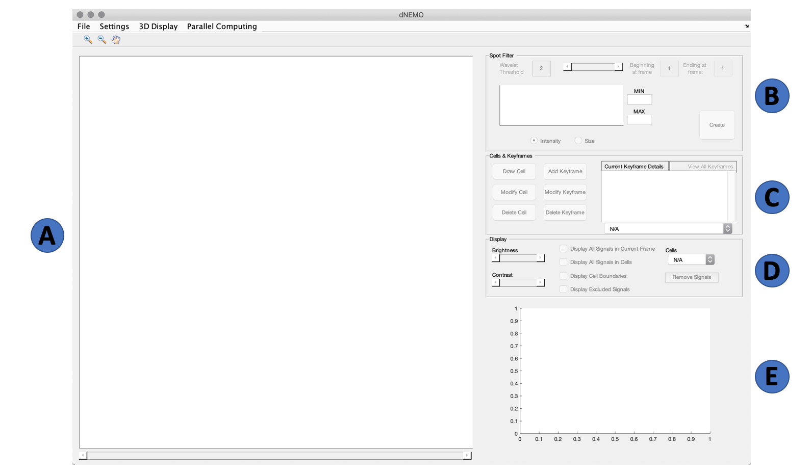

Each of the three main panels, ‘Spot Filter’, ‘Cells & Keyframes’, and ‘Display’, will be explained in detail in later sections. The main components which fall outside these three panels are as follows:

1. **Image axis**: the main axis which will display the image, spots identified within the image, provide interaction for cell segmentation and selecting spots of interest.
2. **Spot filter panel**: the main panel for defining parameters for spot detection. The specific components of this panel are defined in Section 8 (Creating Keyframe Objects).
3. **Cells & Keyframes panel**: the main panel for initiating new keyframe and cell objects. The specific components of this panel are defined in Sections 8 & 9 (Creating Keyframe Objects & Segmenting Cells Using Drawing Tool).
4. **Display panel**:the main panel for interacting with both the image and the data displayed on top of the image within the image axis. The specific components of this panel are defined in Section 6 (Display Panel).
5. **Trajectory axis**: the axis which contains trajectories defining the number spots per cell over time. Trajectories will automatically appear in this axis when a keyframe and a cell have been created in the application.

5. Loading Images Into dNEMO

To load images into dNEMO, navigate to File > Load Images. This will open an interactive file selection GUI where an image/movie can be selected. dNEMO currently supports files with .TIF(F) or .DV extensions. dNEMO utilizes Bio-Formats (1) for handling image input, and is packaged with the tool.

Once a compatible image file is selected, dNEMO will prompt for additional information if the image file’s metadata cannot be parsed for additional information. The user will be prompted to confirm whether the image is 2D or 3D, and how many Z-slices comprise each frame for the latter.

Once the image is present in the main axis, the ‘3D Display’ Menu can be selected to alternate between the max intensity projection and 3D stack of the current frame. When the ‘Full 3D Stack’ option is selected, an additional slider appears to the right of the image axis.

At the lower right-hand corner of the image axis a small annotation will display the current frame as T = <FRAME>. If the ‘Full 3D Stack’ option is selected, an additional annotation above the frame number will display the current z-slice as Z = <SLICE >.

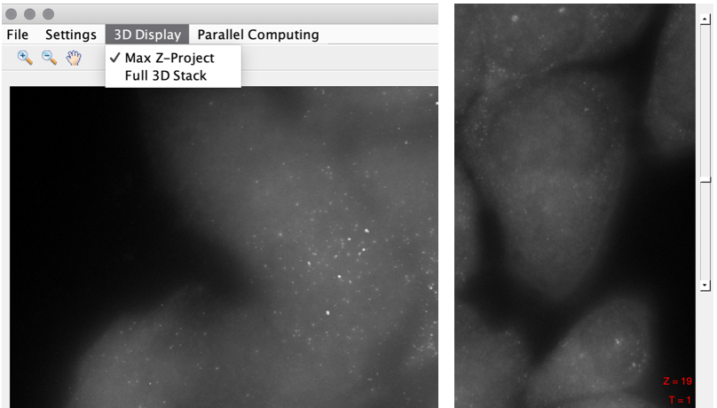

6. Display Panel

The display panel is used to quickly manipulate objects within the image axis throughout the application. With the exception of the cell selection dropdown and signal removal button, all other components can be accessed during dNEMO operations, so long as the structure the control operates on already exists (e.g., the ‘Display Cell Boundaries’ toggle will be greyed out until cells have been drawn).

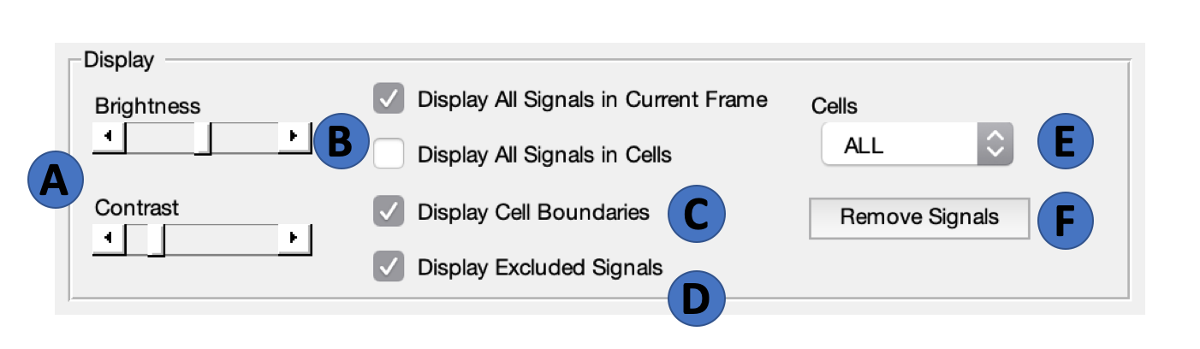

The various components of the ‘Display’ panel are as follows:

1. **Brightness & Contrast Sliders**: used to manipulate image brightness and contrast.
2. **Signal Display Toggles:** pair of toggles which alternate between displaying all signals for the current frame and all signals associated to cells. Only one of these two toggles can be active at a given time. When a specific cell is selected using the Cell Selection Dropdown (E) and the ‘Display All Signals in Cells’ is on, the signals for the specific cell selected will be shown alone.
3. **Display Cell Boundaries**: toggles the boundaries of cells once drawn. When a specific cell is selected using the Cell Selection Dropdown (E), the boundary of the selected cell will be shown alone.
4. **Display Excluded Signals:** toggles signals which have been removed, either manually using the manual removal tool (F) or were removed for some feature property inherent to the keyframe object (e.g. spots below a certain size, above a certain intensity). More details about the manual object removal tool can be found in Section 11 (Manual Removal of Erroneous Signals).
5. **Cell Selection Dropdown**: dropdown menu which allows for selection of individual cells for examination. When an individual cell is selected, the cell’s outline and signals will appear alone in the image axis if the ‘Display Cell Boundaries’ and ‘Display All Signals in Cells’ toggles are checked, respectively. Similarly, the cell’s trajectory will appear alone in the trajectory axis.
6. **Remove Signals Button:** button which initiates spot removal operation in the image axis. Clicking this button again will terminate the removal operation. More information about the manual spot removal operation can be found in Section 11 (Manual Removal of Erroneous Signals).

7. Spot Detection Settings

In the upper right-hand corner of the interface there is a ‘Settings’ menu item. Clicking on ‘Settings’ will bring up a drop-down menu with the item ‘Signal Parameters.’ Click on the ‘Signal Parameters’ bar to bring up the settings input GUI. Within this GUI are several parameters which can be modified by the user. They will be used when creating any new Keyframe objects, which defines the signals captured for some range of frames within a given movie. These parameters can be changed before or during Keyframe creation, and can be modified after a Keyframe has already been created.

The parameters are as follows:

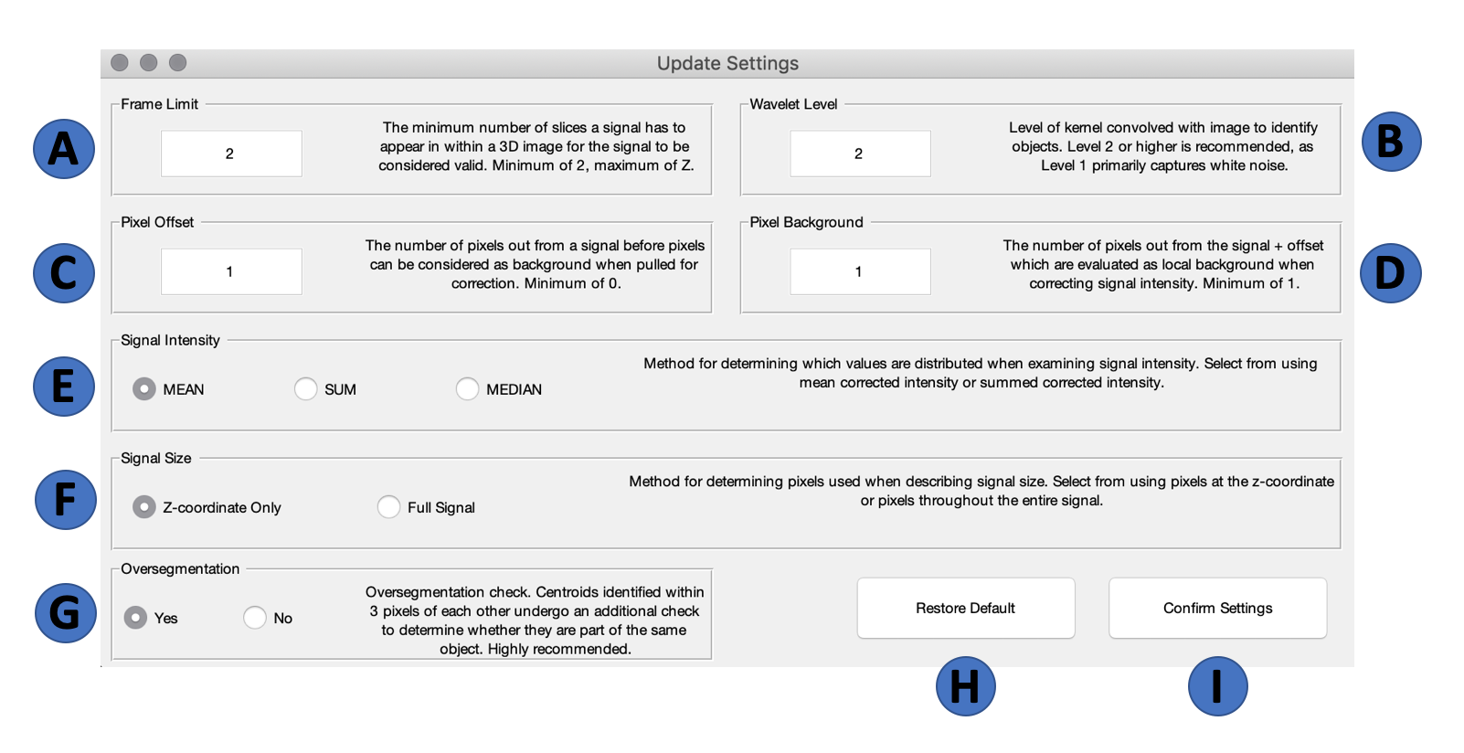

1. **Frame Limit**: The minimum number of slices a signal has to be in to be considered valid. Minimum of 1, maximum of Z. The frame limit operates as a lower bound on detected signals; signals in 3D images will initially be checked between slices to examine which ones are likely connected, and if the frame limit is set to 1 will then begin to accept any signals within each slice not connected to signals in a neighboring slice.
2. **Wavelet Level:** Level of the kernel convolved with the image to identify objects. The most delicate details of an image are caught up in the level 1 transform, largely representative of noise within the image. Level 2 has been found by us to most reliably capture diffraction-limited objects, and is recommended. Higher levels of the kernel will capture larger objects within the image, at the expense of removing smaller objects.
3. **Pixel Offset:** The number of pixels out from a signal before pixels can be considered as background when pulled for correction. This acts as a sort of buffer ring around the object. Minimum of 0.
4. **Pixel Background:** The number of pixels out from the signal + defined offset which is then collected as local background about an identified object. Minimum of 1.
5. **Signal Intensity:** Indicates the method for which signal intensities are compared against each other when determining how to more methodically remove signals known to be erroneous by the user. Available measurements are average, integrated, and median signal intensity, corrected for local background.
6. **Signal Size:** Indicates the method for which signal sizes are compared against each other when determining how to more methodically remove signals known to be erroneous by the user. Available measurements are either at the identified z-coordinate for a given signal or the entirety of the pixels comprising a signal.
7. **Oversegmentation:** Binary check which determines whether an oversegmentation check is performed on identified signals in a given image. Centroids identified within 3 pixels of each other undergo an additional check to determine whether they are part of the same object. While this does increase runtime, it is highly recommended.
8. **Default Button:** Resets current fields to their default values when the program starts up, which are shown in the image above.
9. **Confirm Settings Button:** Applies changes to the detection parameters. If there is no active keyframe creation happening, the parameters will be saved for when a keyframe will next be created. If a keyframe is actively being created, the

8. Creating Keyframe Object

Creation of the Keyframe object is handled by both the ‘Cells & Keyframes’ panel and the ‘Spot Filter’ panel. The components of the Cells & Keyframes panel are listed here:

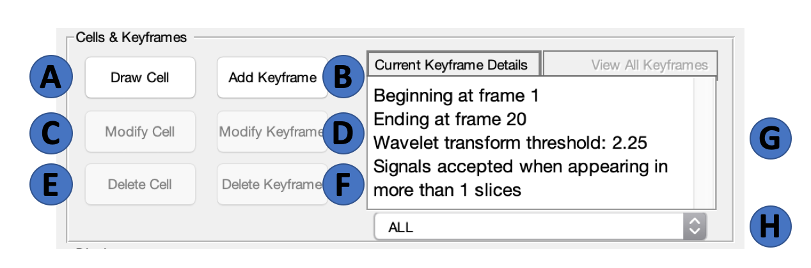

1. **Draw Cell Button**: button used to initialize cell segmentation operation
2. **Add Keyframe Button:** button used to initialize keyframe creation process.
3. **Modify Cell Button:** button used to initialize modification process for previously created cells.
4. **Modify Keyframe Button:** button used to initialize modification process for previously created keyframes
5. **Delete Cell Button:** button used to remove a created cell from the application.
6. **Delete Keyframe Button:** button used to remove a created keyframe from the application.
7. **Keyframe Details Panel**: panel showing parameters for the current keyframe.
8. **Keyframe Selection Dropdown:** dropdown selection for multiple keyframe objects. Selecting a single Keyframe allows for modification or deletion of a keyframe object.

To begin the creation of a keyframe object, click the ‘Add Keyframe’ button in the ‘Cells & Keyframes’ panel. This will initiate the wavelet transform over the currently displayed image, and a waitbar will appear showing progress of the transform. Once the wavelet transform is complete, the ‘Spot Filter’ Panel will become accessible. The components of the ‘Spot Filter’ panel are listed here:

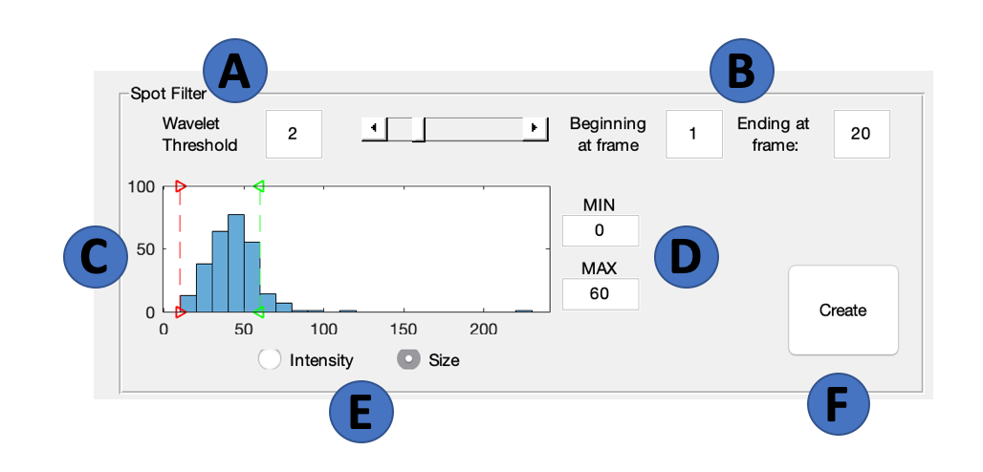

1. **Wavelet Threshold**: The primary means of control over thresholding the wavelet transform, this value represents the threshold separating what is to be considered foreground and background in the created wavelet map. The higher the value, the fewer spots will be detected, and the lower the value the more spots will be detected. The slider to the right of the edit box corresponds to this threshold.
2. **Frame Range:** These values indicate the range of frames the current keyframe settings would operate on if the ‘Create’ button (F) were clicked. The wavelet transform, plus all applicable limitations on detected spots’ features, would be propagated across the movie frames indicated here.
3. **Interactive Histogram Axis:** Clickable axis which allows user to see which objects have indicated properties. The current broad feature is displayed below (E), but the specifics of what feature is being displayed can be selected in the Settings > Signal Parameters interface. Whenever the histogram is interacted with, spots with features that fall beyond the bars are indicated on the image axis. See Section 7 (Detection Settings) for more information on available features to select/limit.
4. **Histogram Min/Max:** Typing in relative minimum or maximum values for the currently displayed histogram allows user to decide discrete values without dragging the bars in the axis. When bars are moved, the corresponding value is also displayed in these boxes.
5. **Histogram Select:** Radio buttons to swap between intensity and size feature histograms.
6. **Create Keyframe Button:** Clicking on this button begins the keyframe creation process. The wavelet transform and indicated feature selections/limitations will be applied to every image indicated in the frame range (B).

Before clicking on the ‘Create’ button, the spots displayed on the image axis can be interacted with via the histogram, wavelet threshold, and detection settings. Changing any detection settings while in the process of creating a keyframe will update the current image’s detected spots.

9. Cell Segmentation

The software dNEMO provides a manual segmentation interface for defining individual cells within the image over time. This process can be started with or without defining a Keyframe for the current movie. The steps to this process are as follows:

1. Click on the ‘Draw Cell’ button within the ‘Cells & Keyframes’ panel.

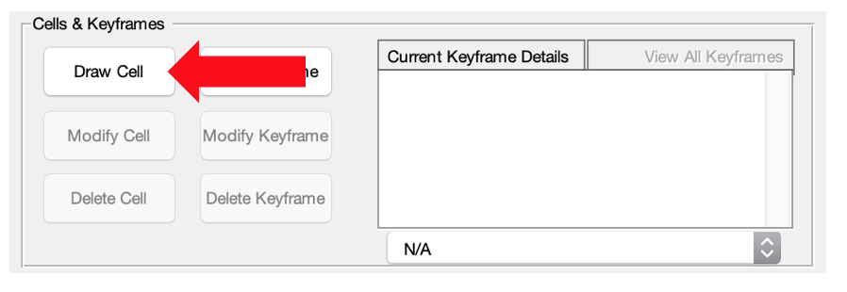

1. Hover over the main figure axis containing the image. The pointer should now look like a crosshair over the axis. Click on the axis at the edge of some cell to begin the process of adding a polygon over the given image.
2. Continue clicking along the edge of the cell to define the region as an individual cell. Return to the initial point you laid down at the start of the process and click on it to complete the cell, or double click to have the polygon automatically close the last point placed and the initial point.

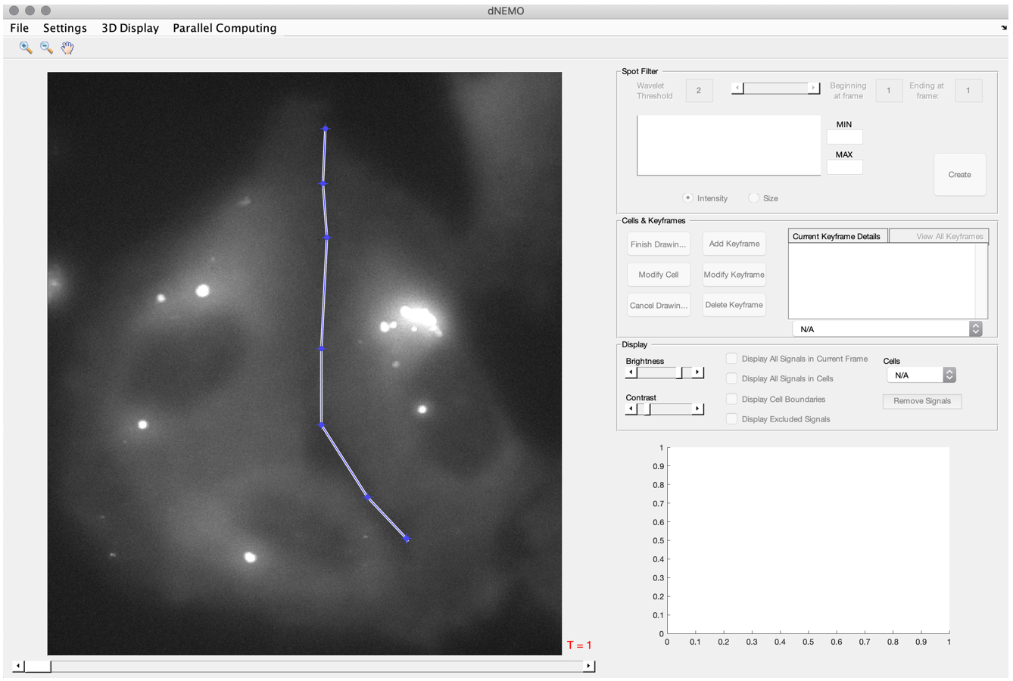

1. Increment the movie forward in time using the slider at the bottom of the main figure axis, moving the polygon by selecting either the space inside it with your mouse or an edge. Vertices can similarly be shifted and moved.
2. Once the cell appears to be defined across the entire movie, click on the button labeled ‘Finish Drawing’ in the ‘Cells & Keyframes’ panel. This will instantly check the polygons ascribed to the new cell against the set of coordinates for all Keyframes which contain coordinates for the given frames.

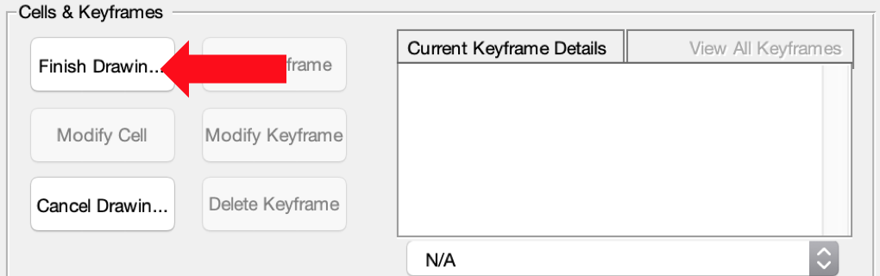

1. At any point if the segmentation would like to be terminated without saving the polygons placed as a new cell, the button ‘Cancel Drawing’ can be selected from the ‘Cells & Keyframes’ panel.

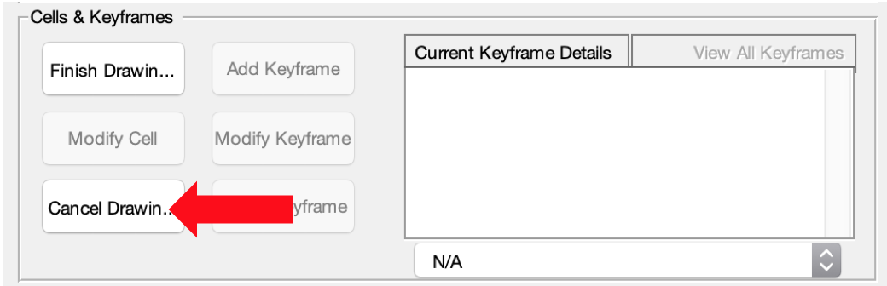

10. Modifying and Deleting Keyframe Objects

11. Manual Removal of Erroneous Signals

Objects can be removed from the currently displayed set by manually selecting them or clicking within the image and dragging the cursor to create a box which removes any signals within it from the current keyframe. The process can be initiated from the ‘Remove Signals’ button in the ‘Display’ panel.

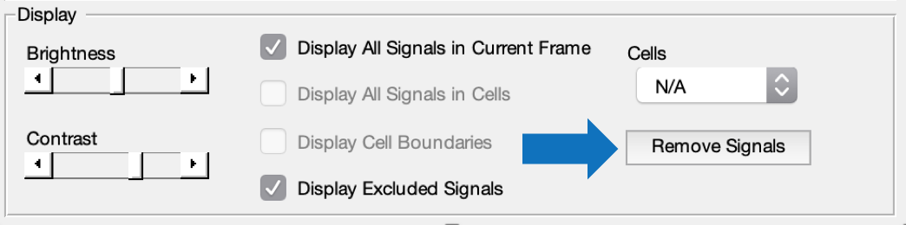

At this point, other operations like creating/modifying/deleting keyframes and cells will be turned off until the ‘Remove Signals’ button is clicked again. Once the removal process is started, clicking on objects within the main screen will mark them for removal from the current keyframe. Removed objects can be returned by clicking on that same object again.

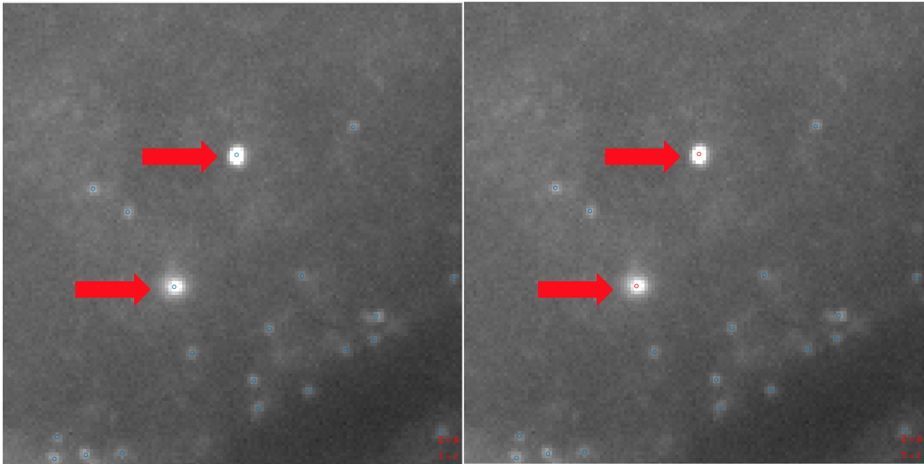

Larger regions with objects erroneously caught up in detection can be selected by clicking down on the image and dragging across the image to create a box which removes all objects currently within it. As with clicking on a spot again to return it to the keyframe, dragging a box over previously removed objects will return them to the keyframe’s set of objects for the current frame.

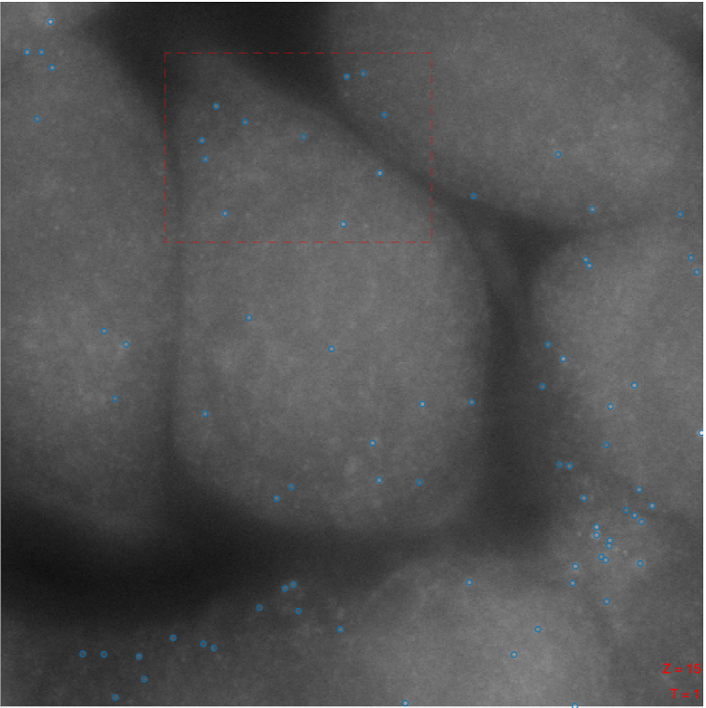

12. The Inspector Tool

The Inspector Tool allows for closer examination of the spots, the physical properties of them, and the pixels making up each spot. Once a keyframe for detected spots has been created, clicking on the image axis will highlight the nearest object. Right clicking the image axis after a spot is highlighted will open a menu for the inspector tool.

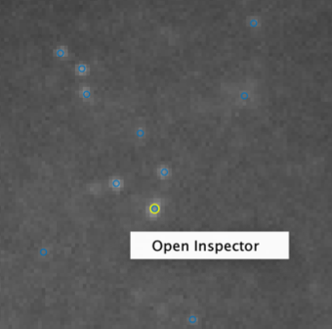

The inspector tool has several graphs and axes for examining detected objects’ features in detail. The components of the inspector tool are as follows:

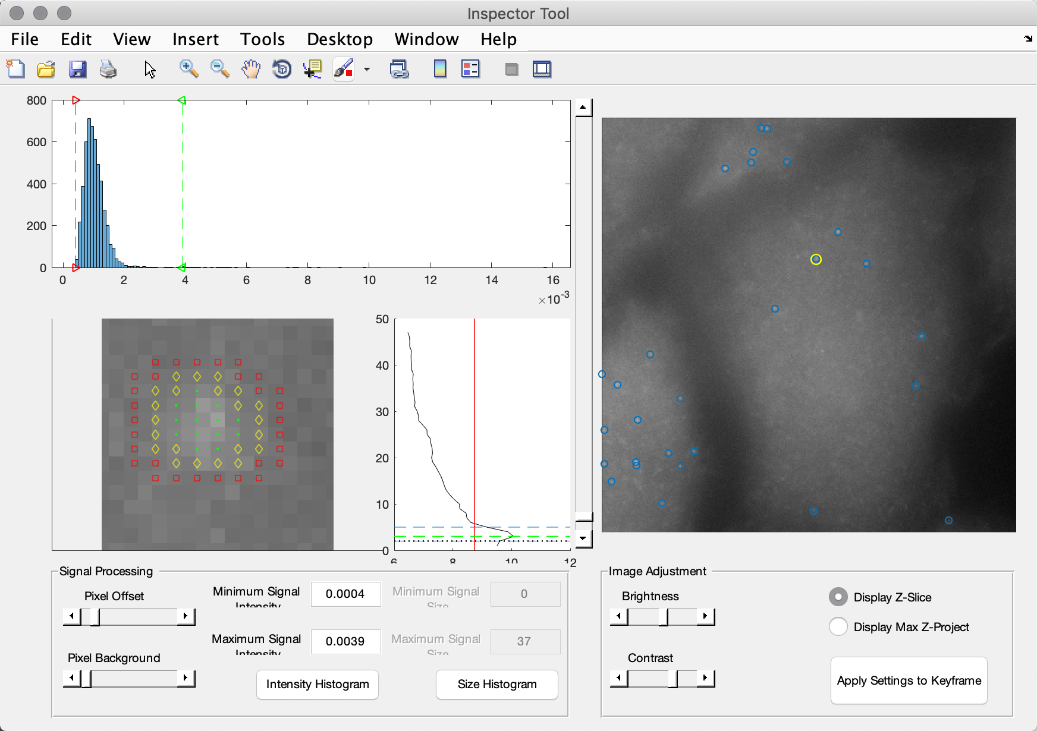

** NEED NEW IMAGE, axes look stretched on the inspector

13. Output Files

To save dNEMO results, navigate to File > Save. A prompt will appear asking where to store the created result files. Once a filename and save location have been selected, dNEMO will create a new folder with the same filename and save several files.

The first of these files is a ‘full_results’ mat-file. This file contains all the necessary data to reload keyframes, cells, and removals back into the dNEMO application. However, this file is not in a reader-friendly format, so additional files with more structure are simultaneously created.

The first of these is the ‘ALL_SPOTS’ mat-file, which contains both the keyframe detection settings for any created keyframes and all detected spots plus features. The list of features detected per spot is indicated in the table below. Measurements taken for objects are commensurate with the indicated signal measurement in the main application. For example, if a user indicates intensity measurements should be taken at the z-coordinate, the intensity measurements reported for the spots are for pixels at the z-coordinate.

|  |  |
| --- | --- |
| **Frame** | Frame number |
| **XCoord** | Centroid x-coordinate |
| **YCoord** | Centroid y-coordinate |
| **ZCoord** | Centroid z-coordinate |
| **INT_AVG** | Mean spot intensity, background corrected |
| **INT_MED** | Median spot intensity, background corrected |
| **INT_SUM** | Integrated spot intensity, background corrected |
| **INT_MAX** | Maximum spot intensity, background corrected |
| **SIZE** | Spot size (number of pixels) |
| **INT_AVG_RAW** | Raw mean spot intensity |
| **INT_MAX_RAW** | Raw maximum spot intensity |
| **INT_SUM_RAW** | Raw integrated spot intensity |
| **BG_MEAN** | Mean intensity of background pixels associated with spot |
| **BG_STD** | Standard deviation of intensities of background pixels associated with spot |
| **BG_MAX** | Maximum intensity of background pixels associated with spot |
| **BG_SUM** | Integrated intensity of background pixels associated with spot |
| **BG_SIZE** | Size of background region associated with spot (number of pixels) |

The second of these additional files is the ALL_CELLS mat-file, which contains cell polygon information, the cellular trajectories, and spot information sorted into individual cells. The properties for spots are identical to that of the ‘ALL_SPOTS’ file, but stored with their associated cell.

The third of these is an optional AVI of the segmented cells and detected spots. A prompt will ask the user for positive affirmation before creating this file.

14. Reloading Results into dNEMO

The only file necessary for recapitulating saved results in dNEMO is the ‘full_results’ mat-file. Open dNEMO in MATLAB and load in an image which has a prior ‘full_results’ mat-file. After the image has been loaded into dNEMO, navigate to File > Reload Results. There will be a prompt asking for a full_results mat-file to load into dNEMO. Navigate to where the previously created full_results mat-file was saved and open it to reload results into the dNEMO application.

15. Guided Example: smFISH

This section provides a walkthrough for how to process a sample smFISH image through dNEMO. The sample image ‘SMFISH_SAMPLE.tif’ can be found in the ‘sample_images’ folder within the dNEMO MATLAB directory.

This sample image is a 1024 x 1024 x 47 image containing smFISH data.

1. To start, open dNEMO from the command window by typing the following:

>>> RUN_ME

1. When the application opens up, navigate to File > Load Images. A prompt will appear asking for an image file. Navigate to the ‘sample_images’ folder within dNEMO and open ‘SMFISH_SAMPLE.tif’. This sample image has the dimensions 1024 x 1024 x 47, so when prompted for dimensionality select ‘3D’ and click okay to confirm 47 z-slices.
2. Adjust the brightness and contrast as needed, and navigate to the 3D Display > Full 3D Stack to examine individual slices of the image. Use the slider that appears to the right of the image axis to traverse the z-stack. Then select 3D Display > Max Z Project to return the image to a maximum intensity projection.
3. It is generally advised to begin by creating a keyframe to detect spots. Go to the ‘Cells & Keyframes’ panel and click ‘Add Keyframe’. A waitbar should appear showing the wavelet transform operating on each slice of the 3D image. Once the operation is finished, circles indicating identified spots will appear on the image axis.
4. In the ‘Spot Filter’ panel, a number of keyframe parameters can be adjusted. The wavelet threshold in the top left-hand corner determines what pixels should be considered foreground and background in the produced wavelet map, which is then operated on by watershed. Increasing this value reduces the number of spots and decreasing this value increases the number of spots. Lower the threshold to 1.25 to gather the fainter smFISH transcripts in the image which may have been missed at the higher threshold.
5. If you choose to, the minimum number of z-slices a spot has to appear in to be considered valid can be changed to fit sparser or denser imaging conditions. Navigate to Settings > Signal Parameters, and a small GUI will appear indicating detection parameters you can adjust. An example of such an adjustment would be to increase the ‘Frame Limit’ parameter to 5 in order to select for objects bright enough to appear in a minimum of 5 z-slices. For this image a frame limit of 2 appears to work well. Click ‘Confirm Settings’ to return to the GUI.
6. Omitting spots based on their physical properties can also be achieved using the interactive histogram in the ‘Spot Filter’ panel. Clicking inside the histogram permits shifting the bars to exclude spots from consideration based on their features, which is then shown in the main axis by changing the spots’ markers from blue to red.
7. Once comfortable with the spots identified in the given image, click the ‘Create’ button in the lower right-hand corner of the ‘Spot Filter’ panel. The keyframe will be assigned, and any parameters selected for will be assigned to the current keyframe. This image is only 1 frame, so the parameters aren’t propagated over multiple movie frames.
8. Once the waitbar goes away, the keyframe object is created, and spots have been detected. Now it is time to associate them with individual cells. To make it a little bit easier to see the cells, go to the ‘Display’ panel and adjust the brightness and contrast as needed, and toggle ‘Display All Signals In Current Frame’ off.
9. Click the ‘Draw Cell’ button in the ‘Cells & Keyframes’ panel, and click onto the image axis. A point will be left on the image, and an edge trailing along behind the mouse pointer. Trace along the outline of a single cell and either reconnect with the initial vertex or double click to complete the polygon. Holding down the ‘A’ key and clicking on edges will add additional vertices. Vertices can be stretched and shifted, and clicking and dragging in the middle of the polygon will allow you to move the entire object.
10. When content with the cell outline, click ‘Finish Drawing Cell’ to save the outline, or ‘Cancel Drawing Cell’ to return to start without saving. When finished drawing a cell, the outline will appear in the image axis. Toggling between the ‘Display All Signals in Current Frame’ and ‘Display All Signals in Cells’ will shift between the objects detected in the current frame and objects associated with individual cells.
11. Repeat the cell segmentation process to create several more single-cell outlines.
12. Congratulations, you now have N new individual cell measurements to add to your experimental results! Save these results by navigating to File > Save. The prompt will ask for a location to save the mat-files. dNEMO will create a new folder with the same name containing three results mat-files. After those files are output, an additional prompt will inquire about producing an AVI of the cells quantified. While usually more helpful for a movie than a fixed image, select ‘Yes’ and an AVI of the image with the cells and objects identified will be saved to the same folder.

16. Guided Example: EGFP-NEMO

17. References

1. Linkert, M., C. T. Rueden, C. Allan, J.-M. Burel, W. Moore, A. Patterson, B. Loranger, J. Moore, C. Neves, D. MacDonald, A. Tarkowska, C. Sticco, E. Hill, M. Rossner, K. W. Eliceiri, and J. R. Swedlow. 2010. Metadata matters: access to image data in the real world. The Journal of Cell Biology 189(5):777.