计算机图形学课程报告

计算机科学与技术学院

班 级： CS1601
学 号： U201614531
姓 名： 刘本嵩
指导教师：
完成日期： 2019.12.17

1 回答问题
- 你选修计算机图形学课程，想得到的是什么知识？现在课程结束，对于所得的知识是否满意？如果不满意，你准备如何寻找自己需要的知识。
想大致了解计算机图形学相关知识，例如了解游戏界面如何渲染之类的常识。满意。
- 你对计算机图形学课程中的哪一个部分的内容最感兴趣，请简述之。
图形渲染相关内容。这部分涉及到线性代数等知识，高级光线处理等部分还涉及物理学知识。
（3）你对计算机图形学课程的内容，教学方法有什么看法和建议。
无

2 实验内容
请注意，下面的源码有库依赖，请在随报告附赠的源码包获取，或访问Gitlab: https://git.recolic.org/recolic-hust/opengl

2.1 OpenGL动画
2.1.1 实验内容及要求
利用OpenGL，设计一个动画，让一个矩形（或者是球）沿着一个椭圆的轨道运行，椭圆的长轴和短轴的比值为4:3。
（1）可以参考中点法画椭圆的方式
（2）注意椭圆与坐标轴的四个交点以及切线斜率为正负1的位置。
（3）可以利用GLUT框架实现
（4）注意使用双缓存，其他颜色等属性不限。
2.1.2 实现的方法、过程
实现函数calc_square_vertex_buf_data，用来生成一个矩形所需的vertex buffer。
实现函数calc_ellipse_point，输入0到1的一个数字，用来确定椭圆上对应的一个点。
实现函数calc_ellipse_vertex_buf_data，用来预先把椭圆所需的vertex buffer画好。
其余代码都是固定套路，例如初始化VAO，VBO，texture，shader，计算fps信息，逐帧渲染等等。
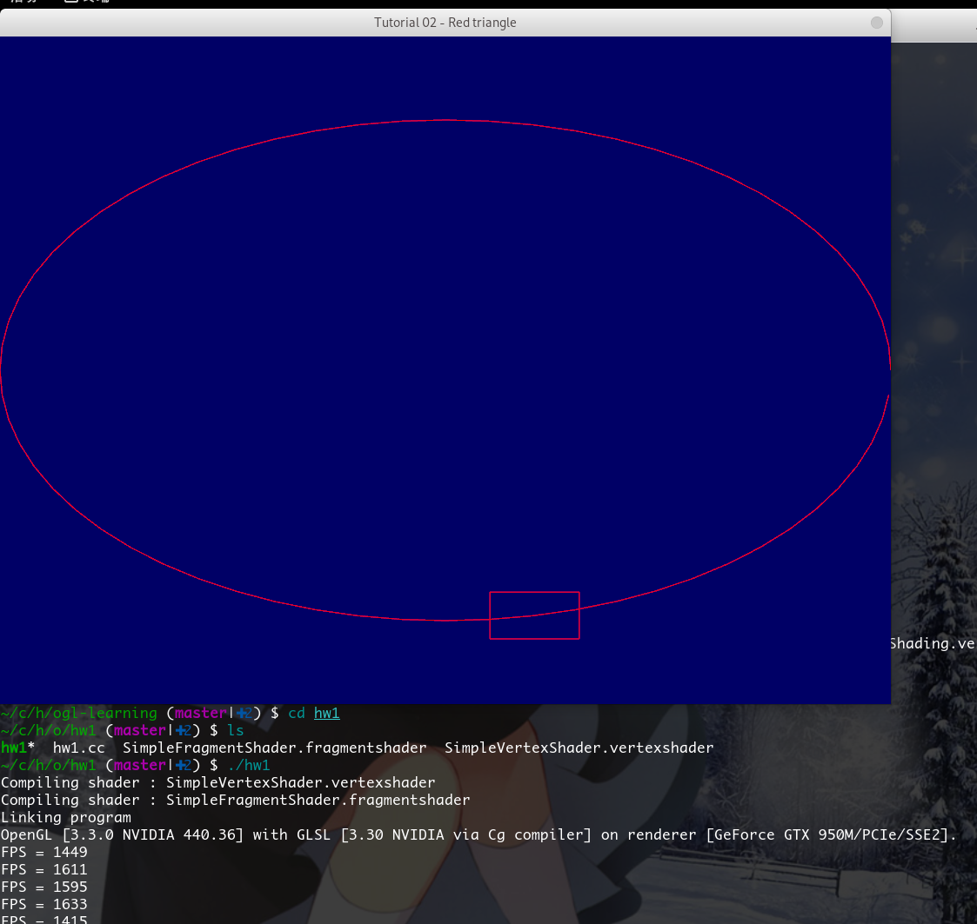
2.1.3 源程序
程序1：OpenGL动画
//*# -------------------- ./SimpleVertexShader.vertexshader ---------------------*/
#version 330 core

// Input vertex data, different for all executions of this shader.
layout(location = 0) in vec3 vertexPosition_modelspace;

void main(){

gl_Position.xyz = vertexPosition_modelspace;
gl_Position.w = 1.0;

}

//*# -------------------- ./hw1.cc ---------------------*/
// Include standard headers
#include <stdio.h>
#include <stdlib.h>

// Include GLEW
#include <GL/glew.h>

// Include GLFW
#include <GLFW/glfw3.h>
GLFWwindow* window;

// Include GLM
#include <glm/glm.hpp>
using namespace glm;

#include <common/shader.hpp>
#include <vector>
#include <chrono>
using namespace std::chrono;

#include <rlib/stdio.hpp>
#include <common/fps.hpp>

auto calc_square_vertex_buf_data(std::pair<float, float> center) {
auto dx = 0.1, dy = 0.07;
auto x1 = center.first - dx, x2 = center.first + dx,
y1 = center.second - dy, y2 = center.second + dy;

#ifdef DEBUG
rlib::println("debug: square, x1,y1,x2,y2 = ", x1, y1, x2, y2);
#endif

return std::vector<float>{
x1, y1,
x1, y2,
x1, y1,
x2, y1,

x2, y2,
x1, y2,
x2, y2,
x2, y1
};
}

auto calc_ellipse_point(float location_0_to_1) {
auto y_sign = location_0_to_1 > 0.5 ? -1.0 : 1.0;
auto x = cos(location_0_to_1 * 2 * M_PI);
auto y = sqrt(1.0-x*x) * 0.75 * y_sign;
#ifdef DEBUG
rlib::println("debug: center x,y = ", x, y);
#endif
return std::make_pair((float)x, (float)y);
}

auto calc_ellipse_vertex_buf_data()
{
const float cx = 0, cy = 0, rx = 1, ry = 0.75, num_segments = 64;

float theta = M_PI * 2 / float(num_segments);
float c = cosf(theta); //precalculate the sine and cosine
float s = sinf(theta);
float t;

float x = 1;//we start at angle = 0
float y = 0;

std::vector<float> buf;
for(int ii = 0; ii < num_segments; ++ii)
{
//apply radius and offset
if(ii != 0) { buf.emplace_back(x * rx + cx); buf.emplace_back(y * ry + cy); }
if(ii != num_segments-1) { buf.emplace_back(x * rx + cx); buf.emplace_back(y * ry + cy); }

//apply the rotation matrix
t = x;
x = c * x - s * y;
y = s * t + c * y;
}

return buf;
}

int main( void )
{
// Make println faster
// rlib::enable_endl_flush(false);
rlib::sync_with_stdio(false);

// Initialise GLFW
if( !glfwInit() )
{
fprintf( stderr, "Failed to initialize GLFW\n" );
getchar();
return -1;
}

glfwWindowHint(GLFW_SAMPLES, 4);
glfwWindowHint(GLFW_CONTEXT_VERSION_MAJOR, 3);
glfwWindowHint(GLFW_CONTEXT_VERSION_MINOR, 3);
glfwWindowHint(GLFW_OPENGL_FORWARD_COMPAT, GL_TRUE); // To make MacOS happy; should not be needed
glfwWindowHint(GLFW_OPENGL_PROFILE, GLFW_OPENGL_CORE_PROFILE);

// Open a window and create its OpenGL context
window = glfwCreateWindow( 1024, 768, "Tutorial 02 - Red triangle", NULL, NULL);
if( window == NULL ){
fprintf( stderr, "Failed to open GLFW window. If you have an Intel GPU, they are not 3.3 compatible. Try the 2.1 version of the tutorials.\n" );
getchar();
glfwTerminate();
return -1;
}
glfwMakeContextCurrent(window);

// Initialize GLEW
glewExperimental = true; // Needed for core profile
if (glewInit() != GLEW_OK) {
fprintf(stderr, "Failed to initialize GLEW\n");
getchar();
glfwTerminate();
return -1;
}

// Ensure we can capture the escape key being pressed below
glfwSetInputMode(window, GLFW_STICKY_KEYS, GL_TRUE);

// Dark blue background
glClearColor(0.0f, 0.0f, 0.4f, 0.0f);

GLuint VertexArrayID;
glGenVertexArrays(1, &VertexArrayID);
glBindVertexArray(VertexArrayID);

// Create and compile our GLSL program from the shaders
GLuint programID = LoadShaders( "SimpleVertexShader.vertexshader", "SimpleFragmentShader.fragmentshader" );

GLuint vertexbuffer;
glGenBuffers(1, &vertexbuffer);
glBindBuffer(GL_ARRAY_BUFFER, vertexbuffer);

const size_t msPerRound = 10000;
auto ellipse_vertex_buffer = calc_ellipse_vertex_buf_data();

init_fps();

do {
// Prepare vertex buffer
auto g_vertex_buffer = ellipse_vertex_buffer;

auto location = (float)( duration_cast< milliseconds >(
system_clock::now().time_since_epoch()
).count() % msPerRound ) / msPerRound;
auto square_vertex_buffer = std::move(calc_square_vertex_buf_data(calc_ellipse_point(location)));

g_vertex_buffer.insert(g_vertex_buffer.end(), square_vertex_buffer.begin(), square_vertex_buffer.end());
glBufferData(GL_ARRAY_BUFFER, g_vertex_buffer.size() * sizeof(float), g_vertex_buffer.data(), GL_STATIC_DRAW);

// Clear the screen
glClear( GL_COLOR_BUFFER_BIT );

// Use our shader
glUseProgram(programID);

// 1rst attribute buffer : vertices
glEnableVertexAttribArray(0);
glBindBuffer(GL_ARRAY_BUFFER, vertexbuffer);
glVertexAttribPointer(
0, // attribute 0. No particular reason for 0, but must match the layout in the shader.
2, // size
GL_FLOAT, // type
GL_FALSE, // normalized?
0, // stride
(void*)0 // array buffer offset
);

// Draw the lines!
glDrawArrays(GL_LINES, 0, g_vertex_buffer.size() / 2);
++ fps_counter;

glDisableVertexAttribArray(0);

// Swap buffers
glfwSwapBuffers(window);
glfwPollEvents();

} // Check if the ESC key was pressed or the window was closed
while( glfwGetKey(window, GLFW_KEY_ESCAPE ) != GLFW_PRESS &&
glfwWindowShouldClose(window) == 0 );

// Cleanup VBO
glDeleteBuffers(1, &vertexbuffer);
glDeleteVertexArrays(1, &VertexArrayID);
glDeleteProgram(programID);

// Close OpenGL window and terminate GLFW
glfwTerminate();

return 0;
}

//*# -------------------- ./SimpleFragmentShader.fragmentshader ---------------------*/
#version 330 core

// Ouput data
out vec3 color;

void main()
{

// Output color = red
color = vec3(1,0,0);

}

2.2日地月模型
2.2.1 实验内容及要求
利用OpenGL，设计一个日地月运动模型动画。
（1）月亮绕地球可以使用圆形轨道，地球绕太阳使用实验1的椭圆轨道。
（2）运动关系正确，相对速度合理，且圆形轨道和椭圆轨道不能在一个平面内。
（3）增加光照处理，光源设在太阳上面。
（4）为了提高太阳的显示效果，可以在侧后增加一个专门照射太阳的灯。
（5）加分项：增加纹理处理。
2.2.2 实现的方法、过程
除了框架代码外，寻找地球月球太阳和星空的高清图片，写一个函数从图片建立球纹理。背景星空就是一个巨大半径的球，和其他星球用相同方式处理。
阴影效果，光照效果，光线反射效果均有标准shader的实现，稍作修改即可采用。
地球/月球/太阳的自转由rotatePlanet实现，公转由orbitPlanet实现。
玩家操作时，使用WASD控制前后左右移动，用空格键向上飞行，Z键向下飞行。移动鼠标可以自由移动视角，主键盘+(=)键可以加快宇宙运行，-键减慢宇宙运行，PAUSE键暂停宇宙运行，再按一次即可恢复运行。
由于未知bug，背景星空未能正常显示。
因为反射系数被设置的非常小，因此星球反射太阳光可能难以在截图中察觉。
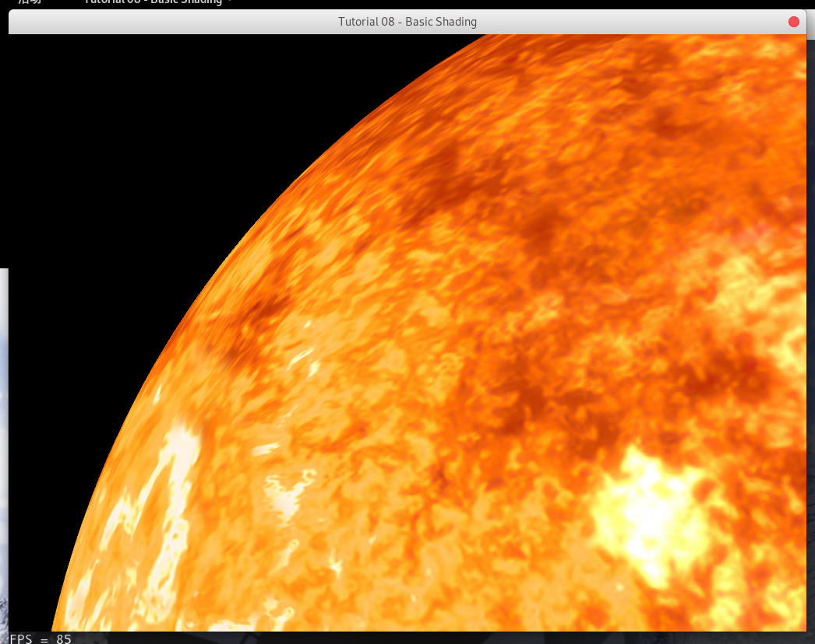
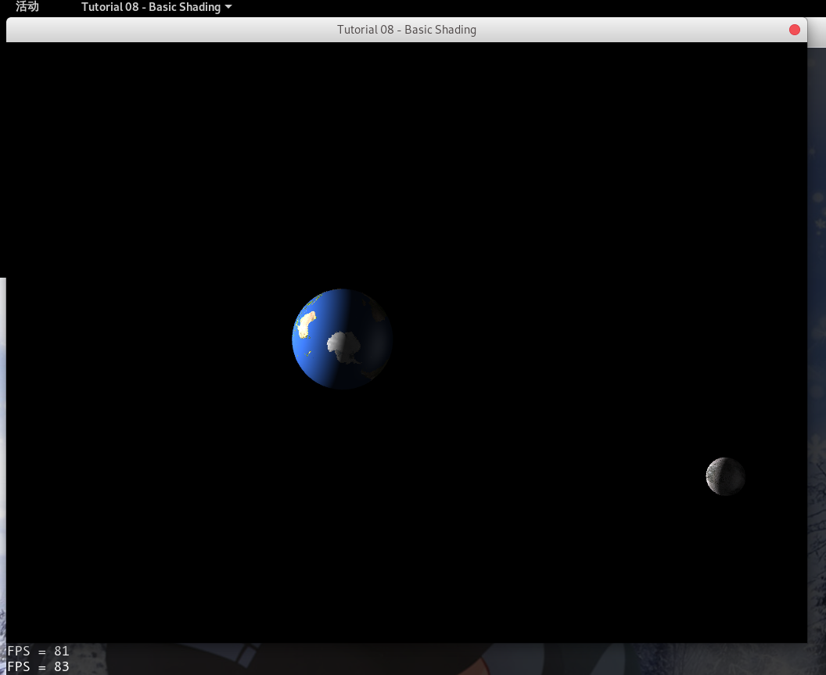
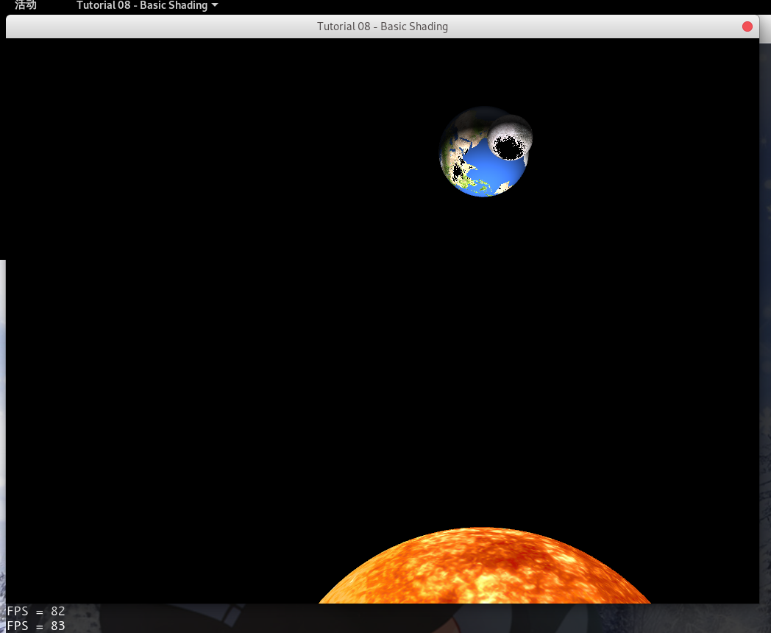
2.2.3 源程序
程序2：日地月模型
//*# -------------------- ./StandardShading.vertexshader ---------------------*/
#version 330 core

// Input vertex data, different for all executions of this shader.
layout(location = 0) in vec3 vertexPosition_modelspace;
layout(location = 1) in vec3 vertexNormal_modelspace;
layout(location = 2) in vec2 vertexUV;

// Output data ; will be interpolated for each fragment.
out vec2 UV;
out vec3 Position_worldspace;
out vec3 Normal_cameraspace;
out vec3 EyeDirection_cameraspace;
out vec3 LightDirection_cameraspace;

// Values that stay constant for the whole mesh.
uniform mat4 MVP;
uniform mat4 V;
uniform mat4 M;
uniform vec3 LightPosition_worldspace;

void main(){

// Output position of the vertex, in clip space : MVP * position
gl_Position = MVP * vec4(vertexPosition_modelspace,1);

// Position of the vertex, in worldspace : M * position
Position_worldspace = (M * vec4(vertexPosition_modelspace,1)).xyz;

// Vector that goes from the vertex to the camera, in camera space.
// In camera space, the camera is at the origin (0,0,0).
vec3 vertexPosition_cameraspace = ( V * M * vec4(vertexPosition_modelspace,1)).xyz;
EyeDirection_cameraspace = vec3(0,0,0) - vertexPosition_cameraspace;

// Vector that goes from the vertex to the light, in camera space. M is ommited because it's identity.
vec3 LightPosition_cameraspace = ( V * vec4(LightPosition_worldspace,1)).xyz;
LightDirection_cameraspace = LightPosition_cameraspace + EyeDirection_cameraspace;

// Normal of the the vertex, in camera space
Normal_cameraspace = ( V * M * vec4(vertexNormal_modelspace,0)).xyz; // Only correct if ModelMatrix does not scale the model ! Use its inverse transpose if not.

// UV of the vertex. No special space for this one.
UV = vertexUV;
}

./sun.jpg
./space.jpg
./earth.jpg
./moonyy.jpg
//*# -------------------- ./hw2.cc ---------------------*/
// Include standard headers
#include <stdio.h>
#include <stdlib.h>
#include <vector>
#include <cmath>

// Include GLEW
#include <GL/glew.h>

// Include GLFW
#include <GLFW/glfw3.h>
GLFWwindow* window;

// Include GLM
#include <glm/glm.hpp>
#include <glm/gtc/matrix_transform.hpp>
#include <glm/gtx/string_cast.hpp>
using namespace glm;

#include <common/shader.hpp>
#include <common/texture.hpp>
#include <common/controls.hpp>
#include <common/objloader.hpp>
#include <common/vboindexer.hpp>
#include <common/fps.hpp>

#include <rlib/stdio.hpp>
#include "imported.hpp"

#include <thread>

int main()
{
// Initialise GLFW
if( !glfwInit() )
{
fprintf( stderr, "Failed to initialize GLFW\n" );
getchar();
return -1;
}

glfwWindowHint(GLFW_SAMPLES, 4);
glfwWindowHint(GLFW_CONTEXT_VERSION_MAJOR, 3);
glfwWindowHint(GLFW_CONTEXT_VERSION_MINOR, 3);
glfwWindowHint(GLFW_OPENGL_FORWARD_COMPAT, GL_TRUE); // To make MacOS happy; should not be needed
glfwWindowHint(GLFW_OPENGL_PROFILE, GLFW_OPENGL_CORE_PROFILE);

// Open a window and create its OpenGL context
window = glfwCreateWindow( 1024, 768, "Tutorial 08 - Basic Shading", NULL, NULL);
if( window == NULL ){
fprintf( stderr, "Failed to open GLFW window. If you have an Intel GPU, they are not 3.3 compatible. Try the 2.1 version of the tutorials.\n" );
getchar();
glfwTerminate();
return -1;
}
glfwMakeContextCurrent(window);
R_GL_ERROR_CHECKPOINT;

// Initialize GLEW
glewExperimental = true; // Needed for core profile
if (glewInit() != GLEW_OK) {
fprintf(stderr, "Failed to initialize GLEW\n");
getchar();
glfwTerminate();
return -1;
}
glGetError();

// Ensure we can capture the escape key being pressed below
glfwSetInputMode(window, GLFW_STICKY_KEYS, GL_TRUE);
// Hide the mouse and enable unlimited mouvement
glfwSetInputMode(window, GLFW_CURSOR, GLFW_CURSOR_DISABLED);

// Set the mouse at the center of the screen
glfwPollEvents();
glfwSetCursorPos(window, 1024/2, 768/2);

// Enable depth test
glEnable(GL_DEPTH_TEST);
// Accept fragment if it closer to the camera than the former one
//glDepthFunc(GL_LESS);
glDepthFunc(GL_LEQUAL);

// Cull triangles which normal is not towards the camera
glEnable(GL_CULL_FACE);

GLuint VertexArrayID;
glGenVertexArrays(1, &VertexArrayID);
glBindVertexArray(VertexArrayID);
R_GL_ERROR_CHECKPOINT;

// Create and compile our GLSL program from the shaders
programID = LoadShaders( "StandardShading.vertexshader", "StandardShading.fragmentshader" );
R_GL_ERROR_CHECKPOINT;

// Get a handle for our "MVP" uniform
GLuint MatrixID = glGetUniformLocation(programID, "MVP");
GLuint ViewMatrixID = glGetUniformLocation(programID, "V");
GLuint ModelMatrixID = glGetUniformLocation(programID, "M");

// import begin
R_GL_ERROR_CHECKPOINT;
generateIDs();
R_GL_ERROR_CHECKPOINT;
initVAO();
R_GL_ERROR_CHECKPOINT;
float distScale = 35.0 / 149597870.7; // AU in km
float radScale = 1.0 / 6378.1; // E in km
// world space
vec3 sunCenter = vec3(0.0);
vec3 earthCenter = vec3(0.0);
vec3 moonCenter = vec3(0.0);

// make sun
std::vector<vec3> sunVertices;
std::vector<vec3> sunNormals;
std::vector<vec2> sunUvs;
std::vector<unsigned int> sunIndices;
sunCenter = vec3(0.0);
float sunRadius = pow(radScale * 696000.0, 0.5);
R_GL_ERROR_CHECKPOINT;
generateSphere(sunVertices, sunNormals, sunUvs, sunIndices, sunCenter, sunRadius, 96);
R_GL_ERROR_CHECKPOINT;
GLuint sun = createTexture("sun.jpg");
R_GL_ERROR_CHECKPOINT;

// make earth
std::vector<vec3> earthVertices;
std::vector<vec3> earthNormals;
std::vector<vec2> earthUvs;
std::vector<unsigned int> earthIndices;
earthCenter = vec3(distScale * 149597890, 0.0, 0.0);
float earthRadius = pow(radScale * 6378.1, 0.5);
generateSphere(earthVertices, earthNormals, earthUvs, earthIndices, earthCenter, earthRadius, 72);
GLuint earth = createTexture("earth.jpg");

rlib::println("Sun.R = ", sunRadius, "earth.R=", earthRadius);

// make moon
std::vector<vec3> moonVertices;
std::vector<vec3> moonNormals;
std::vector<vec2> moonUvs;
std::vector<unsigned int> moonIndices;
moonCenter = earthCenter - vec3((20 * distScale * 384399.0), 0.0, 0.0);
float moonRadius = pow(radScale * 1737.1 / 2, 0.5);
generateSphere(moonVertices, moonNormals, moonUvs, moonIndices, moonCenter, moonRadius, 48);
GLuint moon = createTexture("moonyy.jpg");

// make space
std::vector<vec3> spaceVertices;
std::vector<vec3> spaceNormals;
std::vector<vec2> spaceUvs;
std::vector<unsigned int> spaceIndices;
vec3 spaceCenter = vec3(0.0);
generateSphere(spaceVertices, spaceNormals, spaceUvs, spaceIndices, spaceCenter, 400.0, 128);
GLuint space = createTexture("space1.png");
R_GL_ERROR_CHECKPOINT;

auto debugMsg = [&](){
rlib::println("DEBUGLINE: SunNode_model=", glm::to_string(sunVertices[0]), ", Earth=", glm::to_string(earthVertices[0]));
};

float scale;
float sunRot;
float earthOrb;
float earthRot;
float moonOrb;
float moonRot;
float spaceRot;
GLuint diffUniformLocation;
// import end

// Get a handle for our "LightPosition" uniform
glUseProgram(programID);
GLuint LightID = glGetUniformLocation(programID, "LightPosition_worldspace");
glfwSetKeyCallback(window, key_callback);

init_fps();
do{
// Clear the screen
glClear(GL_COLOR_BUFFER_BIT | GL_DEPTH_BUFFER_BIT);

// Use our shader
glUseProgram(programID);

// Compute the MVP matrix from keyboard and mouse input
computeMatricesFromInputs();
glm::mat4 ProjectionMatrix = getProjectionMatrix();
glm::mat4 ViewMatrix = getViewMatrix();
glm::mat4 ModelMatrix = glm::mat4(1.0);
glm::mat4 MVP = ProjectionMatrix * ViewMatrix * ModelMatrix;

glUniformMatrix4fv(MatrixID, 1, GL_FALSE, &MVP[0][0]);
glUniformMatrix4fv(ModelMatrixID, 1, GL_FALSE, &ModelMatrix[0][0]);
glUniformMatrix4fv(ViewMatrixID, 1, GL_FALSE, &ViewMatrix[0][0]);
glm::vec3 lightPos = glm::vec3(0,0,0);
glUniform3f(LightID, lightPos.x, lightPos.y, lightPos.z);

scale = universeTimeSpeed * M_PI;
sunRot = scale / 25.38;
earthOrb = scale / 365;
earthRot = -scale;
moonOrb = scale / 27.32;
moonRot = scale / 27.32;
spaceRot = scale / 5000;

// call function to draw our scene
rotatePlanet(sunVertices, sunNormals, sunCenter, vec3(0.0, 0.0, 1.0), sunRot);
orbitPlanet(earthVertices, earthNormals, earthCenter, sunCenter, vec3(0.0, 0.0, 1.0), earthOrb);
rotatePlanet(earthVertices, earthNormals, earthCenter, vec3(0.0, 0.0, 1.0), earthRot);
orbitPlanet(moonVertices, moonNormals, moonCenter, earthCenter, vec3(0.0, 0.0, 1.0), moonOrb);
rotatePlanet(moonVertices, moonNormals, moonCenter, vec3(0.0, 0.0, 1.0), moonRot);
rotatePlanet(spaceVertices, spaceNormals, spaceCenter, vec3(0.0, 0.0, 1.0), spaceRot);
R_GL_ERROR_CHECKPOINT;

loadBuffer(sunVertices, sunNormals, sunUvs, sunIndices);
loadTexture(sun, GL_TEXTURE0, programID, "myTextureSampler");
diffUniformLocation = glGetUniformLocation(programID, "diffuse");
glUniform1i(diffUniformLocation, false); // change this to sunDiffuse or something in your free time because this is sloppy
render(MVP, ViewMatrix, ModelMatrix, 0, sunIndices.size());
R_GL_ERROR_CHECKPOINT;

loadBuffer(earthVertices, earthNormals, earthUvs, earthIndices);
loadTexture(earth, GL_TEXTURE0, programID, "myTextureSampler");
diffUniformLocation = glGetUniformLocation(programID, "diffuse");
glUniform1i(diffUniformLocation, true);
render(MVP, ViewMatrix, ModelMatrix, 0, earthIndices.size());
R_GL_ERROR_CHECKPOINT;

loadBuffer(moonVertices, moonNormals, moonUvs, moonIndices);
loadTexture(moon, GL_TEXTURE0, programID, "myTextureSampler");
diffUniformLocation = glGetUniformLocation(programID, "diffuse");
glUniform1i(diffUniformLocation, true);
render(MVP, ViewMatrix, ModelMatrix, 0, moonIndices.size());

loadBuffer(spaceVertices, spaceNormals, spaceUvs, spaceIndices);
loadTexture(space, GL_TEXTURE0, programID, "myTextureSampler");
diffUniformLocation = glGetUniformLocation(programID, "diffuse");
glUniform1i(diffUniformLocation, false);
render(MVP, ViewMatrix, ModelMatrix, 0, spaceIndices.size());

++fps_counter;

// Swap buffers
glfwSwapBuffers(window);
glfwPollEvents();

} // Check if the ESC key was pressed or the window was closed
while(glfwGetKey(window, GLFW_KEY_ESCAPE ) != GLFW_PRESS && glfwWindowShouldClose(window) == 0);
glDisableVertexAttribArray(0);
glDisableVertexAttribArray(1);
glDisableVertexAttribArray(2);

/*
// Cleanup VBO and shader
glDeleteBuffers(1, &vertexbuffer);
glDeleteBuffers(1, &uvbuffer);
glDeleteBuffers(1, &normalbuffer);
glDeleteProgram(programID);
glDeleteTextures(1, &Texture);
glDeleteVertexArrays(1, &VertexArrayID);
*/
deleteIDs();

// Close OpenGL window and terminate GLFW
glfwTerminate();

return 0;
}

//*# -------------------- ./StandardShading.fragmentshader ---------------------*/
#version 330 core

// Interpolated values from the vertex shaders
in vec2 UV;
in vec3 Position_worldspace;
in vec3 Normal_cameraspace;
in vec3 EyeDirection_cameraspace;
in vec3 LightDirection_cameraspace;

// Ouput data
out vec3 color;

// Values that stay constant for the whole mesh.
uniform sampler2D myTextureSampler;
uniform mat4 MV;
uniform vec3 LightPosition_worldspace;

uniform bool diffuse;

void main(){
if(!diffuse) {
// No light processing
color = texture( myTextureSampler, UV ).rgb;
return;
}

// Light emission properties
// You probably want to put them as uniforms
vec3 LightColor = vec3(1,1,1);
float LightPower = 3000.0f;
float reflectFactor = 0.01f;

// Material properties
vec3 MaterialDiffuseColor = texture( myTextureSampler, UV ).rgb;
vec3 MaterialAmbientColor = vec3(0.1,0.1,0.1) * MaterialDiffuseColor;
vec3 MaterialSpecularColor = vec3(0.3,0.3,0.3);

// Distance to the light
float distance = length( LightPosition_worldspace - Position_worldspace );

// Normal of the computed fragment, in camera space
vec3 n = normalize( Normal_cameraspace );
// Direction of the light (from the fragment to the light)
vec3 l = normalize( LightDirection_cameraspace );
// Cosine of the angle between the normal and the light direction,
// clamped above 0
// - light is at the vertical of the triangle -> 1
// - light is perpendicular to the triangle -> 0
// - light is behind the triangle -> 0
float cosTheta = clamp( dot( n,l ), 0,1 );

// Eye vector (towards the camera)
vec3 E = normalize(EyeDirection_cameraspace);
// Direction in which the triangle reflects the light
vec3 R = reflect(-l,n);
// Cosine of the angle between the Eye vector and the Reflect vector,
// clamped to 0
// - Looking into the reflection -> 1
// - Looking elsewhere -> < 1
float cosAlpha = clamp( dot( E,R ), 0,1 );

color =
// Ambient : simulates indirect lighting
MaterialAmbientColor +
// Diffuse : "color" of the object
MaterialDiffuseColor * LightColor * LightPower * cosTheta / (distance*distance) +
// Specular : reflective highlight, like a mirror
reflectFactor * MaterialSpecularColor * LightColor * LightPower * pow(cosAlpha,5) / (distance*distance);
}//*# -------------------- ./imported.hpp ---------------------*/
#ifndef RLIB_GL_IMPORTED_HPP_
#define RLIB_GL_IMPORTED_HPP_ 1

// Include standard headers
#include <stdio.h>
#include <stdlib.h>
#include <vector>
#include <cmath>
#define STB_IMAGE_IMPLEMENTATION
#include <common/stb/stb_image.h>
#include <rlib/macro.hpp>

// Include GLEW
#include <GL/glew.h>

// Include GLFW
#include <GLFW/glfw3.h>

// Include GLM
#include <glm/glm.hpp>
#include <glm/gtc/matrix_transform.hpp>
using namespace glm;

#include <iostream>
#include <string>
using std::cout;
using std::endl;
using std::string;
using std::vector;

//vec2 and vec3 are part of the glm math library.
//Include in your own project by putting the glm directory in your project,
//and including glm/glm.hpp as I have at the top of the file.
//"using namespace glm;" will allow you to avoid writing everyting as glm::vec2
std::vector<vec3> points;
std::vector<vec2> uvs;

namespace VAO {
enum {GEOMETRY=0, COUNT}; //Enumeration assigns each name a value going up
//LINES=0, COUNT=1
}

namespace VBO {
enum {POINTS=0, NORMALS, UVS, INDICES, COUNT}; //POINTS=0, COLOR=1, COUNT=2
};

GLuint vbo [VBO::COUNT]; //Array which stores OpenGL's vertex buffer object handles
GLuint vao [VAO::COUNT]; //Array which stores Vertex Array Object handles
GLuint programID;

#ifdef DEBUG
#define R_GL_ERROR_CHECKPOINT CheckGLErrors("GL Error at " __FILE__ ":" RLIB_MACRO_TO_CSTR(__LINE__))
#else
#define R_GL_ERROR_CHECKPOINT
#endif
bool CheckGLErrors(string location)
{
bool error = false;
for (GLenum flag = glGetError(); flag != GL_NO_ERROR; flag = glGetError())
{
cout << "OpenGL ERROR: ";
switch (flag) {
case GL_INVALID_ENUM:
cout << location << ": " << "GL_INVALID_ENUM" << endl; break;
case GL_INVALID_VALUE:
cout << location << ": " << "GL_INVALID_VALUE" << endl; break;
case GL_INVALID_OPERATION:
cout << location << ": " << "GL_INVALID_OPERATION" << endl; break;
case GL_INVALID_FRAMEBUFFER_OPERATION:
cout << location << ": " << "GL_INVALID_FRAMEBUFFER_OPERATION" << endl; break;
case GL_OUT_OF_MEMORY:
cout << location << ": " << "GL_OUT_OF_MEMORY" << endl; break;
default:
cout << "[unknown error code]" << endl;
}
error = true;
}
if(error)
throw std::runtime_error("CheckGLErrors failed. See log.");
return true;
}

//Describe the setup of the Vertex Array Object
void initVAO()
{
glBindVertexArray(vao[VAO::GEOMETRY]); //Set the active Vertex Array
R_GL_ERROR_CHECKPOINT;

glEnableVertexAttribArray(0); //Tell opengl you're using layout attribute 0 (For shader input)
R_GL_ERROR_CHECKPOINT;
glBindBuffer( GL_ARRAY_BUFFER, vbo[VBO::POINTS] ); //Set the active Vertex Buffer
R_GL_ERROR_CHECKPOINT;
glVertexAttribPointer(
0, //Attribute
3, //Size # Components
GL_FLOAT, //Type
GL_FALSE, //Normalized?
sizeof(vec3), //Stride
(void*)0 //Offset
);
R_GL_ERROR_CHECKPOINT;

glEnableVertexAttribArray(1);
glBindBuffer(GL_ARRAY_BUFFER, vbo[VBO::NORMALS]);
glVertexAttribPointer(
1, //Attribute
3, //Size # Components
GL_FLOAT, //Type
GL_FALSE, //Normalized?
sizeof(vec3), //Stride
(void*)0 //Offset
);

glEnableVertexAttribArray(2); //Tell opengl you're using layout attribute 1
glBindBuffer(GL_ARRAY_BUFFER, vbo[VBO::UVS]);
glVertexAttribPointer(
2,
2,
GL_FLOAT,
GL_FALSE,
sizeof(vec2),
(void*)0
);

glBindBuffer(GL_ELEMENT_ARRAY_BUFFER, vbo[VBO::INDICES]);
R_GL_ERROR_CHECKPOINT;
}
//Gets handles from OpenGL
void generateIDs()
{
glGenVertexArrays(VAO::COUNT, vao); //Tells OpenGL to create VAO::COUNT many
// Vertex Array Objects, and store their
// handles in vao array
glGenBuffers(VBO::COUNT, vbo); //Tells OpenGL to create VBO::COUNT many
//Vertex Buffer Objects and store their
//handles in vbo array
}
//Clean up IDs when you're done using them
void deleteIDs()
{
glDeleteProgram(programID);

glDeleteVertexArrays(VAO::COUNT, vao);
glDeleteBuffers(VBO::COUNT, vbo);
}

//Loads buffers with data
void loadBuffer(const vector<vec3>& points, const vector<vec3> normals,
const vector<vec2>& uvs, const vector<unsigned int>& indices)
{
R_GL_ERROR_CHECKPOINT;
glBindBuffer(GL_ARRAY_BUFFER, vbo[VBO::POINTS]);
R_GL_ERROR_CHECKPOINT;
glBufferData(
GL_ARRAY_BUFFER, //Which buffer you're loading too
sizeof(vec3)*points.size(), //Size of data in array (in bytes)
&points[0], //Start of array (&points[0] will give you pointer to start of vector)
GL_DYNAMIC_DRAW //GL_DYNAMIC_DRAW if you're changing the data often
//GL_STATIC_DRAW if you're changing seldomly
);

R_GL_ERROR_CHECKPOINT;
glBindBuffer(GL_ARRAY_BUFFER, vbo[VBO::NORMALS]);
R_GL_ERROR_CHECKPOINT;
glBufferData(
GL_ARRAY_BUFFER, //Which buffer you're loading too
sizeof(vec3)*normals.size(), //Size of data in array (in bytes)
&normals[0], //Start of array (&points[0] will give you pointer to start of vector)
GL_DYNAMIC_DRAW //GL_DYNAMIC_DRAW if you're changing the data often
//GL_STATIC_DRAW if you're changing seldomly
);

glBindBuffer(GL_ARRAY_BUFFER, vbo[VBO::UVS]);
glBufferData(
GL_ARRAY_BUFFER,
sizeof(vec2)*uvs.size(),
&uvs[0],
GL_STATIC_DRAW
);

glBindBuffer(GL_ELEMENT_ARRAY_BUFFER, vbo[VBO::INDICES]);
glBufferData(
GL_ELEMENT_ARRAY_BUFFER,
sizeof(unsigned int)*indices.size(),
&indices[0],
GL_STATIC_DRAW
);

R_GL_ERROR_CHECKPOINT;
}

//For reference:
// https://open.gl/textures
GLuint createTexture(const char* filename)
{
int components;
GLuint texID;
int tWidth, tHeight;

//stbi_set_flip_vertically_on_load(true);
unsigned char* data = stbi_load(filename, &tWidth, &tHeight, &components, 0);

if(data != NULL)
{
glGenTextures(1, &texID);
glBindTexture(GL_TEXTURE_2D, texID);

if(components==3)
glTexImage2D(GL_TEXTURE_2D, 0, GL_RGB, tWidth, tHeight, 0, GL_RGB, GL_UNSIGNED_BYTE, data);
else if(components==4)
glTexImage2D(GL_TEXTURE_2D, 0, GL_RGBA, tWidth, tHeight, 0, GL_RGBA, GL_UNSIGNED_BYTE, data);

glTexParameteri(GL_TEXTURE_2D, GL_TEXTURE_WRAP_S, GL_REPEAT);
glTexParameteri(GL_TEXTURE_2D, GL_TEXTURE_WRAP_T, GL_REPEAT);
glTexParameteri(GL_TEXTURE_2D, GL_TEXTURE_MIN_FILTER, GL_LINEAR);
glTexParameteri(GL_TEXTURE_2D, GL_TEXTURE_MAG_FILTER, GL_LINEAR);

//Clean up
glBindTexture(GL_TEXTURE_2D, 0);
stbi_image_free(data);

return texID;
}

return 0; //Error
}

//Use program before loading texture
// texUnit can be - GL_TEXTURE0, GL_TEXTURE1, etc...
void loadTexture(GLuint texID, GLuint texUnit, GLuint program, const char* uniformName)
{
glActiveTexture(texUnit);
glBindTexture(GL_TEXTURE_2D, texID);

GLuint uniformLocation = glGetUniformLocation(program, uniformName);
glUniform1i(uniformLocation, 0);

R_GL_ERROR_CHECKPOINT;
}

// fun fact: did you know planets are just elaborate spheres? Believe it.
void generateSphere(vector<vec3>& positions, vector<vec3>& normals,
vector<vec2>& uvs, vector<unsigned int>& indices,
vec3 center, float radius, int divisions)
{
float step = 1.f / (float)(divisions - 1);
float u = 0.f;

// Traversing the planes of time and space
for (int i = 0; i < divisions; i++) {
float v = 0.f;

//Traversing the planes of time and space (again)
for (int j = 0; j < divisions; j++) {
vec3 pos = vec3( radius * cos(2.f * M_PI * u) * sin(M_PI * v),
radius * sin(2.f * M_PI * u) * sin(M_PI * v),
radius * cos(M_PI * v)) + center;

vec3 normal = normalize(pos - center);

positions.push_back(pos);
normals.push_back(normal);
uvs.push_back(vec2(u, v));

v += step;
}

u += step;
}

for(int i = 0; i < divisions - 1; i++)
{
for(int j = 0; j < divisions - 1; j++)
{
unsigned int p00 = i * divisions + j;
unsigned int p01 = i * divisions + j + 1;
unsigned int p10 = (i + 1) * divisions + j;
unsigned int p11 = (i + 1) * divisions + j + 1;

indices.push_back(p00);
indices.push_back(p10);
indices.push_back(p01);

indices.push_back(p01);
indices.push_back(p10);
indices.push_back(p11);
}
}
}

//Draws buffers to screen
void render(mat4 MVP, mat4 viewMatrix, mat4 modelMatrix, int startElement, int numElements)
{
//Don't need to call these on every draw, so long as they don't change
glBindVertexArray(vao[VAO::GEOMETRY]); //Use the LINES vertex array
glUseProgram(programID);

//mat4 MVP = projectionMatrix * viewMatrix * modelMatrix;

glUniformMatrix4fv(glGetUniformLocation(programID, "MVP"),
1,
false,
&MVP[0][0]);

glUniformMatrix4fv(glGetUniformLocation(programID, "V"),
1,
false,
&viewMatrix[0][0]);

glUniformMatrix4fv(glGetUniformLocation(programID, "M"),
1,
false,
&modelMatrix[0][0]);

CheckGLErrors("loadUniforms");

glDrawElements(
GL_TRIANGLES, //What shape we're drawing - GL_TRIANGLES, GL_LINES, GL_POINTS, GL_QUADS, GL_TRIANGLE_STRIP
numElements, //How many indices
GL_UNSIGNED_INT, //Type
(void*)0 //Offset
);

CheckGLErrors("render");
}

void rotatePlanet(vector<vec3>& points, vector<vec3>& normals, vec3 center, vec3 axis, float theta) {
axis = normalize(axis);
float x = axis.x;
float y = axis.y;
float z = axis.z;
float x2 = x * x;
float y2 = y * y;
float z2 = z * z;

mat3 rMat = mat3( cos(theta) + x2 * (1 - cos(theta)), x * y * (1 - cos(theta)) - z * sin(theta), x * z * (1 - cos(theta)) + y * sin(theta),
y * x * (1 - cos(theta)) + z * sin(theta), cos(theta) + y2 * (1 - cos(theta)), y * z * (1 - cos(theta)) - x * sin(theta),
z * x * (1 - cos(theta)) - y * sin(theta), z * y * (1 - cos(theta)) + x * sin(theta), cos(theta) + z2 * (1 - cos(theta)));

for (int i = 0; i < points.size(); i++) {
points[i] = (rMat * (points[i] - center)) + center;
normals[i] = normalize(points[i] - center);
}

}

void orbitPlanet(vector<vec3>& points, vector<vec3>& normals, vec3& childCenter, vec3 parentCenter, vec3 axis, float theta) {
axis = normalize(axis);
float x = axis.x;
float y = axis.y;
float z = axis.z;
float x2 = x * x;
float y2 = y * y;
float z2 = z * z;

rotatePlanet(points, normals, childCenter, axis, -theta);

mat3 rMat = mat3( cos(theta) + x2 * (1 - cos(theta)), x * y * (1 - cos(theta)) - z * sin(theta), x * z * (1 - cos(theta)) + y * sin(theta),
y * x * (1 - cos(theta)) + z * sin(theta), cos(theta) + y2 * (1 - cos(theta)), y * z * (1 - cos(theta)) - x * sin(theta),
z * x * (1 - cos(theta)) - y * sin(theta), z * y * (1 - cos(theta)) + x * sin(theta), cos(theta) + z2 * (1 - cos(theta)));

childCenter = (rMat * (childCenter - parentCenter)) + parentCenter;

for (int i = 0; i < points.size(); i++) {
points[i] = (rMat * (points[i] - parentCenter)) + parentCenter;
normals[i] = normalize(points[i] - childCenter);
}

}

#endif

2.3 心得与体会
在实验过程中，尽管过程中任由许多不会的地方，而且有待于今后的提高和改进，但我加深了对书本上知识的理解与掌握，同时也学到了很多书本上没有东西，并积累了一些宝贵的经验，这对我以后的学习与工作是不无裨益的。
我最初学图形相关的东西时，所有东西都只是当作黑盒，只知道这样算能做到什么事情。图形学有一个好处是，很容易看到结果，甚至是能实时互动地检查结果。后来我才慢慢了解到相关的数学，就好像掀开了黑盒看到里面，慢慢知其所以然。如果有足够的时间，不是赶着考试或面试，这种漫长的过程其实也没有太多问题。
另外，对一个事情的了解可能随着学习更多知识，以至于在更多应用当中，会逐步更深入了解个中的方方面面。例如学习了抽象代数，就会把矩阵和其乘法考虑成非交换群，以至于可以考虑不用矩阵而是其他更局限的群来表示几何变换，也了解到旋转矩阵的冗余及非正交等问题。之后还可用几何代数等方法更直观地表示一些几何关系。

