47. An Efficient Method for Association Mapping in Phase-unknown Genotype Data

Petteri Sevon, Päivi Onkamo, Hannu Toivonen, Heikki Mannila

Keywords: association analysis, LD mapping, SNP, data mining, genotype, phase-unknown

- Introduction

In genetic association analysis a researcher tries to find shared alleles or haplotypes in a group of patients, which would be much rarer in controls. The analysis is based on availability of haplotype data, where phases (which alleles of an individual come from mother, which from father) are known. However this type of data is not always easy to obtain; it is required that either 1) relatives of the probands are genotyped or 2) population based haplotyping algorithms are used. The former is laborious and expensive, the latter is currently restricted to rather simple situations, due to restrictions of the algorithms for resolving haplotypes from a sample of independent genotypes [1]. Using phase-unknown genotypes directly for association mapping would have two benefits compared to haplotyping trios: 50% larger sample in terms of alleles can be obtained with equal genotyping cost, and no relatives would have to be recruited.
We have previously introduced a non-parametric, data mining inspired method Haplotype Pattern Mining (HPM) for gene mapping in case-control haplotype data [2], [3], [4]. The method is model-free, as it does not require any explicit assumptions to be made about population or mode of inheritance. Here, we introduce Haplotype Pattern Mining in Genotype data (HPM-G), which extends the applicability of original HPM to phase-unknown genotype data.

- Method

In the HPM-G method, shared haplotype patterns of nearby markers that are strongly associated with the disease are searched for in case-control genotype data. These patterns reflect preserved fragments from common ancestral chromosomes, potentially bearing the disease susceptibility mutation. The pattern-disease association is measured with a 2×2 contingency table for the observed genotypes, the columns corresponding to matching or not matching the pattern, and the rows to the case or control status. We chose an optimistic matching strategy; a pattern matches an individual, if it matches any of the possible configurations. A pattern is considered strongly associated, if the χ²-test statistic calculated from the contingency table exceeds a threshold value given as a parameter. The patterns are allowed to contain gaps, which increases robustness with respect to marker mutations and missing or erroneous data. The language of the patterns is restricted by maximum length in markers, and number and maximum length of gaps allowed in the patterns, also given as parameters. Based on the qualified patterns, a score is then calculated for each marker. The score for a marker is the number of strongly associated patterns overlapping it.

- Results

In order to assess the performance of HPM-G, we generated 100 replicate data sets imitating small founder populations in various settings. The disease model corresponds to a complex disorder with high proportion of phenocopies (60-90%). In the baseline setting the data consisted of 150 affected individuals and 150 controls, there was one founder mutation, and the proportion of haplotypes on the affected individuals bearing the disease-causing mutation (denoted by A hereafter) was 10%. There were 5 alleles per each marker. In each of the experiments we estimated the statistical power of the method, or the empirical probability of covering the predisposing mutation, as a function of the length of the region to be investigated further. The experiments were carried out with the following pattern parameters for both HPM and HPM-G: maximum pattern length 7 (10 with SNP data), maximum number of gaps 1, and maximum gap length 1. The χ²-threshold was set separately for each setting, following the rule of thumb that the number of qualified patterns should be about 200 on the average. We found that with the phenocopy rate and sample sizes as defined in the test sets, the power to cover the correct region harboring the disease mutation was high except the lowest values of A (Fig. 1). Compared to original HPM using haplotype data, the difference in power was nominal (data not shown), which refers that not much from the information on association in the data set is actually lost even though haplotyping step is omitted.

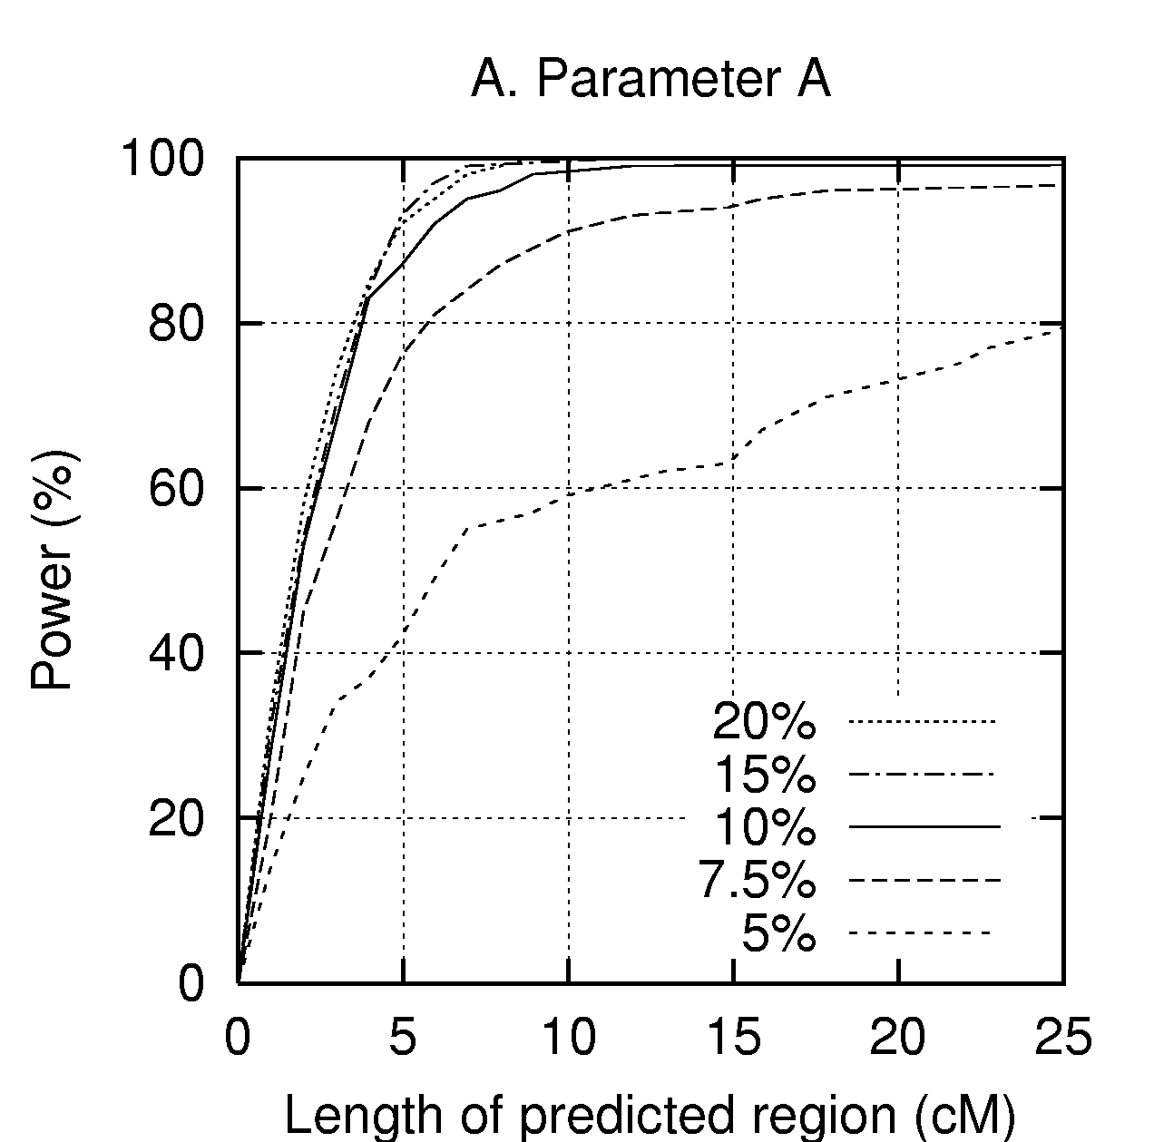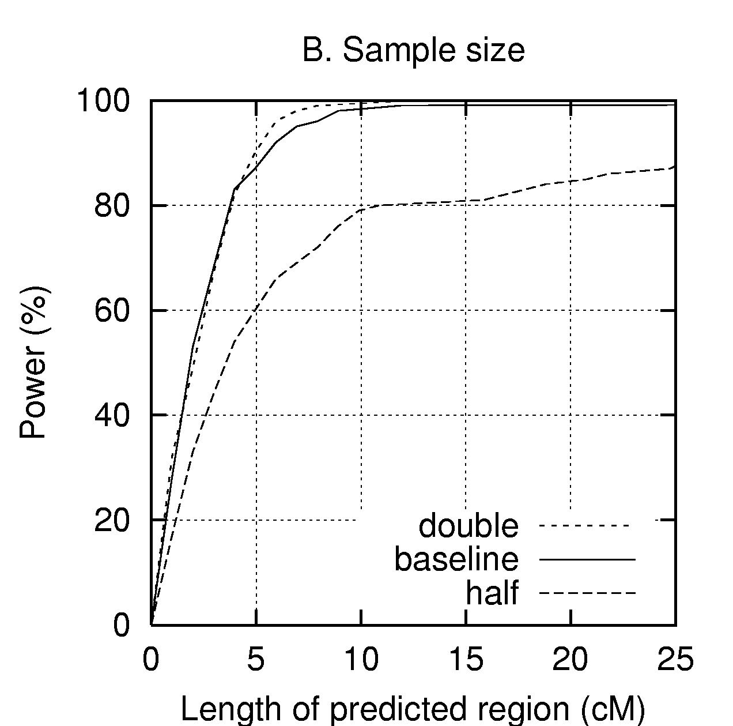

Figure 1. The effects of different population and sampling parameters on the localization power of HPM-G. A) The effect of A (proportion of mutation bearing chromosomes in affected individuals). B) The effect of sample size.

- References

[1] Stephens M., Smith N.J., Donnelly P. 2001. A new statistical method for haplotype reconstruction from population data. American Journal of Human Genetics 68:978-989.

[2] Toivonen H.T.T., Onkamo P., Vasko K., Ollikainen V., Sevon P., Mannila H., Herr M., Kere J. 2000a. Data mining applied to linkage disequilibrium mapping. American Journal of Human Genetics 67:133-145.

[3] Toivonen H.T.T., Onkamo P., Vasko K., Ollikainen V., Sevon P., Mannila H., Kere J. 2000b. Gene mapping by haplotype pattern mining. In IEEE International Symposium on Bio-Informatics and Biomedical Engineering. Arlington, VA, November 8-10.

[4] Onkamo P., Ollikainen V., Sevon P., Toivonen H.T.T., Mannila H., Kere J. 2002. Association analysis for quantitative traits by data mining: QHPM. Annals of Human Genetics 66:419-429.

Department of Computer Science, P.O.Box 26 (Teollisuuskatu 23) FIN-00014 University of Helsinki, Finland. E-mail: petteri.sevon@cs.Helsinki.fi
Helsinki Institute of Information Technology, Basic Research Unit, Department of Computer Science, P.O.Box 26 (Teollisuuskatu 23) FIN-00014 University of Helsinki, Finland. E-mail: paivi.onkamo@cs.helsinki.fi
Same as in 2. E-mail: hannu.toivonen@cs.Helsinki.fi
Same as in 2. E-mail: heikki.mannila@cs.Helsinki.fi

