109. Digital Signal Processing in Protein
Secondary Structure Prediction

Debasis Mitra, Michael E. Smith1

Keywords: digital signal processing, protein secondary structure prediction

- Introduction
Considerable research effort has been devoted to predicting the secondary structure of proteins solely from their amino acid sequences. Methods for predicting protein secondary structure have as their basis in graph theory, various computational and mathematical techniques, including statistical modeling, constraint programming, neural network and other avenues of machine learning. However, despite the plethora of prediction techniques, present methods typically have a 75% approximate level of accuracy, however there is considerable room for improvement. [1]

- Digital Signal Processing
We present a novel approach to secondary structure prediction using Digital Signal Processing (DSP) techniques. DSP is an engineering discipline concerning the creation, manipulation and analysis of digital signals. Our technique involves two DSP operators, Convolution and Deconvolution, to predict secondary structure, and it is quite easy to follow using any DSP toolkit.
Convolution is a method of applying a filter on an incoming signal, producing an outgoing signal. Deconvolution is the inverse operation of convolution and permits the incoming signal to be recovered if the outgoing signal and the filter are known. Also, with this operator, the filter also can be calculated given the incoming and outgoing signals.

- DSP and Secondary Structure Prediction
Our method predicts three states’ (helix, strand, and coil) of the secondary structure. We consider the primary structure of a protein as the so called incoming signal and the secondary structure of the same protein as the corresponding outgoing signal. Each protein has a corresponding filter, which when convolved with the incoming signal (primary structure) produces the outgoing signal (secondary structure). It is our contention that the unknown secondary structure of a target protein t can be predicted by using the appropriate filter fb for a base protein b of a significant amino acid sequence-similarity and whose (b’s) secondary structure is known. Convolution will then be performed on the incoming signal of the target protein t using the filter fb (of b) to produce an estimated secondary structure of t.
The method is homologous in nature as the prediction of unknown secondary structure is based on the known secondary structure of a protein with a similar primary structure. Availability of huge numbers of secondary structures, in public protein databases, makes the homologous methods quite attractive. Our method involves the following steps:
- Perform a PSI BLAST search with the primary structure of the protein t whose secondary structure is to be predicted (the target protein). The objective is to obtain a protein b of significant primary sequence similarity.
- From the results of the search, select the protein of closet match, as the base protein b.
- Obtain the secondary structure of the base protein bs from the Protein Data Bank.
- Create incoming signals ti and bi from the primary structure of the target and base proteins respectively by substituting each amino acid for its numeric hydrophobicity value, of Ktye and Doolittle [2].
- Create an outgoing signal from the secondary structure bsi of the base protein by substituting the values 1, 2 for helix and strand respectively and 3 for all others.
- Obtain the filter fb by performing deconvolution on the outgoing (bsi) and the incoming signals (bi), of the base protein b.
- Perform convolution of the filter fb and the incoming signal ti of the target protein t. The resulting signal is the predicted secondary structure tsi. Convert this numeric signal tsi into secondary structural elements ts by replacing 1, 2 with helix and strand and all other values with coil.
- Compute the accuracy by expressing as a percentage the number of correct predictions divided by the length of the target primary structure.

The results of sixty experiments are presented in Figure 1. It indicates that the prediction accuracy and sequence similarity seem logarithmic. Even at 10% level of similarity, accuracy is around 40%, however this value substantially increases to over 65% with 30% similarity. We have an average prediction accuracy of 71%. This gives an indication that our method can be used as a basis of prediction if the base protein is of significant primary sequence similarity. We are investigating other measures of protein similarity and such research will lead to the identification of a better base protein for secondary structure prediction than we have using PSI BLAST. Future research will involve further analysis of more protein data to ascertain the relationships between the various measures of protein similarity and the accuracy of secondary structure prediction.
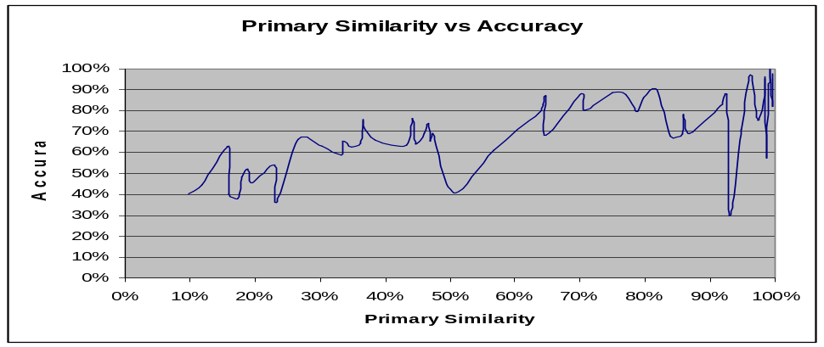
Figure 1 – Experimental results. Primary Similarity is a measure of similarity of the aligned target and base primary structures from [3]. Accuracy is the prediction accuracy

4 References and bibliography
[1] Chandonia, J., Karplus M. 1999. New Methods for Accurate Prediction of Protein Secondary Structure. PROTEINS: Structure, Function and Genetics, 35:293-306

[2] Kyte, J., Doolittle, R. 1982. A Simple Method for Displaying the Hydropathic Character of a Protein. Journal of Molecular Biology, 157:105-132

[3] Pearson, W., et al. 1997. Comparison of DNA sequences with protein sequences, Genomics 46:24-36

[4] Proakis, J., Manolakis, D. 1996. Digital Signal Processing, Principles, Algorithms, and Applications. Prentice-Hall.

Department of Computer Science, Florida Institute of Technology, Melbourne, Florida, USA ? E-mail: {dmitra,msmith}@cs.fit.edu

