124. Meta-analysis on Microarrays Using Effect Size

Jung Kyoon Choi, Sangsoo Kim, Ook Joon Yoo

Keywords: microarray, meta-analysis, effect size, fixed effects, random effects, Bayesian meta-analysis

- Introduction

One of the most challenging tasks microarray analysts will face would be how to extract, compare, and integrate information from an enormous amount of accumulating data. However, the lack of standards for microarray experiments generates heterogeneous datasets of which direct comparison is not possible. The reasonable approach, in this situation, is to combine results of individual studies. For this purpose, we introduced the most developed meta-analytic method, which expresses the result in the form of effect size.
Effect size refers to a family of indices that measure the magnitude of a treatment effect. By virtue of wide utility of effect size indices, the effect size method is generally applicable to many types of microarray studies. Here we employed two sets of cancer studies. One set contains our four cDNA microarray datasets on liver cancer (LC), which are created in controlled experimental conditions. The other set is comprised of four publicly available prostate cancer (PC) studies. This set was used for another meta-analysis method in the previous study (Rhodes et al. 2002).

- Models and implementations

Effect size of each study was measured by a standardized mean difference (Hedges and Olkin. 1985) between normal and tumor groups for each gene. To address interstudy variation, a fixed effects (FE) and random effects (RE) model were employed. Based on the result of homogeneity tests (Figure 1), the FE model was adopted for the LC datasets, assuming that the effect size of each study is a draw from a population with an overall mean. By contrast, for the PC datasets, the RE model was shown to be proper. The RE model postulates that each study effect is a draw from a distribution with a study-specific mean, which in turn is a draw from a superpopulation with an overall mean. Therefore it requires estimating and incorporating a between-study variance. The conventional method developed by DerSimonian and Laird (1986) and a Bayesian approach were applied and compared for the RE model.
The effect sizes were efficiently combined to obtain the estimate of the overall mean and its z score. By gathering the separate datasets, we could gain the same effect as increasing sample size. The data integration promoted the discovery of the small but consistent effects with increased sensitivity and reliability. In many cases, the z score of the overall mean exceeded a given threshold, while none of the study effects did. We term these "integration-driven discoveries" and the ratio over the total discoveries was computed. We show that the more significant the overall mean, the higher proportion integration-driven discoveries account for (Figure 2). Expression patterns of the significant genes can be visualized at http://centi.kribb.re.kr/~choi/MA/PCsupp.
- Figures
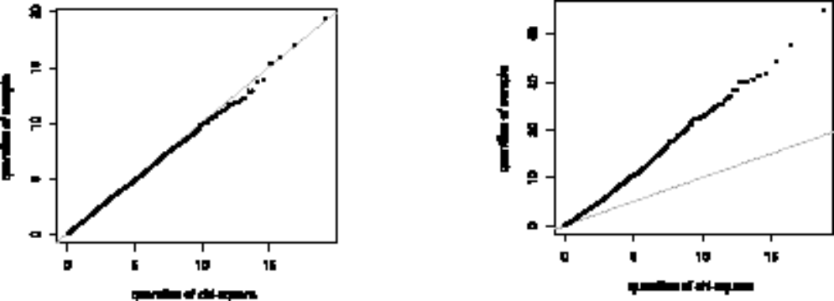
Figure 1: Gene by gene testing for the homogeneity of the study effects. Overall test results are shown by the QQ plot of the observed vs. expected Q values. The expected Q values are from a chi-squared distribution.
Left; The plot for the LC datasets. Right; The plot for the PC datasets.

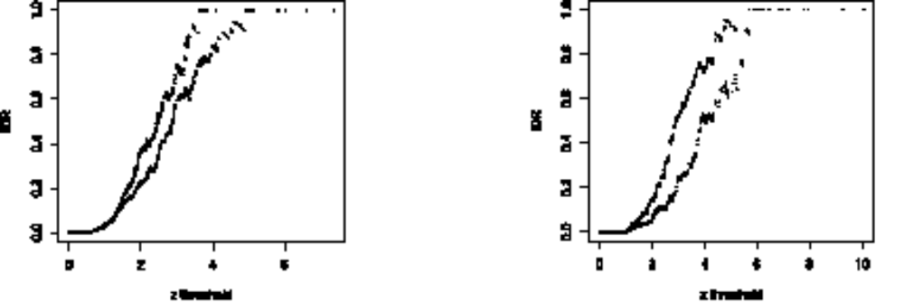
Figure 2: Integration-driven discovery rate (IDR) for given thresholds of the z values. The thresholds were set from the ordered z scores. IDR was computed separately for z>0 and z<0.
Left; IDR for the LC datasets. Right; IDR for the PC datasets.

4 References

[1] DerSimonian, R. and Laird, N. M. 1986. Meta-analysis in clinical trials. Controlled Clinical Trials 7:177-188.

[2] Hedges, L. V. and Olkin, I. 1985. Statistical methods for meta-analysis. Academic Press, Orlando.

[3] Rhodes, D. R., Barrette, T. R., Rubin, M. A., Ghosh, D. and Chinnaiyan, A. M. 2002. Meta-analysis of microarrays: Interstudy validation of gene expression profiles reveals pathway dysregulation in prostate cancer. Cancer Research. 62:4427-4433.

Department of Biological Sciences, Korea Advanced Institute of Science and Technology. E-mail: jkchoi@kaist.ac.kr
Genome Research Center, Korea Research Institute of Bioscience and Biotechnology. E-mail: sskimb@mail.kribb.re.kr
Department of Biological Sciences, Korea Advanced Institute of Science and Technology. E-mail: ojyoo@kaist.ac.kr

