176. Identification of specificity-determining
positions in large protein families

Olga V. Kalinina, Andrey A. Mironov,, Mikhail S. Gelfand²,³,
Aleksandra B. Rakhmaninova²

- Introduction

The exponential growth of genomic data gives new possibilities for analysis and prediction of the pro-tein function. A number of recent studies attempted to predict functionally important (e.g. determining specificity) sites in protein alignments using comparative genomics data, as reviewed in [1].

We present a technique for identification of specificity-determining positions (SDPs). Unlike most other methods, it does not rely on any structural information about the protein family using instead only multiple sequence alignment and data about othrological/paralogical relationships within the family. Our technique extends the method of [2], but it differs from this and other existing methods. Firstly, our algorithm takes into account non-uniformity of amino-acid substitution frequences and considers groups of proteins at different inter-group and intra-group evolutionary distances. Secondly, we introduce a formal procedure (the Bernoulli estimator) for setting the cutoff that separates SDPs from non-informative positions.

2 Methods

We assume that a position determines specificity if it is conserved within each orthology group but varies between groups. Let p be a position of the multiple sequence alignment, let α = 1,…,20 be a residue type, and let i = 1,…, M denote an orthology group, where M is the number of the groups. Mutual information I_{p} at position p is defined by:
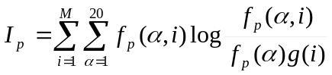,
where ƒ_{p} (α, i) is the frequency of residue α in group i at position p, ƒ_{p} (α) is the frequency of residue α in position p of the MSA, g(i) is the relative size of the group i (g(i) = n(i)/N, where n(i) is the size of group i), N is the number of proteins in the family.

Normalized frequencies 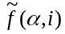 are calculated using smoothing with amino acid substitution matrix:
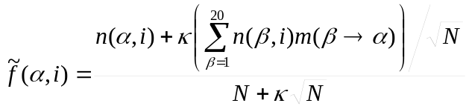,
where n(α,i) is the number of occurrences of residue α in group i or in the whole alignment, N is the total number of proteins in the alignment, m(β→α) is the probability of amino acid substitution β→α according to the matrix describing group I, 0 ≤ κ ≤ 1is a smoothing parameter.

To compute the statistical significance of derived values of I_{p} we start with shuffling as described in [2] and derive a sequence of Z-scores {Z_{p}}. To set a threshold, we order Z-scores by decrease, obtaining a ranked sequence: Z₁, Z₂, …, and find k:
,
where L is the alignment length, 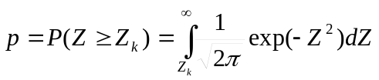, 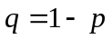.

The obtained value of k is called the Bernoulli estimator. We assume that all Z-scores 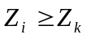 correspond to the specificity-determining positions, that is the set of SPDs is comprised of k positions with highest Z-scores.

We tested our method on the MIP family of membrane transporters. We compared the predicted set of SDPs with the available structural and experimental information.

3 Results

The Bernoulli estimator function selects 27 SDPs, whereas the average size of the MIP family members is about 250 residues. Fourteen of the predicted residues lie within 7Å from the substrate, and two more lie on the channel side of the helices forming the channel, which strongly suggests that they participate in the transport mechanism. All residues experimentally shown to be critical for the pore selectivity are among candidate SDPs. Nine residues seem to participate in formation of the tetrameric structure; this explanation is indirectly supported by the experimental data. Thus, a function can be easily assigned to 25 out of 27 predicted SDPs.

Preliminary analysis of the LacI family of bacterial transcription factors also demonstrates good agreement with the protein structure.

Thus, a fully automated method for identifying specificity-determining positions in multiple alignments of protein families produces results fully compatible with structural and experimental data.

This study was partially supported by grants from HHMI (55000309) and LICR (CRDF RB0-1268).

4 References

[1] Hannenhalli, S.S.; Russell, R.B. 2000. Analysis and prediction of functional sub-types from protein sequence alignments. J. Mol. Biol. 303: 61-76
[2] Mirny, L.A.; Gelfand, M.S. 2002. Using orthologous and paralogous proteins to identify specificity-determining residues in bacterial transcription factors. J. Mol. Biol. 321: 7-20

? Department of Mathematics and Mechanics, Moscow State University, Moscow, 119899, Russia, ok81@yandex.ru
? Integrated Genomics, P.O. Box 348, Moscow, 117333, Russia
? State Scientific Center GosNIIGenetika, 1st Dorozhny pr., 1, Moscow, 113545, Russia

