Submitting a Poster Abstract to RECOMB 2006

Paul Revere, John Q. Adams. John F. Kennedy

Keywords: red sox, bunker hill, minutemen, north end, patriots, boston marathon

- Introduction.

Poster abstracts should be submitted online via the poster web page of the conference. The abstracts of accepted posters will be published in book form and will be available at the meeting and subsequently posted on the web. The following instructions are intended to maximize space available to authors while ensuring agreeable and consistent appearance, efficient handling and timely publication. Final posters may, of course, be in any format, as long as they fit onto a board of 1 m height and 1 m width. Acceptance of an abstract is conditional on at least one of its authors preregistering for RECOMB electronically before February 19, 2006 (see http://recomb06.dei.unipd.it).

Abstracts must be received by January 20, 2006; authors will be notified about acceptance before February 3, 2006. Files we cannot open or which do not satisfy the format instructions will be returned.

- Software and files.

The abstract, written in clear and reasonably grammatical English, must be prepared in exactly the same format as the example in the templates, and should fit on two pages, everything included, after conversion to pdf. If at all possible, use LaTeX 2e article document class, with all the default options, and with a minimum of other packages and other files. To conserve space, do not split the abstract into many small sections.

For those for whom LaTeX is impossible, use Word or other easily translatable word-processing software. Download the Word template and substitute your own text, titles and headings, conserving the same fonts, sizes and styles.

The output from latex processing or the Word document file should be converted to a pdf format for final web submission. Make sure that the extra information that you provide during the web submission (title, authors, keywords, etc) is in agreement with the content of the abstract.

- Figures and tables.

Figures must be created with the standard LaTeX figure environment or should be included as an eps file. Tables should be created with the table environment. Make sure figures are readable and not too crowded. Do not use type sizes smaller than footnote-size in figures and tables. No color please.
Figures in Word must be incorporated in the abstract before converting to pdf. In any case, they must appear properly positioned in the final pdf file.

Use the general format in Figure 1, if possible

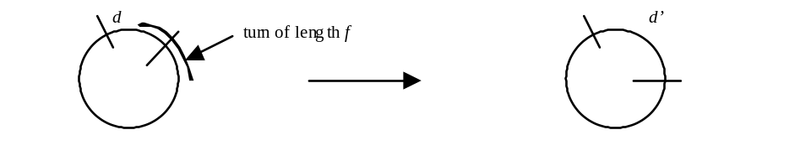Figure 1: Effect of turn length f on the distance from d to d’.

Tabular displays should have the general format of Table 1, if possible.

 | x = 10.3 |  | x = 10.5 |  | x = 21.7 |  | x = 22.8
g | gmt | jfk | fbi | mac | fax | era | ibm | pdf
a/20 | 117.01 | 117.02 | 318.31 | 318.27 | 29.83 | 29.85 | 36.35 | 36.40
d/40 | 338.88 | 338.03 | 53.34 | 53.31 | 97.29 | 67.24 | 26.74 | 126.52
5e | 246.58 | 246.50 | 47.57 | 47.57 | 24.28 | 24.89 | 55.54 | 155.26
7f | 157.64 | 157.54 | 36.83 | 36.83 | 38.80 | 38.02 | 72.63 | 172.60
2g/3 | 58.08 | 58.05 | 27.35 | 27.32 | 56.20 | 56.23 | 95.47 | 195.49
⎧log h⎤h² | 18.99 | 18.99 | 99.00 | 98.99 | 58.94 | 158.99 | 98.99 | 98.99
m.t. | 4.6 | 5.1 | 3.8 | 4.1 | 2.2 | 1.9 | 3.6 | 3.7

Table 1: Number of turns and distance between top and bottom.

4 References and bibliography.

Use the styles exemplified by [1], [2], [3] and [4] below. Order bibliography items alphabetically as shown. The two-page limit includes the bibliography.

References

[2] Caprara, A. 1997. Sorting by reversals is difficult. In: Proceedings of the First Annual International Conference on Computational Molecular Biology (RECOMB 97), New York: ACM. pp. 75-83.

[1] Huynen, M.A. and Bork, P. 1998. Measuring genome evolution. Proceedings of the National Academy of Sciences USA 95:5849-5856.

[3] McLysaght, A., Seoighe, C. and Wolfe, K.H. 2000. High frequency of inversions during eukaryote gene order evolution. In Sankoff, D. and Nadeau, J.H., editors, Comparative Genomics, Dordrecht, NL: Kluwer Academic Press. pp. 47-58.

[4] Reinelt, G. 1991. The Traveling Salesman – Computational Solutions for TSP Applications. Berlin: Springer Verlag.

Institute of Red Sox Nation, Fenway Park, Lansdowne Street, Boston, North America, E-mail: 2004champs@redsoxnation.com
Broad Institute of MIT and Harvard, 320 Charles Street, Cambridge, MA, USA. E-mail: wonderfulscience@broad.mit.edu
Dept. of Inspections and Training Operations, Starfleet Academy, Spock Street 1, Klingonia, Nexus. E-mail: kirk@it.starfleet.ne

