**Conference Venue and Directions**

The conference will be held on the main campus of the Chinese University of Hong Kong (CUHK):

Cheng Yu Tung Building

The Chinese University of Hong Kong

12 Chak Cheung Street

Shatin, New Territories, Hong Kong

**Getting to CUHK**

From Hong Kong International Airport to CUHK:

Taxi

Take a green taxi which is designated for the New Territories where CUHK is situated. The trip is about 40 minutes and the fare is about HK$300. Please show the following to the taxi driver:

* Cheng Yu Tung Building, The Chinese University of Hong Kong

香港中文大學 鄭裕彤樓

Airport bus

Take airport bus route number A41 from the airport to Sha Tin Central Station. The bus runs from 06:00 to 24:00 at 20-minute intervals. The bus ride takes about 70 minutes and the fare is HK$22.3. You will need to take either one of the following connecting modes of transportation from Sha Tin Central Station to CUHK:

* **Taxi**: Take a red taxi to the University. It will take about 15 minutes and the fare is about HK$50.
* **MTR train**: The MTR train station is situated above the bus station. Take the train to the University Station (second stop from Sha Tin for the Lo Wu/ Lok Ma Chau direction). The train runs every five to 10 minutes from 06:00 to 24:00. The train ride takes about 10 minutes and the fare is HK$4.5. Leave at Exit B upon reaching University Station. The conference venue, Cheng Yu Tung Building, is within 3 minutes walking distance as shown in the map below:

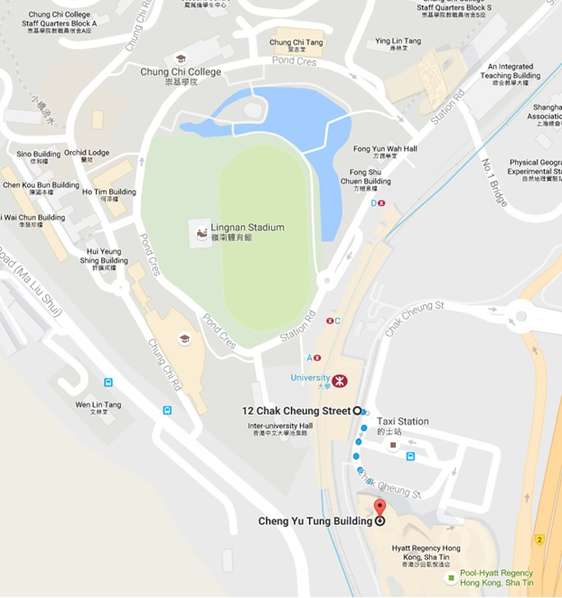

*CUHK Campus Map*

[*www.cuhk.edu.hk/english/campus/cuhk-campus-map.html*](http://www.cuhk.edu.hk/english/campus/cuhk-campus-map.html)

**