**Best Lightweight Headphones**

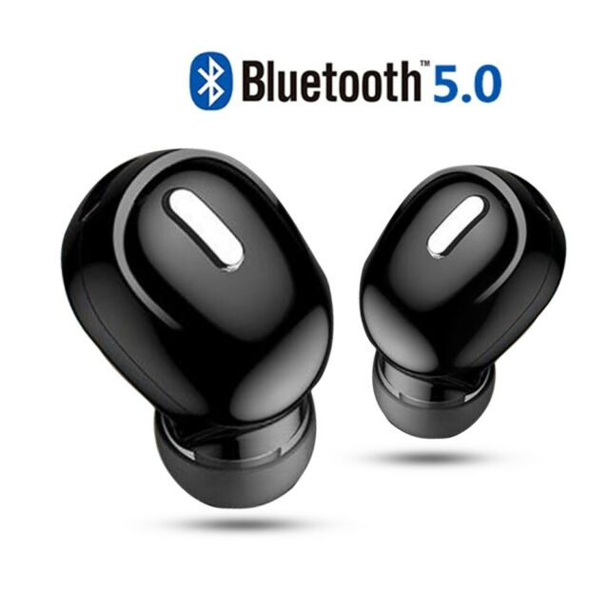

Bose hasn’t released a pair of true wireless earbuds since the SoundSport Free in 2017, but it seems the company is about to make up for lost time. Last year, Bose said it was readying two sets of new earbuds — the Noise Canceling Earbuds 500 and 700, [still listed on this website](https://www.anrdoezrs.net/links/8532386/type/am/sid/verge/https:/www.bose.com/en_us/better_with_bose/new-headphones.html) — and a new video suggests the launch of at least one of those could be imminent. Bose has apparently reconsidered its branding choices and is reverting back to its signature “QuietComfort” series: the Noise Canceling Headphones 700 are now simply called the Bose QuietComfort Earbuds. Seems like the right decision to me.