**waterproof earbuds**

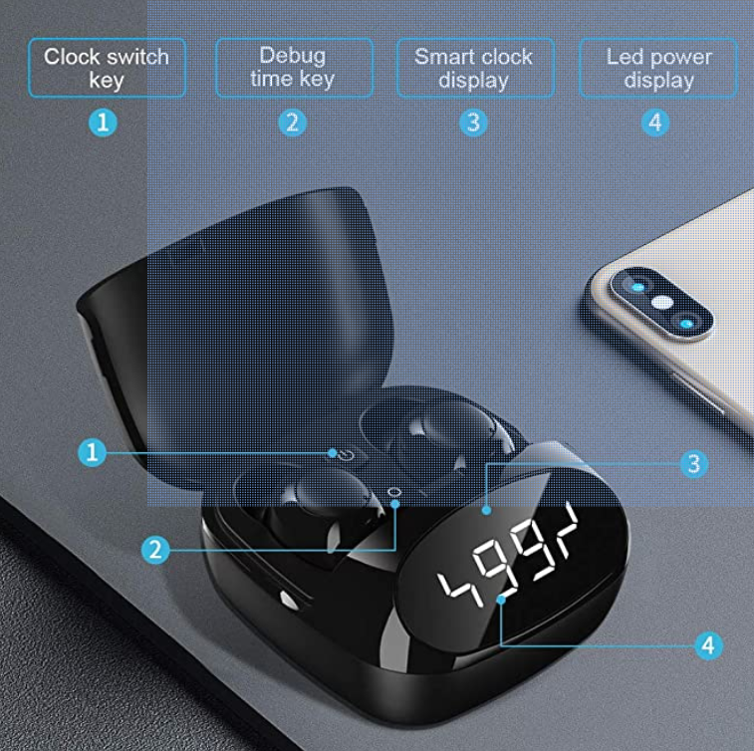

# True Wireless Earbuds, Body-Moving Bass, IP68 Sweatproof, 36H Playtime, Fast Charge, Secure Earhooks, Bluetooth 5, CVC 8.0 Clear Calls, Sports Earphones for Gym, Sport