James Whatnell (B5041902)

June 2018

An online platform for dissertation students & their supervisors

BSc Computer Science

## Abstract

Dissertations are something every student will have to go through at the end of their studies & two of the most crucial parts of this process is deciding on which topic to cover & being able to easily receive the incredibly valuable feedback they get from their supervisors.

As such this dissertation looks at the development of a more efficient system for handling dissertation topics & providing a platform for supervisors to easily provide feedback to students. The hope with this project being to make the whole dissertation system easier & more user-friendly for everyone, providing a single platform for most your dissertation needs.

## Declaration

“I declare that this dissertation represents my own work except where otherwise stated.”

Signed: James Whatnell

Date: 01/05/18

## Acknowledgements

Firstly, I would like to take the opportunity to thank my supervisor, John Colquhoun for providing guidance & feedback throughout the course of this project, as well as everyone who took my surveys, both students & staff whom have provided me with valuable insight on their thoughts & finally the students who were kind enough to take part in the user testing of the platform.

Contents

Abstract 1

Declaration 2

Acknowledgements 3

Chapter 1 Introduction 7

1.0 Introduction 7

1.1 Motivation 7

1.2 Aims & Objectives 8

1.2.1 Aim 8

1.2.2 Objectives 8

1.3 Project Plan 8

1.3.1 Software development model 8

1.3.2 Schedule 10

1.4 Outline 10

Chapter 2 Background Research 11

2.0 Introduction 11

2.1 Surveys 11

2.1.1 Premise 11

2.1.2 Strategy 11

2.1.3 Student results 11

2.1.4 Supervisor results 14

2.2 Development technologies 17

2.3 Hosting technologies 18

2.4 Similar systems 19

2.3.1 NESS 19

2.3.2 ePortfolio 19

Chapter 3 System Design 20

3.1 Introduction 20

3.2 Preliminary Designs 20

3.2.1 Basic layout 20

3.2.2 Login page 21

3.2.3 Home page 21

3.2.4 Dissertation topics page 22

3.2.5 Submit page 23

3.2.6 Feedback page 24

Chapter 4 Implementation 26

4.1 Introduction 26

4.2 Platform structure 26

4.3 Architecture 27

4.3.1 Login page 27

4.3.2 Home page 27

4.3.3 Dissertation topics page 28

4.3.4 Submit page 28

4.3.5 Feedback Page 28

4.3.6 Admin dashboard 29

4.3.7 Admin users page 29

4.3.8 Admin modules page 29

4.3.9 Admin pages page 29

4.3.9 Edit page 29

4.4 The database 30

4.4.1 User tables 30

4.4.2 Notification table 31

4.4.3 Upload table 31

4.4.4 Subjects & Topics table 32

4.4.5 Pages table 32

4.5 Security 33

Chapter 5 Testing 34

5.1 Introduction 34

5.2 Functionality testing 34

5.2.1 Basic checks 34

5.2.2 Login page 34

5.2.3 Home page 34

5.2.4 Navigation bar 35

5.2.5 Dissertation topics page 35

5.2.6 Submit page 36

5.2.7 Feedback page 36

5.2.8 Admin dashboard 36

5.2.9 Users page 36

5.2.10 Modules page 36

5.2.10 Pages page 36

5.2.11 Edit page 37

5.2.12 Results 37

5.3 Security testing 37

5.4 User testing 38

5.4.1 The task 38

5.4.2 The sample 38

5.4.3 The questionnaire 38

Results 39

Chapter 6 Conclusion 39

6.1 Introduction 39

6.2 Aims & Objectives 40

6.3 Time plan 41

6.4 What went well 42

6.5 What could have went better 42

6.6 The future 42

6.7 Conclusion 43

Chapter 7 Bibliography 43

Bibliography 43

Chapter 8 Appendices 44

Functionality testing results 44

# 

# Chapter 1 Introduction

## Introduction

This chapter explains the motivation of why the project is worth undertaking, the aim the project ultimately strives to reach & the objectives of the project. Furthermore, this chapter gives an overview of the project plan & how the project was managed & planned out. Lastly this chapter gives a brief outline of each chapter within this paper.

## Motivation

The motivation for this project is to turn quite an old & dated system into something more modern & centralise the whole dissertation process. Picking a dissertation topic is something every student will have experienced, some even changing topics later down the line & the overwhelming response from the feedback I have received has been that the current system isn’t that intuitive or great. Using pen & paper to pick a topic is not very in line with the modern era & comes with the problem of relying on one set date to either attend the dissertation fair or email the member of staff responsible for allocating them. This is an unnecessary amount of work to set up entire dissertation fairs for every subject & handle a bunch of forms for each student picking their topic. Not only that, but you must dedicate a member of staff’s time to read & then enter each one into an electronic system. Furthermore, there are risks with using this approach as the forms could get lost or get damaged in some way. In the case of emailing that isn’t too great either because as a student, you must spend time looking up the correct person to email & still you have the problem of dedicating staff time to enter this manually from all these emails. In the case of entering your topic through NESS, while an improvement the system was not designed for this purpose & only fulfils the first part of what I aim for with this project.

The second part of which will be about improving the method of receiving feedback from your supervisor. The current problem with that being on the student side, it can be difficult to manage all your feedback & these could be ranging from an email to a document uploaded to Slack. On the supervisor’s side you have this problem of having to manage multiple different potential lines of communication, depending on the supervisor, they could be using a wide range of software to communicate with their students, from Dropbox, email, Slack & more. Even assuming the supervisor strictly offers feedback to students via email, they must keep on top of them constantly to ensure they don’t get buried under other work-related emails & it can be difficult to remember & manage all these requests for feedback.

As such the benefit will be of both students & staff to find a better system that’s easier to use & more time efficient. In terms of the wider scheme I have no doubt that other universities use similar dated systems of handling their dissertations & think such a system could benefit every student & supervisor.

## Aims & Objectives

### 1.2.1 Aim

1. Create a centralised web portal for the school of computing for allocating dissertation topics & providing a hub for uploading work to be more easily reviewed by supervisors.

The overall aim of this project & end goal for our system. This aim would later be split in two for our project plan as this helped split the project up into more manageable chunks that we could work on to reach this end goal. Further detail of this split can be found at Chapter 1, section 1.3, project plan.

### 1.2.2 Objectives

1. Research current systems supervisors & students use (Dropbox, Slack, Email, etc).

Before undergoing our project, we needed to look at what students & supervisors currently used for the purposes we were trying to replace with our project. Further detail of this you will find within Chapter 2, background research.

1. Conduct questionnaires to find out whether students & supervisors desire a different system to the one currently in place.

To get an idea of students & supervisors thoughts on the current system we needed to gather research on their opinions of the current system & what they thought of our pitched idea to gauge whether they thought such a system would benefit them & be better than the current one. Further detail of our findings can be found in Chapter 2, background research.

1. Design & implement the web portal.

Next the design of the system & how the user interface would look, this meant researching lots of similar systems to get an idea of how to structure everything & make the user experience as easy to use & intuitive as possible. Further detail of the design can be found in Chapter 3, system design.

1. Evaluate the final product, find out whether students & supervisors prefer this centralised system over the current one.

Lastly the final objective to see whether the current system is preferred over the old one, this will tell us whether our project was ultimately a success in providing a system that’s superior to the current one & delivers on our aim. Further detail of this can be found at Chapter 5, testing & Chapter 6, conclusion.

## Project Plan

### 1.3.1 Software development model

Due to how large the project would be to create an entire dissertation portal for not only managing dissertation topics & providing a hub for submission of work to be reviewed by supervisors it was decided that the best course of action was to use an Agile development model. This would allow to split the project into two smaller chunks as the project essentially would aim to provide two functions.

1. Provide a system to allocate dissertation topics, allowing for students to learn more about each topic, select a topic & change their topic.
2. Provide a system that allowed users to submit work that could be reviewed by supervisors.

As such, we could split the project into two sprints, as neither relied on the function of each other they could be worked on independently & later merged to create one complete system.

However, other models were considered, such as the waterfall model, one of the oldest & simple of software development models. Waterfall models follow a sequential approach in which a task is complete one after the other, an example of which you see below in figure 2. 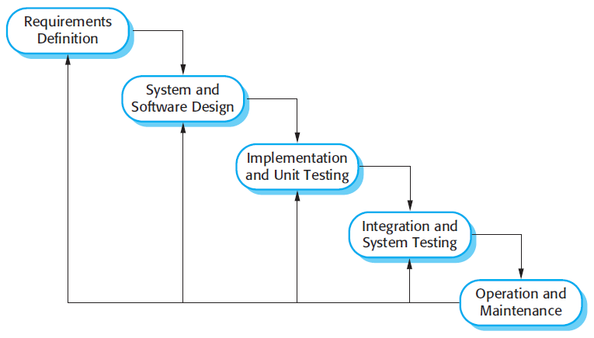

Figure 1 – Typical waterfall model

The reason we did not pick this over Agile simply being that Agile offered a better model for helping make the project not only more manageable & easier to test but provide a better model for evolving the platform over time. This would come of use when I would add the admin features which were not initially intended but given the choice of model made the process significantly easier to implement. Furthermore, from a future perspective, this model could continue to be used to add more features & tweak the system to further improve upon this project.

### 1.3.2 Schedule

Figure 2 - GANNT chart

To help organize & illustrate the project schedule a GANNT chart was created. This helped visualize & break down each task with the first split being by semester to give the project quarterly goals to strive for.

We then would use our two sprints to split up the work of the platform during second semester, each sprint containing their own sub-tasks that together all forms to complete a sprint. Each of these tasks are assigned a start & end date to help keep the project on schedule, most of these usually given more time than needed to allow for the possibility of the project falling behind. A good example of this being the “design interface” task which was given three weeks to complete, this meant had we fallen behind on previous tasks we could safely overrun & still safely meet our quarterly deadline for semester 1.

## 1.4 Outline

This paper is divided into 8 chapters as follows:

**Chapter 1**, the introduction, details the motivation behind the project, the aims & objectives of the project & finally the project plan.

**Chapter 2**, the background research, looks at the background research done for the project such as gathering opinion from students & supervisors, the technology used to implement the website & the different types of hosting considered during the project.

**Chapter 3**, the system design, looks at the design of the system & general UI of the platform. Providing us with an overview of how the user will interact with the platform & providing an interface that will be easy to use & simple to understand.

**Chapter 4**, the implementation, looks at the implementation of the platform & what techniques were chosen to implement each part of the system.

**Chapter 5**, testing, looks at how the platform was tested to ensure that the system works to our specification & fits the purpose outlined prior. This gives us an overview of the testing techniques used to ensure that not only the platform functions as intended, but that it is safe from attack & exploit too.

**Chapter 6**, conclusion, looks at the end of the project, what was learned, what could have been done better & where the project went wrong.

**Chapter 7**, bibliography, lists the resources used to support the creation & research for this dissertation.

**Chapter 8**, appendices, provides some supplementary material that gives further detail to support my dissertation.

# 

# Chapter 2 Background Research

## 2.0 Introduction

This chapter covers the background research undertaken during the project. This primarily focuses on the potential technology, similar systems & the feedback gathered from students & supervisors.

## 2.1 Surveys

### 2.1.1 Premise

As the project resolved around the idea of providing a better platform, it was imperative that data was gathered on the opinion of both students & supervisors. This was done through online surveys, of which students were asked to fill a survey out asking them of their opinion on the current system & providing some hypothetical questions about our system. As for supervisors they were asked similar questions, but the questions were more relevant to a supervisor with more questions focused toward being able to provide feedback from one platform.

### 2.1.2 Strategy

To more efficiently gather feedback, I would end up purchasing two short & easy to remember domains, this would allow me to use them to redirect users to my survey, one being for students & the other for supervisors. This would make the process of gathering feedback easier & hopefully more attractive as users they did not have to type in long & complicated URLs to get to my survey.

### 2.1.3 Student results

The results of my surveys are as follows, for the student survey we ended up gathering 11 responses & they are as follows:

Question 1: Overall, how satisfied are you with the current method you pick your dissertation topic?

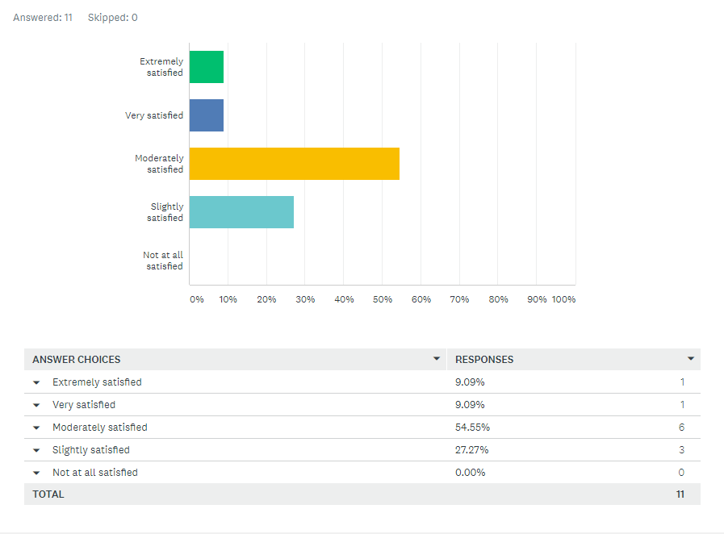

Figure 3 – Student Questionnaire (Question 1 breakdown)

As can be seen most students are decently satisfied with the current system they pick their dissertation topic, but very few are very or extremely satisfied, this shows most students are content with the current system but don’t particularly like the system either. This shows that the current system student’s pick their topic could be improved upon.

Question 2: Do you like the current system for changing your dissertation topic?

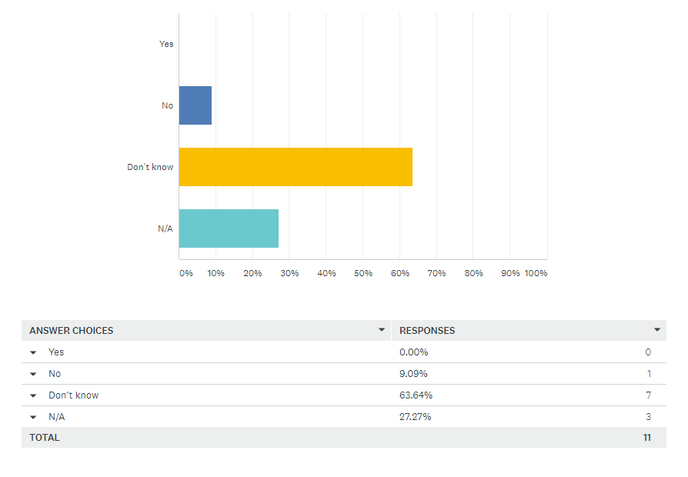

Figure 4 – Student Questionnaire (Question 2 breakdown)

The results of this question show us that most students are unsure about whether they like the current system for changing their dissertation topic. The most likely case being most students won’t have done this & they have no experience using the system. We did however get response of someone not liking the system & no one responding that they did like the current system. Due to the small number of students surveyed who have went through the process of changing their topic this doesn’t tell us much but does show at least that more people dislike than like it.

Question 3: Would you like to see a system that provides more information about each dissertation topic?



Figure 5 – Student Questionnaire (Question 3 breakdown)

The results of this question show overwhelmingly that every student surveyed would like to see a system that gave them greater detail on each dissertation topic. This shows that our feature of providing a system to provide students with more detail on each topic would be greatly welcomed & considered useful to students.

Question 4: Would you have liked/like to see a better system for picking your dissertation topic?

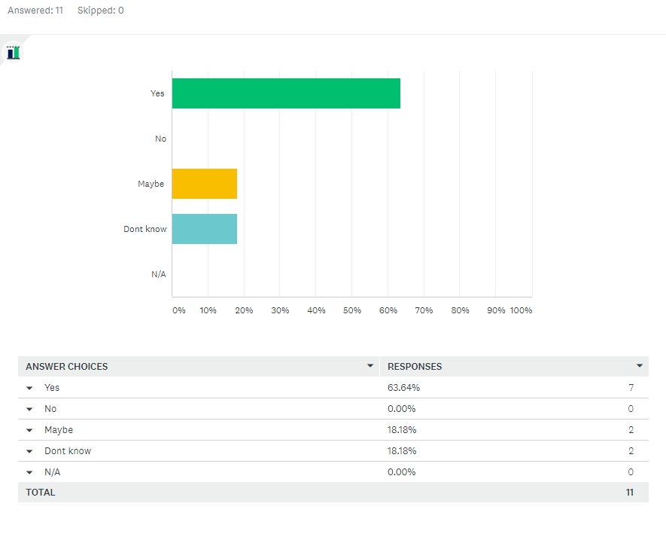

Figure 6 – Student Questionnaire (Question 4 breakdown)

The results of this questionnaire show that the majority of students surveyed would like to see a better system for picking their dissertation topic with the rest being either unsure or not knowing. This shows that there is a desire to a system better than the current one.

Question 5: Would you have liked/like to see a better system for changing your dissertation topic?

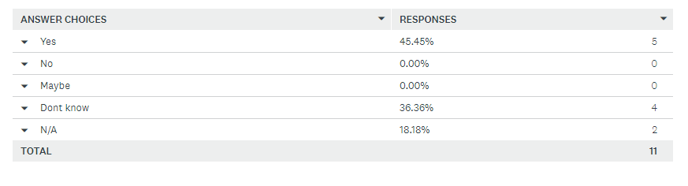

Figure 7 – Student Questionnaire (Question 5 breakdown)

The results of this question give us a mix result with about half of the students wishing to see a better system for changing their dissertation topic & the other half unsure or not knowing. Ultimately, this response is positive as we can still that the biggest response is “Yes” & thus our system for changing dissertation topics would hopefully be a welcome addition.

Question 6: Would you prefer using a centralized web portal for picking & changing your dissertation topic over the current system?

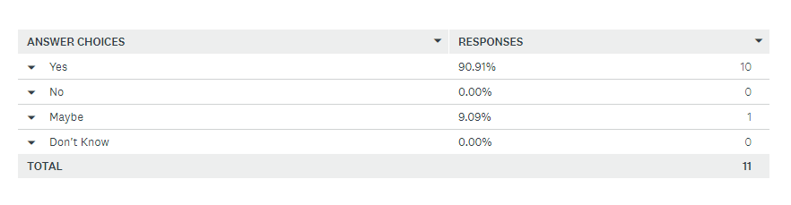

Figure 8 – Student Questionnaire (Question 6 breakdown)

The results for this question overwhelming support the idea of our project idea over the current system with 90% of students picking yes.

Question 7: If there was a centralized web portal available to you for uploading work & receiving feedback from your supervisor would you use it?

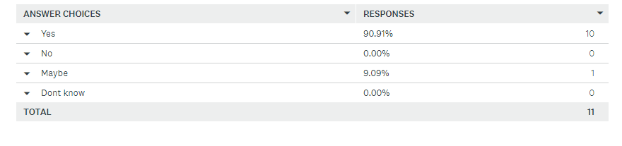

Figure 9 – Student Questionnaire (Question 7 breakdown)

Once again, another positive response to our project as students overwhelmingly would use a centralized web platform for uploading work.

Question 8: Would you prefer this over the current method you receive feedback from your supervisor?

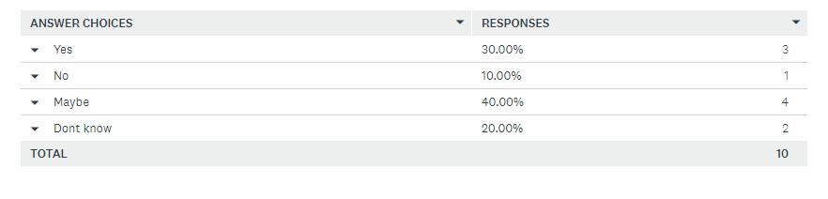

Figure 10 – Student Questionnaire (Question 8 breakdown)

The last survey question for students shows us that while most students would try out such a system for uploading work for review, we get a very mixed response as to whether they would prefer this over the current one.

### 2.1.4 Supervisor results

For the supervisor survey we ended up gathering 2 responses & they are as follows:

Question 1: Overall, how satisfied are you with the current method students pick their dissertation topic?

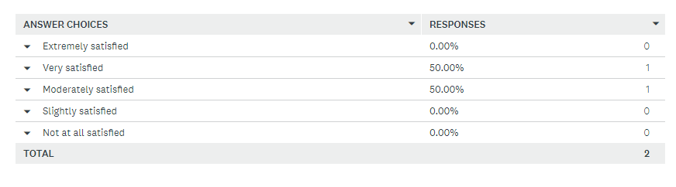

Figure 11 – Supervisor Questionnaire (Question 1 breakdown)

The result of this question tells us that supervisors are satisfied with the current system.

Question 2: Overall, how satisfied are you with the current method you provide feedback to students? 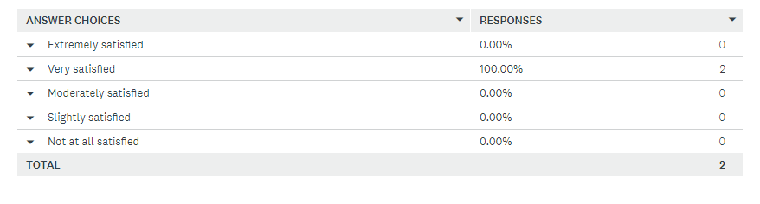

Figure 12 – Supervisor Questionnaire (Question 2 breakdown)

The results of this question show us that supervisors are fairly satisfied with the current method they provide feedback to students.

Question 3: Do you like the current system for changing students dissertation topic?

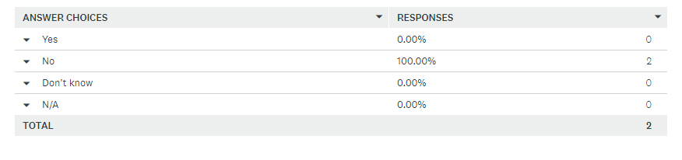

Figure 13 – Supervisor Questionnaire (Question 3 breakdown)

This result of this question gives us an interesting result with all our supervisors telling us that they did not like the current system to which students changed their dissertation topic.

Question 4: Do you think there should be a system that provides more information about each dissertation topic?

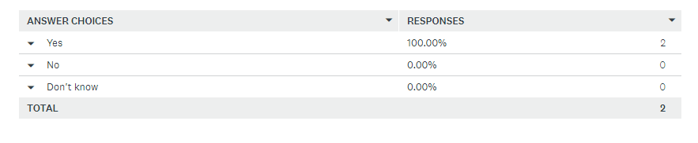

Figure 14 – Supervisor Questionnaire (Question 4 breakdown)

The result of this question shows us that our supervisors think that there should be a better system for providing more detail on each topic.

Question 5: Would you like to see a better system for students to pick their dissertation topic?

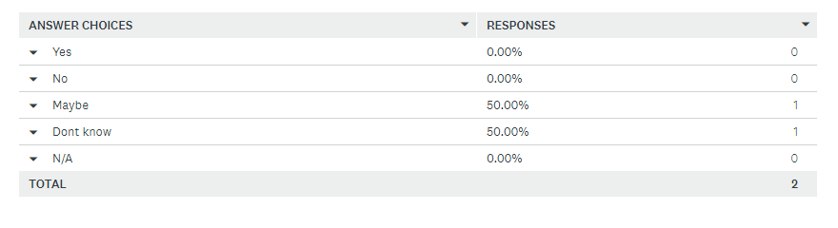

Figure 15 – Supervisor Questionnaire (Question 5 breakdown)

The result of this question shows a more mixed result with supervisors being unsure of whether they would like to see a better system for students to pick their dissertation topic.

Question 6: Would you like to see a better system for students to change their dissertation topic?

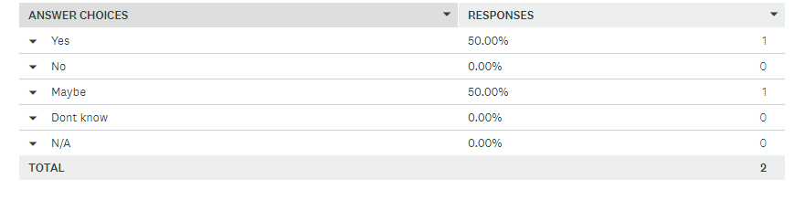

Figure 16 – Supervisor Questionnaire (Question 6 breakdown)

The results of this question, however gave us a more positive response to the idea of seeing a better system for students to change their dissertation topics.

Question 7: Do you think using a centralized web portal for picking & changing dissertation topics would be better over the current system?

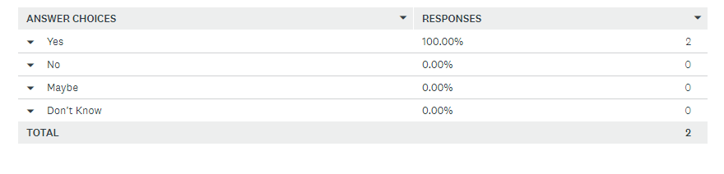

Figure 17 – Supervisor Questionnaire (Question 7 breakdown)

The results on this topic show us that our supervisors believe that using a centralized web platform to pick & change students dissertation topic would be better over the current one.

Question 8: If there was a centralized web portal available to you for students to upload dissertation work for review & for you to provide feedback would you use it? 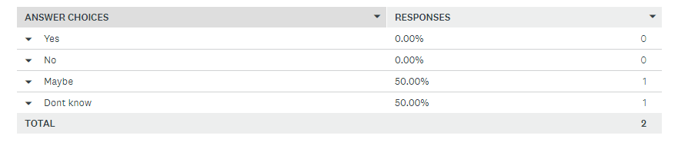

Figure 18 – Supervisor Questionnaire (Question 8 breakdown)

Lastly, our final question for supervisors shows us that supervisors have a mixed response to whether they would use a system for them to review uploaded work from students.

## 2.2 Development technologies

There was also the subject of researching how I would implement the platform. This research would investigate the potential of using a bunch of different technologies such as whether to use a JavaScript library like React or Angular or just stick with jQuery. In the end, I choose to just use jQuery for all my JavaScript need, the reasoning being a mix of prior knowledge & the time that would be required to learn these libraries & reasoning that there would be little benefit. This holds especially true for Angular as I was not intending on creating a single page platform.

Other technologies that were researched include the likes of which HTML/CSS libraries to use, in the end, this came down to two choices, Bootstrap or Foundation. Though other types of CSS libraries were used, such as Font Awesome to provide the platform with a library of icons. In terms of the main two though I ended up going with Bootstrap as I was familiar with Bootstrap & in the past have really enjoyed working with the library. The benefits of using bootstrap being that it is the most popular HTML/CSS library, offering a very fluid grid system that greatly simplifies making a user-friendly website for all sorts of devices & screen sizes. This grid system ensures that no matter the device or screen the website will scale correctly & be useable on both mobile devices & desktop.

For our database needs there was only one choice, that being MySQL, this being the database engine with the largest market share & most commonly used database for cloud hosting solutions. Having experience with MySQL too this made the choice even more clear as this would mean I wouldn’t have learned a new database engine which would have consumed time & potentially cause the project to go over schedule.

Other technologies that were researched would be that of PHP which would be our server-side scripting language of choice for this platform & would be how we scripted most of the logic for each feature & interacted with our database. This would also provide the platform with a way of reusing common elements of each page such as the navigation bar & footer so that we could simply include them on every page, making every page tidier & meaning if we ever had to change our common elements like navigation bar we could just edit one file & would instantly see the results on every single page. Another benefit of PHP being the use of AJAX with PHP which would later go on to help create the more interactive & complex elements of the platform such as the notification system. Another technology researched to be used with PHP would be that of JSON, which would give us a way to store & exchange data between the browser & server, which we would need for stuff like our notification system so that we could communicate with the browser.

## Hosting technologies

Since the idea behind the platform was to be an online system we also had to research how we would host the platform & what would be the best technology to use to do this. Due to the nature of our project, it was very important to pick a technology that would be very reliable as this being a system designed to help in the most crucial part of a student’s study, this platform needed to be available at all times so that students could upload & get feedback from their supervisor without the risk of the system going down right before a deadline or some other important milestone. Another important must have feature of our hosting technology being that it could meet peak demands & be scalable with what we needed. Being a service for dissertations we could expect that during the likes of summer we would see very little traffic to the site as most students would have finished their dissertations by then but expect very high traffic during the Spring when most students are nearing the end of their dissertations. As such, having scalability will mean the university wouldn’t have to pay for resources they don’t need & meaning they could save money during low peaks since they don’t need to pay for many resources & could then scale back up when they do need the resources during high traffic.

As such the hosting technology, we ended up choosing would be that of cloud hosting. Cloud hosting is a type of hosting that not only allows for our platform to scale with need but ensure greater stability & performance over other hosting solutions. The reason for this being cloud hosting hosts from multiple different servers, using the resources from each to ensure reliability & security. As such this protects us from our server going down as our platform will be hosted by an underlying network, we can simply pull resources from the remaining network. Another benefit to this being the significantly better protection against DDOS attacks, as a network of servers can withstand this type of attack much better than a single server system. The reasoning for this being that since we pull resources from multiple different servers when one begins to slow down we can simply just pull the request from another server on the network. As such, to DDOS attack such a system you would require a significantly greater force & have to bring down the entire network of hosts. Minus the threat from attack this benefit is very useful for responsive load balancing as we can instantly scale to the demand needed.

As such, we would have to find a cloud hosting service to host our platform. In the end, we would end up hosting our platform on krystal.co.uk, a UK based cloud hosting company with over 15 years’ experience & being used to host for famous companies like the NHS, Cadbury, Nike, Iceland & the FT.

## 2.4 Similar systems

Another point of research was looking into similar systems to get an idea of how similar platforms are already implemented & give the project an idea of what sort of design might benefit the platform.

### 2.3.1 NESS

The first of which researched was NESS, being the closest current online platform Newcastle University provides to our project, even once being used to select dissertation topics for some students.

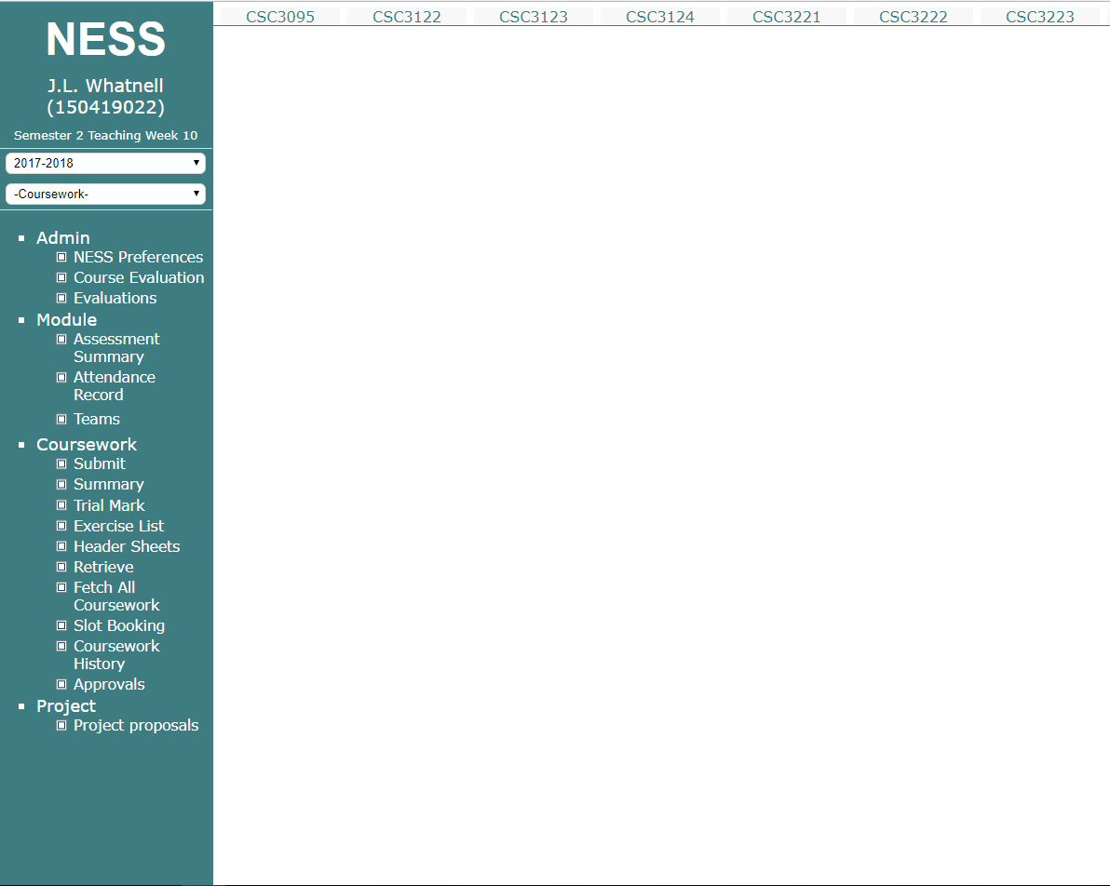

Figure 19 – NESS

NESS does some of the features we aim to implement with our system too, such as the ability to for students to upload work & have this be reviewed & then be able to receive & view this feedback. As such, we benefit at looking to this system to get an idea of how we might design our own platform & looking at what could be learnt from the layout.

### 2.3.2 ePortfolio

Another similar system that was researched was that of ePortfolio, this system logs meetings with your supervisor & so allows a way for supervisors set objectives for their students after each meeting. 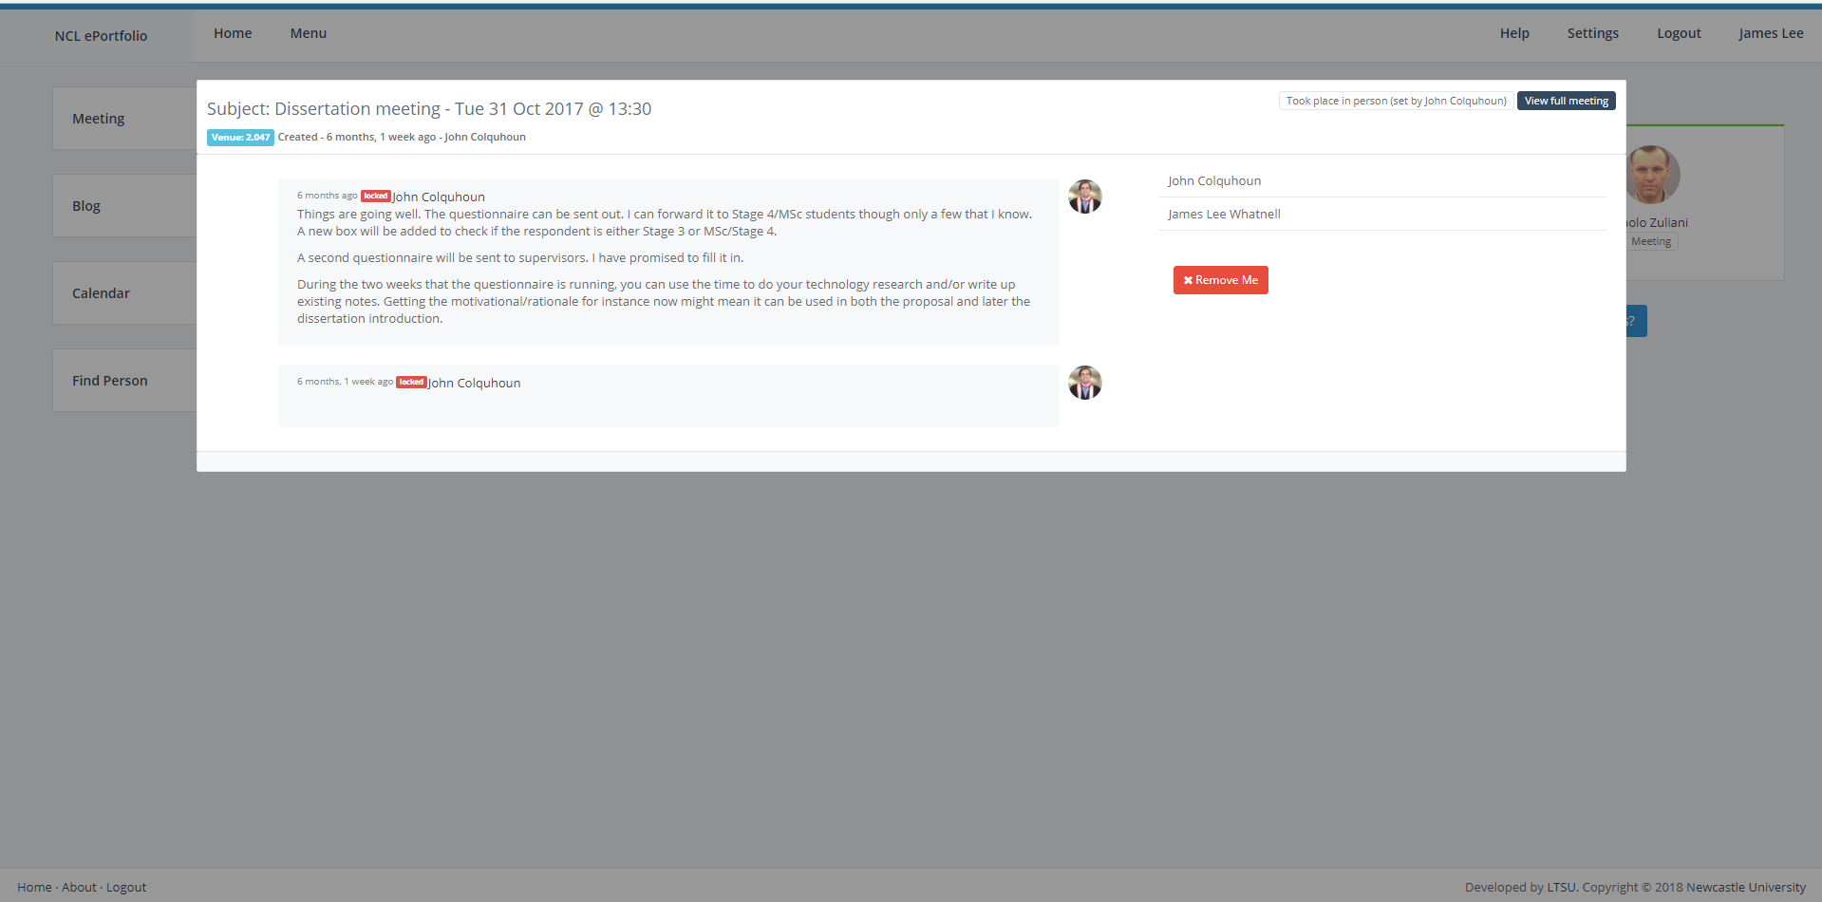

Figure 20 – ePortfolio

This means supervisors could leave digital feedback after meetings & provides students with a way to recap on their meetings & the valuable advice given by their supervisor. This system, however does not really fulfil much else of what we aim to do & as such don’t really have conflicting functions. Regardless, we could benefit greatly by looking at the design of this system, being that this system is quite clean & would be well suited to our platform.

# 

# Chapter 3 System Design

## 3.1 Introduction

This chapter covers the design of the platform & the choices that were made to fulfil the requirements set out with our aim & objectives.

## 3.2 Preliminary Designs

Before we could work on the platform a requirement was set out to create some basic designs of how our platform would look & function. This would provide guidance for when development would begin during second semester. As will be seen later within Chapter 4 however, elements of the design were changed later down the line & certain features which were not initially intended were added. The biggest of which being the admin page which was implemented to give an overview of basic information on the platform & allow for editing of each topic page, as well as the ability to add a new page for new topics.

### 3.2.1 Basic layout

The basic layout of each page is quite simple, simply using a horizontal navigation bar at the top of every page to navigate around each page & providing a logout button on the far right of the bar for when the user wishes to logout the platform. The platform being closed the first thing most users will be greeted with will be that of the login page, an example of which can be seen below on the sign-up section. As such, to access the features of the site a user will require a valid username & password. This login page works for both users & staff, so this page will greet both types of users before they enter.

### 3.2.2 Login page

The first page of our platform is the login page, this consists of a form for the username & password with a simple button to then login once pressed with a valid combination. Upon entering a valid username & password this will direct them to the home page of our platform, more detail of which you can find in the home page section. If the user enters nothing in both or one of the fields then the field will pop up with a prompt to please fill the empty field. If the user enters an invalid combination, then they will be redirected back to the login page.

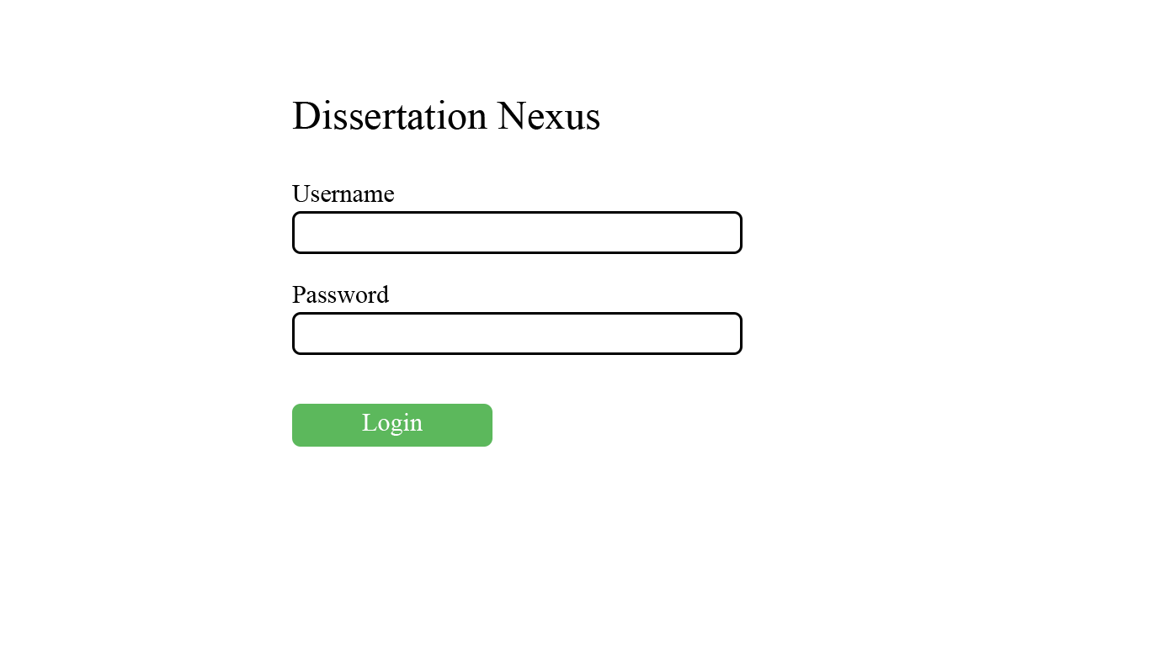

Figure 21 – Login page design

### 3.2.3 Home page

The home page is the first page the user will be greeted with upon entering in a valid username & password. As can be seen from the figures below this page will look slightly different depending on the type of user you are, with students getting a notification system for when they receive feedback, a card filled with relevant information about their supervisor & a set of goals which will be set by their supervisor. Supervisors on the other hand will just see the notification system which will notify them of students uploading work that needs to be reviewed.

From here both types of users will have access to the navigation bar that will allow them to use all the features of the platform, that being the ability to access dissertation topics & view information on each, the ability to submit work if you’re a student & lastly the ability to view your feedback or if you’re a supervisor leave feedback on submitted work.

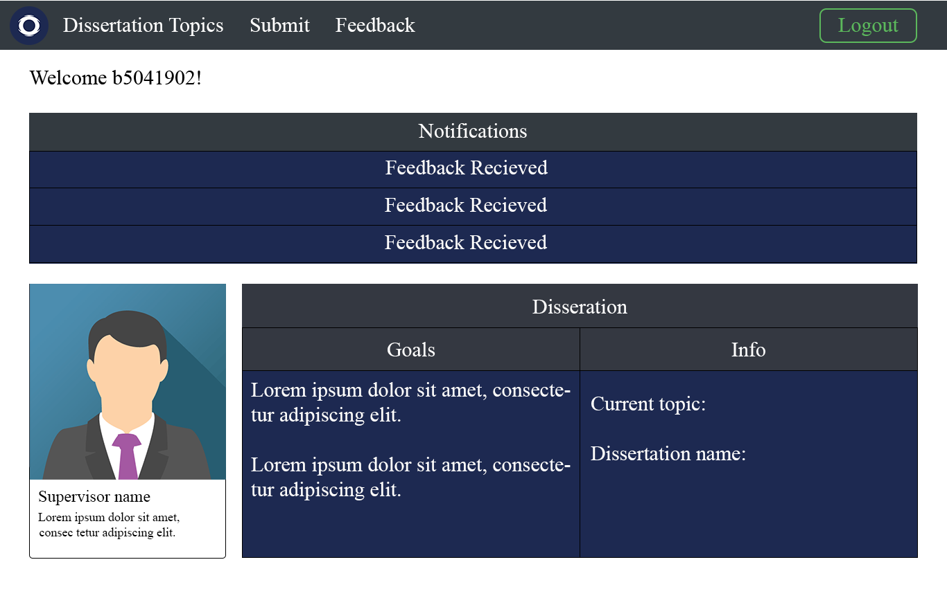Figure 22 – Home page for students 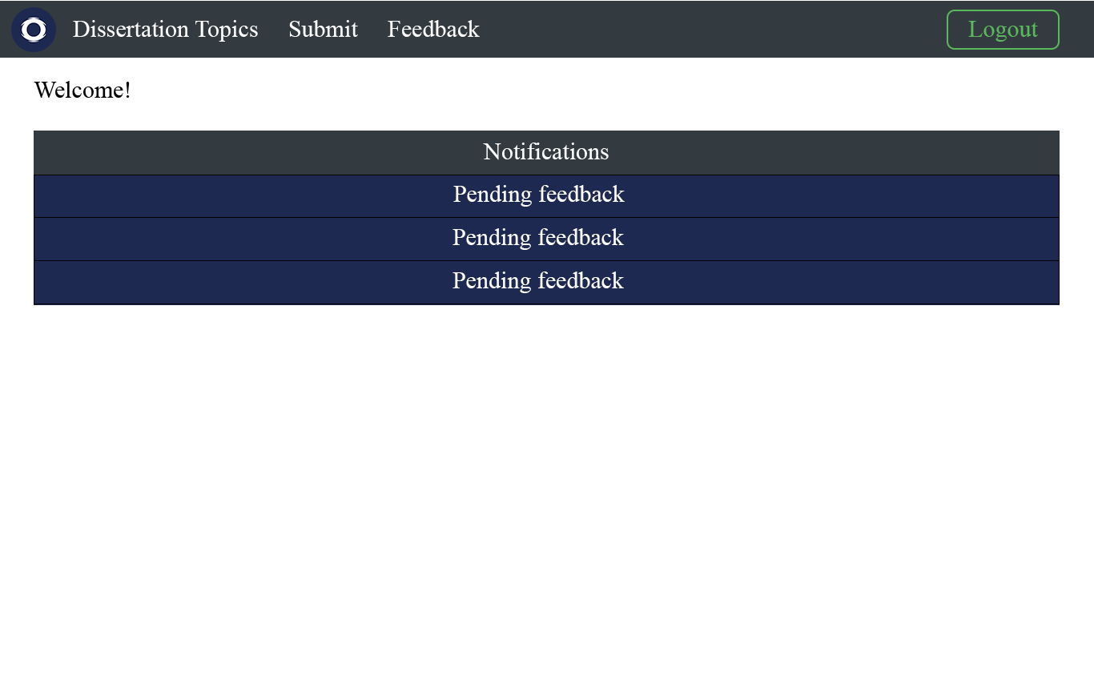

Figure 23 – Home page for supervisors

### 3.2.4 Dissertation topics page

The dissertation topic page allows users to view all dissertation topics & learn more about each one. In the case of students, the only topics that will be displayed will be that of relevant topics, so an example being a computer science student will only see topics that are relevant to computer science, such as HCI & software engineering. This means students won’t have to spend time looking for the topics that are important to them & since we only show topics that they can directly pick from when the time comes to do so. Staff however, will be able to view all topics. This page will also provide a way for students to select their dissertation topics assuming they have not already & allow for the ability to change their topic assuming this has been approved. As can be seen below the structure for this is simply just a list which will contain all the relevant topics assuming you’re a supervisor & list all of them if you are a staff member. Each element within this list will link to a page on the site that will offer greater detail on that specific topic, so students can learn about each topic & conclude as to which topic might interest them best. Lastly, at the bottom we have the buttons for selecting & changing your dissertation topics, these will only be visible under certain conditions, the selected topic only being visible, assuming you have not picked a topic yet & the change topic only being visible if you have selected a topic already & have been approved to change your topic. Supervisors, however will not view either of these buttons as they are not assigned topics.

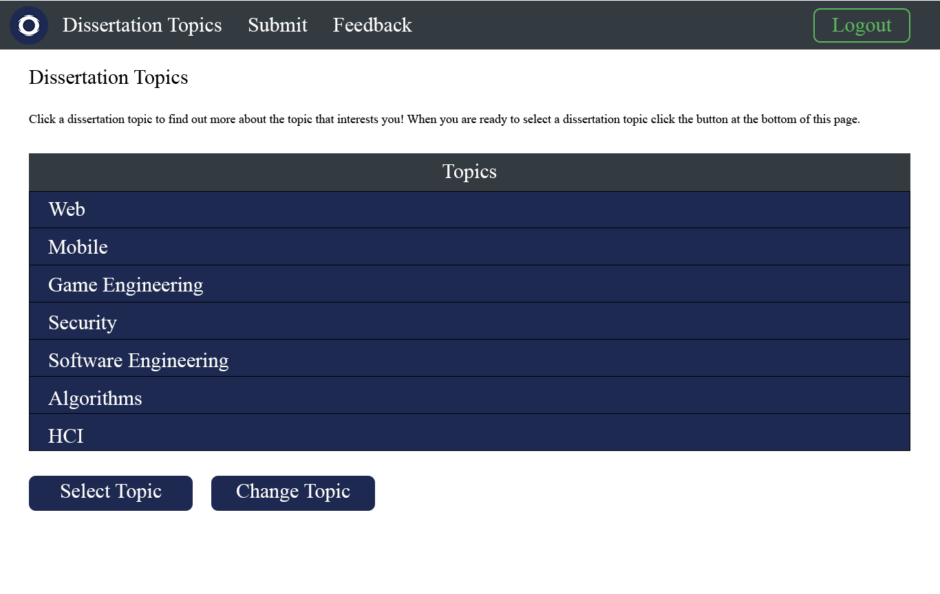

Figure 24 – Dissertation topics page

## 3.2.5 Submit page

The submit page will allow students to submit work to be reviewed by their supervisor. As can be seen with the figure below this will simply be a form consisting of a button to select the file you wish to upload, a field to enter your email for confirmation of submission, in this case we will send an email to the student telling them that the submission either succeeded or failed, a field for the title of what you’re submitting such as “poster” for a poser & lastly a field for entering information about what they are submitting, this allows students to give some background information on what kind of feedback they want on their submission, for example, they might submit a poster for review & specifically be wanting feedback on the information aspect of the poster rather than the design one. This gives the student a certain level of communication with their supervisor, so they can get targeted feedback.

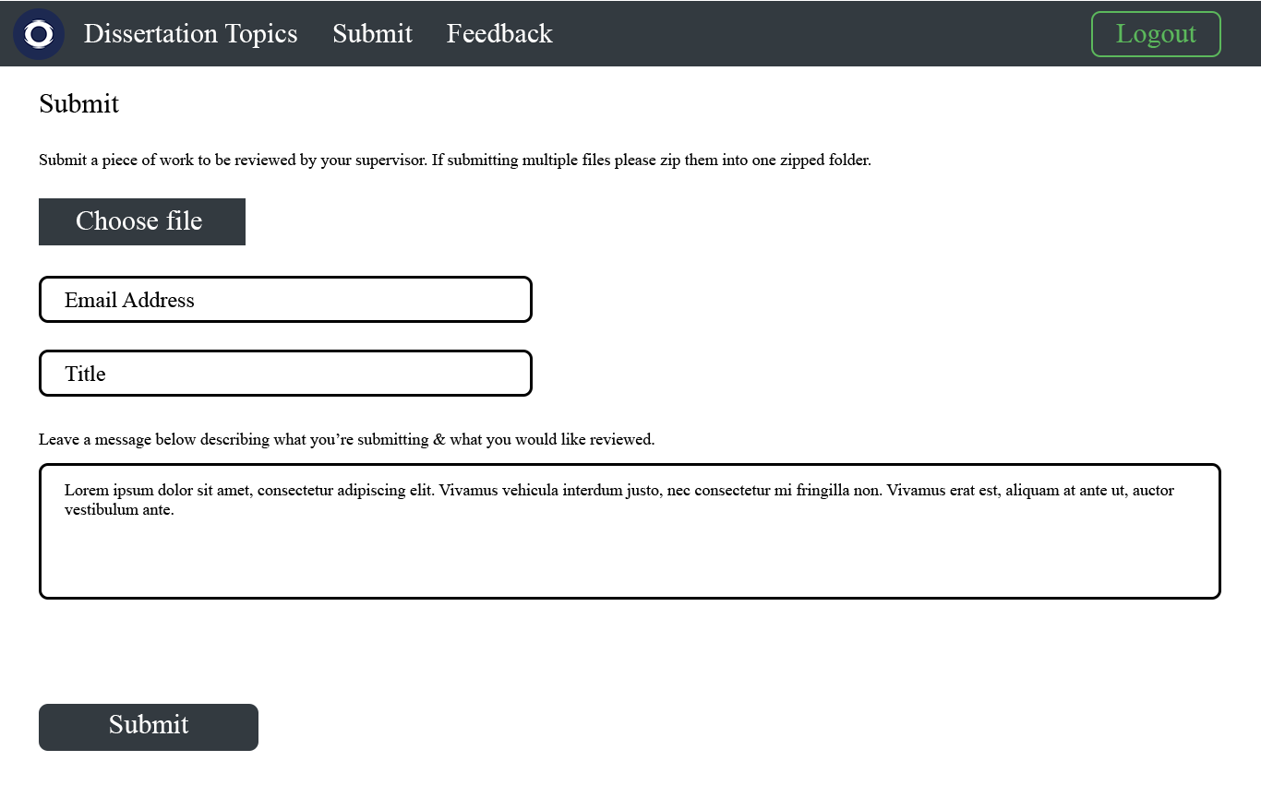

Figure 25 – Submit page

Once these fields have been filled the student can then click the submit button which will check the fields to for certain requirements. For file requirements the platform will check for stuff such as that the file size isn’t too large, the file type is of an accepted type & that the file doesn’t already exist. Checks also take place on the fields themselves, such as the email field to make sure a valid email was entered & to ensure that we strip tags to prevent injection attacks.

Assuming they pass these checks the file will submit successfully & an entry will be made into the database & file stored someone locally on the host machine. The student will then be redirected back to the page & notified the submission succeeded with a message.

## 3.2.6 Feedback page

The feedback page will allow for users to view or submit feedback on submitted work, depending on the type of user they are. Students will be able to see everything they have submitted, with details on the submission such as the title, when they submitted & when they received feedback from their supervisor & the feedback itself once they have received such. If a work has yet to receive feedback this field will simply tell the user, they are pending feedback from their supervisor. To view the feedback the student simply must click on the feedback link which will open a modal box that will contain their feedback, this means they don’t have to reload the page or go to a different one & can easily view feedback from all their submitted work.

Supervisors on the other hand will be able to offer feedback on all work submitted by the students they are supervising. This will give them a button that they can click to bring up a popup box to fill in their feedback & then send this feedback to the student. 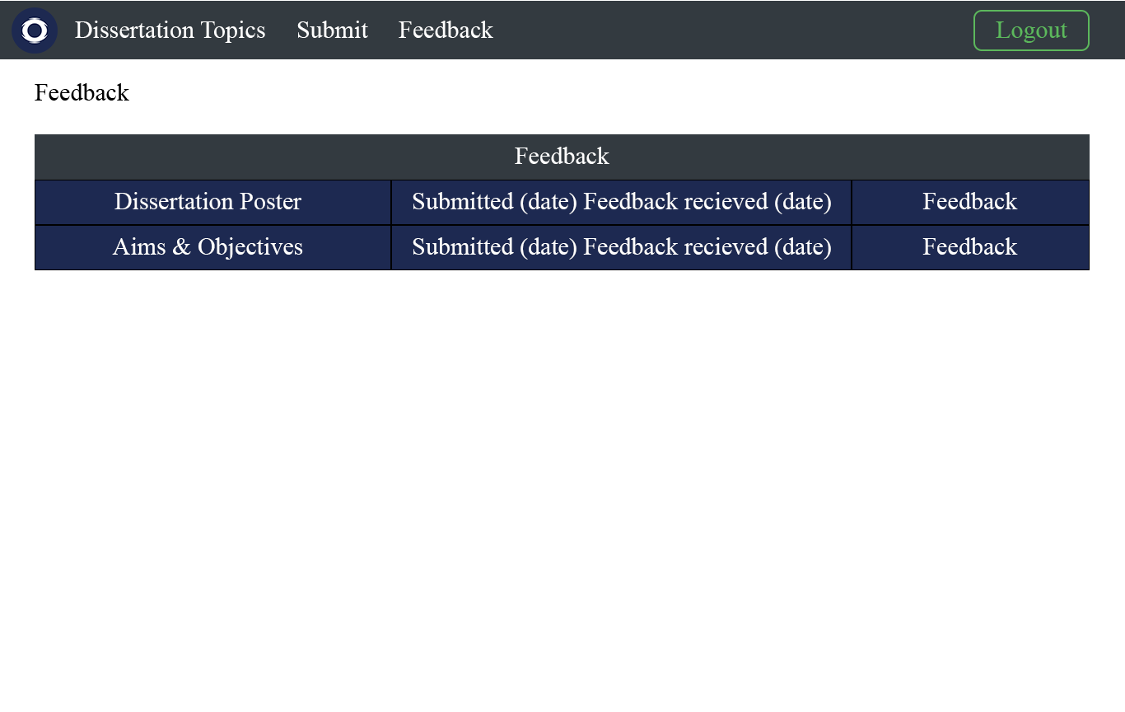

Figure 26 – Feedback page

# Chapter 4 Implementation

## 4.1 Introduction

This chapter covers the implementation of our designs & development of our platform. This will detail the structure of our platform, how we developed the platform & the changes we made from our initial designs.

## 4.2 Platform structure

The figure below shows us a representational structure of our platform & every page minus greater detail on the admin features which will be covered later.

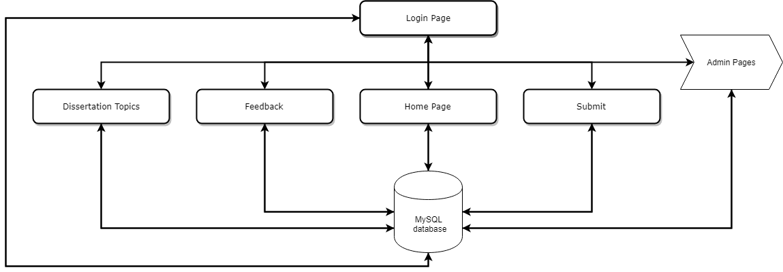

Figure 27 – Main structure

As can be seen the structure of the platform is quite simple, we start with our login page which works to gatekeep access onto the platform. Upon entering the correct details this will let users access the rest of our pages, depending on the type of user. The user can access the primary features of the platform by simply using the navigation bar to jump from one page to the other, the only exception being the admin section of the site.

The gain access to the admin section of the site & user must be logged into a staff account, to get to this page we simply display this as an extra link on our navigation bar. This will take give us the following structure as seen in the diagram below.

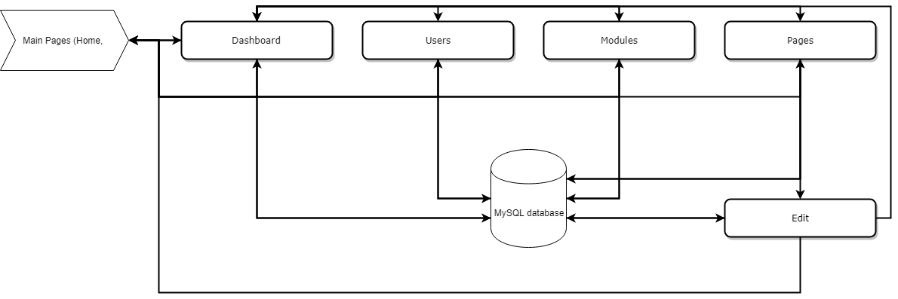

Figure 28 – Admin structure

From the dashboard we can access the other admin features, such as users & modules page. To edit a page, we must first go to our pages page & then click on a page we would like to edit which will then take us to the edit page. All these pages have access to the regular navigation bar, so they can go back to all the previous pages such as the home page & dissertation topic page no matter where they are in the admin section.

## 4.3 Architecture

The figure below shows the overall view of the architecture of our platform & how each page connects to our database.

### 4.3.1 Login page

Upon pressing the login button this page will go to our login PHP file which will check first if the provided username & password match with anything in our students table, if we find a match then we save their session information & redirect them to the home page. If we don’t find a match though we then look at the staff table & do the same thing, saving their session information & redirecting them to the home page. This session information will be used throughout every page to check who is currently logged into the system & what type of user they are. If we don’t get a match with a staff in our database either, then we simply redirect them back to the login page telling them they have entered an invalid username or password.

### 4.3.2 Home page

The home page connects to our database in several ways. Firstly, for the notification system we use AJAX to load unread notifications for that user from our notification table on the load up of the page body. This is then followed by regular checking of our notification table so that our notifications are updated live without the need to refresh the page. To clear notifications the user simply just clicks them, which will clear the notification that they clicked on. This means that users can keep notifications they might find useful, this means a supervisor for example, could kind of double this as sort of a check list in which they clear the notifications for student work they have already provided feedback for & decide to keep the ones they have yet to do to help remind them later when they log back into the platform.

Another system that connects with our database is the supervisor card, this is only visible to students & is a personalised card which gives basic info on their designated supervisor. This system uses the staff table to get the contact details of the supervisor & finally a link which will be used to attach to the button on the card & can then be clicked by students to go to the exact Newcastle University staff page of their supervisor which will provide even greater detail on stuff such as contact information. Initially our platform intended to display the picture of the supervisor too, but due to time constraint & limited purpose other than purely design choice instead our system currently just uses a stock profile icon for every supervisor. Though this system could be expanded later down the line to implement this by adding an extra column to our staff table & using that to fetch the picture.

Lastly, we have the goal system which is also only visible to students, which is simply just a set of goals to aim toward which will be set by their supervisor. This system uses the goal table & simply just gathers that student’s goals from the database & displays them onto the list.

### 4.3.3 Dissertation topics page

The topics page likewise connects to our database in numerous ways. The first of which being upon loading we will load our dissertation topics PHP file which if you are a student will select all topics from the subject you are enrolled in, such as computer science from the topics table & then display them in a list. If you’re a supervisor the same PHP file is used & just checks the sessions to differentiate between the two, so when you’re a supervisor we will select all topics from the topic table & display them all in a list.

Amongst this we have the buttons to select & change topic, upon a student clicking either one of these we will open a modal box which contains a dropdown menu, this dropdown menu is generated by our dissertation selection PHP file, in which we simply select all the topics relevant to the student & display them in a dropdown menu for them to select one. Upon selecting one from the dropdown & pressing the confirm button we will then call the select topic PHP file which will update the user table to change the students enrolled topic to the one selected.

### 4.3.4 Submit page

Upon pressing the submit button after entering the necessary fields we will call the upload PHP file which will check the uploaded file name, size & type. This is where we set restrictions on what file types we accept; the maximum file size & ensure we don’t have conflicting file names & don’t overwrite submissions. If the file doesn’t meet the list of accepted file types or is too large we simply redirect the user back to the submit page & give them a message to tell them about the issue when trying to upload their file. For conflicts we use uniqid function in PHP to generate a new filename & append this onto the dot file type, the reason this works being uniqid is function that will generate a unique identifier based on the current time in microseconds, so we can guarantee when we submit this file to your database & move the file to be stored we won’t have a conflict. Assuming we meet the file type & file size requirements the file will we stored in our database & the file will be moved to our file destination.

### 4.3.5 Feedback Page

The feedback page upon loading will use our feedback PHP file to gather all the relevant feedback for the type of user logged in. For students, we select everything from the upload table that they uploaded & display this within a table, this will contain information, such as the title, message & finally either a message telling the user they are yet to receive feedback or a link that will open a box containing the feedback on that submission. For supervisors they will see the title, message, submitted user & a button to provide feedback or view the feedback they sent after they have sent the feedback on that work. If they have yet to send feedback & click the button to leave feedback they will be greeted by a modal box which contains a field for the title of the feedback & finally a large text box to leave their actual feedback. Upon confirming this we call the leave feedback PHP file which will select the piece of work selected & update this in the table database to contain the feedback left. Amongst this we will update the notification table & send the user a notification telling them they have received feedback on a submitted piece of work.

### 4.3.6 Admin dashboard

The main purpose of the dashboard is to provide some basic data on the platform, in this case we connect with the database to gather information on a bunch of different tables to get a count of the number of users, subjects, topics & topic pages we have stored in each table. This currently offers only basic information on our databases & could later be expanded to offer greater detail on our database & platform.

### 4.3.7 Admin users page

The users page uses PHP AJAX live search to connect with our database & provide us with a user friendly & interactive search bar which we can use to search for data in our users table. Currently this works by searching for whatever user id you type into the database, this uses the LIKE operator so that you don’t have to type in the entire of an id to start getting results. From this we will generate a table that will display certain information about the searched user, such as what their enrolled topic is, what their enrolled subject is & finally who their supervisor is.

### 4.3.8 Admin modules page

The modules page works very similar to how the user page works, by using PHP AJAX to live search the modules database using the search box provided. Likewise, with the user page you simply enter in the id of the module you’re looking for & you will receive a table containing all the modules that match the id you partially or fully entered.

### 4.3.9 Admin pages page

Just like with the previous two pages we use PHP AJAX live search here too, but with the added feature that each element within the table will have buttons that offer the option of editing or deleting the searched page. Upon clicking the edit button, you will be taken to the edit page which will allow you to edit the selected page, so you change or update details about the information provided on that page to keep the page up to date without the need to mess around with HTML. The delete button simply just deletes this page from our database & from our memory.

### 4.3.9 Edit page

Finally, the edit page, simply contains some fields to edit the page & uses CKEDITOR to provide us with our body field, this lets gives the user access to lots of styling options for the text & allowing for inserting of pictures, links & more. The downside, however being we currently do not display what is contained within the current page so if you only need to edit a tiny detail you will need to copy the contents of the original page into the fields & then edit what you need to edit. All the actual editing of the contents of the page will take place in the page body section & simply by using a template we set out within our PHP file that gets used upon clicking the submit button we just insert this text into that template. As well as editing the actual page itself, we can edit the topic this page belongs to, using a dropdown menu which gives us the option to select from every single topic. Lastly, the other fields are simply to edit the page details such as the page title, meta tags & meta description.

## 4.4 The database

For our platform we would have one database containing eight tables. As can be seen in the figure below.

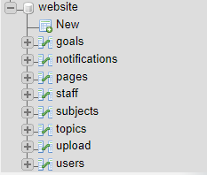

Figure 29 – platform database

## 4.4.1 User tables

For our login system we use two tables, a users table that stores the details of login details of all students & the staff table which stores login details of supervisors & other staff members. The structure of both of which can been seen in the figures below.

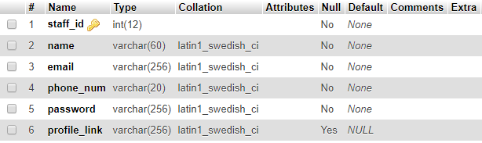

Figure 30 – Staff table

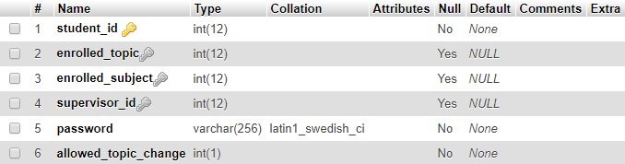

Figure 31 – Users table

For our login system we use the id & password & compare them to each table to see if we get a match from either. If we do then we log the user in & store some of the details in the database in our session, in the case of students we will store stuff like their enrolled topic, subject & the id of their supervisor.

The contact information of the staff is used for our card system on the home page, the way this works is that we look at who that student’s supervisor is using the supervisor_id of the users table & then simply get the contact information from the staff table & echo this into the supervisor card.

The enrolled subject field is used to filter out the topics on the topic page so that when a user goes to this page they will only see topics that are relevant to that topic. Once a student decides to pick a topic we then store this in enrolled_topic & reference this to a topic in the topics table. Lastly, we have a field for whether we allow the student to change their topic after they have already picked one. This is simply a 1 or 0 field, 1 meaning they can change their topic, 0 meaning they can’t.

## 4.4.2 Notification table

For our notification system we use one table to store all our notifications, as can be seen in the figure below.

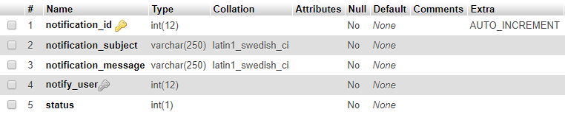

Figure 31 – Notification table

For our notifications we simply store the subject & message of the notification, the user of who needs to be notified of this message & lastly the status which we use to tell whether the notification has been cleared or not. Likewise, to do this we use either 0 or 1 to denote this, with 0 being an unread notification & 1 being a notification that has been cleared by the user.

### 4.4.3 Upload table

For our upload system we use one table to store all the uploaded files, a figure of which can be seen below.

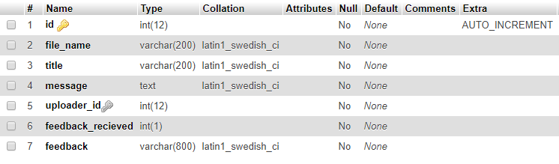

Figure 32 – Upload table

When a student uploads a file, we store the title & message he inputted as well as store the id of the student who uploaded the file. Feedback on submissions are stored in a field called feedback & to tell when a submission has received feedback we simply use a field using the usual 0 or 1 system where 0 means the file has yet to receive feedback & 1 meaning the files received feedback.

### 4.4.4 Subjects & Topics table

To store our subjects & topics we use a table to store the subjects & one to store the topics & then simply link the topics to a subject within the subject table. A figure of these can be seen below.

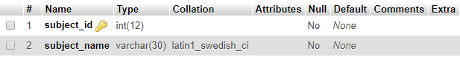

Figure 33 – Subject table

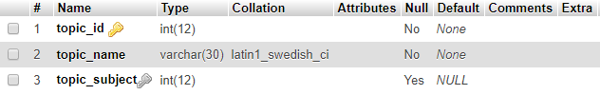

Figure 34 – Topic table

This works by firstly storing a set of or one subject & then when we create a topic we link this to a subject & give the topic a name. This works with the student table to check what subject they are currently enrolled in, so we can display all topics from the topics table that match the subject of the student. The same works for when a student selects a topic, we simply get all the topics that are relevant to them & display this in a dropdown menu.

### 4.4.5 Pages table

To store the page for every topic so we could later edit & add new ones we needed to have a table for this, a figure of which can be seen below.

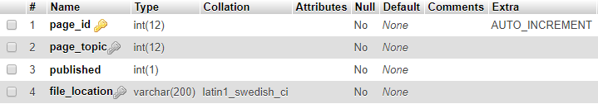

Figure 35 – Page table

On this table we firstly store what the page topic is so that we know which topic this page is about & can correctly link this on the topics page when a student clicks to learn more about the selected topic. Then we have the published field which is another simple 0 or 1 field which tells us whether we should display this page or not & finally we have the file location field which tells us where the file is so that we can echo this as the link on our list so that when the user clicks on the topic they are linked to this page.

## 4.5 Security

An important part of developing the site was thinking about security & how we would protect the platform from the likes of injection attacks, URL exploitation to gain access to parts of the platform the user shouldn’t have access to & general other forms of exploitation.

Firstly, to differentiate between users & limit access to certain parts of the platform we used sessions so that we could use these later to tell what type of user the person logged in currently is & what their specific id is. This meant we could use this to ensure that students could not access the admin section by simply checking the stored id in the session data. This was also useful for limiting access to features only needed by their respective roles, so supervisors not needing to use the upload feature will not be able to access the page for this. This ensures consistency & stability within the platform.

To prevent against SQL & JavaScript injection all fields were made sure to escape strings which helps remove special characters & prepare statements for all our SQL statements. This helps to prevent against SQL & other types of injection attacks such as JavaScript injection.

To secure users our platform all passwords are hashed so that even if our database is compromised the infiltrator won’t have access to plaintext passwords. For this we use PHPs only hashing function password_hash which uses a strong one-way hashing algorithm. This uses the bycrpt algorithm & is designed to change over time as new & more secure algorithms are added to PHP. As such not only does this provide us with a secure form of hashing but provides us with future proofing as PHP updates so will our hashing to ensure that the platform is ahead of the curve on security & doesn’t risk getting compromised over time.

Furthermore, we secured our hosted platform with an X. 509 SSL certificate using Let’s Encrypt. This ensures that your information is kept private, with communication between the browser & website being encrypted.

# Chapter 5 Testing

## 5.1 Introduction

This chapter covers the testing of our platform, the methods used to test our platform & the results of each test. For each test we will analyse the results & what they tell us about the platform.

## 5.2 Functionality testing

The first type of testing undertaken was that of functionality testing, this testing was to ensure everything worked as intended & produced the results we would expect them to. We needed to do this first to ensure that everything worked as intended first, as the most important part of our system is that everything works. To thoroughly test the system, we split the testing into each page so that we could evaluate the functionality of each page individually & then conclude on the functionality of the system as one whole.

### 5.2.1 Basic checks

The following basic checks were carried out on every page:

Check that CSS is displaying correctly.

Check that text is displaying correctly & easy to read.

Check that formatting on page is working as expected.

### 5.2.2 Login page

The following tests carried out on the login page are as follows:

Successful login with a valid username & password combination.

Attempted login with empty fields.

Attempted login with incorrect username & password.

### 5.2.3 Home page

The following tests carried out on the home page are as follows:

Notification system:

Check that the notification bar was correctly displaying & was collapsible.

Check that notifications were for the correct user & not displaying the wrong notifications for the wrong user.

Check that notifications could be cleared by clicking on them.

Check that notifications were updated live on the page without the need to refresh.

Check that these tests passed for both student & staff member.

Supervisor card:

Check that the correct supervisor card was displayed for the student logged in.

Check that these were not displaying for supervisors & were exclusive to only students.

Check that information was displaying correctly on the card.

Check that the link to the supervisor’s staff page on the Newcastle University website worked.

Goals:

Check that goals were displaying correctly.

Check that every goal was for the right student & not displaying other students goals.

Check that the goals we’re only visible to students & not staff.

### 5.2.4 Navigation bar

The following tests carried out on the navigation bar are as follows:

Check that every link works & correctly links to each page.

Check that the home icon correctly links back to the home page.

Check that the logout button correctly logs the user out on every page.

Check that the logo doesn’t break on any of the pages or modals.

Check that the admin section is only visible & accessible to members of staff.

Check that the submit page is not visible to staff.

### 5.2.5 Dissertation topics page

The following tests carried out on the dissertation topics page are as follows:

Check that students could see all the relevant dissertation topics for their enrolled subject.

Check that students could click on each topic & be sent to the correct page providing greater detail on that topic.

Check that supervisors could see all topics in the database.

Check that supervisors could click on each topic & be sent to the correct page.

Check that students who had not picked a topic could successfully click the select topic button.

Check that the modal presented after pressing the select or change topic buttons displayed correctly & listed the correct possible topics that the student could choose from.

Check that upon confirming a topic selection or change that the topic would change in the database.

Check that students who already have a topic & are not permitted to change topic don’t see either button.

Check that students who have picked a topic but can change topic only see the change topic button.

Check that the two buttons would are not visible to staff.

### 5.2.6 Submit page

The following tests carried out on the dissertation topics page are as follows:

Submission with missing combination of fields (missing file, missing email, ect).

Submission with incorrect file type.

Submission with a very large file

### 5.2.7 Feedback page

The following tests carried out on the feedback page are as follows:

Feedback table is displayed & formatted correctly for both student & supervisor.

Leave feedback on a variety of different students work.

Students can view feedback on work that has been reviewed by a supervisor.

### 5.2.8 Admin dashboard

The following tests carried out on the admin dashboard page are as follows:

Check that the admin navigation menu worked (this would be tested for every admin page).

Check that the information displayed about each table is correct.

Check that our admin controls button works & that we can successfully add a page (this would be tested for every admin page).

### 5.2.9 Users page

The following tests carried out on the users page are as follows:

Ensure that the live search works, & we can filter our users by id.

Check that information in the table is correct & our filter is applying correctly.

### 5.2.10 Modules page

The following tests carried out on the modules page are as follows:

Ensure that the live search works, & we can filter our modules by id.

Check that information in the table is correct & our filter is applying correctly.

### 5.2.10 Pages page

The following tests carried out on the pages page are as follows:

Ensure that the live search works, & we can filter our pages by id.

Check that information in the table is correct & our filter is applying correctly.

Ensure that our delete button works & pages are successfully deleted from both the database & memory.

Check that our edit buttons works & directs us to the edit page.

### 5.2.11 Edit page

The following tests carried out on the edit page are as follows:

Check that all our fields are correctly displayed & allow the user to type in input.

Check that our dropdown selection box correctly displays all topics.

Check that our published buttons works & can be pressed.

Check that when submitted our page successfully updates our page table & edits our actual page.

### 5.2.12 Results

The results of each of these tests can be found appended in Chapter 8, but overall the results showed us that every test passed with every button, link & field working as expected. This shows us the site works well functionally, with every feature working as expected from basic navigation from page to page to more complex features such as ensuring the likes of our notification system working correctly. This however does not mean the platform will work flawlessly when under more intense testing however, as such user testing must be done to identify more difficult to spot errors.

## 5.3 Security testing

The second type of testing we undertook was that of security testing, this would test that our platform was not vulnerable to a wide variety of risks such as injection & using the URL to access pages without being logged in or the correct user.

The first testing that we would undergo would be that of trying to break into the system using an SQL attack, to do this we would use the SQL “105 OR 1=1”, assuming the system is vulnerable to this attack, we should see that the system will give us access to the home page & log us in as the first user in our users table. This test passed & we were not able to gain access to the website by using an SQL injection attack such as this, this come to no surprise as we prepare our SQL statements in the PHP file & escape strings.

The next test that I would undertake would be that of testing whether we could gain access to different pages to our website simply by using the URL. As expected, this test passed & the user could not access the rest of our platform without first logging in. This is due to the use of sessions throughout the platform that enforce that a session must be set, otherwise we redirect them to the login page.

## 5.4 User testing

Lastly, we had user testing, which would test our platform with actual end users & then gather their feedback on the system using a questionnaire. This would allow the users to rate the system on general criteria & then finally answer some questions about what were their general thoughts & how they compare the platform to the current system & whether they prefer this platform over what they use currently.

### 5.4.1 The task

To test our system users were asked to do a series of tasks that a regular user might do, this was designed to test every aspect of the system for students to give us their thoughts on every feature.

The tasks to be completed by the students:

1. Login with the provided username & password.
2. Check out more information about their currently assigned supervisor, testing the button to link them to the student staff page on the Newcastle University website for more information.
3. Check out their notifications & see that they were given a few mock notifications for feedback received.
4. Try clear their notifications by clicking on them.
5. Go to the submit page & submit two different files to the system, one that will cause an error & another that will succeed.
6. Check out the feedback page & see the information on the file they just submitted, whilst there should see a mock submission with feedback already received. Click on the feedback link to then read this mock feedback.
7. Go to the dissertation topics page & check out all the dissertation topics the system has selected to be relevant for them & click on as many topics as they wish to learn more about.
8. Select & later change the students dissertation topic.

### 5.4.2 The sample

For our user testing, we gathered 5 3rd year students, all of which whom had experience using the current dissertation system & were nearing the end of their dissertation.

### 5.4.3 The questionnaire

After a user had completed every task we would have them complete an online questionnaire, this would provide us with an easy platform to analyse & graphically represent our results.

The general structure of our questionnaire being as follows:

Questions 1-4 giving general 1-10 scores on basic criteria such as the performance of the system, the ease of use of the system, rating how easy they thought everything was to navigate & use, the interface of the system, how they would rate the overall look & layout of the website & lastly the functionality of the system, whether they thought everything behaved as they expected.

Questions 5 – 6 are questions on whether they then prefer this system over the current one & whether they would use this system if it was implemented.

### Results

The results of the user test were quite positive with most a positive rating for most questions. When asked about the performance the average weighted response being 6.4 out of 10, giving us a decent score. From speaking with students most pointed out that switching from one page to the next felt slightly slow, a way I could have tried fix this was to attempt to implement AJAX on every page so that the user didn’t not have to reload the page when switching between different pages on the website.

Asked how they would rate the ease of use & the average weighted score gave us an 8.2 out of 10. Talking with the students most commented on the simple design & easy navigation of the website. This would directly relate to our next question which would ask how they would rate the interface & design of our system, to which our average, weighted score gave us a 6.0 out of 10. Students commented that while the design was too simple & didn’t look that great or interesting. Our last 1 – 10 questions would ask how they would then rate the functionality of the system, which gave us a weighted score of 6.8.

Lastly, we had two yes or no questions, the first of which we asked whether they would use this system if it were implemented & the result being every student yes for this question. This shows that while not without fault on the likes of design which fell quite short all students liked the system & would use such a platform. The very final yes or no question asked whether they preferred this over the current dissertation system & once more every student responded with yes. This shows that our system is fit for purpose & appealing enough to replace the current system currently in use by Newcastle University, though I have no doubt the platform would need significant tweaks if it were ever to do this shows there is a desire for a system to this one.

# 

# Chapter 6 Conclusion

## 6.1 Introduction

This chapter covers the conclusion of my dissertation & final thoughts on the success & failures of the platform, where the platform could have improved & what could have been done better given the chance. The final closing thoughts of which will conclude whether the project was ultimately a success & worthwhile, as well as whether the project met the aim & objectives we set out within chapter 1.

## 6.2 Aims & Objectives

In this section we will be going over each aim & objective & concluding whether we succeeded in fulfilling each one.

**Objective 1:** Research current systems supervisors & students use (Dropbox, Slack, Email, etc).

Researching of current systems was done & documented very early into the project, with details of which being found in Chapter 2, background research. In this I covered a significant number of current systems used by both students & supervisors & therefore can conclude I succeeded in fulfilling this objective.

**Objective 2:** Conduct questionnaires to find out whether students & supervisors desire a different system to the one currently in place.

Questionnaire’s were conducted quite early during the project, of which we gathered 11 student responses & 2 supervisor responses. While the project could have done with more responses, especially on the supervisor side, we achieved this objective in gathering feedback on the system. The results of which indicating that students would like to see a better system & don’t particularly like the current one in place while supervisors are more neutral.

**Objective 3:** Design & implement the web portal.

The design & implementation of the platform was conducted & finished with testing suggesting everything was finished to a good standard & user feedback being quite positive. As such, we can say that we achieved this objective.

**Objective 4:** Evaluate the final product, find out whether students & supervisors prefer this centralised system over the current one.

During testing we managed to evaluate the platform with 5 students, however were unable to get an evaluation from a supervisor due to time constraints. From the feedback we received from students at least, we can definitely see that there is a positive response & preference to this platform over the current system used. As such, we can conclude that we partially succeeded in this goal as while we know that results of what students think of the final system we failed to gather data on what supervisors thought of the final system.

**Aim:** Create a centralised web portal for the school of computing for allocating dissertation topics & providing a hub for uploading work to be more easily reviewed by supervisors.

Our aim was therefore achieved as we successfully implemented a platform for allocating & uploading work to be more easily reviewed by supervisors & achieved our objectives leading up this final aim. With our final system students can easily get information on each dissertation topic & pick the topic that interests them, as well as upload work which can be reviewed by their supervisor & then reviewed from the feedback page.

## 6.3 Time plan

Throughout the project I would try to stick to the project plan laid out below but would end up struggling to meet my original deadline for some of these tasks. For the first semester I would complete every task on time & would even complete tasks early but with the second semester having the opposite problem & would suffer a few setbacks when developing the platform. The biggest reason for these setbacks being the underestimation of the time consumption in implementing the platform as while I had experience with certain technologies such as Bootstrap & JavaScript, I had significantly less with PHP & AJAX, which meant a significant amount of time was consumed learning & understanding how to implement certain features, a good example of which being the live notification system which would take a significant amount of time to get working as intended as this was the first time I ever implemented such a feature before.

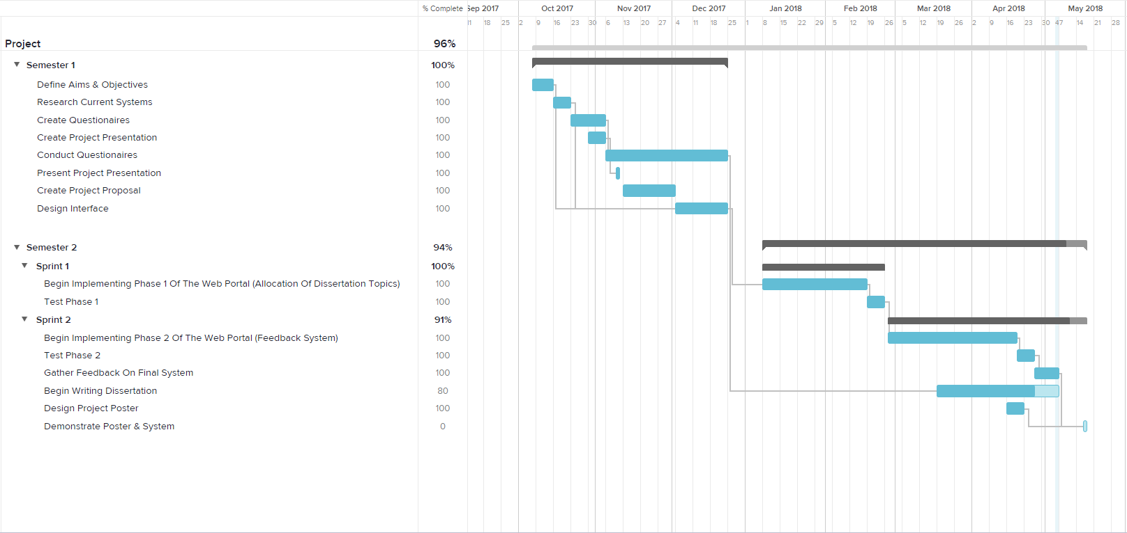

Figure 36 – Updated project plan

As such due to the setback with development I wouldn’t end up completing the platform until 18/04/2018, this didn’t help either that I ended up implementing features I didn’t initially intend on adding but decided to try providing a more complete platform, the biggest of which being the admin section.

As for the project plan I went by, I feel Agile was the right choice as this helped split up a task I had already underestimated into more manageable chunks that could be worked on independently & tested independently of each other. Had I gone for something like Waterfall I feel I might have had even more time consumed due to how difficult & daunting to manage everything would have been & get working together from the start.

## 6.4 What went well

The initial start of the project went very well with all our tasks being completed on time & even some being completed early such as the designs of the system. This really helped to get these initial research & design tasks done early as they provided much needed guidance in the more chaotic & daunting part of the project by providing a base to build up from. As such the design & research phase went quite well.

Another thing that went well was the final testing of the platform, although this was not without fault as we did not have sufficient time to gather user data from supervisors, testing was smooth & for the most part being without fault. Furthermore, student user feedback was quite high & generally preferred providing a much-needed sign that the system is fit for purpose.

## 6.5 What could have went better

Given the chance to redo the project I would definitely do a few things better next time. The main things being the development of the platform & the gathering of feedback.

In terms of development I feel I should have used my time more wisely during the early part of the project to learn more on PHP & AJAX as this was greatly slow me down later down the line as I had little experience with either & had to spend a great deal of time thinking of how to implement certain systems & learning how to use them instead of just implementing them. This would have certainly helped to have run more on schedule later during the project as I would have had to spend less time looking information up online such as guides to help me gain a better understanding of the technology I used.

Secondly, in terms of gathering feedback I should have dedicated more time to getting feedback from people so that we could have had a greater sample size & this being especially true for the user testing as the student sample size was only 8 & I didn’t have time to gather feedback from supervisors, this mostly being due to the previous issue described in which development ended up taking significantly longer than originally planned & so time was cut short on being able to gather feedback.

## 6.6 The future

In terms of the future of this platform I would have liked to implement certain features I think the system would benefit from & flesh out the already existing ones to make the user experience better & platform even better. In terms of features I would have liked to add a significant amount more to the admin section, as currently the section is rather basic, only display basic database information & allowing for the creation & editing of topic pages. Ideally, I would have wanted to implement a tier system of access for this admin section too so that not every staff member has complete access to everything & the platform could have offered limited access to certain staff such as certain supervisors being responsible for maintaining & editing a topic they are responsible for but not any of the other topics.

In terms of making the system more user friendly, I would have liked to add an AJAX search bar to the topic page so that users & supervisors could sort the topics, this would have especially been useful for supervisors as they could potentially expect to see over 100 topics since they can see them all. At the least to combat this it would have perhaps been sensible to just limit each supervisor to a subject just like students as most supervisors most likely only deal with one subject to begin with, so most computer scientist lecturers don’t really need to see topics subjects such as medicine or literature.

## 6.7 Conclusion

In conclusion the project ended up meeting our aim & objectives, providing an online platform for students & their supervisors & not only passing all our tests quite easily, but being met with positive feedback from students who undertook the project user feedback tests & being preferred over the current system. As such I feel I can be proud of the project as a whole & hope that such a platform could be of use in the future to better guide & develop easier & better systems for the dissertation process not just at Newcastle University but all universities everywhere. In the future, I have no doubt the platform could be expanded upon & further developed so that further improvements could be made to the features & design so that the platform might one day be implemented in a real-world environment.

# Chapter 7 Bibliography

# Bibliography

(n.d.). Retrieved from ePortfolio: https://portfolio.ncl.ac.uk/eportfolio/home/

(n.d.). Retrieved from NESS: https://ness.ncl.ac.uk/

*Cloud Hosting*. (n.d.). Retrieved from Krystal: https://krystal.co.uk/cloud-hosting

Gabry, O. E. (2017, March 17). *Software Engineering — Software Process & Software Process Models*. Retrieved from Medium: https://medium.com/omarelgabrys-blog/software-engineering-software-process-and-software-process-models-part-2-4a9d06213fdc

GHOSHAL, A. (2013, November 28). *Web application testing: How to get the most out of your sessions*. Retrieved from The Next Web: https://thenextweb.com/apps/2013/11/28/guide-testing-web-app-steps-approach-testing-get-sessions/

http://php.net/docs.php. (n.d.). Retrieved from PHP: http://php.net/docs.php

*Practical Guide to Cloud Computing.* (2017, December). Retrieved from http://www.cloud-council.org/deliverables/CSCC-Practical-Guide-to-Cloud-Computing.pdf

Raghu, V. (2015, September 8). *The Absolute Beginner’s Guide to User Testing*. Retrieved from Sitepoint: https://www.sitepoint.com/the-absolute-beginners-guide-to-user-testing/

Team, C. (2017, September 19). *Bootstrap vs Foundation: Who Has An Upper Hand?* Retrieved from TemplateToaster: https://blog.templatetoaster.com/bootstrap-vs-foundation/

*What is Cloud Hosting?* (n.d.). Retrieved from Interoute: https://www.interoute.com/what-cloud-hosting

# Chapter 8 Appendices

## Functionality testing results

|  |  |  |
| --- | --- | --- |
| Page | Number of tests conducted | Number of tests passed |
| Login page | 3 | 3/3 |
| Topics Page | 10 | 10/10 |
| Submit Page | 3 | 3/3 |
| Feedback Page | 3 | 3/3 |
| Home Page | 12 | 12/12 |
| Admin Dashboard | 3 | 3/3 |
| Admin - Users Page | 2 | 2/2 |
| Admin - Modules Page | 2 | 2/2 |
| Admin - Pages Page | 4 | 4/4 |
| Admin – Edit Page | 4 | 4/4 |
| Common tests | 3 | 3/3 |
| Navigation Bar | 6 | 6/6 |