**USERGUIDE for GOGC V1.0**

1. To install the application, run GOGC Installer_web.exe located in the folder. Ensure all required dependencies are installed during the setup process.

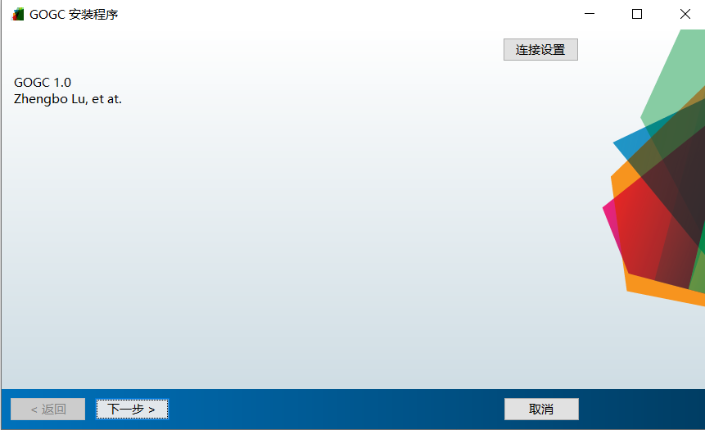

1. Open GOGC.exe

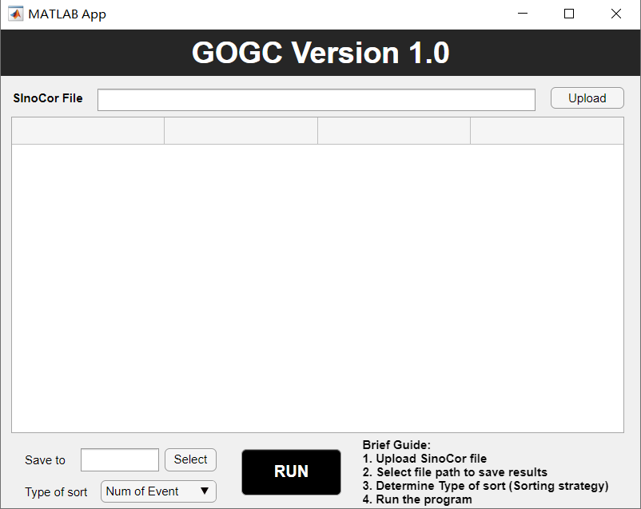

1. Upload SinoCor file

* Upload your SinoCor file in the format provided in the sample files.

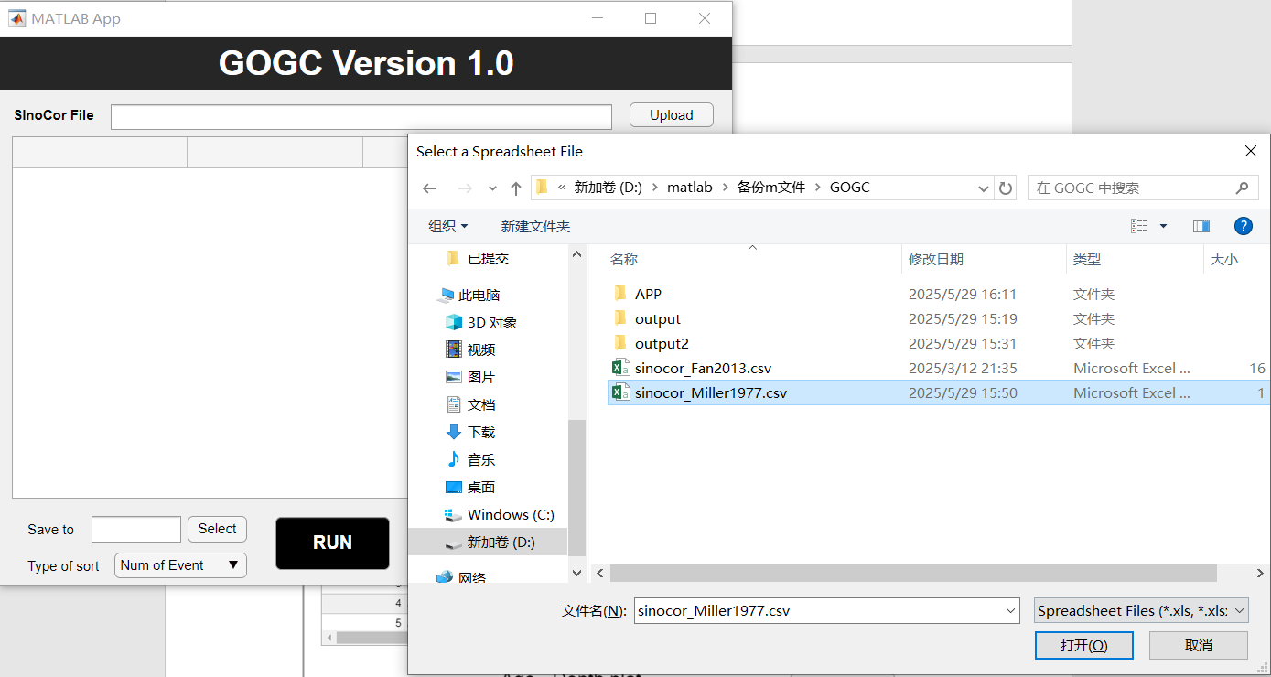

1. Select file path for outputs

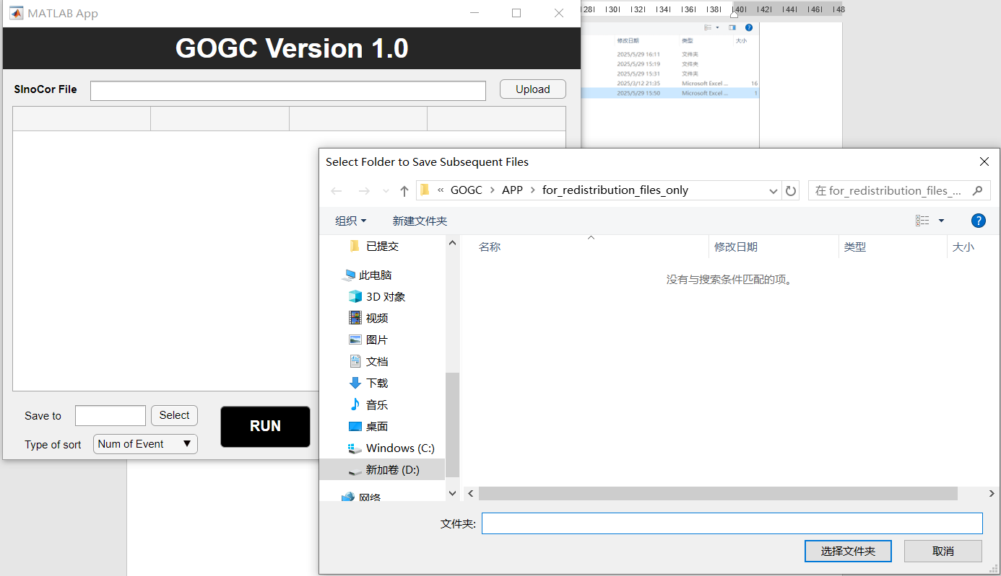

1. Determine the sorting strategy of sections

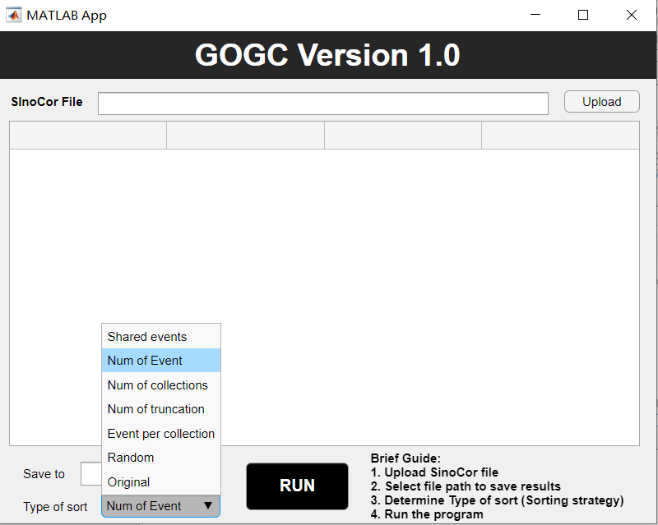

1. Run GOGC

* Press “Run” to start the program
* Outputs include:
  + Step CS in round *m* and step *n*
  + Graphic correlation plot in format of “.fig” and “.pdf”
  + Final “Composite Standard”