User Guide for STRATIGIRAFFIC

Quick Start
(You can follow the steps below while referring to the figures at the bottom of the page)
1) Install: run SGF_Installer_web.exe (see the left figure below for the installer interface). Follow the on-screen instructions to install SGF. Don’t forget to create a desktop shortcut for quick and convenient access.
If Windows blocks the installer, choose More info → Run anyway (or the equivalent option) to proceed.
2) Launch: Open the created shortcut for STRATIGIRAFFIC.exe on the desktop (see the right figure below for the main interface).
3) Upload Local Stratigraphic Sequence table (LSS): click ‘Upload’ button and select your Local Stratigraphic Sequence file (Use ‘LSS-demo.csv’ provided in the demo folder ‘SGF 20260109 with demo’ or you own table in the same format as ‘LSS-demo.csv’).
4) Upload Age Constraints table (AC): click ‘Upload’ button and select your Age Constraints table (Use ‘AC-demo.xlsx’ provided in the demo folder ‘SGF 20260109 with demo’ or you own table in the same format as ‘AC-demo.xlsx’).
5) Select a path that you ‘Save age model to’.
6) Click ‘Draw LOC’ button: the age–depth plot will be generated and the calibration table will be exported/updated automatically.
If this is your first run, a parallel acceleration service may start automatically; it speeds up subsequent runs but may take a few minutes.
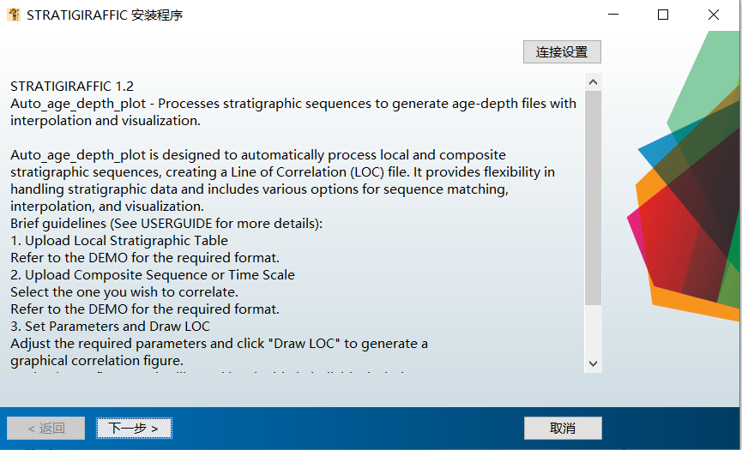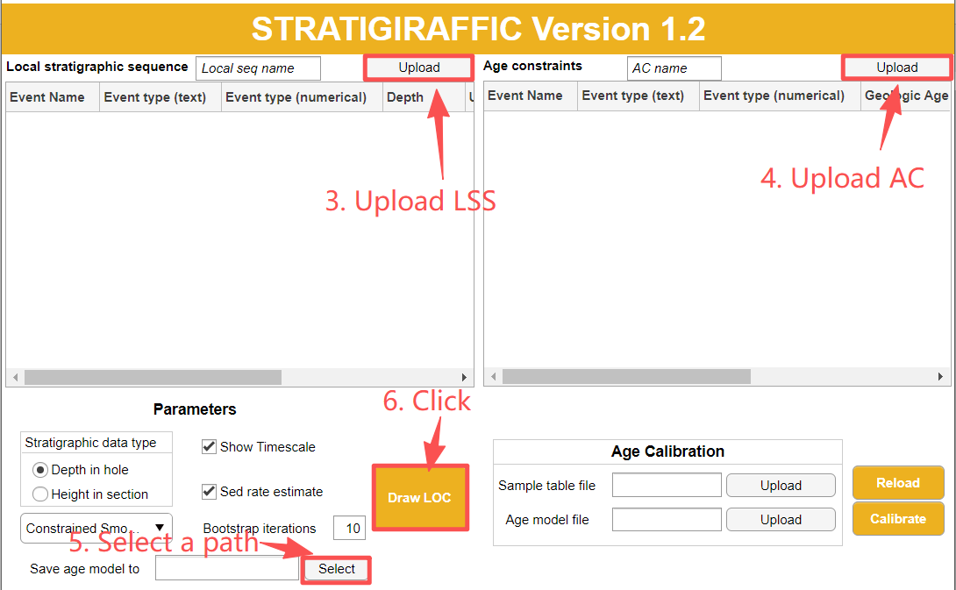
2. Launch to this interface
- Install SGF

—

Function 1: Construct an Age Model with SGF

Install the application
Run SGF_Installer_web.exe from this folder.
If Windows displays a security prompt (e.g., “Unknown publisher”), choose Run anyway / More info → Run anyway, and avoid interrupting the installation.
Make sure all required dependencies are installed when prompted.

Launch the app
Open STRATIGIRAFFIC.exe.
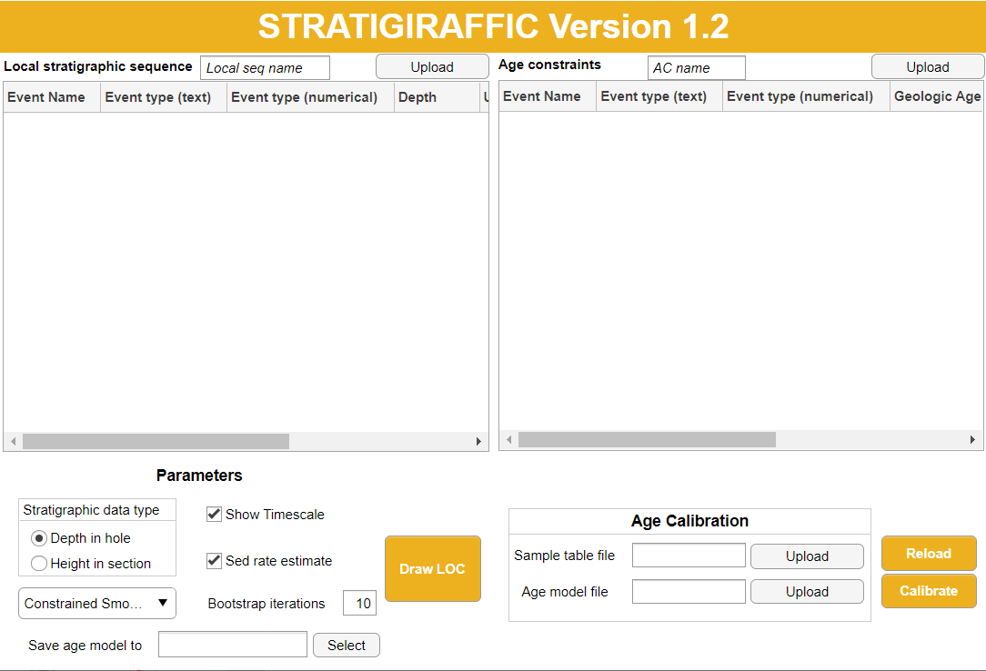
Upload a Local Stratigraphic Sequence (LSS)
Upload your local stratigraphic sequence using the same format as the example file LSS-demo.csv.
The LSS table contains seven columns describing stratigraphic horizons (depth/height attributes):
• Event Name: Name of the datum (e.g., T. Globigerinatheka index). Use the same name in the Age Constraints table (AC) for the same horizon.
• Event type (text): A descriptive label (e.g., PF = Planktonic Foraminifera). This is for display/legend purposes and can be customized.
• Event type (numerical): Numeric code describing the horizon type. Use the same code in the AC table for the same horizon. See table below for codes.
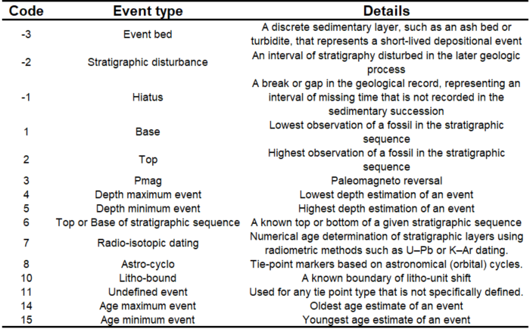
• Depth: Depth (or height) of the horizon in the local sequence.
• Uncertainty_neg: Downward (negative) depth uncertainty.
• Uncertainty_pos: Upward (positive) depth uncertainty.
• Score: Confidence/weight of the depth placement (typically 0–10; higher = more reliable). Use -1 to indicate infinite.
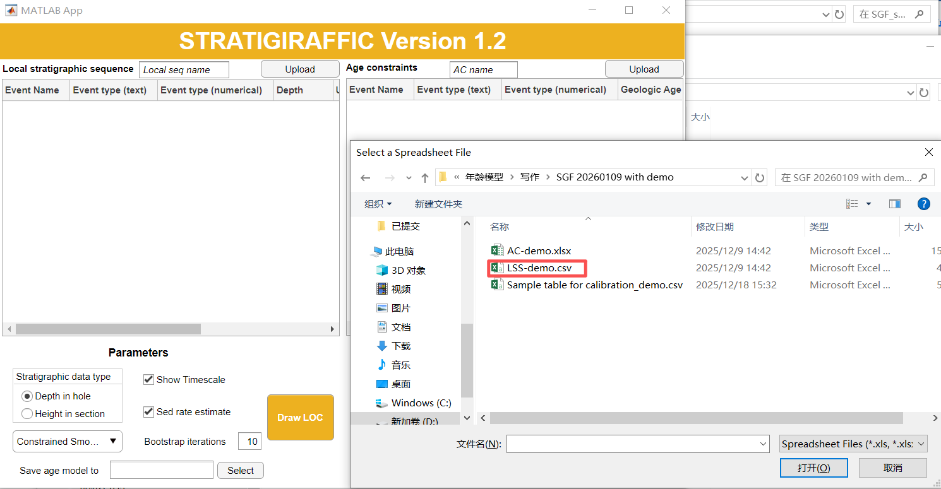
Upload an Age Constraints table (AC)
Upload the age-constraint table you want to correlate with, using the same format as the example file AC-demo.xlsx.
The AC table contains seven columns describing age attributes of stratigraphic tie points:
• Event Name: Tie-point name. Must match the corresponding horizon name in the LSS table.
• Event type (text): Descriptive label (e.g., PF).
• Event_Code: Numeric horizon-type code. Must match the corresponding code in the LSS table.
• Geologic Age: Calibrated age of the horizon/tie point.
• Uncertainty_neg: Negative (older) age uncertainty.
• Uncertainty_pos: Positive (younger) age uncertainty.
• Score: Confidence/weight of the age calibration (typically 0–10; higher = more reliable). Use -1 to indicate infinite.
Important: for the same stratigraphic horizon, ensure the Event Name and Event type (numerical) are identical between the LSS and AC tables.
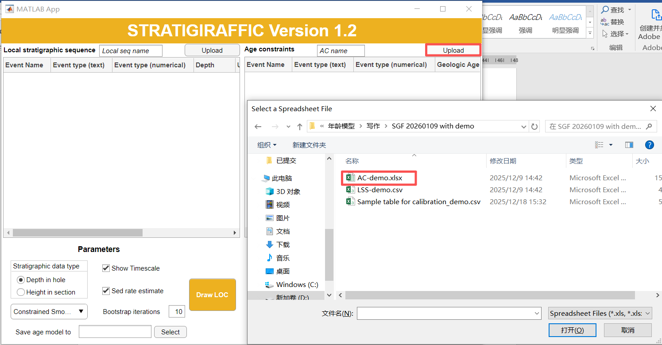
Set parameters
Select the stratigraphic type of the local sequence: Core or Section (outcrop) (this controls the plot layout).
Choose the fitting method from the dropdown menu. Constrained Smoothing Spline – GCV is recommended in most cases.
Set Bootstrap Iterations to estimate uncertainty in calibrated ages (propagating uncertainties from both tables).
• For robust uncertainty estimates, ≥200 iterations is recommended.
• For a quick preview, start with a small number (e.g., 10) to check that inputs and settings behave as expected.
Tick Show Timescale to add timescale boxes (epoch/stage) and polarity reversals (Cenozoic paleomagnetism currently supported).
Tick Sed rate estimate to display a sedimentation-rate subplot.
Choose an Output path to save the age-model file. This file stores inputs, fitted functions, and outputs, and can be reloaded or shared.
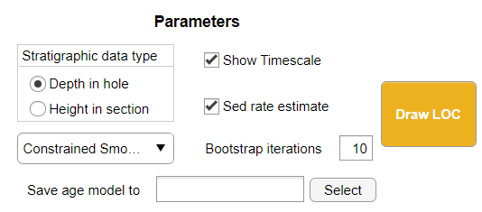
Draw the age–depth plot and run age calibration
Click Draw LOC to generate the age–depth plot.
On the first run, a parallel acceleration service may start automatically. This may take a few minutes the first time, but will significantly speed up subsequent calculations. You do not need to start it manually during routine use; it may shut down automatically after a long idle period.
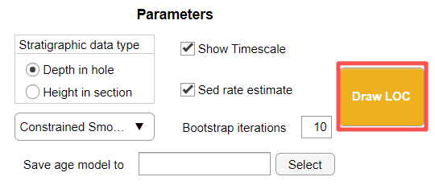
Outputs
Age–depth model figure: displayed in a separate interactive figure window. You can pan/zoom, drag items, and click data points to view details.
Age calibration table: generated automatically using the fitted age–depth relationship to interpolate ages for events in the LSS.
• Calibrated ages are appended as one or more new columns (depending on how many age–depth plots are produced).
• The on LOC column indicates whether an event lies on the LOC (1 = yes, 0 = no).
• The calibration method is documented in Note_LOC.
• If Bootstrap Iterations > 0, additional columns are appended with uncertainty summaries (e.g., 95% and 99% confidence intervals and the median of the bootstrap distribution).
You can export outputs by saving/copying from the figure and table windows in your preferred formats.
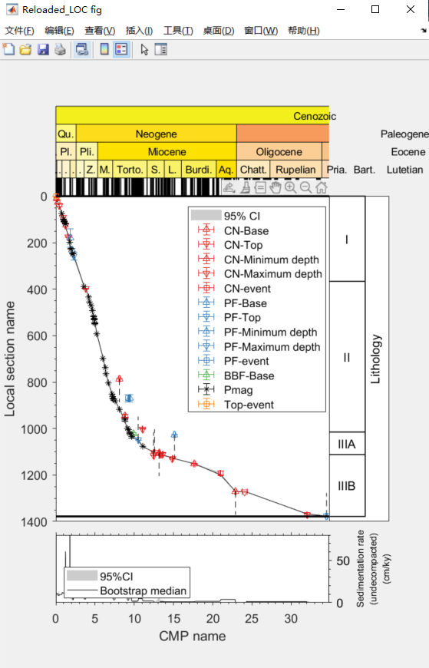
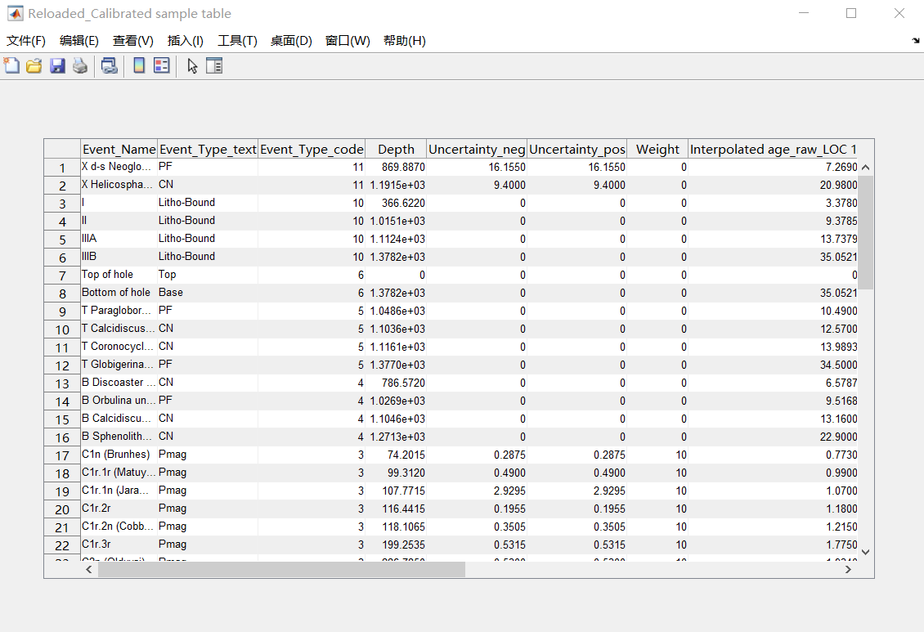

Function 2: Reload and Reuse an Existing Age Model

Reload an existing age model
Upload an age-model file generated by STRATIGIRAFFIC (or shared by another user).
The app will reload the age–depth model figure and the associated calibrated table.
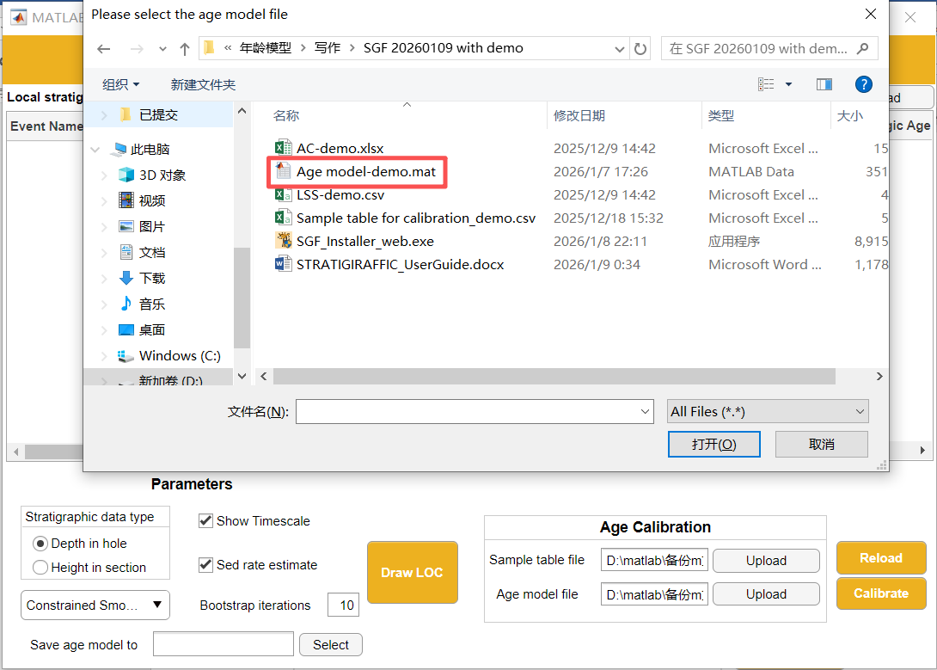
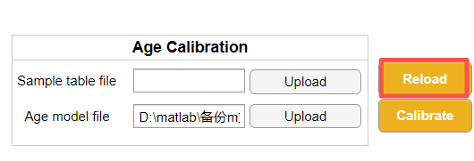

Calibrate a sample table using an existing age model
Upload demo sample table ‘Sample table for calibration_demo.xlsx’ or your Sample table in the same structure. The table may have any structure, provided that:
• Each row represents a sample from the same stratigraphic sequence, and
• There is a column named Depth containing depth/height for each sample.
Run calibration using the loaded age model. Three new columns will be appended:
• Age (mid)
• Upper 95% CI
• Lower 95% CI

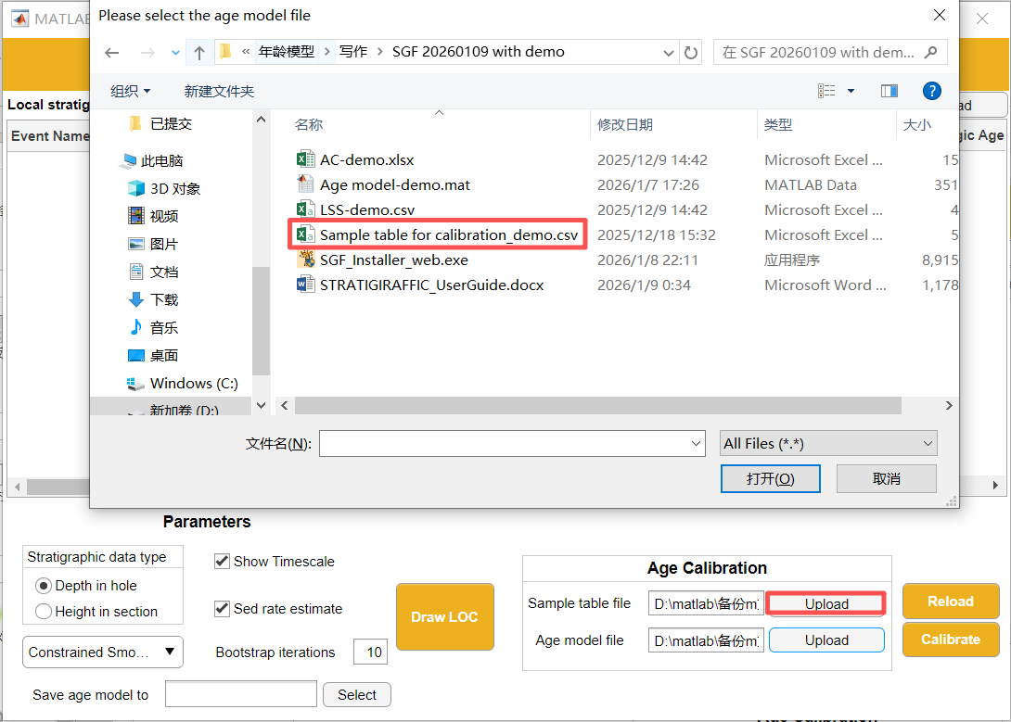
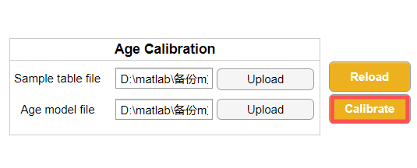

Citation

Lu, Z.B., Pearson, P.N., Fan, J.X., et al. STRATIGIRAFFIC: A software tool for age–depth model development and application, with an application to ODP Site 1052 (in prep.).

Contact

For questions or suggestions, please contact:
• Zhengbo Lu: zb_lu@foxmail.com
• Paul Pearson: p.pearson@ucl.ac.uk

