Confusion Matrix:
A confusion matrix is a summary of prediction results on a classification problem.
The number of correct and incorrect predictions are summarized with count values and broken down by each class. This is the key to the confusion matrix.
The confusion matrix shows the ways in which your classification model is confused when it makes predictions.
It gives us insight not only into the errors being made by a classifier but more importantly the types of errors that are being made.

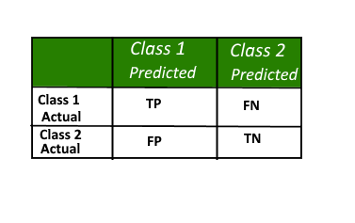
Here,
• Class 1 : Positive
• Class 2 : Negative
Definition of the Terms:
• Positive (P) : Observation is positive (for example: is an apple).
• Negative (N) : Observation is not positive (for example: is not an apple).
• True Positive (TP) : Observation is positive, and is predicted to be positive.
• False Negative (FN) : Observation is positive, but is predicted negative.
• True Negative (TN) : Observation is negative, and is predicted to be negative.
• False Positive (FP) : Observation is negative, but is predicted positive.
Classification Rate/Accuracy:
Classification Rate or Accuracy is given by the relation:
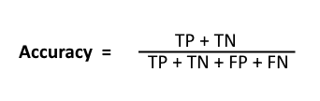
However, there are problems with accuracy. It assumes equal costs for both kinds of errors. A 99% accuracy can be excellent, good, mediocre, poor or terrible depending upon the problem.
Recall:
Recall can be defined as the ratio of the total number of correctly classified positive examples divide to the total number of positive examples. High Recall indicates the class is correctly recognized (small number of FN).
Recall is given by the relation:
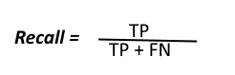
Precision:
To get the value of precision we divide the total number of correctly classified positive examples by the total number of predicted positive examples. High Precision indicates an example labeled as positive is indeed positive (small number of FP).
Precision is given by the relation:
