EXPT NO: 06                                                                            ROLL NO: 220701209

             LINUX PRIVELEGE ESCALATION

## AIM:

This experiment aims to explore Linux privilege escalation techniques including kernel exploits, misconfigured sudo privileges, and SUID binary exploitation. It provides hands-on experience in identifying and exploiting real-world vulnerabilities to escalate privileges on Linux systems for better understanding of secure configurations and attacker methodologies.

## PROCEDURE:

1. Enumerate Linux kernel version and search for CVEs.

2. Transfer and compile kernel exploits on target machines.

3. Use `sudo -l` to check misconfigured binaries and escalate via GTFOBins.

4. Exploit vulnerable SUID binaries to read sensitive files or spawn root shells.

5. Dump password hashes using unshadow and crack using John the Ripper.

6. Bypass protections using LD_PRELOAD or service misconfiguration

## TASK 1 – INTRODUCTION

## Introduced the fundamentals of privilege escalation in Linux systems.

## Highlighted the significance of escalating from a low-privilege user to root.

## Emphasized enumeration as a critical first step using commands like uname -a, id, and sudo -l.

## Outlined common escalation vectors such as kernel exploits, misconfigured binaries, and SUID bits.

## Reinforced the goal of identifying misconfigurations that could allow unauthorized access or privilege abuse.

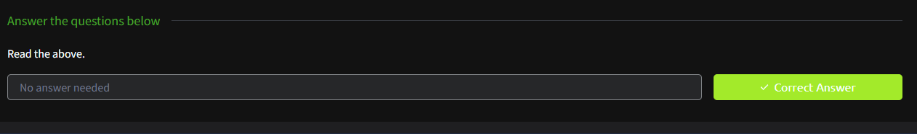**TASK 2 – ENUMERATION**

## Used system commands (hostname, uname -a, id, env, ps, ls -la, ifconfig) to gather system-level information.

## Listed current user’s permissions, environment variables, and active processes.

## Inspected the /etc/passwd file and running services for hints on misconfigurations.

## Checked for installed software and outdated packages that could be exploited.

## Picture 3Identified enumeration as an essential precondition before attempting privilege escalation.

## TASK 3 – KERNEL EXPLOITS

## Identified kernel version using uname -a and determined it was vulnerable.

## Researched public CVEs and found a suitable kernel exploit (CVE-2015-1328).

## Downloaded the exploit source code from Exploit-DB (37292.c).

## Transferred the exploit to the target machine using wget via a Python HTTP server.

## Compiled the exploit with gcc and executed it to escalate privileges.

## Successfully gained root access and retrieved the first flag (flag1.txt).

## Picture 4Demonstrated how kernel vulnerabilities can directly lead to root access in CTF/lab scenarios.

## TASK 4 – SUDO MISCONFIGURATION

## Used sudo -l to enumerate commands the user karen could run as root.

## Identified find and nmap as exploitable binaries using GTFOBins.

## Spawned a root shell using sudo find . -exec /bin/sh \; -quit.

## Gained root privileges again via interactive mode in nmap: !sh.

## Accessed and read /etc/shadow file and extracted password hashes.

## Verified access by opening the flag2.txt located in a privileged user’s home directory.

## Showed how improper sudo access to certain binaries can lead to full privilege escalation.

## TASK 5 – KERNEL EXPLOITS

- Identified kernel version using `uname -a` and searched CVE.

- Found exploit CVE-2015-1328 and downloaded code from Exploit-DB.

- Transferred code to `/tmp` via Python SimpleHTTPServer and `wget`.

- Compiled using `gcc 37292.c -o kernelexploit` and executed.

- Successfully escalated to root and accessed `flag1.txt`.

- Emphasized stability risks with kernel exploits in real-world environments.

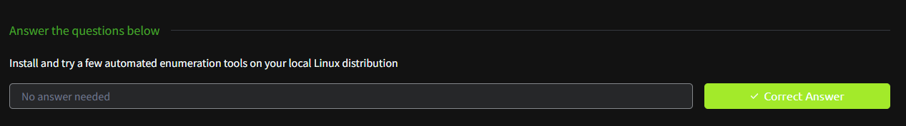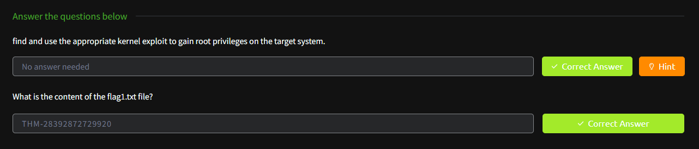

## TASK 6 – SUDO MISCONFIGURATION

- Used `sudo -l` to list programs executable by user `karen`.

- Used GTFOBins to find escalation path via `find` and `nmap`.

- Spawned root shell with: `sudo find . -exec /bin/sh \; -quit`

- Used `nmap` in interactive mode to get shell: `nmap --interactive`.

- Accessed `/etc/shadow` and extracted hash for user frank.

- Confirmed root access by reading `flag2.txt` in privileged user's directory.



## TASK 7 – SUID BINARY ABUSE

- Listed all SUID binaries: `find / -type f -perm -04000 -ls 2>/dev/null`

- Identified base64 with SUID bit and used GTFOBins for file read.

- Read `/etc/shadow` via SUID-enabled base64 decoding method.

- Combined `/etc/passwd` and `/etc/shadow` using `unshadow`.

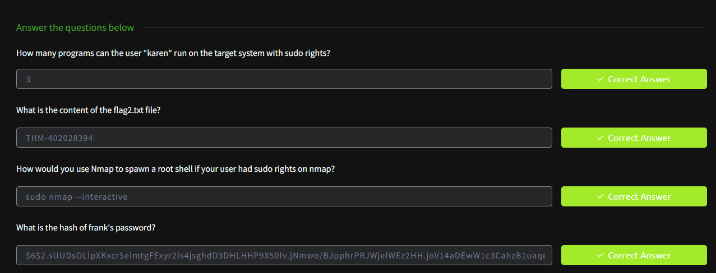- Cracked hashes using John the Ripper and rockyou.txt wordlist.

- Accessed `flag3.txt` using base64 decode method from GTFOBins.

TASK 8 – SUDOERS MISCONFIGURATION

- Analyzed `/etc/sudoers` file and identified misconfigured entries.

- Found user allowed to run specific commands as root without a password.

- Exploited command such as `/usr/bin/less` or `/bin/bash` via sudo.

- Gained a root shell and validated access by checking `/root/` directory.

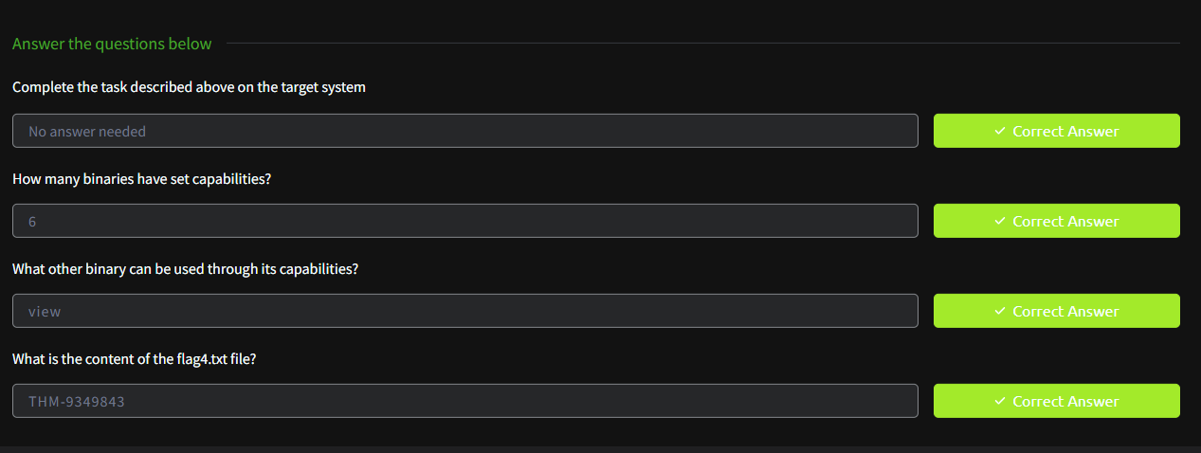- Reinforced that sudoers should be tightly restricted and regularly audited.

TASK 9 – ENVIRONMENTAL VARIABLE ABUSE

- Identified vulnerable scripts or binaries relying on insecure $PATH.

- Created a fake executable with same name as trusted binary and placed it earlier in $PATH.

- Triggered privilege escalation when root ran the vulnerable script.

- Showed how PATH hijacking can escalate privileges due to lazy script writing.

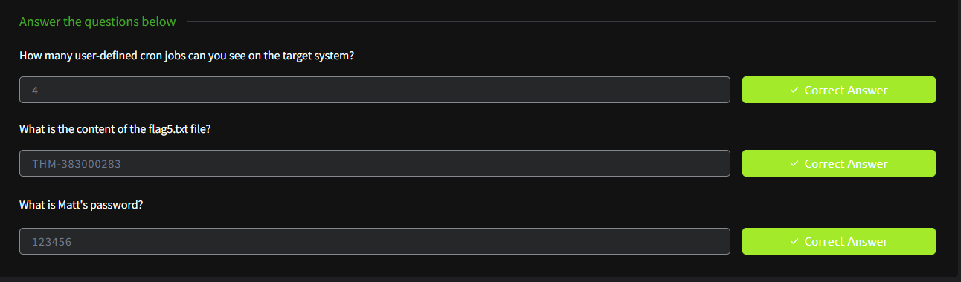- Stressed best practices for securing scripts with full path references.

TASK 10 – BACKUP MISCONFIGURATION

- Discovered world-writable backup directories with sensitive data.

- Analyzed and modified backups to insert payloads.

- Restored the manipulated backup or exploited symlink attacks to gain code execution.

- Confirmed elevated access and retrieved associated flags.

- Revealed real-world missteps in backup script design and access control.

- Stressed best practices for securing scripts with full path references.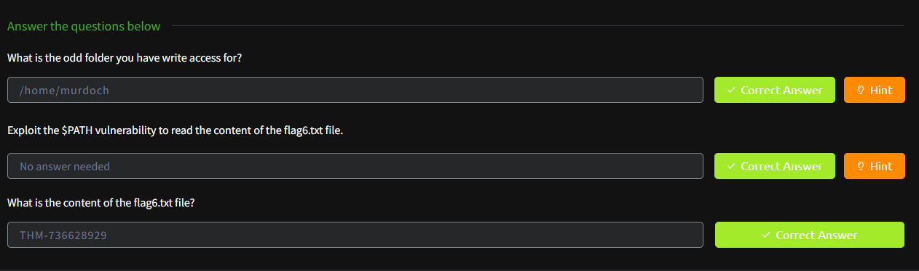

TASK 11 – SERVICE MISCONFIGURATION

- Found custom services with writeable binary paths or configs.

- Modified service binary or configuration file to execute reverse shell.

- Restarted service and gained root access.

- Validated exploitation via service misconfiguration and confirmed with a root flag.

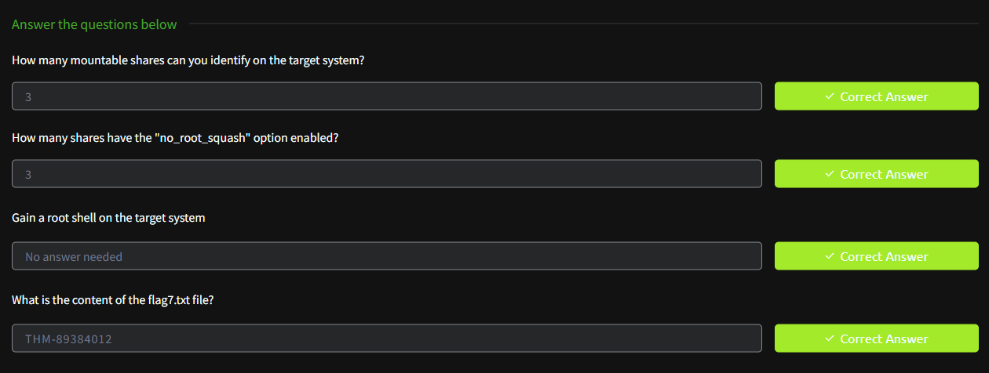- Outlined how improper service permissions are common real-world attack vectors.

TASK 12 – CRON JOB EXPLOITATION

- Listed scheduled cron jobs using `crontab -l` and inspected global cron directories.

- Identified scripts run by root with insecure write permissions.

- Injected payloads or replaced the original cron script.

- Waited for cron job execution and confirmed root shell access.

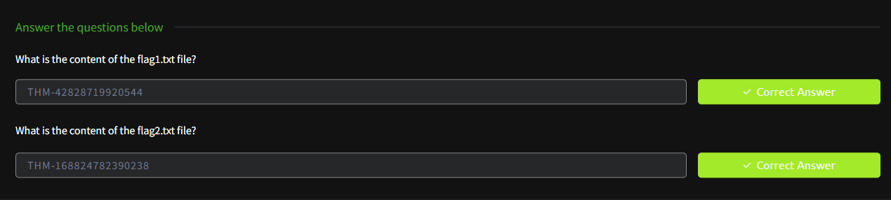- Captured final flag and validated escalation path.

## RESULT:

Successfully escalated privileges through multiple Linux techniques and retrieved all required flags. Demonstrated understanding of local privilege escalation through hands-on exploitation and tool usage on simulated targets.