**Date Submitted: 12/13/2019**

Youtube Link:

<https://youtu.be/VdnXhGqwCvo>

Board Implementation:

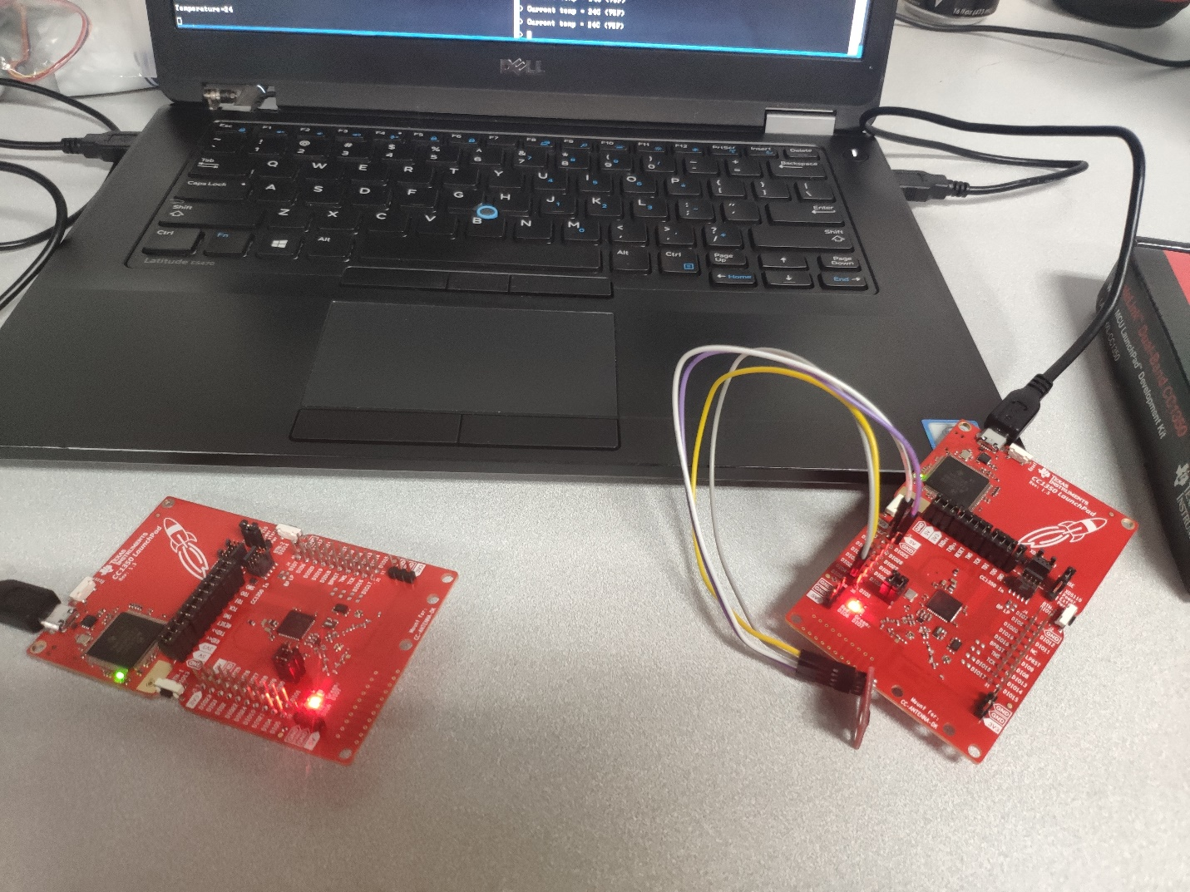

Screenshot of Terminals:

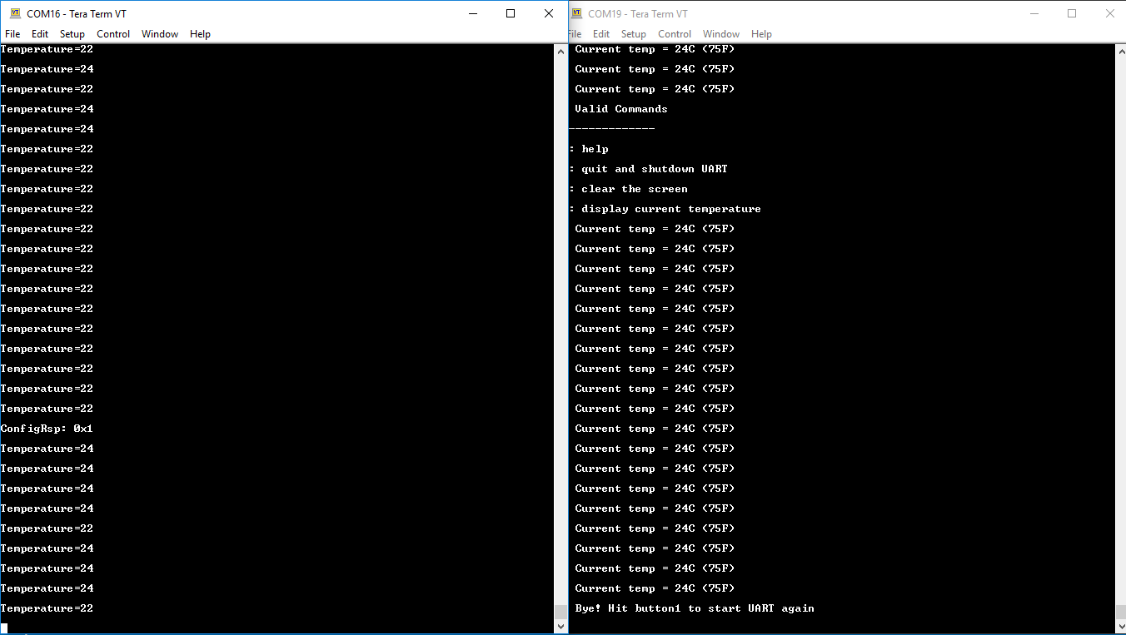

Collector Sender