TITLE:

Midterm by Ron Joshua Recrio

GOAL:

* Understand I2C protocol
* Interact with the MPU-6050
* Filter the values using IQMath

DELIVERABLES:

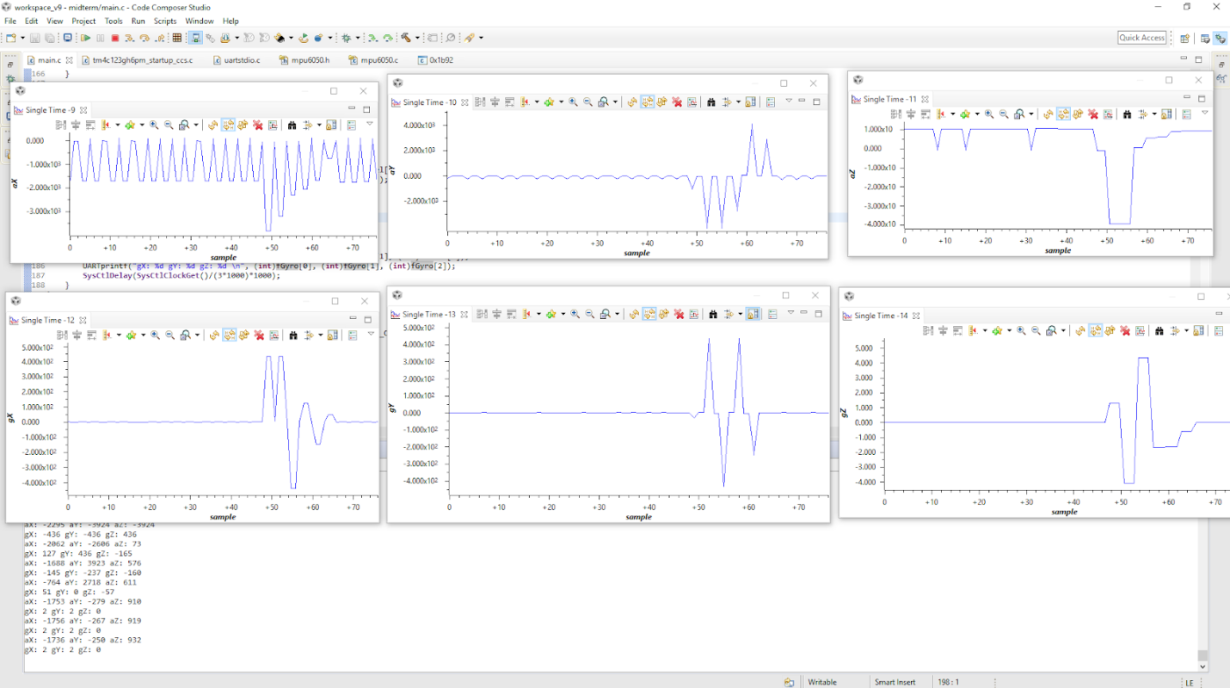 The intended project deliverables were to use the MPU-6050 to firstly show the raw values. Then using those values, implement a filter that uses IQMath in order to have faster efficiency in terms of calculation cycles. Using any tool, graph said values. All parts of this project were completed.

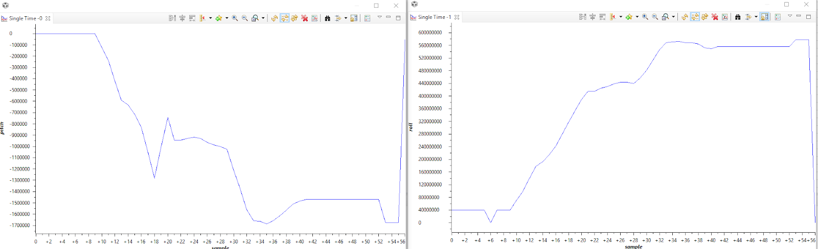 Screenshots of the Graphs:

COMPONENTS:

There were only two components: the Tiva-C, and the MPU-6050. The MPU-6050 is an Inertial Measurement Unit (IMU) that has six degrees of freedom which are up/down, back/forth, right/left, pitch, roll, and yaw. The limitation of this device is that it can only be accurate up to ±16g for it's accelerometer and 2000°/s for the gyroscope. The interface that it uses is I2C which uses Serial Data (SDA) and Serial Clock (SCL) to communicate between a master (Tiva-C) and a slave (MPU-6050). The registers used in the component were 67-72 for the gyroscope's values, and 59-65 for the accelerometer's values. A lot of other registers were used such as 107 for device resetting and other configuration registers, but the sensorlib handles those for us. The I2C is initialized to create a link between the Tiva-C and the IMU, and the UART is configured to send the data to the computer.

SCHEMATICS:

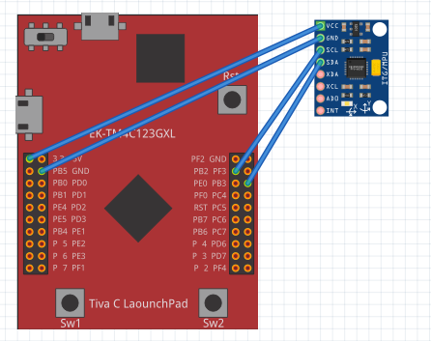

IMPLEMENTATION:

The first thing implemented were the libraries and configuring the search paths for them. The most important ones are driverlib, sensorlib, and IQMath libraries. Going through main we have 3 subroutines: ConfigureUart(), I2C0_Init(), and MPU6050().

Configuring UART is straightforward. It configures two pins to be dedicated UART communication pins and also configures the UART settings using uartstdio funtions.

I2C0_Init() is also straightforward. The subroutine enables I2C0 and configures PB2 as SCL, and PB3 as SDA.

MPU6050() is the main part of the program. This contains setting up the MPU6050 as well as the continous loop to gather data and output the values using UART. The first step is to call on another subroutine MPU6050Init() which initializes the MPU6050 in order for it to properly communicate with the TivaC. Once the initialization is complete, the next step is to configure the settings of the MPU6050. Using MPU6050ReadModifyWrite(), it is possible to rewrite the configuration of the IMU. After modifying the MPU6050, the next part is the infinite loop to gather data. In order to gather data, the MPU6050DataRead() function is used. Once sent, it is possible to use MPU6050DataAccelGetFloat() and MPU6050DataGyroGetFloat() to obtain the raw values. After obtaining the raw values, UARTprintf() is used to output the data to terminal using serial communication. The continued version of this code also uses the Complementary Filter function. This function strictly uses IQMath types and functions to filter the raw values, and provide the pitch and the roll. These values are also outputted to terminal using UARTprintf(). This process loops indefinitely.

CODE:

Task 1-2:

**#include** <stdarg.h>

**#include** <stdbool.h>

**#include** <stdint.h>

**#include** <stdlib.h>

**#include** "inc/tm4c123gh6pm.h"

**#include** "inc/hw_i2c.h"

**#include** "inc/hw_memmap.h"

**#include** "inc/hw_types.h"

**#include** "inc/hw_gpio.h"

**#include** "driverlib/i2c.h"

**#include** "driverlib/sysctl.h"

**#include** "driverlib/gpio.h"

**#include** "driverlib/pin_map.h"

**#include** "driverlib/uart.h"

**#include** "driverlib/interrupt.h"

**#include** "driverlib/hibernate.h"

**#include** "sensorlib/i2cm_drv.h"

**#include** "sensorlib/hw_mpu6050.h"

**#include** "sensorlib/mpu6050.h"

**#include** "uartstdio.h"

// Given, but not used

**#define** ACCEL_SLAVE_ADDR 0x1D

**#define** XOUT8 0x06

**#define** YOUT8 0x07

**#define** ZOUT8 0x08

**volatile** bool g_bMPU6050Done; // used for checking if MPU is idle

tI2CMInstance sI2CInst; // I2C Master instance

// Given

**void** **ConfigureUART**(**void**)

{

SysCtlPeripheralEnable(SYSCTL_PERIPH_GPIOA); // enable PORTA as peripheral

SysCtlPeripheralEnable(SYSCTL_PERIPH_UART0); // enable UART0

GPIOPinConfigure(GPIO_PA0_U0RX); // Configure PA0 as RX for UART0

GPIOPinConfigure(GPIO_PA1_U0TX); // Configure PA1 as TX for UART0

GPIOPinTypeUART(GPIO_PORTA_BASE, GPIO_PIN_0 | GPIO_PIN_1); // Set Pin type to UART

UARTClockSourceSet(UART0_BASE, UART_CLOCK_PIOSC); // Set Clock Source as internal oscillator

UARTStdioConfig(0, 115200, 16000000); // Configure UART to send at 115200

}

// Given

**void** **I2C0_Init** ()

//Configure/initialize the I2C0

{

SysCtlPeripheralEnable (SYSCTL_PERIPH_I2C0); //enables I2C0

SysCtlPeripheralEnable (SYSCTL_PERIPH_GPIOB); //enable PORTB as peripheral

GPIOPinTypeI2C (GPIO_PORTB_BASE, GPIO_PIN_3); //set I2C PB3 as SDA

GPIOPinConfigure (GPIO_PB3_I2C0SDA);

GPIOPinTypeI2CSCL (GPIO_PORTB_BASE, GPIO_PIN_2); //set I2C PB2 as SCLK

GPIOPinConfigure (GPIO_PB2_I2C0SCL);

I2CMasterInitExpClk (I2C0_BASE, SysCtlClockGet(), true); //Set the clock of the I2C to ensure proper connection

HWREG(I2C0_BASE + I2C_O_FIFOCTL) = 80008000;

I2CMInit(&sI2CInst, I2C0_BASE, INT_I2C0, 0xff, 0xff, SysCtlClockGet()); // Initialize I2C Master

}

//Given, but not used

**void** **I2C0_Write** (uint8_t addr, uint8_t N, ...)

//Writes data from master to slave

//Takes the address of the device, the number of arguments, and a variable amount of register addresses to write to

{

I2CMasterSlaveAddrSet (I2C0_BASE, addr, false); //Find the device based on the address given

**while** (I2CMasterBusy (I2C0_BASE));

va_list vargs; //variable list to hold the register addresses passed

va_start (vargs, N); //initialize the variable list with the number of arguments

I2CMasterDataPut (I2C0_BASE, va_arg(vargs, uint8_t)); //put the first argument in the list in to the I2C bus

**while** (I2CMasterBusy (I2C0_BASE));

**if** (N == 1) //if only 1 argument is passed, send that register command then stop

{

I2CMasterControl (I2C0_BASE, I2C_MASTER_CMD_SINGLE_SEND);

**while** (I2CMasterBusy (I2C0_BASE));

va_end (vargs);

}

**else**

//if more than 1, loop through all the commands until they are all sent

{

I2CMasterControl (I2C0_BASE, I2C_MASTER_CMD_BURST_SEND_START);

**while** (I2CMasterBusy (I2C0_BASE));

uint8_t i;

**for** (i = 1; i < N - 1; i++)

{

I2CMasterDataPut (I2C0_BASE, va_arg(vargs, uint8_t)); //send the next register address to the bus

**while** (I2CMasterBusy (I2C0_BASE));

I2CMasterControl (I2C0_BASE, I2C_MASTER_CMD_BURST_SEND_CONT); //burst send, keeps receiving until the stop signal is received

**while** (I2CMasterBusy (I2C0_BASE));

}

I2CMasterDataPut (I2C0_BASE, va_arg(vargs, uint8_t)); //puts the last argument on the SDA bus

**while** (I2CMasterBusy (I2C0_BASE));

I2CMasterControl (I2C0_BASE, I2C_MASTER_CMD_BURST_SEND_FINISH); //send the finish signal to stop transmission

**while** (I2CMasterBusy (I2C0_BASE));

va_end (vargs);

}

}

//Given, but not used

uint32_t **I2C0_Read** (uint8_t addr, uint8_t reg)

//Read data from slave to master

//Takes in the address of the device and the register to read from

{

I2CMasterSlaveAddrSet (I2C0_BASE, addr, false); //find the device based on the address given

**while** (I2CMasterBusy (I2C0_BASE));

I2CMasterDataPut (I2C0_BASE, reg); //send the register to be read on to the I2C bus

**while** (I2CMasterBusy (I2C0_BASE));

I2CMasterControl (I2C0_BASE, I2C_MASTER_CMD_SINGLE_SEND); //send the send signal to send the register value

**while** (I2CMasterBusy (I2C0_BASE));

I2CMasterSlaveAddrSet (I2C0_BASE, addr, true); //set the master to read from the device

**while** (I2CMasterBusy (I2C0_BASE));

I2CMasterControl (I2C0_BASE, I2C_MASTER_CMD_SINGLE_RECEIVE); //send the receive signal to the device

**while** (I2CMasterBusy (I2C0_BASE));

**return** I2CMasterDataGet (I2C0_BASE); //return the data read from the bus

}

// Interrupt handler for I2C

**void** **I2CIntHandler**(**void**)

{

I2CMIntHandler(&sI2CInst);

}

// Callback function used for checking the success status of the MPU6050

**void** **MPU6050Callback**(**void** *pvCallbackData, uint_fast8_t ui8Status)

{

**if** (ui8Status != I2CM_STATUS_SUCCESS)

{

// used for debugging

}

g_bMPU6050Done = true; // set done to true after a successful MPU_6050 command

}

// Given, but modified

**void** **MPU6050** (**void**)

{

**float** fAccel[3], fGyro[3]; // variables used to hold the current values of the MPU

tMPU6050 sMPU6050; // initialize an MPU6050

g_bMPU6050Done = false; // always set to false before an MPU6050 command to check if it changes after.

MPU6050Init(&sMPU6050, &sI2CInst, 0x68, MPU6050Callback, &sMPU6050); // initialize MPU6050

**while**(!g_bMPU6050Done) // always wait for the MPU6050 to be done after each command.

{

}

g_bMPU6050Done = false;

// Change the accelerometer config as +/- 4G

MPU6050ReadModifyWrite(&sMPU6050, MPU6050_O_ACCEL_CONFIG, ~MPU6050_ACCEL_CONFIG_AFS_SEL_M, MPU6050_ACCEL_CONFIG_AFS_SEL_4G, MPU6050Callback, &sMPU6050);

**while**(!g_bMPU6050Done)

{

}

g_bMPU6050Done = false;

// Reset the device after changing the configuration

MPU6050ReadModifyWrite(&sMPU6050, MPU6050_O_PWR_MGMT_1, 0x00, 0b00000010 & MPU6050_PWR_MGMT_1_DEVICE_RESET, MPU6050Callback, &sMPU6050);

**while** (!g_bMPU6050Done)

{

}

g_bMPU6050Done = false;

MPU6050ReadModifyWrite(&sMPU6050, MPU6050_O_PWR_MGMT_2, 0x00, 0x00, MPU6050Callback, &sMPU6050);

**while** (!g_bMPU6050Done)

{

}

// Loop gathering values and sending them out

**while**(1)

{

**int** i;

g_bMPU6050Done = false;

MPU6050DataRead(&sMPU6050, MPU6050Callback, &sMPU6050); // send a read command to the MPU6050

**while**(!g_bMPU6050Done)

{

}

// Get both Accelerometer and Gyroscope values as floats.

MPU6050DataAccelGetFloat(&sMPU6050, &fAccel[0], &fAccel[1], &fAccel[2]);

MPU6050DataGyroGetFloat(&sMPU6050, &fGyro[0], &fGyro[1], &fGyro[2]);

// Since UART cannot send float values, I multiply them by 100 and pass them as integers.

**for** (i = 0; i < 3; i++)

{

fAccel[i] *= 100;

fGyro[i] *= 100;

}

UARTprintf("aX: %d aY: %d aZ: %d \n", (**int**)fAccel[0], (**int**)fAccel[1], (**int**)fAccel[2]);

UARTprintf("gX: %d gY: %d gZ: %d \n\n", (**int**)fGyro[0], (**int**)fGyro[1], (**int**)fGyro[2]);

// Delay of ~1 second.

SysCtlDelay(SysCtlClockGet()/(3*1000)*1000);

}

}

**void** **main** (**void**)

{

SysCtlClockSet(SYSCTL_SYSDIV_5|SYSCTL_USE_PLL|SYSCTL_XTAL_16MHZ|SYSCTL_OSC_MAIN); // set the clock

ConfigureUART(); // configure the UART of Tiva C

I2C0_Init(); // initialize the I2C0 of Tiva C

MPU6050(); // MPU6050 main function to set up and gather values.

// should never be reached

**while** (1)

{};

}

Task 3-4:

**#include** <stdarg.h>

**#include** <stdbool.h>

**#include** <stdint.h>

**#include** <stdlib.h>

**#include** "inc/tm4c123gh6pm.h"

**#include** "inc/hw_i2c.h"

**#include** "inc/hw_memmap.h"

**#include** "inc/hw_types.h"

**#include** "inc/hw_gpio.h"

**#include** "driverlib/i2c.h"

**#include** "driverlib/sysctl.h"

**#include** "driverlib/gpio.h"

**#include** "driverlib/pin_map.h"

**#include** "driverlib/uart.h"

**#include** "driverlib/interrupt.h"

**#include** "driverlib/hibernate.h"

**#include** "sensorlib/i2cm_drv.h"

**#include** "sensorlib/hw_mpu6050.h"

**#include** "sensorlib/mpu6050.h"

**#include** "uartstdio.h"

// new included libraries for IQMath

**#include** "IQmath/IQmathLib.h"

**#include** <math.h>

// Given, but not used

**#define** ACCEL_SLAVE_ADDR 0x1D

**#define** XOUT8 0x06

**#define** YOUT8 0x07

**#define** ZOUT8 0x08

// Given

**#define** ACCELEROMETER_SENSITIVITY 8192.0

**#define** GYROSCOPE_SENSITIVITY 65.536

// Given

**#define** M_PI 3.14159265359

// Given

**#define** dt 0.01

**volatile** bool g_bMPU6050Done; // used for checking if MPU is idle

tI2CMInstance sI2CInst; // I2C Master Instance

// Modified Complementary Filter that uses IQMath for efficiency

**void** **ComplementaryFilter**(_iq16 accData[3], _iq16 gyrData[3], _iq16 *pitch, _iq16 *roll)

{

_iq16 pitchAcc, rollAcc; //pitch and roll accumulated

// calculate pitch and roll changes

*pitch += _IQ16mpy(_IQ16div(gyrData[0], GYROSCOPE_SENSITIVITY) , dt);

*roll -= _IQ16mpy(_IQ16div(gyrData[1], GYROSCOPE_SENSITIVITY), dt);

// Calculate forces on the IMU to detect movement

**int** forceMagnitudeApprox = _IQ16abs(accData[0]) + _IQ16abs(accData[1]) + _IQ16abs(accData[2]);

UARTprintf("Force: %d\n" , forceMagnitudeApprox); // print Force to check for movement

// if movement is detected filter the values

**if** (forceMagnitudeApprox > 1390000 && forceMagnitudeApprox < 1390000 * 4)

{

pitchAcc = _IQ16div(_IQ16mpy(_IQ16atan2(accData[1], accData[2]) , 180), M_PI);

*pitch = *pitch * 0.98 + pitchAcc * 0.02; // filtering formula

rollAcc = _IQ16div(_IQ16mpy(_IQatan2(accData[0], accData[2]), 180), M_PI);

*roll = *roll * 0.98 + rollAcc * 0.02; // filtering formula

// filtering for the yaw could have also been implemented similarly.

}

}

// Given

**void** **ConfigureUART**(**void**)

{

SysCtlPeripheralEnable(SYSCTL_PERIPH_GPIOA); // enable PORTA as peripheral

SysCtlPeripheralEnable(SYSCTL_PERIPH_UART0); // enable UART0

GPIOPinConfigure(GPIO_PA0_U0RX); // Configure PA0 as RX for UART0

GPIOPinConfigure(GPIO_PA1_U0TX); // Configure PA1 as TX for UART0

GPIOPinTypeUART(GPIO_PORTA_BASE, GPIO_PIN_0 | GPIO_PIN_1); // Set Pin type to UART

UARTClockSourceSet(UART0_BASE, UART_CLOCK_PIOSC); // Set Clock Source as internal oscillator

UARTStdioConfig(0, 115200, 16000000); // Configure UART to send at 115200

}

// Given

**void** **I2C0_Init** ()

//Configure/initialize the I2C0

{

SysCtlPeripheralEnable (SYSCTL_PERIPH_I2C0); //enables I2C0

SysCtlPeripheralEnable (SYSCTL_PERIPH_GPIOB); //enable PORTB as peripheral

GPIOPinTypeI2C (GPIO_PORTB_BASE, GPIO_PIN_3); //set I2C PB3 as SDA

GPIOPinConfigure (GPIO_PB3_I2C0SDA);

GPIOPinTypeI2CSCL (GPIO_PORTB_BASE, GPIO_PIN_2); //set I2C PB2 as SCLK

GPIOPinConfigure (GPIO_PB2_I2C0SCL);

I2CMasterInitExpClk (I2C0_BASE, SysCtlClockGet(), true); //Set the clock of the I2C to ensure proper connection

HWREG(I2C0_BASE + I2C_O_FIFOCTL) = 80008000;

I2CMInit(&sI2CInst, I2C0_BASE, INT_I2C0, 0xff, 0xff, SysCtlClockGet()); // Initialize I2C Master

}

//Given, but not used

**void** **I2C0_Write** (uint8_t addr, uint8_t N, ...)

//Writes data from master to slave

//Takes the address of the device, the number of arguments, and a variable amount of register addresses to write to

{

I2CMasterSlaveAddrSet (I2C0_BASE, addr, false); //Find the device based on the address given

**while** (I2CMasterBusy (I2C0_BASE));

va_list vargs; //variable list to hold the register addresses passed

va_start (vargs, N); //initialize the variable list with the number of arguments

I2CMasterDataPut (I2C0_BASE, va_arg(vargs, uint8_t)); //put the first argument in the list in to the I2C bus

**while** (I2CMasterBusy (I2C0_BASE));

**if** (N == 1) //if only 1 argument is passed, send that register command then stop

{

I2CMasterControl (I2C0_BASE, I2C_MASTER_CMD_SINGLE_SEND);

**while** (I2CMasterBusy (I2C0_BASE));

va_end (vargs);

}

**else**

//if more than 1, loop through all the commands until they are all sent

{

I2CMasterControl (I2C0_BASE, I2C_MASTER_CMD_BURST_SEND_START);

**while** (I2CMasterBusy (I2C0_BASE));

uint8_t i;

**for** (i = 1; i < N - 1; i++)

{

I2CMasterDataPut (I2C0_BASE, va_arg(vargs, uint8_t)); //send the next register address to the bus

**while** (I2CMasterBusy (I2C0_BASE));

I2CMasterControl (I2C0_BASE, I2C_MASTER_CMD_BURST_SEND_CONT); //burst send, keeps receiving until the stop signal is received

**while** (I2CMasterBusy (I2C0_BASE));

}

I2CMasterDataPut (I2C0_BASE, va_arg(vargs, uint8_t)); //puts the last argument on the SDA bus

**while** (I2CMasterBusy (I2C0_BASE));

I2CMasterControl (I2C0_BASE, I2C_MASTER_CMD_BURST_SEND_FINISH); //send the finish signal to stop transmission

**while** (I2CMasterBusy (I2C0_BASE));

va_end (vargs);

}

}

//Given, but not used

uint32_t **I2C0_Read** (uint8_t addr, uint8_t reg)

//Read data from slave to master

//Takes in the address of the device and the register to read from

{

I2CMasterSlaveAddrSet (I2C0_BASE, addr, false); //find the device based on the address given

**while** (I2CMasterBusy (I2C0_BASE));

I2CMasterDataPut (I2C0_BASE, reg); //send the register to be read on to the I2C bus

**while** (I2CMasterBusy (I2C0_BASE));

I2CMasterControl (I2C0_BASE, I2C_MASTER_CMD_SINGLE_SEND); //send the send signal to send the register value

**while** (I2CMasterBusy (I2C0_BASE));

I2CMasterSlaveAddrSet (I2C0_BASE, addr, true); //set the master to read from the device

**while** (I2CMasterBusy (I2C0_BASE));

I2CMasterControl (I2C0_BASE, I2C_MASTER_CMD_SINGLE_RECEIVE); //send the receive signal to the device

**while** (I2CMasterBusy (I2C0_BASE));

**return** I2CMasterDataGet (I2C0_BASE); //return the data read from the bus

}

// Interrupt handler for I2C

**void** **I2CIntHandler**(**void**)

{

I2CMIntHandler(&sI2CInst);

}

// Callback function used for checking the success status of the MPU6050

**void** **MPU6050Callback**(**void** *pvCallbackData, uint_fast8_t ui8Status)

{

**if** (ui8Status != I2CM_STATUS_SUCCESS)

{

// used for debugging

}

g_bMPU6050Done = true; // set done to true after a successful MPU_6050 command

}

// Given, but modified

**void** **MPU6050** (**void**)

{

**float** fAccel[3], fGyro[3]; // variables used to hold the current values of the MPU

_iq16 cFAccel[3], cFGyro[3], pitch, roll; // new variables used for the filter

tMPU6050 sMPU6050; // initialize an MPU6050

g_bMPU6050Done = false; // always set to false before an MPU6050 command to check if it changes after.

MPU6050Init(&sMPU6050, &sI2CInst, 0x68, MPU6050Callback, &sMPU6050); // initialize MPU6050

**while**(!g_bMPU6050Done) // always wait for the MPU6050 to be done after each command.

{

}

g_bMPU6050Done = false;

// Change the accelerometer config as +/- 4G

MPU6050ReadModifyWrite(&sMPU6050, MPU6050_O_ACCEL_CONFIG, ~MPU6050_ACCEL_CONFIG_AFS_SEL_M, MPU6050_ACCEL_CONFIG_AFS_SEL_4G, MPU6050Callback, &sMPU6050);

**while**(!g_bMPU6050Done)

{

}

g_bMPU6050Done = false;

// Reset the device after changing the configuration

MPU6050ReadModifyWrite(&sMPU6050, MPU6050_O_PWR_MGMT_1, 0x00, 0b00000010 & MPU6050_PWR_MGMT_1_DEVICE_RESET, MPU6050Callback, &sMPU6050);

**while** (!g_bMPU6050Done)

{

}

g_bMPU6050Done = false;

MPU6050ReadModifyWrite(&sMPU6050, MPU6050_O_PWR_MGMT_2, 0x00, 0x00, MPU6050Callback, &sMPU6050);

**while** (!g_bMPU6050Done)

{

}

// Loop gathering values and sending them out

**while**(1)

{

**int** i;

g_bMPU6050Done = false;

MPU6050DataRead(&sMPU6050, MPU6050Callback, &sMPU6050); // send a read command to the MPU6050

**while**(!g_bMPU6050Done)

{

}

// Get both Accelerometer and Gyroscope values as floats.

MPU6050DataAccelGetFloat(&sMPU6050, &fAccel[0], &fAccel[1], &fAccel[2]);

MPU6050DataGyroGetFloat(&sMPU6050, &fGyro[0], &fGyro[1], &fGyro[2]);

// Convert raw values to IQ16 and also for UART

**for** (i = 0; i < 3; i++)

{

cFAccel[i] = _IQ16(fAccel[i]);

cFGyro[i] = _IQ16(fGyro[i]);

fAccel[i] *= 100;

fGyro[i] *= 100;

}

// Print raw values

UARTprintf("aX: %d aY: %d aZ: %d \n", (**int**)fAccel[0], (**int**)fAccel[1], (**int**)fAccel[2]);

UARTprintf("gX: %d gY: %d gZ: %d \n", (**int**)fGyro[0], (**int**)fGyro[1], (**int**)fGyro[2]);

// Filter raw values

ComplementaryFilter(cFAccel, cFGyro, &pitch, &roll);

// Print filtered values

UARTprintf("Pitch: %d Roll: %d \n\n", pitch, roll);

// Delay of ~1 second.

SysCtlDelay(SysCtlClockGet()/(3*1000)*1000);

}

}

**void** **main** (**void**)

{

SysCtlClockSet(SYSCTL_SYSDIV_5|SYSCTL_USE_PLL|SYSCTL_XTAL_16MHZ|SYSCTL_OSC_MAIN); //set the clock

ConfigureUART (); // configure the UART of Tiva C

I2C0_Init (); // initialize the I2C0 of Tiva C

MPU6050 (); // MPU6050 main function to set up and gather values.

// should never be reached

**while** (1)

{};

}