CPE301 – SPRING 2019

Design Assignment 1A

Student Name: Ron Joshua Recrio

Student #: 5003825419

Student Email: recrio@unlv.nevada.edu

Primary Github address: https://github.com/recrio/submissions

Directory: https://github.com/recrio/submissions/tree/master/DesignAssignments/DA1A

1. **INITIAL/MODIFIED/DEVELOPED CODE OF TASK 1/A**

.ORG 0

CLR R17 ; Reg that holds 0

CLR R20 ; Upper Byte Result Cleared

CLR R19 ; Middle Byte Result Cleared

CLR R18 ; Lower Byte Result Cleared

LDI R24, 0xFF; Lower Byte Multiplicand = 255

LDI R25, 0xFF; Upper Byte Multiplicand = 255

LDI R22, 0xFF; Multiplier = 255

NOTDONE:

CPI R22, 0 ; Compare multiplier to 0

BREQ DONE ; If multiplier is 0 then DONE

ADD R18, R24 ; R18 = R18 + R24

ADC R19, R25 ; R19 = R19 + R25 + Carry

ADC R20, R17 ; R20 = R20 + R17 (0) + Carry

DEC R22 ; R22 = R22 - 1

BRNE NOTDONE ; If R22 is not 0 then NOTDONE

DONE: JMP DONE ; For Debugging

1. **SCREENSHOTS OF EACH TASK OUTPUT (ATMEL STUDIO OUTPUT)**

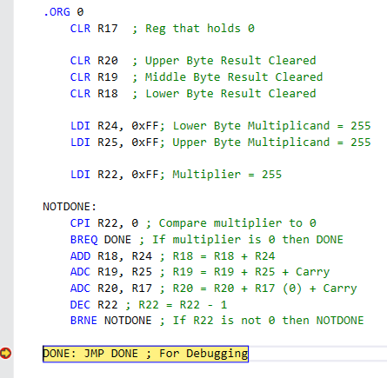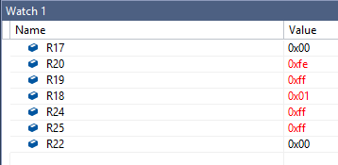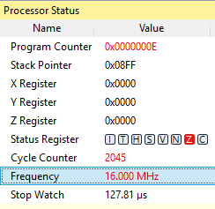

1. **GITHUB LINK OF THIS DA**

https://github.com/recrio/submissions/tree/master/DesignAssignments/DA1A

**Student Academic Misconduct Policy**

<http://studentconduct.unlv.edu/misconduct/policy.html>

“This assignment submission is my own, original work”.

Ron Joshua Recrio