CPE301 – SPRING 2019

Design Assignment 1B

Student Name: Ron Joshua Recrio

Student #: 5003825419

Student Email: recrio@unlv.nevada.edu

Primary Github address: https://github.com/recrio/submissions

Directory: submissions/DesignAssignments/DA1B

1. **COMPONENTS LIST AND CONNECTION BLOCK DIAGRAM w/ PINS**

N/A

1. **INITIAL/MODIFIED/DEVELOPED CODE OF TASK 1/A**

.ORG 0

.EQU STARTADDS = 0x0200

.EQU DIVISIBLES = 0x0400

.EQU NDIVISIBLE = 0x0600

LDI R23, 0 ; Holds Zero

LDI R20, 99 ; Counter = 99

LDI R25, 11 ; First Value = 11

LDI XL, low(STARTADDS) ; X points to

LDI XH, high(STARTADDS) ; 0x0200

LDI YL, low(DIVISIBLES) ; Y points to

LDI YH, high(DIVISIBLES) ; 0x0400

LDI ZL, low(NDIVISIBLE) ; Z points to

LDI ZH, high(NDIVISIBLE) ; 0x0600

POPULATE:

ST X+, R25 ; Store R25 into X, increment pointer

INC R25 ; Increment R25

DEC R20 ; Decrement Counter

BRNE POPULATE ; Keep populating if counter != 0

1. **DEVELOPED MODIFIED CODE OF TASK 2/A from TASK 1/A**

LDI XL, low(STARTADDS) ; X points to

LDI XH, high(STARTADDS) ; 0x0200 again

LDI R20, 99+1 ; Counter = 99+1 because BREQ

; checks before the operations

DIV3:

DEC R20 ; Decrement Counter

BREQ DONEDIV ; If counter = 0, parsed through all numbers

LD R25, X ; R25 = X data

LD R24, X+ ; R24 = X data, increment X pointer

CHECK:

CPI R25, 0 ; Check if R25 = 0

BREQ DIVIDES ; If 0 then divisible

SUBI R25, 3 ; Subtract R25 by 3

BRPL CHECK ; If not negative, go back to CHECK

NDIVIDES:

ST Z+, R24 ; store R24 in Z

RJMP DIV3 ; Jump to DIV3

DIVIDES:

ST Y+, R24 ; store R25 in Y

RJMP DIV3 ; Jump to DIV3

1. **DEVELOPED MODIFIED CODE OF TASK 3/A from TASK 2/A**

DONEDIV:

LDI R20, 99 ; Counter set to 99 again

LDI YL, low(DIVISIBLES) ; Y points to

LDI YH, high(DIVISIBLES) ; 0x0400 again

LDI ZL, low(NDIVISIBLE) ; Z points to

LDI ZH, high(NDIVISIBLE) ; 0x0600 again

SUM:

LD R21, Y+ ; R21 = Y data, increment Y pointer

LD R22, Z+ ; R22 = Z data, increment Z pointer

ADD R17, R21 ; R17 = R17 + R21

ADC R16, R23 ; R16 = R16 + 0 + Carry

ADD R19, R22 ; R19 = R19 + R22

ADC R18, R23 ; R18 = R18 + 0 + Carry

DEC R20 ; Decrement counter

BRNE SUM ; if counter != 0 keep summing

DONE: RJMP DONE

1. **Full Code**

.ORG 0

.EQU STARTADDS = 0x0200

.EQU DIVISIBLES = 0x0400

.EQU NDIVISIBLE = 0x0600

LDI R23, 0 ; Holds Zero

LDI R20, 99 ; Counter = 99

LDI R25, 11 ; First Value = 11

LDI XL, low(STARTADDS) ; X points to

LDI XH, high(STARTADDS) ; 0x0200

LDI YL, low(DIVISIBLES) ; Y points to

LDI YH, high(DIVISIBLES) ; 0x0400

LDI ZL, low(NDIVISIBLE) ; Z points to

LDI ZH, high(NDIVISIBLE) ; 0x0600

POPULATE:

ST X+, R25 ; Store R25 into X, increment pointer

INC R25 ; Increment R25

DEC R20 ; Decrement Counter

BRNE POPULATE ; Keep populating if counter != 0

LDI XL, low(STARTADDS) ; X points to

LDI XH, high(STARTADDS) ; 0x0200 again

LDI R20, 99+1 ; Counter = 99+1 because BREQ

; checks before the operations

DIV3:

DEC R20 ; Decrement Counter

BREQ DONEDIV ; If counter = 0, parsed through all numbers

LD R25, X ; R25 = X data

LD R24, X+ ; R24 = X data, increment X pointer

CHECK:

CPI R25, 0 ; Check if R25 = 0

BREQ DIVIDES ; If 0 then divisible

SUBI R25, 3 ; Subtract R25 by 3

BRPL CHECK ; If not negative, go back to CHECK

NDIVIDES:

ST Z+, R24 ; store R24 in Z

RJMP DIV3 ; Jump to DIV3

DIVIDES:

ST Y+, R24 ; store R25 in Y

RJMP DIV3 ; Jump to DIV3

1. **SCHEMATICS**

N/A

1. **SCREENSHOTS OF EACH TASK OUTPUT (ATMEL STUDIO OUTPUT)**

**Task 1:** Store 99 numbers starting from 0x0200

Before:

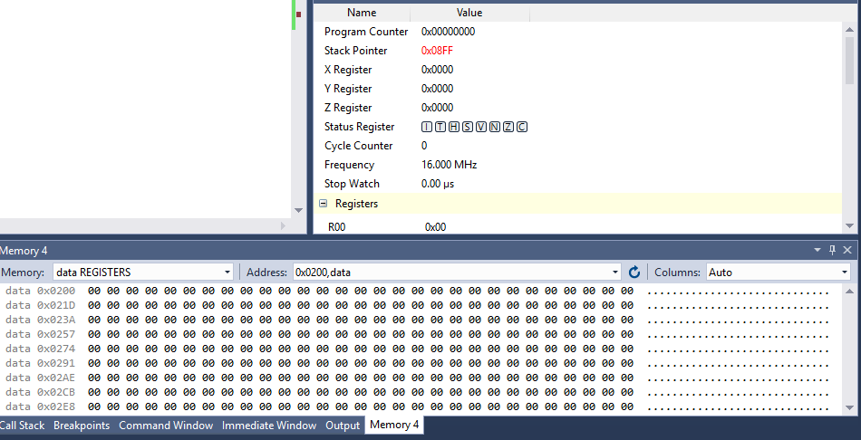

After:

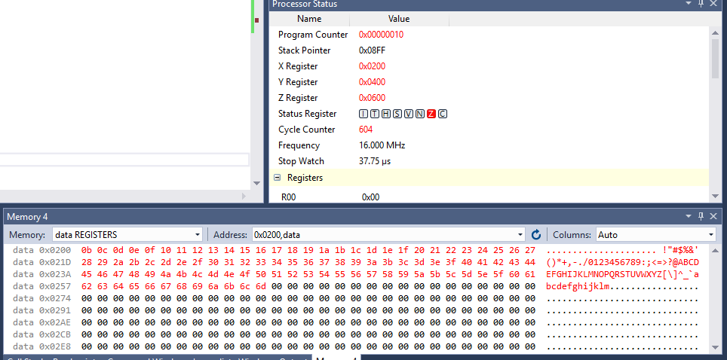

**Task 2:** Store divisible numbers at 0x0400 and the rest at 0x0600

Before:

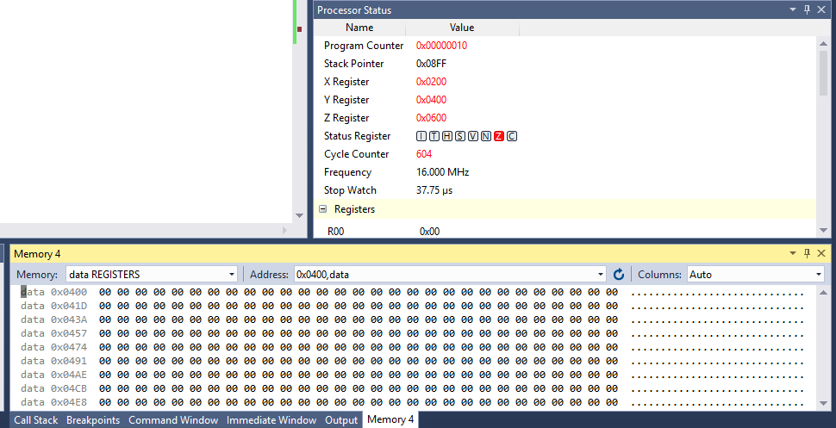

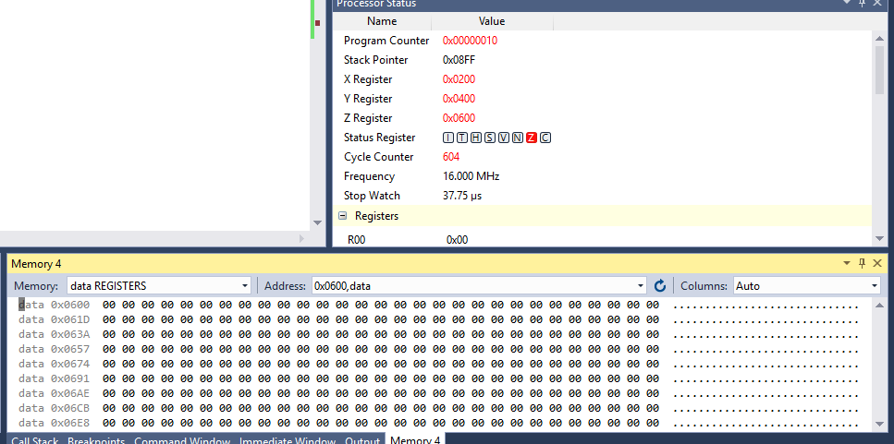

After:

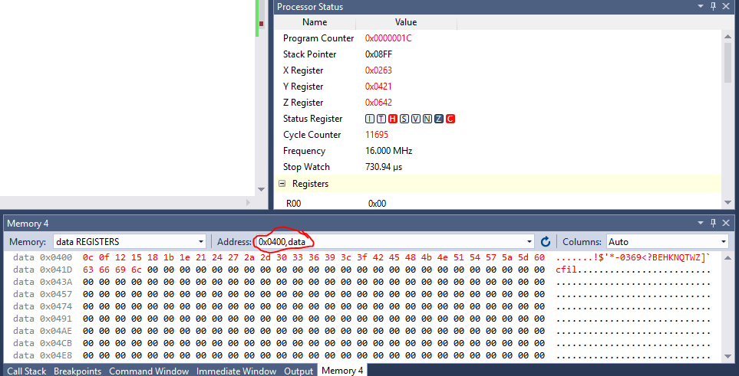

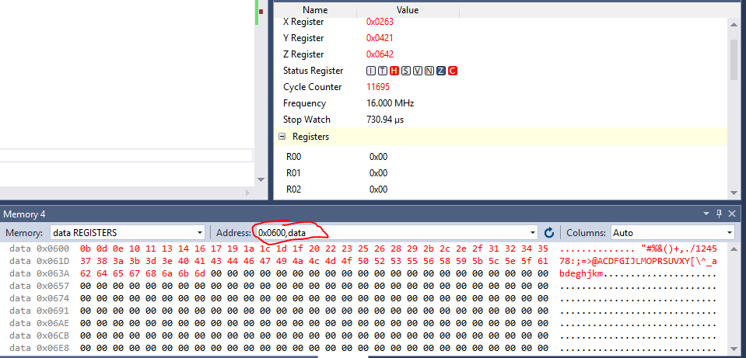

**Task 3:** Simultaneously add up 0x0400 and 0x0600 numbers to R16:R17 and R18:R19 respectively

Before:

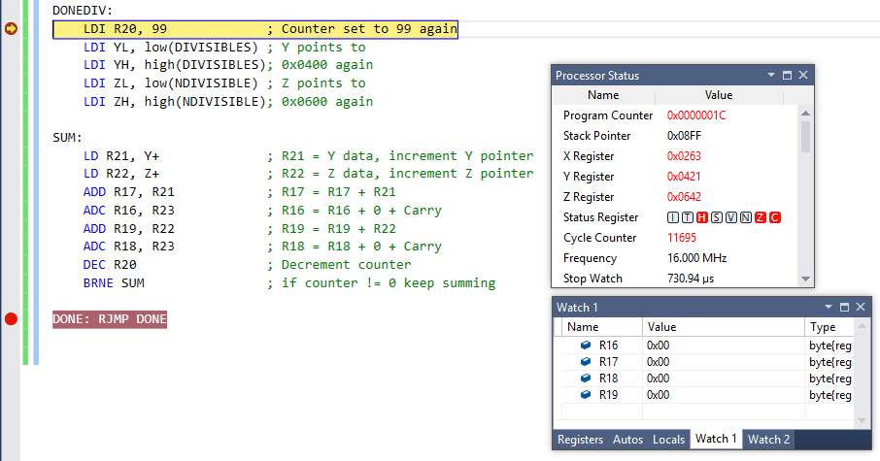

After:

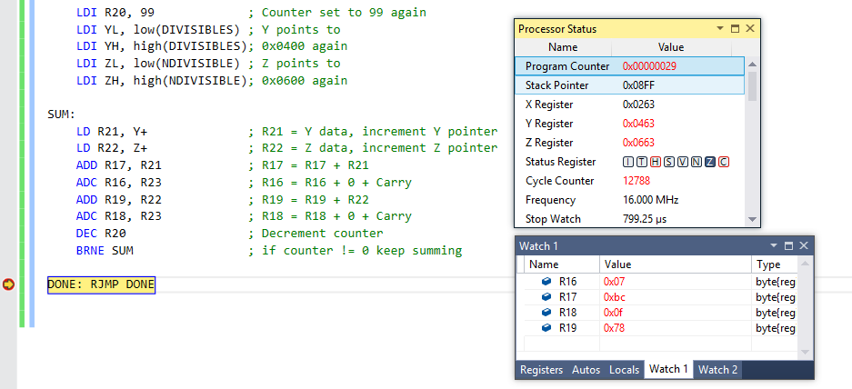

0x07BC = 1980

0x0F78 = 3960

**Task 4:** Verification using C++

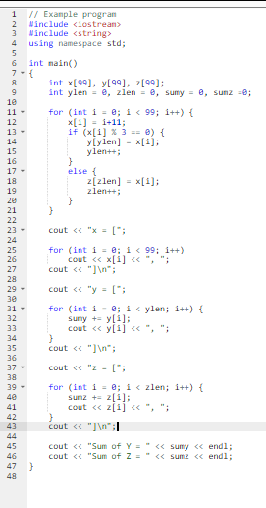

Output:

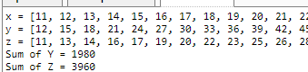

**Task 5:** Execution Time

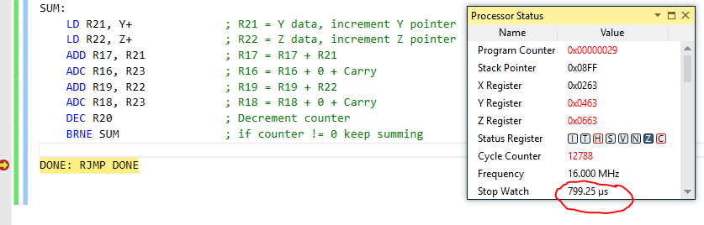

12788/16MHz = 799.25µs

1. **SCREENSHOT OF EACH DEMO (BOARD SETUP)**

N/A

1. **VIDEO LINKS OF EACH DEMO**

N/A

1. **GITHUB LINK OF THIS DA**

https://github.com/recrio/submissions/tree/master/DesignAssignments/DA1B

**Student Academic Misconduct Policy**

<http://studentconduct.unlv.edu/misconduct/policy.html>

“This assignment submission is my own, original work”.

Ron Joshua Recrio