CPE301 – SPRING 2019

Design Assignment 2B

Student Name: Ron Joshua Recrio

Student #: 5003825419

Student Email: recrio@unlv.nevada.edu

Primary Github address: https://github.com/recrio/submissions

Directory: /DesignAssignments/DA2B

Submit the following for all Labs:

1. In the document, for each task submit the modified or included code (only) with highlights and justifications of the modifications. Also, include the comments.
2. Use the previously create a Github repository with a random name (no CPE/301, Lastname, Firstname). Place all labs under the root folder ESD301/DA, sub-folder named LABXX, with one document and one video link file for each lab, place modified asm/c files named as LabXX-TYY.asm/c.
3. If multiple asm/c files or other libraries are used, create a folder LabXX-TYY and place these files inside the folder.
4. The folder should have a) Word document (see template), b) source code file(s) and other include files, c) text file with youtube video links (see template).

1. **COMPONENTS LIST AND CONNECTION BLOCK DIAGRAM w/ PINS**

List of Components used:

ATmega328p Xplained Mini

Multifunction Shield

Block diagram with pins used in the Atmega328P

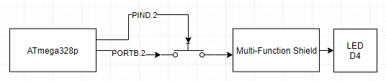

1. **INITIAL CODE OF TASK 2/A**

.ORG 0

init:

CBI DDRC, 2 ; PC2 as input, Clears DDRC2

LDI R16, 4 ; PB2

OUT DDRB, R16 ; SET PB2 as output

LDI R17,0 ; toggle for PC2

LDI R20,5 ; 0b101 for prescaler 1024

STS TCCR1B, R20 ; Set prescaler to 1024

LDI R20, 0 ; For counter/timer reset

EOR R17, R16 ; Toggle with XOR so that it starts as OFF

main:

OUT PORTB, R17 ; Turn off LED

SBIC PINC, 2 ; Skip if PC2 is pressed

RJMP keep_checking ; if not then jump

EOR R17, R16 ; Toggle again

OUT PORTB, R17 ; Turn on LED

EOR R17, R16 ; Toggle back

STS TCNT1H, R20 ; Reset

STS TCNT1L, R20 ; Timer/Counter

RCALL delay ; call delay of 1.25s

RJMP main ; Loop again

keep_checking:

SBI PORTB, 2 ; PB2 = 1, set it high so it will not light up

RJMP main ; Loop back to check for button press

delay: ; TCNT1 should be 19,531 or 0x4C4B

LDS R27, TCNT1H ; high byte of timer/counter

LDS R26, TCNT1L ; low byte of timer/counter

CPI R26,0x4B ; check if low byte matches

BRSH check_high ; if matching, then check high byte

RJMP delay ; else keep checking

check_high:

CPI R27,0x4C ; check high byte

BRLT delay ; if not matching , keep checking

RET ; if timer/counter is finally matching, return

1. **DEVELOPED MODIFIED CODE OF TASK 1/B from TASK 2/A**

.include <m328pdef.inc>

.ORG 0 ; main code location

JMP MAIN

.ORG 0x02 ; interrupt 0 code location

JMP EX0_ISR

MAIN:

// Initialize stack pointer

LDI R20, HIGH(RAMEND)

OUT SPH, R20

LDI R20, LOW(RAMEND)

OUT SPL, R20

LDI R22, (1<<2) ; for toggling PB2

SBI PORTD, 2 ; Pull-UP activated

LDI R20, 0x00 ; setting to make

STS EICRA, R20 ; INT0 low generate an interrupt

SBI DDRB, 2 ; PORTB.2 set to output

LDI R20, 1<<INT0; enable

OUT EIMSK, R20 ; INT0

SEI ; enable global interrupt

HERE:

OUT PORTB, R22 ; Turn off LED

JMP HERE ; infinite loop to catch interrupts

EX0_ISR:

IN R21, PORTB ; Take in status of PORTB

EOR R21, R22 ; Toggle it

OUT PORTB, R21 ; Output to LED

RCALL DELAY ; Call a delay of 1.25s

RETI ; Return with interrupt flag on

DELAY: ; Delay adds up to 20 million clock cycles

LDI r18, 102

LDI r19, 118

LDI r20, 194

L1: DEC r20

BRNE L1

DEC r19

BRNE L1

DEC r18

BRNE L1

RET

1. **VERIFICATION OF TASK 1/B USING C**

#define *F_CPU* 16000000UL

#include <avr/io.h>

#include <avr/interrupt.h>

#include <util/delay.h>

int main(void)

{

DDRB |= (1<<2); // PB2 set to output

PORTB |= (1<<2); // PB2 set to HIGH which means LED OFF

DDRD &= (0<<2); // PD2 set to input

PORTD |= (1<<2); // PD2 Turn Up Resistor

EICRA = 0x00; //Low mode

EIMSK = 1<<INT0; // Masking

sei(); // Turn on global interrupt

while (1)

{

PORTB |= (1<<2); // Turn off LED

}

}

ISR (INT0_vect)

{

PORTB ^= (1<<2); // Toggle PB2

*_delay_ms*(1250); // Delay for 1.25s

}

1. **SCHEMATICS**

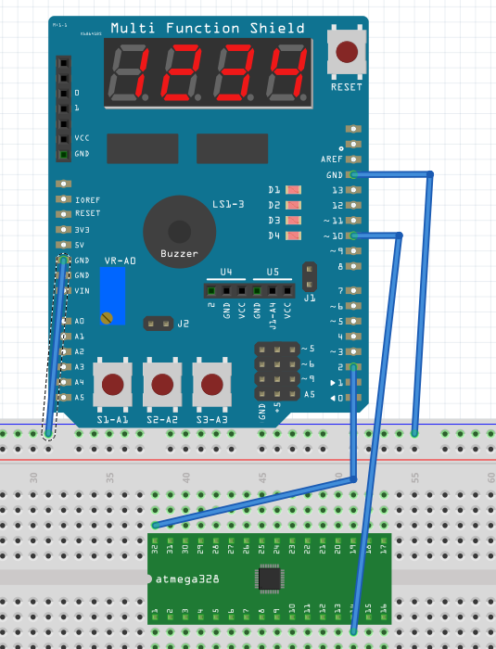

If PD2 (PIN 32) touches ground, then PB2 will output to D4 to turn on the LED

1. **SCREENSHOTS OF EACH TASK OUTPUT (ATMEL STUDIO OUTPUT)**

Before:

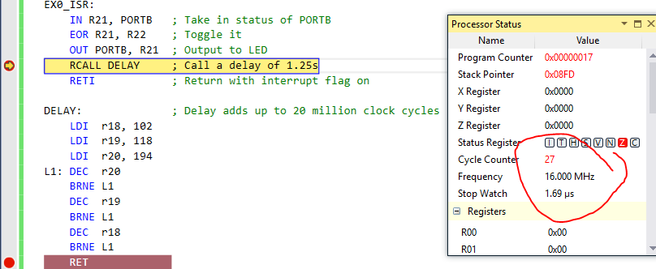

After:

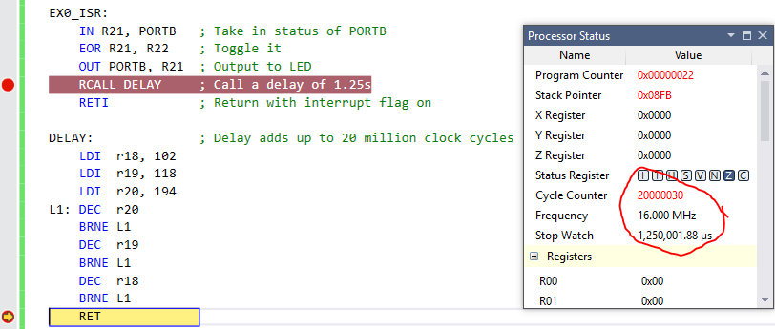

1. **SCREENSHOT OF EACH DEMO (BOARD SETUP)**

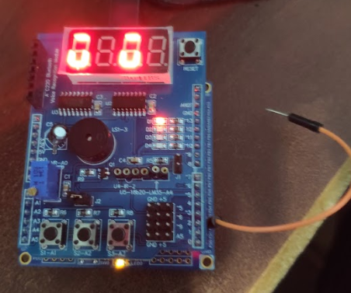

1. **VIDEO LINKS OF EACH DEMO**

<https://youtu.be/l4KSmy9SAN4>

1. **GITHUB LINK OF THIS DA**

**Student Academic Misconduct Policy**

<http://studentconduct.unlv.edu/misconduct/policy.html>

“This assignment submission is my own, original work”.

Ron Joshua Recrio