CPE301 – SPRING 2019

Design Assignment 4A

Student Name: Ron Joshua Recrio

Student #: 5003825419

Student Email: recrio@unlv.nevada.edu

Primary Github address: <https://github.com/recrio/submissions>

Directory: /DesignAssignments/DA4A

Submit the following for all Labs:

1. In the document, for each task submit the modified or included code (only) with highlights and justifications of the modifications. Also, include the comments.
2. Use the previously create a Github repository with a random name (no CPE/301, Lastname, Firstname). Place all labs under the root folder ESD301/DA, sub-folder named LABXX, with one document and one video link file for each lab, place modified asm/c files named as LabXX-TYY.asm/c.
3. If multiple asm/c files or other libraries are used, create a folder LabXX-TYY and place these files inside the folder.
4. The folder should have a) Word document (see template), b) source code file(s) and other include files, c) text file with youtube video links (see template).

1. **COMPONENTS LIST AND CONNECTION BLOCK DIAGRAM w/ PINS**

List of Components used:

ATmega328p Xplained Mini

Multifunction Shield

TB6612FNG Dual Motor Driver Carrier

DC motor

Block diagram with pins used in the Atmega328P

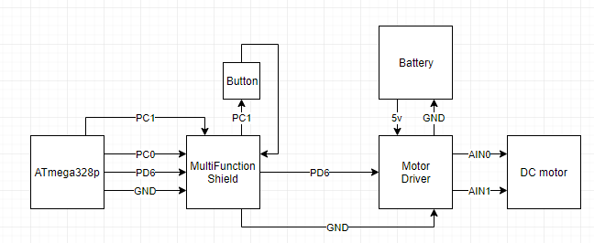

1. **INITIAL CODE OF TASK 1/A**

#define *F_CPU* 16000000UL

#define MAXSPEED 244

#define CONVERSION .238 // 244/1024

#include <avr/io.h>

#include <avr/interrupt.h>

#include <util/delay.h>

void PWM_init(void);

void ADC_init(void);

volatile int ADCvalue; // holds the value of ADC

volatile int motor = 0; // State of motor 0 = off, 1 = on

int main(void)

{

ADC_init(); // initializes ADC

PWM_init(); // initiales PWM

while (1)

{

if (motor == 1) {

ADCSRA |= (1<<ADSC); // Start conversion

while((ADCSRA&(1<<ADIF))==0); // while not done converting do nothing

ADCSRA |= (1<<ADIF); // reset converter

ADCvalue = ADC; // store ADC to ADCvalue for debugging

OCR0A = CONVERSION*ADCvalue; // 224/1024 is the ratio of the speed so that max speed is 95% of the pwm

}

if (motor == 0) {

OCR0A = 0;

}

}

}

ISR(PCINT1_vect) {

if(!(PINC & (1 << PINC1))) { // if Button pressed

*_delay_ms*(100); // debouncing

while(!(PINC&(1<<PINC1))); // extra debouncing

motor ^= 1; // Toggle motor

}

}

void PWM_init(void) {

DDRD |= (1<<PORTD6); // PD6 as output

DDRC |= (1<<PORTC1); // PC1 as output for interrupt

TCCR0A |=

(1<<WGM01)| // Fast

(1<<WGM00)| // PWM

(1<<COM0A1);// Clear OC0A on compare/set OC0A as bottom (non-inverting)

PCMSK1 |= (1<<PCINT9); // Enable PCINT9

PCICR |= (1<<PCIE1); // Enable PCMSK1

TCCR0B |=

(1<<CS02)| // Prescaler

(1<<CS00); // 1024 and start pwm

}

void ADC_init(void) {

DDRC &= (0<<PORTC0); // PC0 as input

PORTC |= (1<<PORTC1); // Pull up resistor

ADMUX |= (1<<REFS0); // REFERENCE VOLTAGE AT AREF

ADCSRA |=

(1<<ADEN)| // ADC enable

(1<<ADPS2)| // ADC

(1<<ADPS1)| // Prescaler

(1<<ADPS0); // 128

sei();

}

1. **SCHEMATICS**

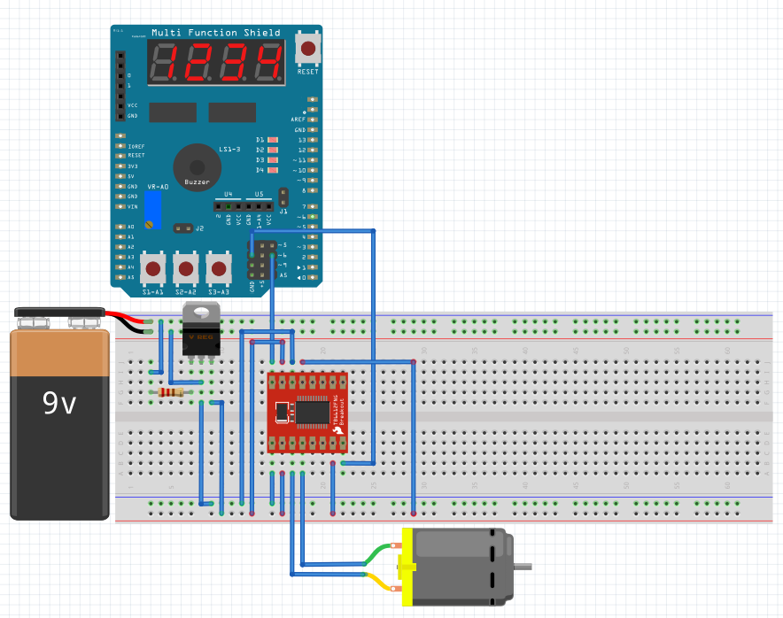

1. **SCREENSHOTS OF EACH TASK OUTPUT (ATMEL STUDIO OUTPUT)**

Logic Analyzer showing 95% duty cycle at max speed:



1. **SCREENSHOT OF EACH DEMO (BOARD SETUP)**

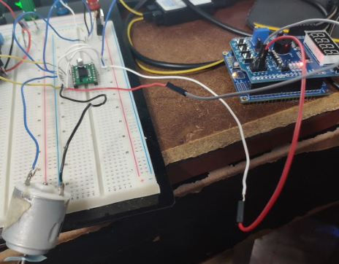

1. **VIDEO LINKS OF EACH DEMO**

<https://youtu.be/PS56JLzTxOk>

1. **GITHUB LINK OF THIS DA**

[https://github.com/recrio/submissions/tree/master/DesignAssignments/DA4A](https://github.com/recrio/submissions/tree/master/DesignAssignments/DA3B)

**Student Academic Misconduct Policy**

<http://studentconduct.unlv.edu/misconduct/policy.html>

“This assignment submission is my own, original work”.

Ron Joshua Recrio