CPE301 – SPRING 2019

Design Assignment 4B

Student Name: Ron Joshua Recrio

Student #: 5003825419

Student Email: recrio@unlv.nevada.edu

Primary Github address: <https://github.com/recrio/submissions>

Directory: /DesignAssignments/DA4A

Submit the following for all Labs:

1. In the document, for each task submit the modified or included code (only) with highlights and justifications of the modifications. Also, include the comments.
2. Use the previously create a Github repository with a random name (no CPE/301, Lastname, Firstname). Place all labs under the root folder ESD301/DA, sub-folder named LABXX, with one document and one video link file for each lab, place modified asm/c files named as LabXX-TYY.asm/c.
3. If multiple asm/c files or other libraries are used, create a folder LabXX-TYY and place these files inside the folder.
4. The folder should have a) Word document (see template), b) source code file(s) and other include files, c) text file with youtube video links (see template).

1. **COMPONENTS LIST AND CONNECTION BLOCK DIAGRAM w/ PINS**

List of Components used:

ATmega328p Xplained Mini

Multifunction Shield

28BYJ-48 (Stepper Motor)

ULN2003A (Unipolar Stepper Motor Driver)

Block diagram with pins used in the Atmega328P

Task 1:

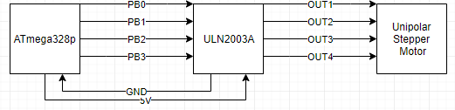

Task 2:

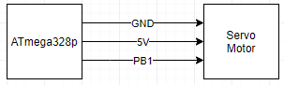

1. **INITIAL CODE OF TASK 1/B**

#define *F_CPU* 16000000UL

#define CONVERSION 10

#include <avr/io.h>

#include <avr/interrupt.h>

#include <util/delay.h>

void TIMER_init(void);

void ADC_init(void);

volatile int ADCvalue; // holds the value of ADC

int main(void)

{

DDRB = 0x0F; // PORTB[3:0] set to output

PORTB = 0; // Initially set output to 0

ADC_init(); // initializes ADC

TIMER_init(); // initializes TIMER

while (1)

{

ADCSRA |= (1<<ADSC); // Start conversion

while((ADCSRA&(1<<ADIF))==0); // while not done converting do nothing

ADCSRA |= (1<<ADIF); // reset converter

ADCvalue = ADC; // store ADC to ADCvalue for debugging

OCR1A = CONVERSION*ADCvalue; // 224/1024 is the ratio of the speed so that max speed is 95% of the pwm

// Sequence

PORTB = 0x09;

while(!(TIFR1 & (1<<OCF1A))); // Delays using CTC

TIFR1 |= (1 << OCF1A); // Resets

PORTB = 0x03;

while(!(TIFR1 & (1<<OCF1A)));

TIFR1 |= (1 << OCF1A);

PORTB = 0x06;

while(!(TIFR1 & (1<<OCF1A)));

TIFR1 |= (1 << OCF1A);

PORTB = 0x0C;

while(!(TIFR1 & (1<<OCF1A)));

TIFR1 |= (1 << OCF1A);

}

}

void TIMER_init(void) {

TCCR1B = (1<<WGM12) | // CTC mode

(1<<CS11); // Prescaler 8

}

void ADC_init(void) {

DDRC &= (0<<PORTC0); // PC0 as input

PORTC |= (1<<PORTC1); // Pull up resistor

ADMUX |= (1<<REFS0); // REFERENCE VOLTAGE AT AREF

ADCSRA |=

(1<<ADEN)| // ADC enable

(1<<ADPS2)| // ADC

(1<<ADPS1)| // Prescaler

(1<<ADPS0); // 128

sei();

}

1. **INITIAL CODE FOR TASK 2/B**

#define *F_CPU* 16000000UL

#include <avr/io.h>

#include <util/delay.h>

void TIMER_init(void);

void ADC_init(void);

int main(void)

{

ADC_init(); // initialize ADC settings

TIMER_init(); // initialize TIMER1

while(1)

{

ADCSRA |= (1 << ADSC); // Starts conversion

while((ADCSRA&(1<<ADIF))==0); // wait for conversion

ADCSRA |= (1<<ADIF); // reset converter

ICR1 = 4999; // fPWM = 50Hz

DDRB |= (1<<PB1); // Set PB1 as output

OCR1A = ADC; // Adjusts pulse width range

*_delay_ms*(100); // Short Delay

}

}

void TIMER_init(void)

{

//Timer1

TCCR1A = (1<<COM1A1) | // Clear OC1A on Compare non-inverting

(1<<COM1B1) | //

(1<<WGM11) ; // Fast

TCCR1B = (1<<WGM13) | // PWM

(1<<WGM12) | // TOP = ICR1

(1<<CS11) | // Prescaler

(1<<CS10); // 64

}

void ADC_init (void)

{

ADMUX = (1<<REFS0); // Set Aref

// right-justified data

ADCSRA |= (1<<ADEN) | // ADC enable

(1<<ADSC) | // AD start conversion

(1<<ADPS2)| // ADC

(1<<ADPS1)| // Prescaler

(1<<ADPS0); // 128

}

1. **SCHEMATICS**

Task 1:

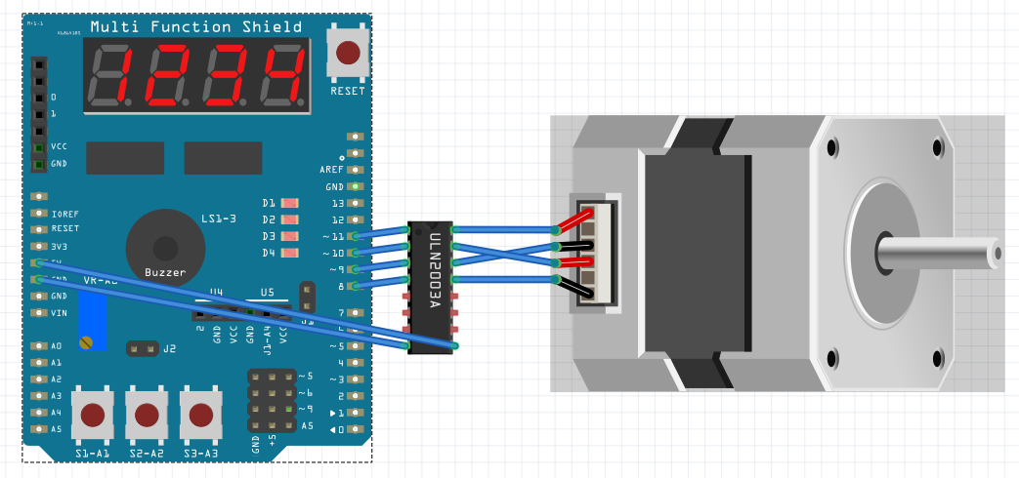

*not exact models

Task 2:

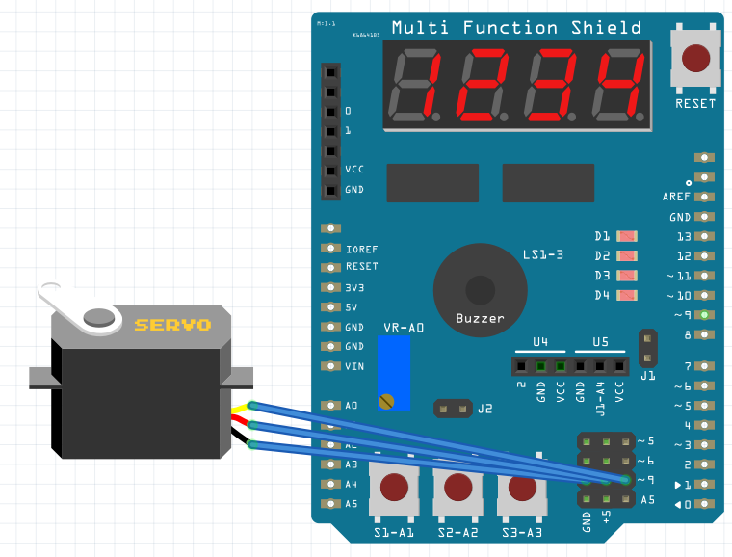

1. **SCREENSHOTS OF EACH TASK OUTPUT (ATMEL STUDIO OUTPUT)**

Task1:

Before



After



Task2:

Before



After



1. **SCREENSHOT OF EACH DEMO (BOARD SETUP)**

Task 1:

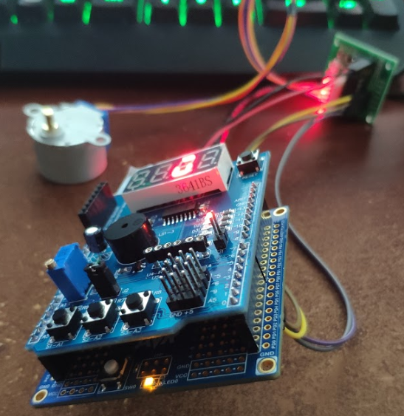

Task 2:

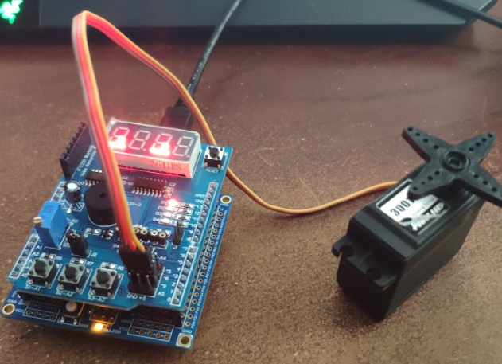

1. **VIDEO LINKS OF EACH DEMO**

Task 1:

<https://youtu.be/ouQdYaP1QoE>

Task 2:

<https://youtu.be/pdVJZY0RRas>

1. **GITHUB LINK OF THIS DA**

<https://github.com/recrio/submissions/tree/master/DesignAssignments/DA4B>

**Student Academic Misconduct Policy**

<http://studentconduct.unlv.edu/misconduct/policy.html>

“This assignment submission is my own, original work”.

Ron Joshua Recrio