CPE301 – SPRING 2019

Design Assignment 5

Student Name: Ron Joshua Recrio

Student #: 5003825419

Student Email: recrio@unlv.nevada.edu

Primary Github address: <https://github.com/recrio/submissions>

Directory: /DesignAssignments/DA5

Partner: Steven Lee

Submit the following for all Labs:

1. In the document, for each task submit the modified or included code (only) with highlights and justifications of the modifications. Also, include the comments.
2. Use the previously create a Github repository with a random name (no CPE/301, Lastname, Firstname). Place all labs under the root folder ESD301/DA, sub-folder named LABXX, with one document and one video link file for each lab, place modified asm/c files named as LabXX-TYY.asm/c.
3. If multiple asm/c files or other libraries are used, create a folder LabXX-TYY and place these files inside the folder.
4. The folder should have a) Word document (see template), b) source code file(s) and other include files, c) text file with youtube video links (see template).

1. **COMPONENTS LIST AND CONNECTION BLOCK DIAGRAM w/ PINS**

List of Components used:

ATmega328p Xplained Mini

NRF24L01

LM35

Block diagram with pins used in the Atmega328P

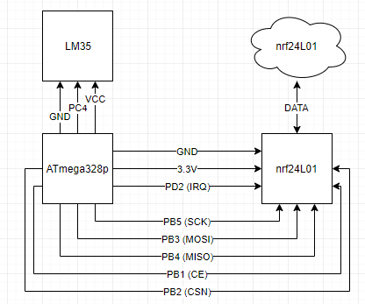

1. **INITIAL CODE OF TASK 1/B**

settings changed in lib file



main.c

// Set clock frequency

#ifndef F_CPU

#define F_CPU 16000000UL

#endif

#include <avr/io.h>

#include <util/delay.h>

#include <avr/interrupt.h>

#include <stdbool.h>

#include <stdio.h>

#include <string.h>

// Set up UART for printf();

#ifndef BAUD

#define BAUD 9600

#endif

#include "inc\STDIO_UART.c"

// Include nRF24L01+ library

#include "inc\nrf24l01.c"

#include "inc\nrf24l01-mnemonics.h"

#include "inc\spi.c"

void print_config(void);

// Used in IRQ ISR

volatile bool message_received = false;

volatile bool status = false;

void ADC_init (void);

volatile unsigned adc_temp;

volatile char temp[20];

int main(void)

{

// Set cliche message to send (message cannot exceed 32 characters)

char tx_message[32]; // Define string array

*strcpy*(tx_message,"It's working!"); // Copy string into array

// Initialize UART

uart_init();

// Initialize ADC

ADC_init();

// Initialize nRF24L01+ and print configuration info

nrf24_init();

print_config();

// Start listening to incoming messages

nrf24_start_listening();

*strcpy*(tx_message,"Initializing Chat Room..."); // Copy string into array

nrf24_send_message(tx_message);

while (1)

{

if (message_received)

{

// Message received, print it

message_received = false;

*printf*("Received Temperature: %s\n\n",nrf24_read_message());

ADCSRA |= (1<<ADSC); // start conversion

while ((ADCSRA&(1<<ADIF))==0){} // Wait for conversion

ADCSRA |= (1<<ADIF); // Clear Interrupt Flag

adc_temp = ADCL; // take in lower bits first

adc_temp = adc_temp | (ADCH<<8); // take in upper bits

adc_temp = (adc_temp/1024.0) * 5000/10;

adc_temp = adc_temp*1.8 + 32;

*snprintf*(temp,sizeof(temp),"%d\r\n",adc_temp); // print to the buffer

// Send message as response

*_delay_ms*(500);

status = nrf24_send_message(temp);

if (status == true) *printf*("Temperature Successfully Sent\n\n");

}

}

}

// Interrupt on IRQ pin

ISR(INT0_vect)

{

message_received = true;

}

// Prints configuration

void print_config(void)

{

*uint8_t* data;

*printf*("Startup successful\n\n nRF24L01+ configured as:\n");

*printf*("-------------------------------------------\n");

nrf24_read(CONFIG,&data,1);

*printf*("CONFIG 0x%x\n",data);

nrf24_read(EN_AA,&data,1);

*printf*("EN_AA 0x%x\n",data);

nrf24_read(EN_RXADDR,&data,1);

*printf*("EN_RXADDR 0x%x\n",data);

nrf24_read(SETUP_RETR,&data,1);

*printf*("SETUP_RETR 0x%x\n",data);

nrf24_read(RF_CH,&data,1);

*printf*("RF_CH 0x%x\n",data);

nrf24_read(RF_SETUP,&data,1);

*printf*("RF_SETUP 0x%x\n",data);

nrf24_read(STATUS,&data,1);

*printf*("STATUS 0x%x\n",data);

nrf24_read(FEATURE,&data,1);

*printf*("FEATURE 0x%x\n",data);

*printf*("-------------------------------------------\n\n");

}

void ADC_init(void) {

ADMUX |= (1<<REFS0)| // Selected AVcc

(1<<MUX2) ;

ADCSRA |= (1<<ADEN)| // Enable ADC

(0<<ADSC)| // Do not start conversion

(0<<ADATE)|// Auto Trigger Disabled

(0<<ADIF)| // Interrupt Flag Cleared

(0<<ADIE)| // Interrupt Disabled

(1<<ADPS2)| // ADC Prescaler Select

(0<<ADPS1)| // Set to

(1<<ADPS0); // 32

}

1. **SCHEMATICS**

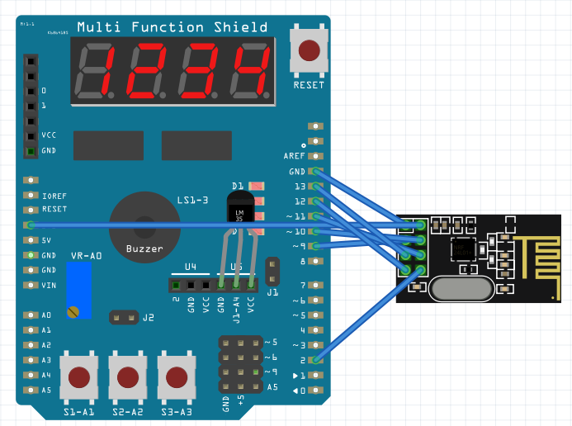

1. **SCREENSHOTS OF EACH TASK OUTPUT (ATMEL STUDIO OUTPUT)**

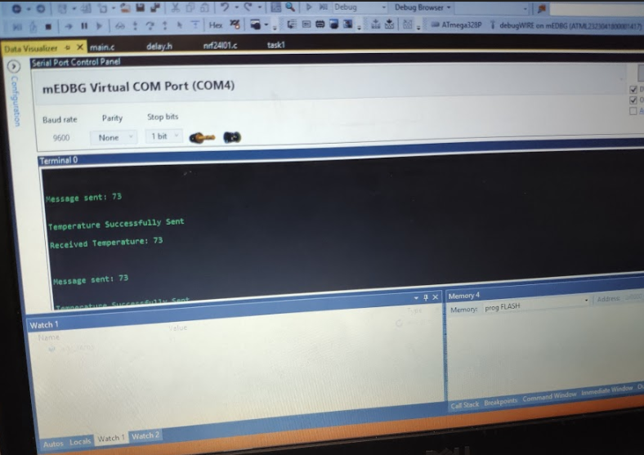

1. **SCREENSHOT OF EACH DEMO (BOARD SETUP)**

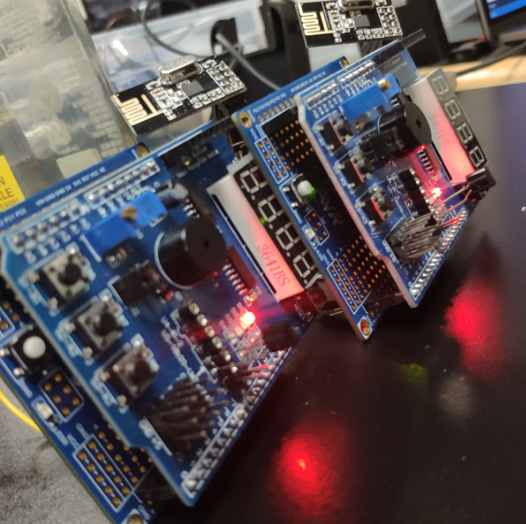

1. **VIDEO LINKS OF EACH DEMO**

<https://youtu.be/ZMXrQmhXJXM>

1. **GITHUB LINK OF THIS DA**

<https://github.com/recrio/submissions/tree/master/DesignAssignments/DA5>

**Student Academic Misconduct Policy**

<http://studentconduct.unlv.edu/misconduct/policy.html>

“This assignment submission is my own, original work”.

Ron Joshua Recrio