CPE301 – SPRING 2019

MIDTERM 1

Student Name: Ron Joshua Recrio

Student #: 5003825419

Student Email: recrio@unlv.nevada.edu

Primary Github address: <https://github.com/recrio/submissions>

Directory: /Midterms/Midterm1

Submit the following for all Labs:

1. In the document, for each task submit the modified or included code (only) with highlights and justifications of the modifications. Also, include the comments.
2. Use the previously create a Github repository with a random name (no CPE/301, Lastname, Firstname). Place all labs under the root folder ESD301/Midterm, sub-folder named LABXX, with one document and one video link file for each lab, place modified asm/c files named as LabXX-TYY.asm/c.
3. If multiple asm/c files or other libraries are used, create a folder LabXX-TYY and place these files inside the folder.
4. The folder should have a) Word document (see template), b) source code file(s) and other include files, c) text file with youtube video links (see template).

1. **COMPONENTS LIST AND CONNECTION BLOCK DIAGRAM w/ PINS**

List of Components used

ATmega328p

LM35

ESP8266

USB to ESP8266 Module

Block diagram with pins used in the Atmega328P

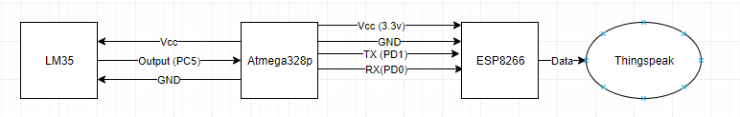

1. **INITIAL/MODIFIED/DEVELOPED CODE OF TASK 1/A**

#define *F_CPU* 16000000UL

#define PRESCALAR 1024

#define BAUDRATE 9600

#define BAUD_PRESCALAR (((*F_CPU* / (BAUDRATE * 16UL))) - 1)

#define ONESEC (0xFFFF - ((*F_CPU*/PRESCALAR)*1) - 60)

#include <avr/io.h>

#include <avr/interrupt.h>

#include <stdio.h>

void USART_init(void); // initializes USART settings

void USART_sendChar(char ch); // sends a character

void USART_sendString(char* str); // sends a string

void TIMER_init(void); // initializes timer sequence for interrupts

void ADC_init(void); // initializes ADC settings

volatile int adc_temp;

int main(void)

{

USART_init(); // initialize USART

TIMER_init(); // initialize Timer/Interrupt

ADC_init();

while (1) // Loop forever

{

}

}

ISR (TIMER1_OVF_vect) {

TCNT1 = ONESEC; // set the timer back

ADCSRA |= (1<<ADSC); // start conversion

while ((ADCSRA&(1<<ADIF))==0){} // Wait for conversion

ADCSRA |= (1<<ADIF); // Clear Interrupt Flag

adc_temp = ADCL; // take in lower bits first

adc_temp = adc_temp | (ADCH<<8); // take in upper bits

adc_temp = adc_temp*(9/5) + 32;

char temp[20]; // buffer

*snprintf*(temp,sizeof(temp),"%d\r\n",adc_temp); // print to the buffer

USART_sendString(temp); // send the temp out

}

void USART_init( void )

{

UBRR0H = 0; // not needed

UBRR0L = BAUD_PRESCALAR; // Baud Prescaler

UCSR0C = _BV(UCSZ01) | _BV(UCSZ00); /* 8-bit data */

UCSR0B = _BV(RXEN0) | _BV(TXEN0); /* Enable RX and TX */

}

void USART_sendChar(char ch) {

while (!(UCSR0A & (1<<UDRE0))); // while data reg is not empty: hold

UDR0 = ch; // place character into reg

}

void USART_sendString(char* str) {

while ((*str != '\0')) { // while not the end of the string

while (!(UCSR0A & (1<<UDRE0))); // while data reg is not empty: hold

USART_sendChar(*str); //take in character to reg

str++; // next character

}

}

void TIMER_init(void) {

TCNT1 = ONESEC; // ONESEC is the number to count up to 0xFFFF for 1 sec delay

TIMSK1 |= (1 << TOIE0); // Enable Interrupt for Timer1

sei(); // Enable Global Interrupt

TCCR1B |= (1<<CS12)|(1<<CS10); // Start timer 1 and set prescaler to 1024

}

void ADC_init(void) {

ADMUX |= (0<<REFS1)| // Reference Select

(1<<REFS0)| // Selected AVcc

(0<<ADLAR)| // Left Adjust Result OFF

(1<<MUX2) | // Analog Channel Select

(0<<MUX1) | // 1 0 1

(1<<MUX0) ; // Channel 5 or PC5

ADCSRA |= (1<<ADEN)| // Enable ADC

(0<<ADSC)| // Do not start conversion

(0<<ADATE)|// Auto Trigger Disabled

(0<<ADIF)| // Interrupt Flag Cleared

(0<<ADIE)| // Interrupt Disabled

(1<<ADPS2)| // ADC Prescaler Select

(0<<ADPS1)| // Set to

(1<<ADPS0); // 32

}

1. **DEVELOPED MODIFIED CODE OF TASK 2/A from TASK 1/A**

#define *F_CPU* 16000000UL

#define PRESCALAR 1024

#define BAUDRATE 115200

#define BAUD_PRESCALAR (((*F_CPU* / (BAUDRATE * 16UL))) - 1)

#include <avr/io.h>

#include <avr/interrupt.h>

#include <stdio.h>

#include <util/delay.h>

void USART_init(void); // initializes USART settings

void USART_sendChar(char ch); // sends a character

void USART_sendString(char* str); // sends a string

void TIMER_init(void); // initializes timer sequence for interrupts

void ADC_init(void); // initializes ADC settings

void AT_init(void); // initializes AT settings

volatile int adc_temp;

int main(void)

{

USART_init(); // initialize USART

AT_init(); // initialize AT setttings

TIMER_init(); // initialize Timer/Interrupt

ADC_init(); // initialize ADC

while (1) // Loop forever

{

}

}

ISR (TIMER1_OVF_vect) {

ADCSRA |= (1<<ADSC); // start conversion

while ((ADCSRA&(1<<ADIF))==0){} // Wait for conversion

ADCSRA |= (1<<ADIF); // Clear Interrupt Flag

adc_temp = ADCL; // take in lower bits first

adc_temp = adc_temp | (ADCH<<8); // take in upper bits

adc_temp = adc_temp*(9/5) + 32; // change to fahrenheit

char temp[20]; // temp buffer

*snprintf*(temp,sizeof(temp),"%d\r\n",adc_temp); // print to the buffer

//USART_sendString(temp);

USART_sendString("AT+CIPSTART=\"TCP\",\"api.thingspeak.com\",80\r\n"); //connect to thingspeak

*_delay_ms*(3000);

USART_sendString("AT+CIPSEND=51\r\n"); // send data 51 characters

*_delay_ms*(1000);

USART_sendString("GET /update?key=DUEPKNU9WHKU2GQL&field1="); // update channel using write key

USART_sendString(temp); // value to input

*_delay_ms*(1000);

USART_sendString("AT+CIPCLOSE\r\n"); // end of send

*_delay_ms*(1000);

TCNT1 = 0; // set the timer back

}

void USART_init( void )

{

UBRR0H = 0; // not needed

UBRR0L = 8; // used for 115200

UCSR0C = _BV(UCSZ01) | _BV(UCSZ00); /* 8-bit data */

UCSR0B = _BV(RXEN0) | _BV(TXEN0); /* Enable RX and TX */

}

void USART_sendChar(char ch) {

while (!(UCSR0A & (1<<UDRE0))); // while data reg is not empty: hold

UDR0 = ch; // place character into reg

}

void USART_sendString(char* str) {

while ((*str != '\0')) { // while not the end of the string

while (!(UCSR0A & (1<<UDRE0))); // while data reg is not empty: hold

USART_sendChar(*str); //take in character to reg

str++; // next character

}

}

void TIMER_init(void) {

TCNT1 = 0; // ONESEC is the number to count up to 0xFFFF for 1 sec delay

TIMSK1 |= (1 << TOIE0); // Enable Interrupt for Timer1

sei(); // Enable Global Interrupt

TCCR1B |= (1<<CS12)|(1<<CS10); // Start timer 1 and set prescaler to 1024

}

void ADC_init(void) {

ADMUX |= (0<<REFS1)| // Reference Select

(1<<REFS0)| // Selected AVcc

(0<<ADLAR)| // Left Adjust Result OFF

(1<<MUX2) | // Analog Channel Select

(0<<MUX1) | // 1 0 1

(1<<MUX0) ; // Channel 5 or PC5

ADCSRA |= (1<<ADEN)| // Enable ADC

(0<<ADSC)| // Do not start conversion

(0<<ADATE)|// Auto Trigger Disabled

(0<<ADIF)| // Interrupt Flag Cleared

(0<<ADIE)| // Interrupt Disabled

(1<<ADPS2)| // ADC Prescaler Select

(0<<ADPS1)| // Set to

(1<<ADPS0); // 32

}

void AT_init(void) {

USART_sendString("AT\r\n"); // Sends AT, expect OK

*_delay_ms*(1000);

USART_sendString("AT+CWMODE=1\r\n"); // Sends mode set to station, expect OK

*_delay_ms*(1000);

USART_sendString("AT+CWLAP\r\n"); // Send command to list Wifi networks, expect list

*_delay_ms*(4000);

USART_sendString("AT+CWJAP=\"ATwifi\",\"ATpassword\"\r\n"); // Send command to join guest wifi, expect OK

*_delay_ms*(3000);

}

1. **SCHEMATICS**

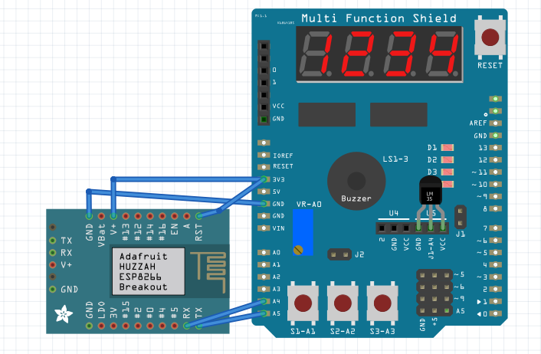

*Not exact models

1. **SCREENSHOTS OF EACH TASK OUTPUT (ATMEL STUDIO OUTPUT)**

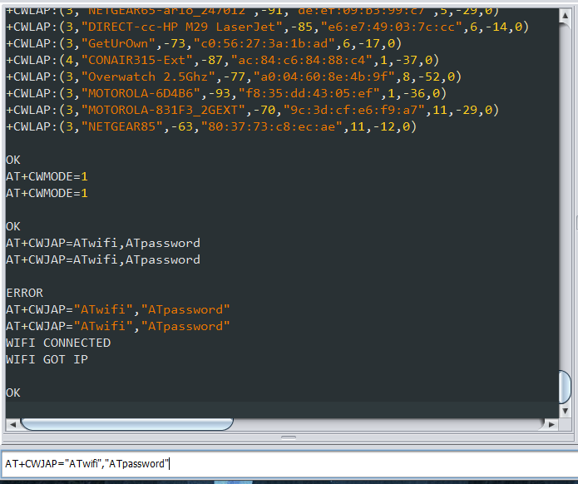1-2.) Terminal Output of LM35 using ADC 3.) AT firmware successfully working on Esplorer

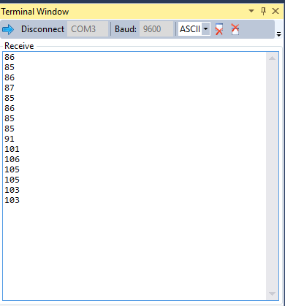

4.) Signed up for Thingspeak and channel made 5-6.) Transmit temps to Thingspeak

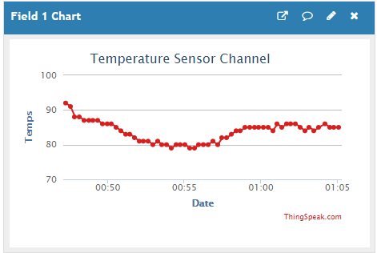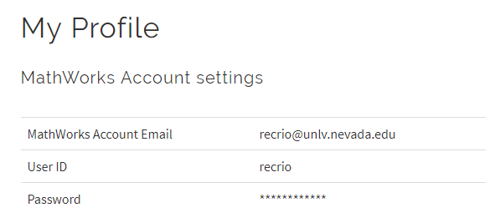

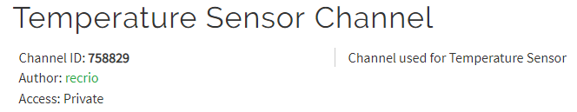

1. **SCREENSHOT OF EACH DEMO (BOARD SETUP)**

Programming ESP8266:

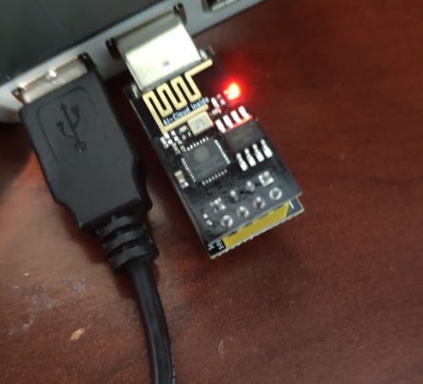

After Programming:

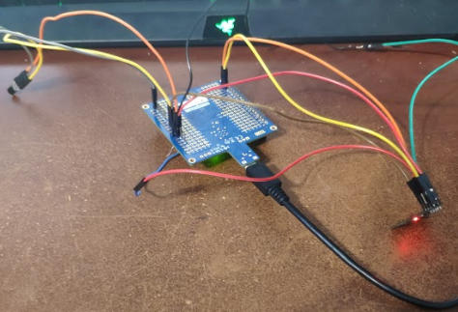

1. **VIDEO LINKS OF EACH DEMO**

<https://youtu.be/hEWqzvV_mSQ>

1. **GITHUB LINK OF THIS DA**

[https://github.com/recrio/submissions/tree/master/Midterms/Midterm1](https://github.com/recrio/submissions/tree/master/DesignAssignments)

**Student Academic Misconduct Policy**

<http://studentconduct.unlv.edu/misconduct/policy.html>

“This assignment submission is my own, original work”.

Ron Joshua Recrio