The goals / steps of this project are the following:

* Use the simulator to collect data of good driving behavior
* Build, a convolution neural network in Keras that predicts steering angles from images
* Train and validate the model with a training and validation set
* Test that the model successfully drives around track one without leaving the road
* Summarize the results with a written report

### Data Collection and processing

First Attempt:

* I started off with completing two training laps. I used Nvidia CNN model to train and validate.
* I was unable to go past first curve with red and white squares
* I used the techniques suggested in the class where I deliberately went slightly off track and recorded the part when I was getting back towards the center. This technique helped me slightly and I was able to cross half the paved road.
* I increased data collection by doing 2 laps each on two different track. But my training was not good enough. My training time on AWS increased to 2 days.

Second attempt:

* I used data.zip provided by Udacity. Along with data augmentation techniques I was able to go around the track successfully.
* I was storing lot of images into memory by using augmentation techniques from project 2 which was not very efficient. I used Keras generators( [Reference](https://srikanthpagadala.github.io/serve/carnd-behavioral-cloning-p3-report.html)). I used batches to train my data.

Some examples of augmented images

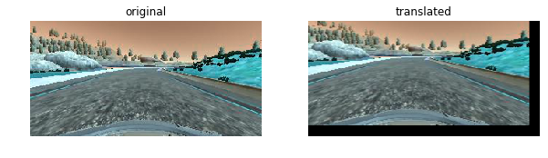

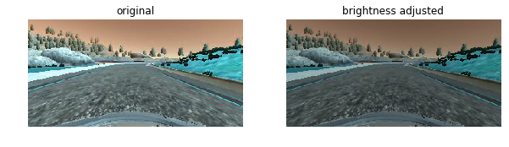

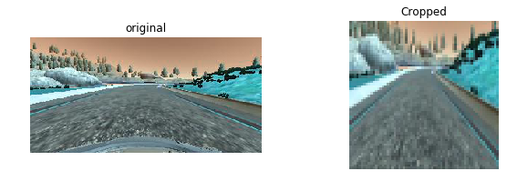

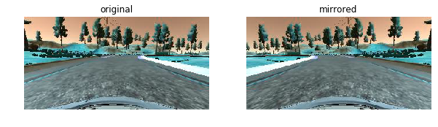

### Model Architecture

#### 1. I started off with Nvidia CNN model as my baseline. Below is my model architecture

* Crop image to eliminate hood and horizon
* Normalize data
* Use 4 convolution layers with batch normalization and activation ELU,
* 1 Flatten layer and 2 dense layer with activation ELU and using dropout to not overfit the network,
* Learning rate 1e-4 instead of default 1e-3 for Adam optimizer

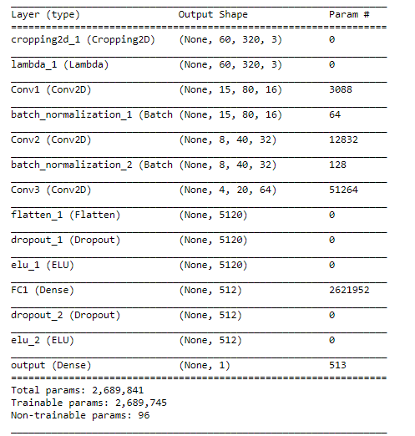

#### 2. Creation of the Training Set & Training Process

I used Keras generator to batch feed images for training. It slowed down the training but help me trained the network on relatively lightly spec PC.

Based on original data, the trained model was biased towards center driving, it didn’t know what to do at turns and when the car went off track. One of the key trick I learned from was to drop off the center(smaller) angle images and add more images at larger angles.

This helped the training tremendously.

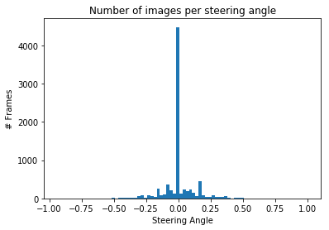 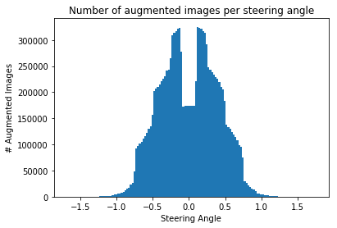

With above architecture and above step I was able to make car go autonomously around the track. Please see attached video run3.mp4.

I was unable to run the car autonomously on the alternate track. It failed at very first turn.

I am planning to comeback to this later and capture the date for second track and train to see if my model is good.