CSCE 4240
Group 11
Jeff Foster
Daniel Morgan

Crest Line Detection Using MATLAB

Purpose
In the reference paper, Comparisons of crest-line extraction algorithms applied to marine dunes (Julien Ogor and Benoit Zerr) several different crest line detection algorithms were achieved using 3D meshes. However, 3D meshes were not a topic of focus in our CSCE 4240 course. We wanted to use methods we directly learned in the classroom. Moreover, extracting this data using a mesh is accurate but leaves something to be desired in terms of computation time & simplicity of coding.
A 3D mesh tends to store data in 3-float vector form, while a 2D LiDAR image stores its variables in integer form. It follows that attempting to access & compute data from this format would be more efficient if an accurate method to extract this data exists. Therefore, we aimed to detect the crest lines using various techniques discussed throughout the course and examine the runtime of each method to determine which yields the best balance of accuracy and performance related to time.

Solution
To detect the rough edges of our crests, we decided to use 4 different techniques as a basis: Sobel, Canny, and Prewitt edge detection as well as one form of wavelet analysis for edge detection using the Haar wavelet. Sobel, Canny, And Prewitt implementations were all done with the edge function in MATLAB with a static threshold of .69. The wavelet procedure was accomplished using a combination of the wave2dec and detcoef2 functions. We deconstructed the wavelet, then reconstructed using only the detail sub-bands, suppressing the approximation sub-band. We then converted the result to a binary image based on a common threshold (we used the static value .69) using the im2bw function. Additional morphological operations were performed on resultant edge maps in conjunction with a square structuring element, MATLAB strel class, of width 15. The process we used to morph is as follows (in order listed, all take current image as arg1):
- dilation – imdilate function, arg2 is structuring element
- thinning – bwmorph function, arg2=’thin’ arg3=Inf
- small object removal – bwareaopen function, arg2=max # pixels, static value of 20 pixel max
Since crest edges were relatively wide (8 pixels at some points), the result was often that points were produced on either side of the edge, near the extremes of the crest. Dilation was an effective way to bridge the gap between the sides and the crest. Running a thin operation with the maximum number of times (arg3 as Inf) drew the crestlines appropriately. The results tend to improve with larger dilation values. However, at extreme values it reaches a point where crests begin to bleed together. We found the optimal threshold for our situation was a value of 15. The figure below exemplifies the advantage of the morphological process.
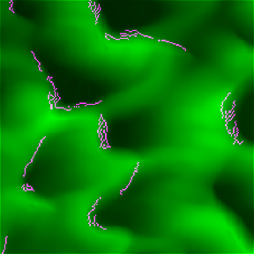 | 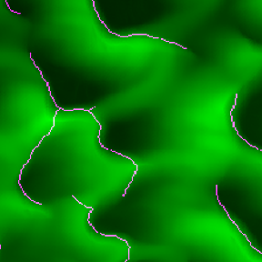

Not Dilated (left) vs. Dilated (right)

Running the Program
To run the included .m MATLAB program file, load it in the MATLAB software. Make sure the provided LiDAR image is in the same working directory with the script. No extra arguments are needed, simply hit the Run command from the Editor Tab. When prompted, allow MATLAB to change the current working directory.
After running the program, the output is the result of our four techniques. The resulting four crest line edge maps are individually composited onto the original LiDAR image using the imfuse function. This is done so edge map lines can clearly be showcased along the crest lines of the image. Each of these are then displayed alongside each other in a single 4x4 figure.

Runtime Comparison
To determine the runtime, we examined only the calls that applied to each edge detection method. After these functions were isolated, we selected the “Run and Time” editor command in MATLAB for each. We then examined the time it took to execute. Three trials were run for each method, and averages of the three runs were then calculated. For the Prewitt, Sobel, and Canny methods we have considered the execution time of each respective call to the MATLAB function edge. Since the wavelet method uses more than one function call, we have aggregated the execution time of the calls to wavedec2 and idwt2 to yield the complete runtime.
The first graph below displays a comparison of runtimes for each of the four methods. Another graph showing the averages of each method’s runtime trials is shown below that.

Result
In terms of crest line detection accuracy, Canny seemed to fair the best overall. Prewitt and Sobel output a reasonable edge map if quick runtime is a high priority, and we would recommend said methods be used when determining a rough edge map quickly. For example, a program could calculate a quick approximation crest line edge map using either Prewitt or Sobel at frequent intervals for ‘real-time processing’ needs. Then it could use Canny to calculate a more accurate line, but at less frequent occasions – such as when a more accurate crest line processing is needed. This could, in effect, balance the cost in many situations.
The wavelet analysis method detected crest lines well but slightly worse than Canny, with the drawback of increased runtime due to having to both deconstruct and reconstruct the wavelet. Because of this combination of hindrances, we would recommend choosing Canny over wavelet - we determined no compelling reasons for preferring wavelet use in this application. Perhaps additional wavelet filtering or use of different wavelet forms could produce a more accurate line, but for our purposes Canny seems to do just fine.
We have decided that the best compromise between accuracy and runtime is to utilize the Canny method. While it is significantly longer to run than either Prewitt or Sobel, its detection was much more acceptable while being both more accurate & faster than the Haar wavelet option.

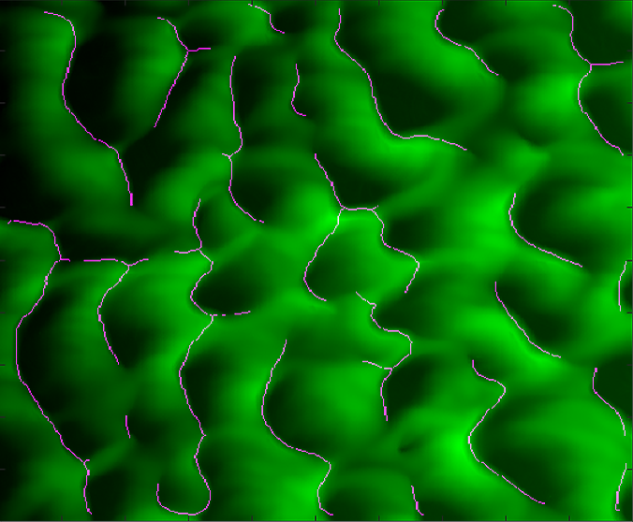 | 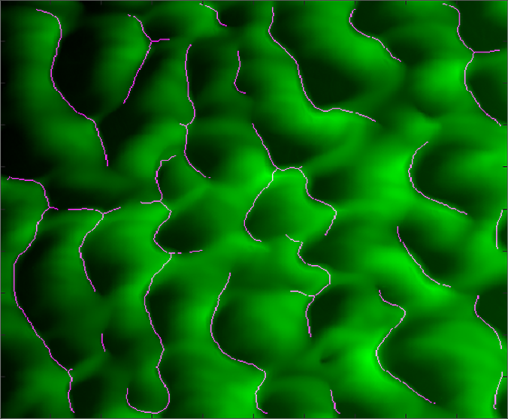
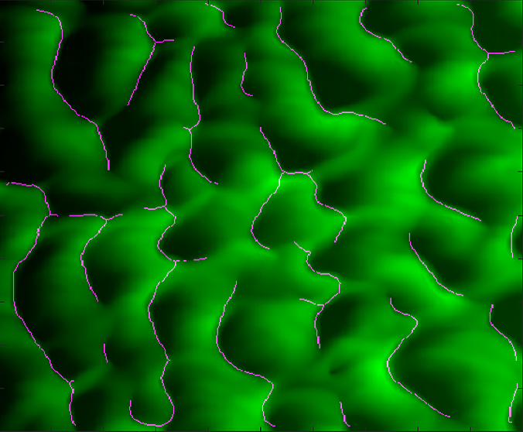 | 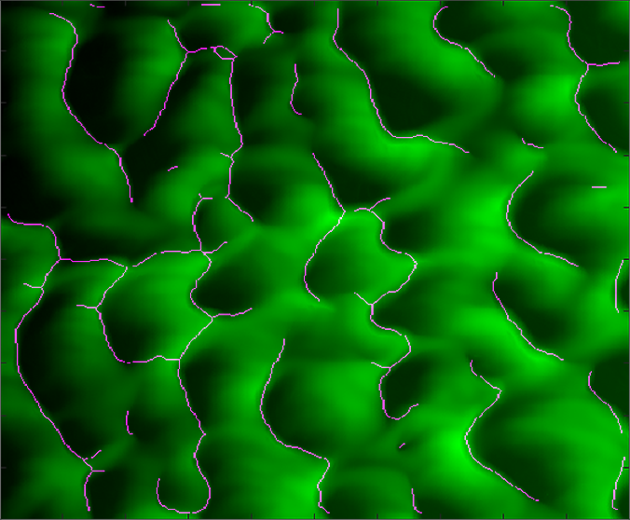

Results (starting top-left, clockwise): (1) Prewitt (2) Sobel (3) Canny (4) Wavelet

Conclusion
Detecting crest lines using digital image processing techniques in combination with MATLAB software is a viable method to determine the crest lines of a given LIDAR image. This solution implemented in MATLAB is easily understood by any person that has taken the CSCE 4240 course. Furthermore, it is quick in both coding time and execution time.
Though we used a constant threshold for testing, the edge threshold & dilation amount could be further developed to allow for dynamic user input of values for both desired crest height and the frequency of crests. This would be best realized in a program which allowed fine tuning of threshold & dilation on-the-fly, based on the user’s discretion.
Going even further, a more complex addition to this program could add a machine learning approach, such as building a database of known crest formations and ideal threshold & dilation values to best describe them. These would then be referenced & used to quickly map similar formations discovered as the program interprets new LIDAR images. This database could be compiled & expanded more and more as the program is used and unique crest forms with ideal values are discovered. However, these additions quickly escape our current goal of achieving accuracy very simply with easy code execution.

