.hdr 1. DRAWING WITH RED
.hoc 1.1. Introduction

The Draw dialect is a domain-specific language intended to simplify drawing. The language was created in Red itself. However, when you draw lines, shapes, animations, you will also make use of Red, and of VID (to place and set up GUI widgets - 'faces'). Here, we will work through some typical graphics tasks, and introduce - or remind you - about relevant Red and VID facilities.

This page is only a sampling of Draw. It does not cover ways of speeding-up animations, or the full range of facilities. Draw has many commands, and some of these have many options - so you will need to explore its official documentation:

Draw: <a href="https://doc.red-lang.org/en/draw.html">https://doc.red-lang.org/en/draw.html
</a>

There are some impressive demos on:
<a href="http://www.red-lang.org/2016/03/060-red-gui-system.html">
http://www.red-lang.org/2016/03/060-red-gui-system.html
</a>

You might also need VID:
Official: <a href="http://www.red-by-example.org/vid.html">
http://www.red-by-example.org/vid.html
</a>

Red-by-example: <a href="https://doc.red-lang.org/en/vid.html">
https://doc.red-lang.org/en/vid.html
</a>

When building a GUI with tightly-linked widgets, it can be very useful to use Red's reactive programming facilities, as shown here:

<a href="http://www.red-lang.org/2016/06/061-reactive-programming.html">
http://www.red-lang.org/2016/06/061-reactive-programming.html
</a>

Thanks to Gregg Irwin for suggestions:
<a href="https://gist.github.com/greggirwin">
https://gist.github.com/greggirwin
</a>

.top
.hoc 2.1. Drawing A Line and Box On A Canvas

Here is the code for our first program:

Red [ needs 'view ]

view [
canvas: base 150x150 draw [box 10x10 100x80]
]

Screenshot:
||draw-line1.png||

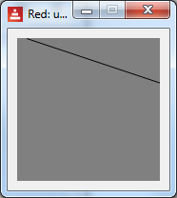

The program needs to incorporate View facilities, at the top.

We use a VID view to set up and place faces (GUI widgets, controls) on the window. Here, we only use a $$0base$$ (though we could also draw on an $$0image$$). We chose to name it 'canvas'.

Following the draw, we have a block of drawing commands, with values if necessary. Here we draw a $$2line$$ from 10x0 to 160x50. Note that the line is too long, and the extra part is clipped.

The top left of the base is (0, 0), and in Red we use $$pair!$$ notation - such as 0x0.

Next we extend the program to draw a $$2box$$, providing its top-left and bottom-right co-ordinates. We have also used a VID option to make the canvas white.

Red [ needs 'view ]

view [
canvas: base 150x150 white draw [
line 10x0 160x50
box 10x10 100x80
]
]

Screenshot:
||draw-line-and-box.png||

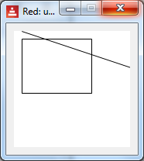

In fact, a box can be created by specifying any 2 opposite corners (such as bottom-left and top-right).

There are lots of shapes, such as circle, ellipse, polygon, etc. Details are in the Draw official documentation.

Note that we provide values - not variables, expressions - for the shape co-ordinates. We cannot put, for example:

xy-coords: 22x33

draw [line xy-coords 100x100] ;-- no!

Later, we will see how to work with this.

Drawing commands can be placed in nested blocks, as in:

[[line 10x0 160x50] [box 10x10 100x80]]

The end result is the same, but the structure can be useful if we need to process shapes (e.g. deleting a particular shape).

.top
.hoc 2.2. Pens, Fill-pens, color

Drawing lines and unfilled shapes is done with a $$2pen$$, whereas filled shapes are drawn with a $$2fill-pen$$.

They have default settings (a 1-pixel black line etc.) but we can provide new settings, such as colour, width, and thickness.

Here is an example:

Red [ needs 'view ]
view [
canvas: base 200x200 white draw [
pen blue line-width 8 line 10x0 160x50
pen red box 10x10 100x60
fill-pen pink box 10x80 120x140
pen off box 10x150 120x190
]
]

Screenshot:
||draw-pens.png||

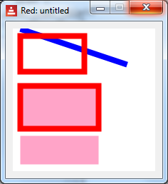

We created a blue pen with an 8-pixel width, and drew a line. The pen command must be followed immediately by a colour.

We altered the pen to red, and drew a box, unfilled.

We set the fill-pen to pink, then drew a box - note the red edges.

We turned the pen off, then drew a pink box. There are no edges on the box.

There are more pen options, such as specifying the shape of the line-end, and how joins appear.

Note also that we can draw on an $$0image$$ widget, as in :

Red [needs 'View]

view [
photo: image 250x250 %country.png
draw [fill-pen gold pen off circle 100x50 25] ;-- add sun
]

Screenshot, showing the added 'sun':
||draw-sun.png||

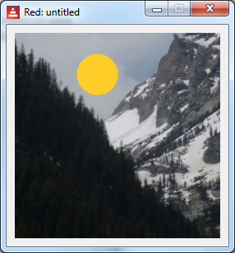

.top
.hoc 2.3. Drawing Text

We can incorporate text in a drawing, as follows:

Red [needs 'View ]
view [
canvas: base 150x150 white
draw [text 50x50 "Hello!!!!" circle 70x60 40]
]

Screenshot:
||draw-text.png||

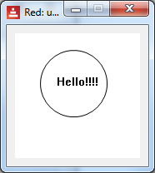

If your text in not part of the drawing (such as instructions, captions on faces - widgets) - you can use the VID $$0text$$ face.

It is also possible to specify fonts and sizes.

.top
.hoc 3.1. The Draw Block - Introduction

In the earlier examples, we followed 'draw' with a block of commands. This is the 'draw-block'. We can add or remove items to it, as required.

Here, we introduce a button, and show how to use a draw-block. We have the code:

Red [needs 'view]

do-but1: function [] [
print ["canvas/draw-before: " canvas/draw]
print ["size .. " canvas/size]
canvas/size: 160x200
canvas/draw: [fill-pen blue box 10x10 60x60]
print ["canvas/draw-after: " canvas/draw]
]

view [
b1: button "draw" [ do-but1]
return
canvas: base 200x200 white draw [ box 44x44 88x88]
]

Running it shows:
||draw-block1.png||

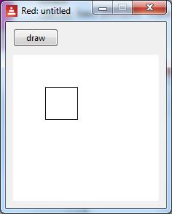

When we click the button, the canvas goes smaller, and we see a blue box:
||draw-block2.png||

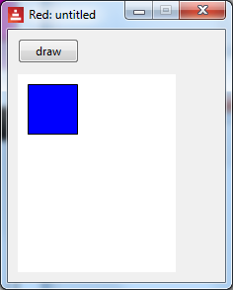

We also see this printed on the console:

canvas/draw-before: box 44x44 88x88
size .. 200x200
canvas/draw-after: fill-pen blue box 10x10 60x60

Note the printing: we can access options using the /refinement notation, as in canvas/size. The /draw contains a block of drawing instructions. It only holds one block, so when we assign the instructions to draw a blue box, the previous state is erased. However it is easy to add drawing instructions to the block, like this:

canvas/draw: [fill-pen blue box 10x10 60x60]
append canvas/draw [box 33x33 170x55] ;-- added this - another blue box
print ["canvas/draw-after: " canvas/draw].

It draws 2 blue boxes, and prints:

canvas/draw-before: box 44x44 88x88
size .. 200x200
canvas/draw-after: fill-pen blue box 10x10 60x60 box 33x33 170x55

We could use append/only if we wanted to keep each shape in its own block, to allow access to individual shapes.

Here is another example, which initially draws an unfilled box. It detects the $$0on-down$$ (mouse-click) event of the base, then draws a red filled box. The initial box vanishes of course, because the draw block is completely replaced by a new one.

Red [ needs 'view ]

in-canvas: function [] [
canvas/draw: [ fill-pen red box 2x2 30x30]
]

view [
canvas: base 200x200 white draw [ box 44x44 88x88]
on-down[in-canvas]
]

In summary, when the draw-block is drawn, the previous drawing is erased, and the new drawing is created. If you want something drawn, put it in the block.

The draw-block thus contains the whole drawing, as text. You can manipulate it, for example to add an 'undo' facility, or to select part of the drawing.

.top
.hoc 3.2. The Draw Block - Variables, Compose, Reduce

What if we want to use a variable, as in:

top-left: 22x33
draw [ line top-left 100x100]

We can't do this - the draw block must use values. We need to do some kind of evaluation first, and in Red, we can use $$compose$$ and $$reduce$$. They are similar, and here is a summary:

The word $$reduce$$ returns a copy of a block, evaluating all expressions
in the block.

The word $$compose$$ returns a copy of a block, evaluating only $$paren!$$ items. A paren! type is surrounded in (parentheses).

We can also use Red symbols. For example the symbol:

'elephant

evaluates to:

elephant

Here are some examples:

>> a: 11 b: 22 ;-- create some variables and a block
>> blk: [line (a + b) a + b "message" 123]
>> compose blk
== [line 33 a + b "message" 123] ;-- note (...) effect
>>
>> ;-- now try reduce, on same block
== [line (a + b) a + b "message" 123]
>> reduce blk
*** Script Error: line has no value

>> ;-- try another block, with a 'symbol
>> blk: ['line a b]
>> reduce blk
== [line 11 22] ;-- what we want

Here is a practical example - we want to use a variable for the start of a line. We can use compose or reduce:

top-left: 4x0

compose [pen red line (d) 3x66] ;compose only ( )
reduce ['pen red 'line d 3x66]

Either of these results in:

pen 255.0.0 line 30x30 3x66

Here is a program which draws a line at a different place, with every button-click. Note that we cannot append to an uninitialised block, so we have used the VID 'do' feature for some once-only initialisation.

Red [needs 'view]
line-end: 100x100

do-but1: func [] [ ;--func allows easier global use
append canvas/draw compose [line 0x100 (line-end)]
line-end: line-end + 0x10
]

view [
b1: button "draw" [do-but1]
return
canvas: base 200x200 white

do [ ;-- initialisation
canvas/draw: copy []
]
]

Screenshot:
||draw-block-fan.png||

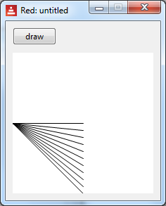

Here is the same basic program, but one click causes 10 lines to be drawn rapidly, without any user-interaction. The button-click code is:

do-but1: func [] [
line-end: 100x100
loop 10 [
append canvas/draw compose [line 0x100 (line-end)]
line-end: line-end + 0x10
]
]

.top
.hoc 4.1. Animation: Rate, On-time

Each face can have a $$0rate$$ timer, which can be made to tick regularly, or wait for a duration.

An integer value (above 0) sets a frequency (per second), a $$time!$$ type sets a duration, and $$none$$ stops it. Here, we set the canvas rate to 1 (per second), and detect the tick via the $$on-time$$ event. The blue square moves diagonally across the screen, to the bottom-right.

Red [ needs 'view ]

top-left: 10x10

canvas-tick: func [] [
top-left: top-left + 8x8
canvas/draw: reduce ['fill-pen blue 'box top-left top-left + 55x55]
]

view [
canvas: base 200x200 white rate 1
on-time [canvas-tick]
]

The animation is jerky, but try changing the increment to e.g. 1x1, and the rate to 20, for a gliding blue box.

.top
.hoc 4.2. The Bouncing Ball Program

This is a standard animation example. A blue ball bounces around the screen. You can stop and start it with buttons - it manipulates the rate to do this. The items you might wish to play around with have been initialised at the top of the code.

It could be improved - the testing for wall contact involves the centre of the ball, whereas it should be the edge. Some work for you to do!

Red [needs 'view]

draw-freq: 25 ;-- init
centre: 10x10
x-step: 1
y-step: 3
want-stop: false

in-canvas: func [] [ ;-- for every tick
canvas/rate: draw-freq
;-- hit an edge? And add a bit of randomness, for fun.
if centre/x > 300 [x-step: -1 * x-step - random 0.2]
if centre/y > 300 [y-step: -1 * y-step - random 0.2]
if centre/x < 0 [x-step: -1 * x-step]
if centre/y < 0 [y-step: -1 * y-step]
incr: to-pair reduce [(3 * x-step) (3 * y-step)]
centre: centre + incr
canvas/draw: reduce ['fill-pen blue 'circle centre 8]
;-- use append in above line, if you want a ball trail
]

do-stop: func [] [
want-stop: true
canvas/rate: none ;-- stop timer
]

do-start: func [] [
want-stop: false
canvas/rate: draw-freq ;starts
]

view [
stop-btn: button "stop" [do-stop]
start-btn: button "start" [do-start]
return

;-- rate set in do-block, below
canvas: base 300x300 white
on-time [in-canvas]

do [ ;-- init
canvas/rate: draw-freq
canvas/draw: copy [] ;-- for the first append
]
]

.top
.hoc 5.1. Mouse Co-ordinates, Events, All-over

When drawing with user-interaction, we can use buttons, etc, and it can also be useful to use the mouse position. Here is a fragment of code. When we click on the base, 'do-down' is called, passing the event object into 'ev'. The /offset refinement provides the position where the left mouse button was depressed.

do-down: func [ev] [
xy-pos: ev/offset ;-- mouse position - a pair
;-- etc...
]

view [
canvas: base 300x300 white on-down [do-down event]
]

Here is a program which draws straight lines between successive mouse-clicks:

Red [needs 'View
"Sketch with mouse"
]

sketching: false

do-down: func [ev] [
xy-New: ev/offset ;-- mouse position - pair
either not sketching [ ;-- first time?
sketching: true
xy-Start: xy-New ;-- no visible line
] [
append canvas/draw compose [line (xy-Start) (xy-New)]
xy-Start: xy-New ;-- remember where we were
]
]

clear-canvas: func [ev] [
sketching: false
xy-Start: ev/offset
canvas/draw: copy [pen red line-width 7]
]

view [
break-btn: button "Break line" [sketching: false]
clear-btn: button "Clear" [clear-canvas event]
return
canvas: base 300x200 white draw [pen red line-width 7]
on-down [do-down event] ;-- click in canvas?
]

And a screenshot:
||draw-red-mouse.png||

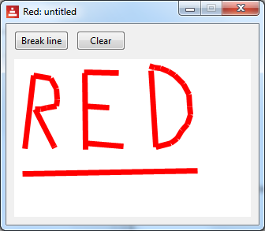

Here is another example which uses the VID $$0all-over$$ command. This allows us to pick up mouse-move events.

This program lets you click anywhere on the canvas, and drag open a box to the required size.

Red [needs 'View]

mouse-state: 'up
draw-block: copy []
coord1: 0x0

do-down: func [event] [
mouse-state: 'down
coord1: event/offset
]

do-up: func [] [
mouse-state: 'up
]

do-move: func [event] [
if mouse-state = 'down [ ;-- and over the canvas
draw-block: copy []
draw-block: compose [box (coord1) (event/offset)] ;--based on mouse coords
; print ["draw-block is: " draw-block]
canvas/draw: draw-block
]
]

view [
canvas: base 200x200 white all-over ;-- nb all-over
on-up [do-up]
on-down [do-down event]
on-over [do-move event]
]

.top
.hoc 5.2. Shape Sub-dialect

The Shape sub-dialect has similar commands to Draw, but they can be more convenient, such as:

- automatically closing shapes

- relative drawing, from the previous point. This is done by using the lit-word version - for example 'line rather than line.

We enclose the commands in a block, after 'shape'. Here is some code

Red [needs 'View]

;-- shape dialect
do-down: func [] [
canvas/draw: [
line-width 5 shape [
line 0x0 90x30 30x90
'hline 90 'vline 22
]
]
]

view [
start-btn: button "Draw" [do-down]
return
canvas: base 300x200 white draw [line-width 7]
]

- It draws 2 lines - note the series of points - (3 here, not 4) - for the line command.

- It uses the relative versions 'hline, 'vline to draw horizontal and vertical lines, with one parameter specified.

- It closes the shape (the long 45 degree diagonal line).

Screenshot:
||draw-sub-dialect.png||

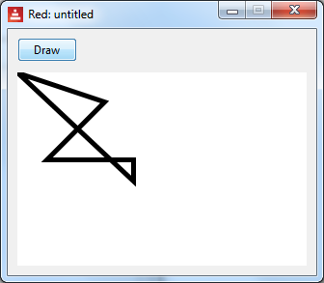

.top
.hoc 6.1 Transformations On Drawings

Red provides facilities to transform drawings, such as scaling, rotating. There are also facilities to work with transformation matrices directly.

In general, the transformations work on all draw commands which follow them. Alternatively, you can restrict the transformations to a block.

Here is the basis of a clock program. It initially draws a vertical line, and then rotates it by 6 degrees, about one of its ends. The rate of the canvas tick is once per second, so effectively, we have a clock minute-hand.

Red [needs 'View ]

do-rot: func [] [
canvas/draw: compose[rotate 6 150x150 (canvas/draw) ]
]

view[
canvas: base 330x330 white rate 1
draw [line 150x150 150x10]
on-time [do-rot]
]

Note that we chose to rotate the current state of canvas/draw, rather than incrementing an 'angle' variable.

This concludes our brief sampling of Red's Draw dialect. Look at the introduction above for more links etc.

