DOCKER DEVOPS ASSIGNMENT
Containerizing a Full-Stack Application
Node.js / Express Frontend + Flask Backend
Docker + Docker Compose + Docker Hub + GitHub
Student Name: Satyam Kumar Singh
GitHub Username: red-eye4656
Docker Hub Username: redeye4656
Project Folder: Docker_Satyam

1. Introduction
This project demonstrates how to containerize a full-stack web application using Docker. The application consists of a Node.js and Express frontend and a Flask backend. Docker Compose is used to run both services together on the same Docker network. The completed Docker images are uploaded to Docker Hub and the complete source code is pushed to GitHub.
2. Objective
Create a frontend using Node.js and Express.
Create a Flask backend to process form submissions.
Connect the Express frontend with the Flask backend.
Organize the project into separate frontend and backend folders.
Create Dockerfiles for both services.
Use Docker Compose to connect and run both services.
Configure .gitignore to exclude node_modules and other unnecessary files.
Build and upload both Docker images to Docker Hub.
Push the complete source code to GitHub.
3. Technologies Used
Technology | Purpose
Node.js | JavaScript runtime for the frontend server
Express.js | Web framework used for the frontend
EJS | Template engine used to render the form
Python | Runtime for the backend
Flask | Backend web framework and API
Docker | Containerization platform
Docker Compose | Runs and connects the frontend and backend services
Docker Hub | Stores and publishes Docker images
Git / GitHub | Source-code version control and hosting
4. Project Structure
The project is organized with separate frontend and backend directories:
Docker_Satyam/
├── frontend/
│ ├── views/
│ │ └── index.ejs
│ ├── public/
│ │ └── style.css
│ ├── server.js
│ ├── package.json
│ ├── Dockerfile
│ └── .dockerignore
├── backend/
│ ├── app.py
│ ├── requirements.txt
│ ├── Dockerfile
│ └── .dockerignore
├── docker-compose.yml
├── .gitignore
└── README.md
5. Frontend Implementation
The frontend is implemented with Node.js and Express. It provides an HTML form for Name, Email, and Message. When the user submits the form, the Express server sends the submitted data as JSON to the Flask backend.
The frontend communicates with the backend using the Docker Compose service name 'backend'. The request URL is http://backend:5000/submit. This works because Docker Compose places both services on the same network.
6. Backend Implementation
The Flask backend exposes a health endpoint at /health and a POST endpoint at /submit. The /submit endpoint receives the JSON form data, processes it, and returns a JSON response containing the submitted information.
The Flask application listens on 0.0.0.0:5000 so that it can accept requests from other containers.
7. Dockerfile Configuration
7.1 Frontend Dockerfile
FROM node:22-alpine
WORKDIR /app
COPY package*.json ./
RUN npm install
COPY . .
EXPOSE 3000
CMD ["npm", "start"]
The frontend image uses the lightweight Node.js Alpine image, installs the required npm dependencies, copies the application files, exposes port 3000, and starts the Express server.
7.2 Backend Dockerfile
FROM python:3.12-slim
WORKDIR /app
COPY requirements.txt .
RUN pip install --no-cache-dir -r requirements.txt
COPY . .
EXPOSE 5000
CMD ["python", "app.py"]
The backend image uses Python 3.12 slim, installs Flask and Flask-CORS from requirements.txt, copies the application code, exposes port 5000, and starts the Flask application.
8. Docker Compose Configuration
Docker Compose is used to build and run both services. The frontend is mapped to port 3000 and the backend to port 5000. The depends_on setting ensures the backend service is started before the frontend service.
services:
frontend:
build: ./frontend
container_name: docker_frontend
ports:
- "3000:3000"
depends_on:
- backend
backend:
build: ./backend
container_name: docker_backend
ports:
- "5000:5000"
9. Running the Application
The application was built and started using Docker Compose:
docker compose build
docker compose up
The Docker Compose output confirmed that the Flask backend was running on port 5000 and the Express frontend was running on port 3000.
10. Application Testing
The frontend was opened at http://localhost:3000. A test form was submitted with a name, email address, and message. The Flask backend processed the request and returned the submitted data. This verified the complete frontend-to-backend flow.
Backend health was also tested using:
curl http://localhost:5000/health
Container-to-container communication was tested using the Docker service name:
docker exec docker_frontend node -e "fetch('http://backend:5000/health').then(r=>r.text()).then(console.log)"
The successful response verified that the frontend container could communicate with the backend container through the Docker Compose network.
11. Docker Container and Image Verification
Running containers were verified with:
docker ps
docker compose ps
Local Docker images were verified with:
docker images
The project produced separate frontend and backend Docker images.
12. Docker Hub Deployment
Docker Hub authentication was completed using the Docker Hub account redeye4656. The two images were tagged and pushed successfully.
redeye4656/docker-satyam-frontend:latest
redeye4656/docker-satyam-backend:latest
Both images were successfully uploaded to Docker Hub and are available under the Docker Hub account.
13. GitHub Deployment
The complete project source code, including the frontend, backend, Dockerfiles, Docker Compose configuration, .gitignore and README.md, was committed and pushed to GitHub.
GitHub Repository:
https://github.com/red-eye4656/Docker-Satyam
14. .gitignore Configuration
The .gitignore file excludes files and directories that should not be committed to GitHub, including node_modules, virtual environments, .vscode configuration, Python cache files, logs and environment files.
node_modules/
.env
.vscode/
.idea/
__pycache__/
*.pyc
.venv/
venv/
.DS_Store
*.log
15. Screenshots and Evidence
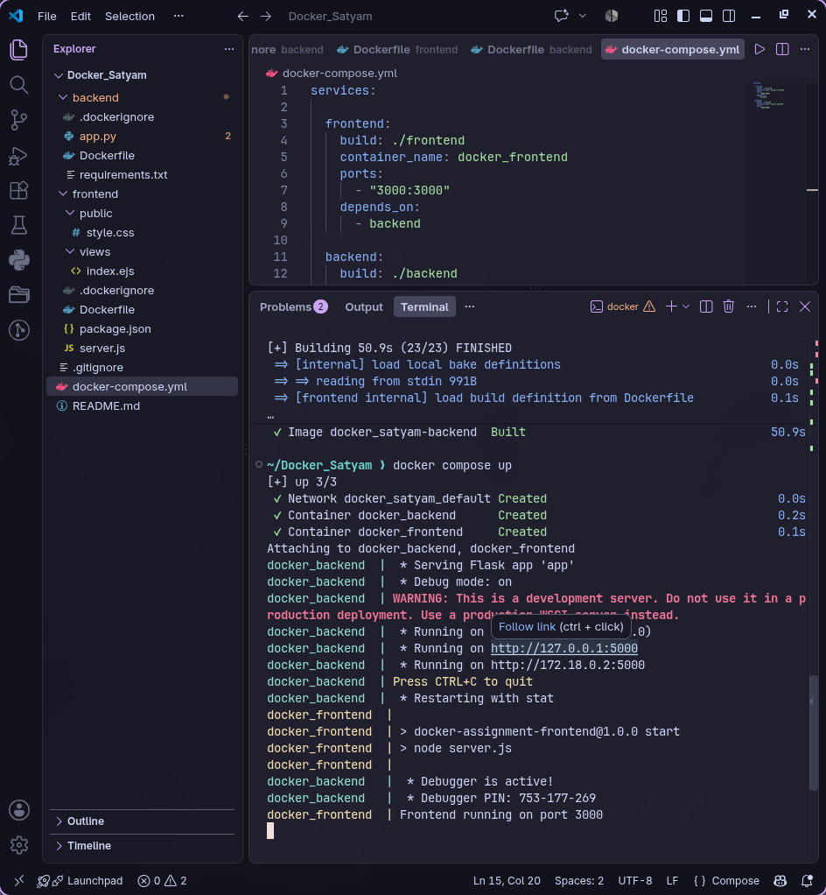

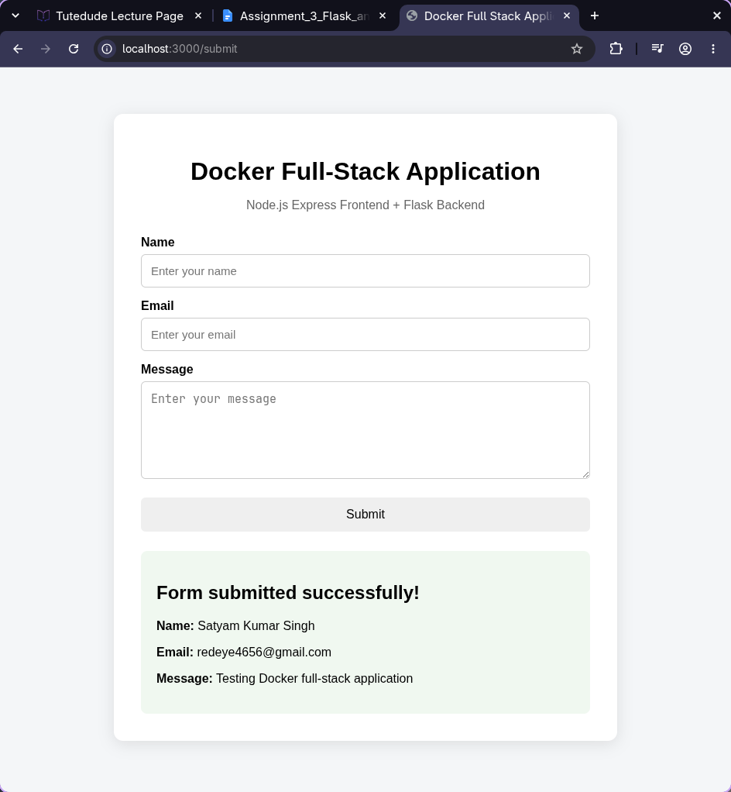

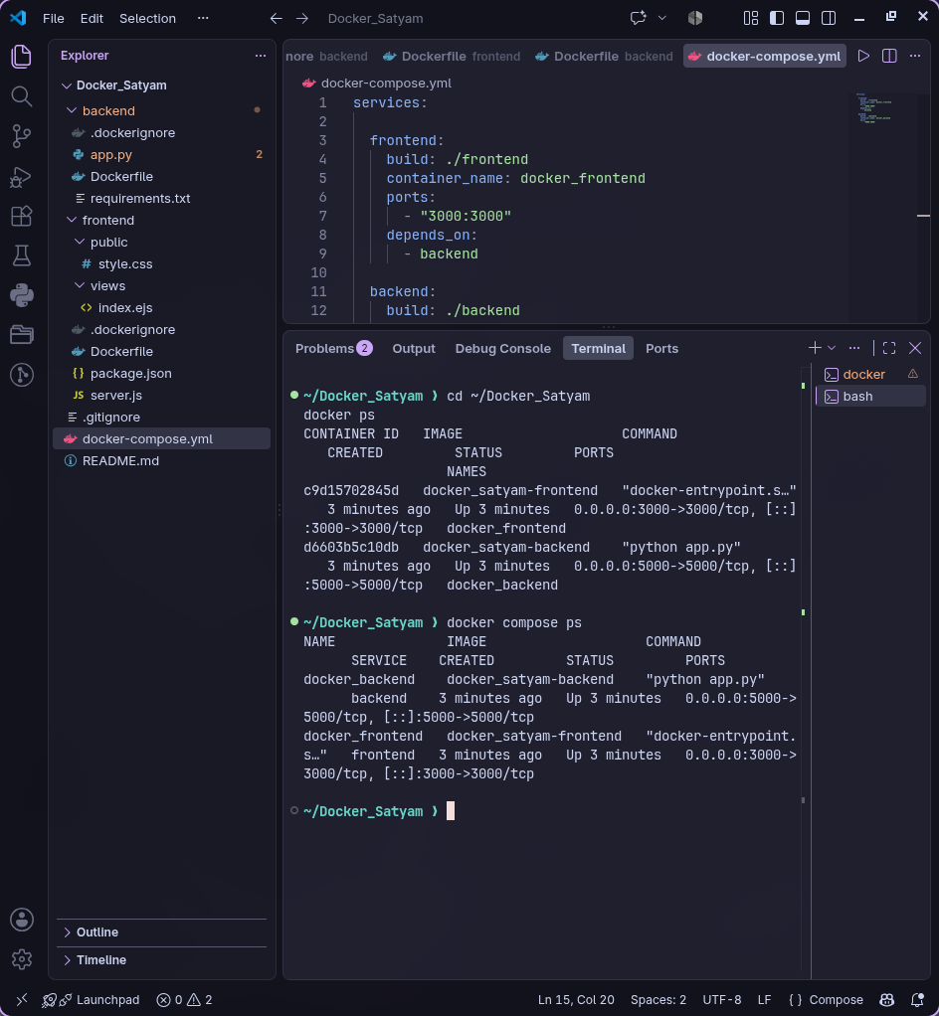

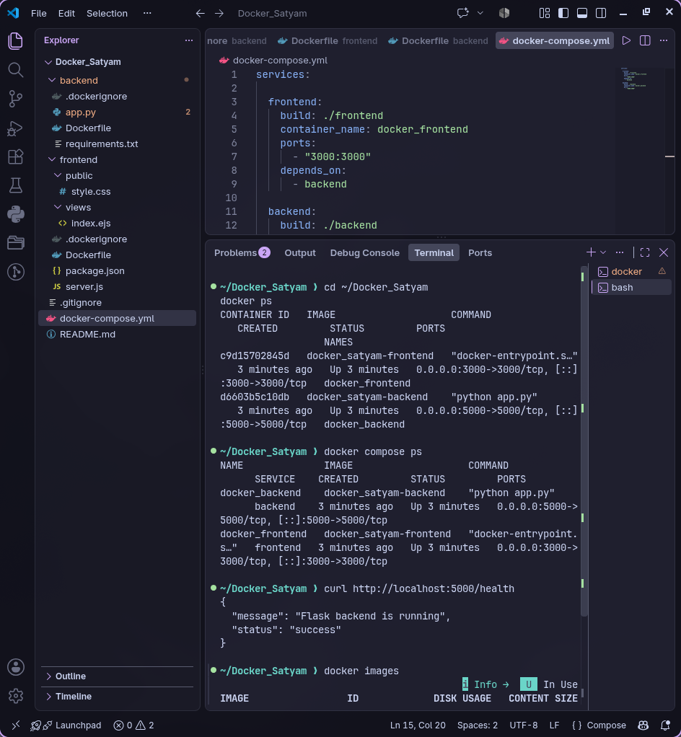
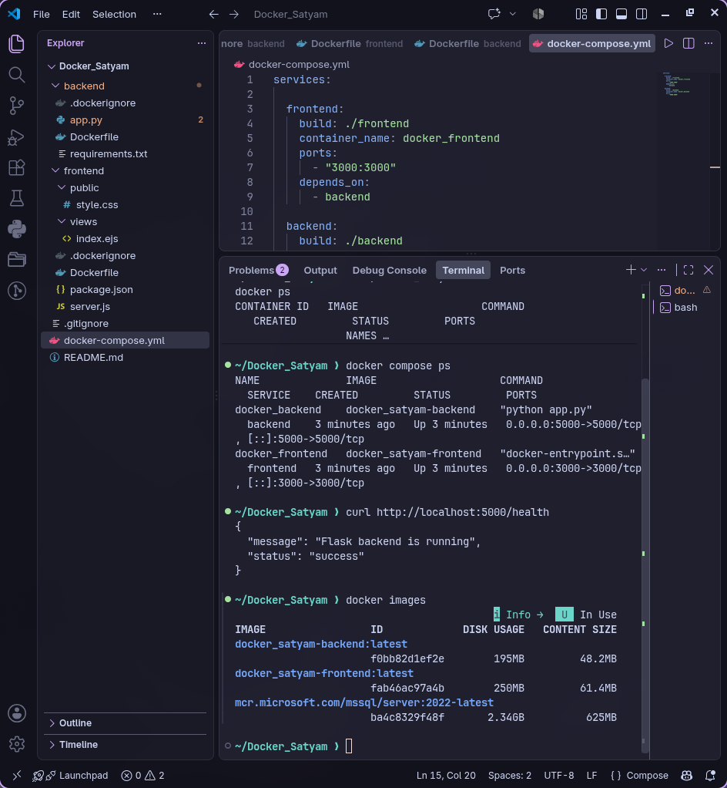
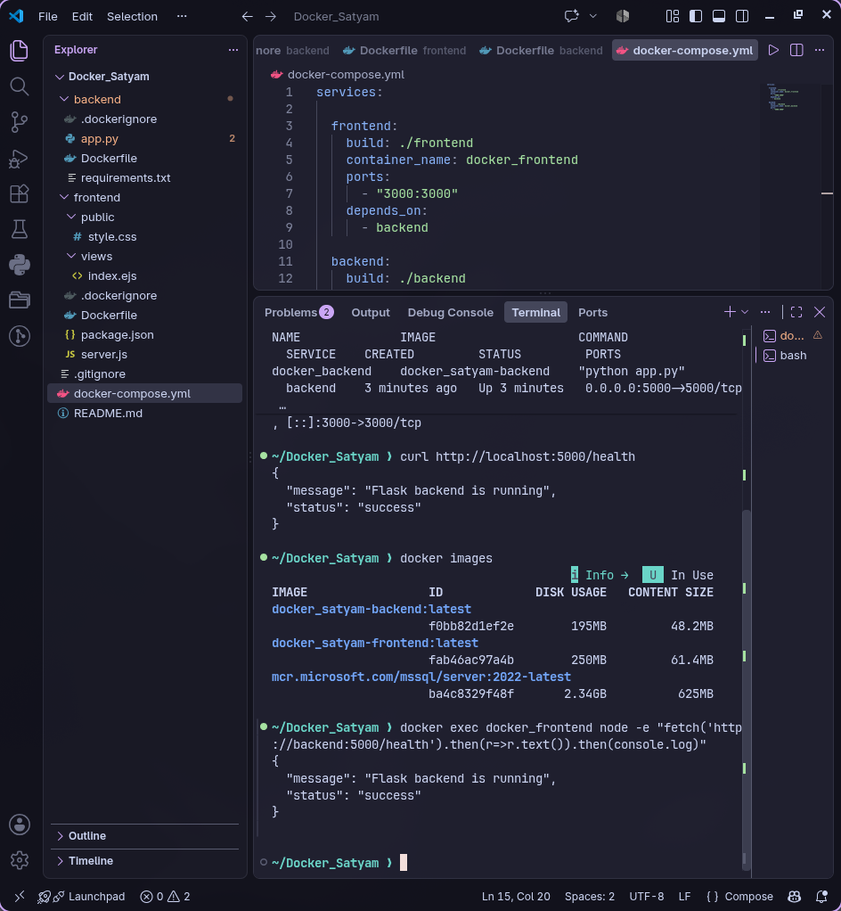
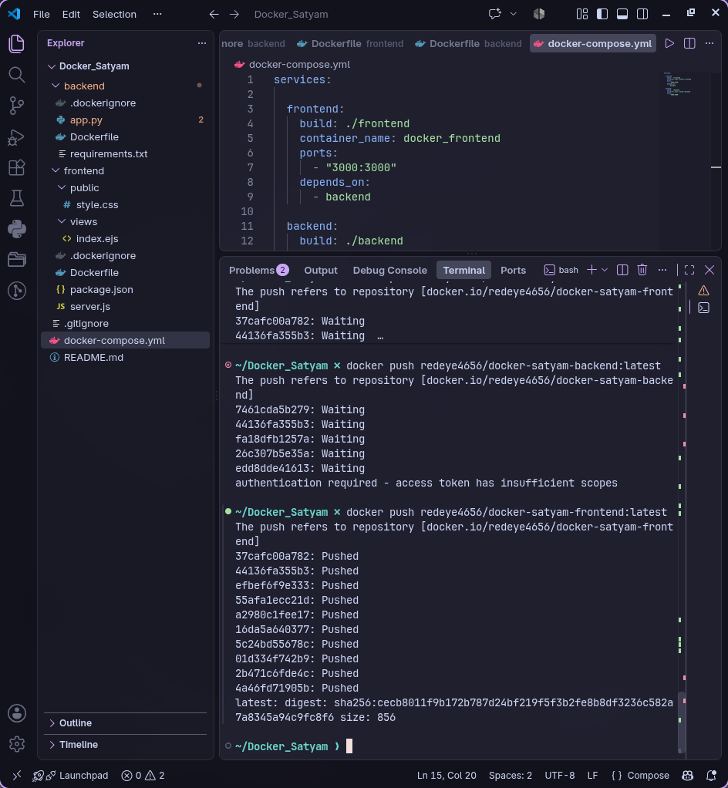
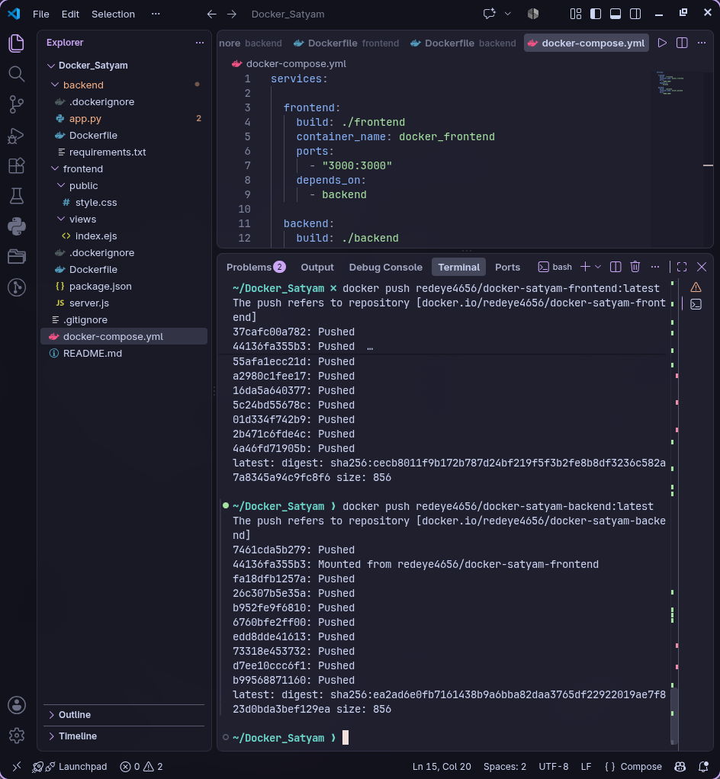
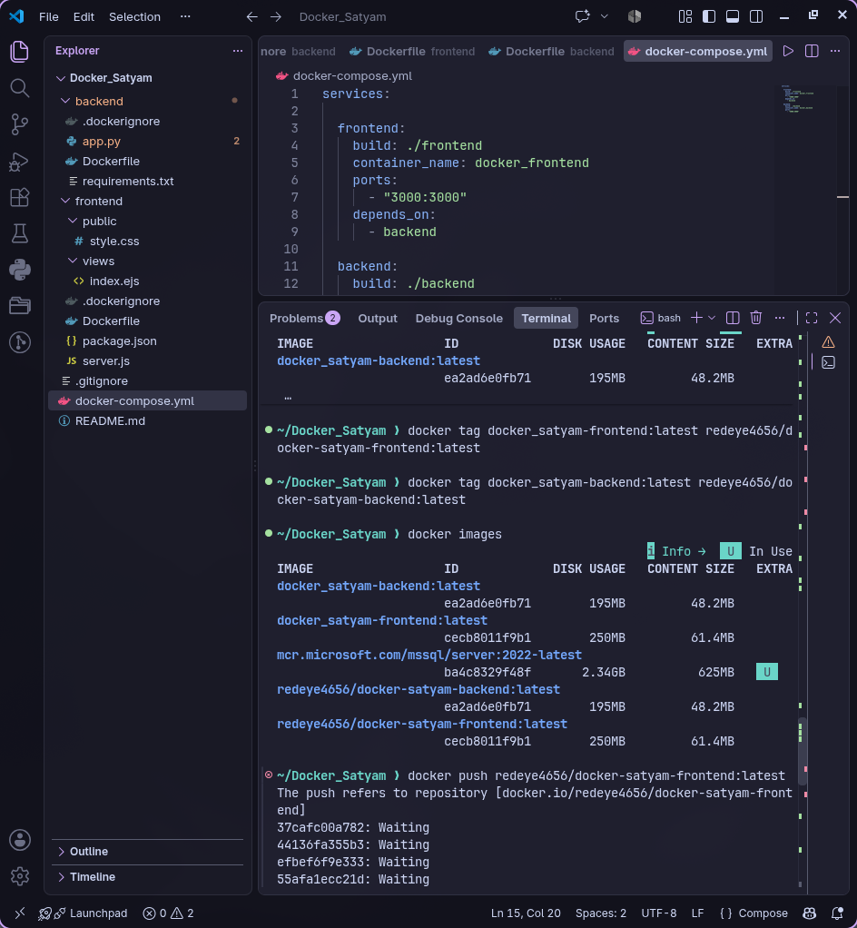
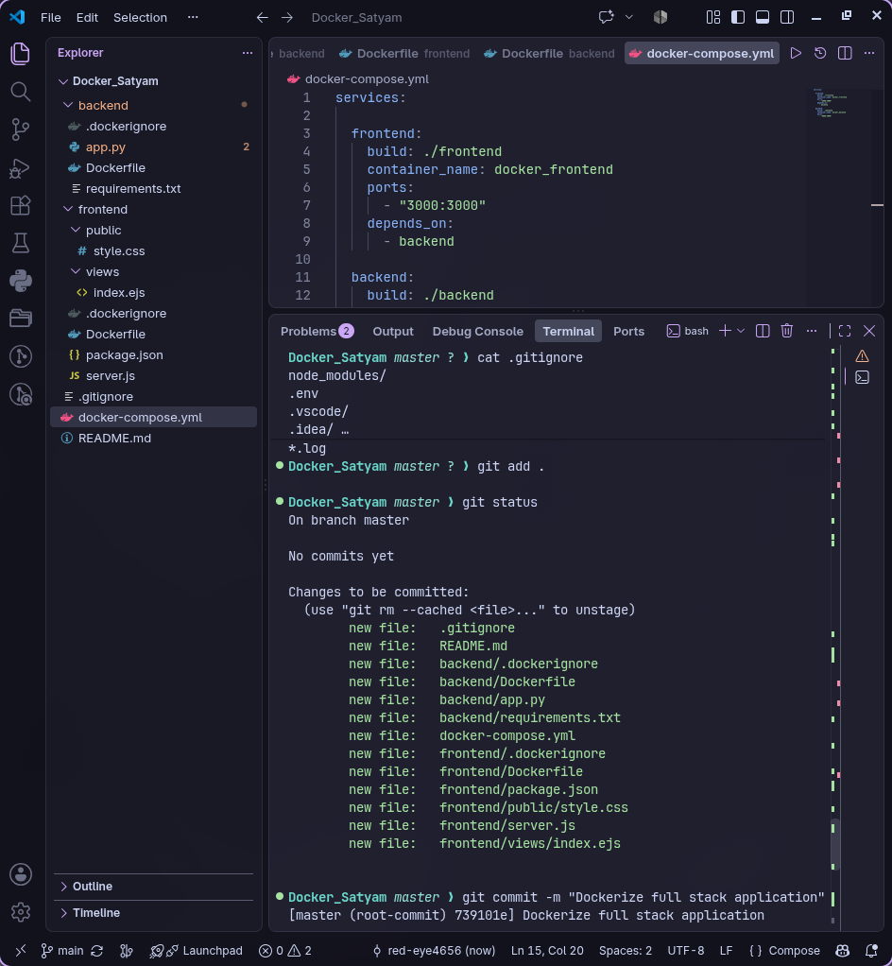

16. Final Submission Links
GitHub Repository:
https://github.com/red-eye4656/Docker-Satyam
Docker Hub Profile:
https://hub.docker.com/u/redeye4656
Docker Hub Images:
redeye4656/docker-satyam-frontend:latest
redeye4656/docker-satyam-backend:latest

