REAL ESTATE CRM
USE CASE DIAGRAM & BPM
Project: Real Estate Property & Client Management CRM

1. Use Case Diagram
The diagram below is a simple version based on the project scope. The main actors are Real Estate Agent, Agency Manager, and System Admin.
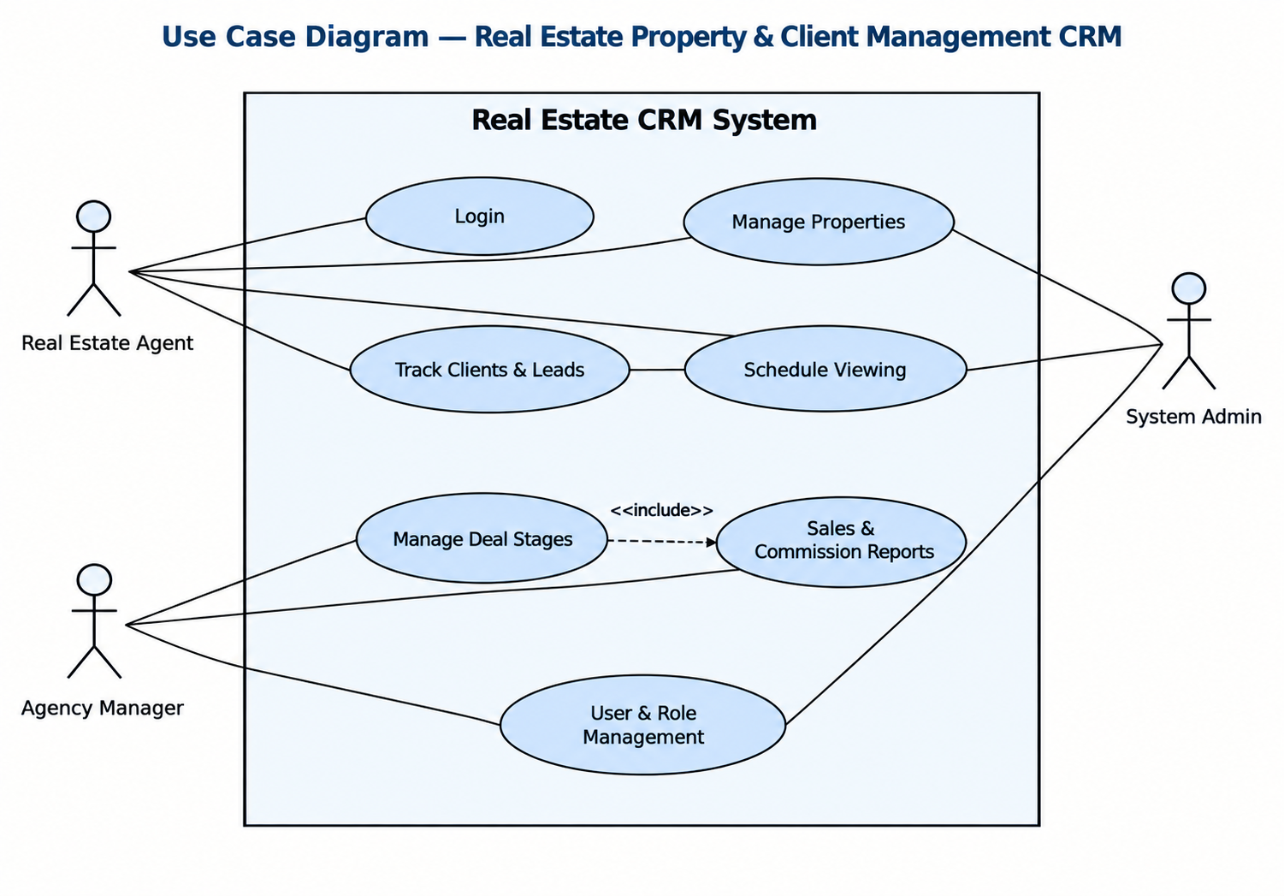

Actor | Main Use Cases | Purpose
Real Estate Agent | Login; Manage Properties; Track Clients & Leads; Schedule Viewing; Manage Deal Stages | Work with assigned properties, clients, leads and viewings.
Agency Manager | Track Clients & Leads; Sales & Commission Reports | Monitor company records, deals and performance.
System Admin | Login; User & Role Management | Manage users and role permissions.

2. Business Process Model (BPM)
This BPM shows a simplified property acquisition and sales process. It follows the project functions for property inventory, client/lead tracking, viewing schedules, deal stages, and sales analytics.
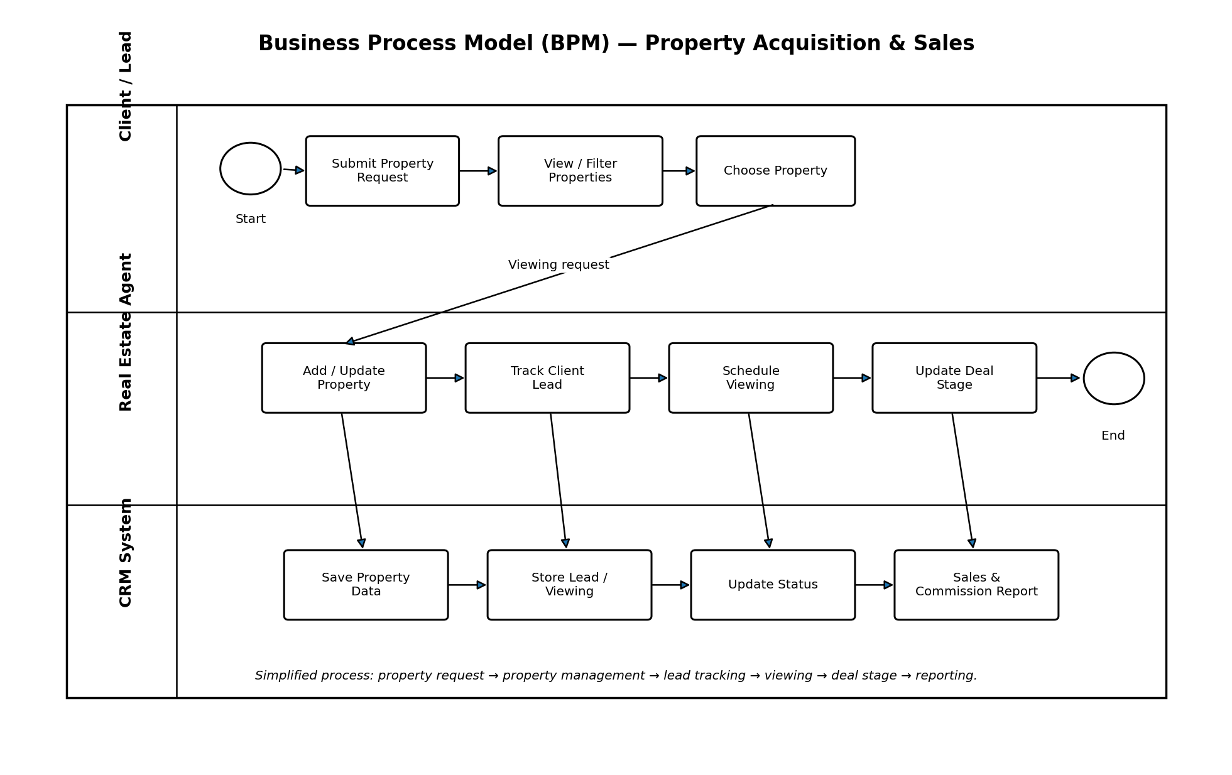

3. Simple Process Steps
1. Client/lead submits a property request.
2. The client can view and filter available properties.
3. The agent adds or updates property information.
4. The CRM stores the property data and tracks the client lead.
5. The agent schedules a property viewing.
6. The agent updates the deal stage.
7. The CRM updates the property/deal status and stores the viewing information.
8. Managers can use sales and commission reports.

Source basis: The project agreement lists User Authentication & Role Management, Property Inventory Management, Client & Deal Tracking, Viewing Schedule & Calendar, and Commission & Sales Analytics as the main project functions.

