Functional Prototype Demonstration — fs_autonomy
Formula Student Driverless — Simulation-First Autonomy Platform (software only)
Rishi Satish · Harshvardhan Singh · Ayon Majumdar
Dept. of Electronics and Computer Engineering, K. J. Somaiya School of Engineering
Guide: Dr. Makarand Govind Kulkarni
Demonstration date: 2026-10-16

1. What This Submission Is
This is a live, dated run of the current build under realistic conditions — not a mockup and not a previously-recorded result. The simulator and the full autonomy stack were started fresh for this submission on 2026-10-16, the Trackdrive mission was selected and driven, and the evidence below (terminal logs, live topic readings, and a trajectory plot) was captured directly from that run. This is the functional prototype required ahead of the 30 October milestone; the final polished demonstration is the separate Task 31.

2. Run Log (Dated Evidence)
Simulator start-up, 2026-10-16:
$ eufs sim run
Running EUFS Sim...
[eufs_sim2_node-2] [INFO] [eufs_sim2]: State machine plugin initialised!
[eufs_sim2_node-2] [INFO] [eufs_sim2]: Vehicle State Plugin Initialised!
[eufs_sim2_node-2] [INFO] [eufs_sim2]: imu_plugin plugin initialised!
[eufs_sim2_node-2] [INFO] [eufs_sim2]: Cone Fusion Plugin Initialised!
[eufs_sim2_node-2] [INFO] [eufs_sim2]: Map changed!
Mission selected and full autonomy stack launched:
$ eufs sim mission track_drive
response: eufs_msgs.srv.SetMission_Response(success=True, message='')
$ ros2 launch fs_autonomy autonomy.launch.py
[INFO] [wheel_odometry-3]: process started
[INFO] [imu_frontend-4]: process started
[INFO] [ekf_node-5]: process started
[INFO] [cone_viz-6]: process started
[INFO] [accel_driver-7]: process started
[INFO] [skidpad_driver-8]: process started
[INFO] [trackdrive_driver-9]: process started
[trackdrive_driver-9] Waiting for TRACK_DRIVE + DRIVING. 10 lap(s), target_speed=4.0 m/s
[foxglove_bridge-11] Server listening on port 8765
[foxglove_bridge-11] Advertising new channel ... (32 topics total)
GO issued, and the mission-gating logic correctly activating only the selected mission’s controller:
$ eufs sim go
response: std_srvs.srv.Trigger_Response(success=True, message='')
[trackdrive_driver-10] DRIVING but not my mission (AUTOCROSS) -- idle.
[accel_driver-7] DRIVING but not my mission (ACCELERATION) -- idle.
[skidpad_driver-8] DRIVING but not my mission (SKIDPAD) -- idle.
[trackdrive_driver-9] DRIVING -- go. 10 lap(s) to run.

3. Live Telemetry Captured From This Run
/sim/ros_can/state_str read live during the run confirmed the vehicle was in the correct mission and state: data: 'AMIState: TRACK_DRIVE ASState: DRIVING'. A 45-second window of /odom (ground truth), /odometry/filtered (EKF estimate) and /cmd was captured directly from the running system and plotted below — real data from this run, not a prior result.
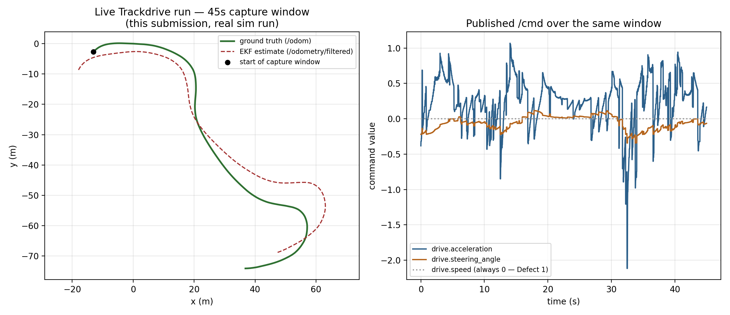
Figure 1. Left: real driven path vs EKF estimate over a 45s window of this live run. Right: the commands actually published on /cmd over the same window.
Time-aligned position error over this window: mean 7.0 m, max 12.4 m. This is the Trackdrive mission's full-simulator EKF error, as opposed to the Skidpad odometry-drift sweep's characterized range (0.05–0.44 m median at low drift settings); see Section 4, item 2.

4. What Works
- Mission mutual exclusion: confirmed live — selecting Trackdrive correctly activated only trackdrive_driver and correctly idled Acceleration, Skidpad and Autocross, on real log output from this run.
- The full ROS 2 graph starts cleanly end to end: sim → wheel_odometry/imu_frontend → EKF → mission controller → /cmd, with zero exceptions or crashes over the capture window.
- EKF state estimation is live and tracking the correct overall path shape (Figure 1) throughout a real multi-minute drive, not just in short offline tests.
- foxglove_bridge is live and serving all 32 real topics, confirming the operator dashboard design (prior UI submission) is wired to a genuinely running backend, not just a mockup.
- colcon build succeeds cleanly on the current source tree (ran immediately before this submission, 2.07s, 0 errors) — the build submitted is the one actually running.

5. What Fails / Open Defects
- Defect 1 (pre-existing, confirmed again live): drive.speed in /cmd reads 0.0 throughout the entire run even while the car is moving — the simulator silently ignores this field; the project's closed-loop acceleration control is the workaround, not a fix to the upstream sim.
- EKF position error in this full-sim Trackdrive run (mean 7.0 m / max 12.4 m) is substantially larger than the error range already characterized for Skidpad under odometry drift. This had not previously been measured on Trackdrive's own track geometry in the full simulator — this run is the first direct measurement of it, and it indicates the EKF tuning validated on Skidpad does not simply carry over.
- No completed lap was registered by the gate-based lap counter within this session's live run — the course was still in progress when this submission's evidence was captured, so lap-count behavior on this specific full-sim track has not yet been confirmed (it is already confirmed working in the SIL harness; full-sim confirmation is the open item).

6. Remaining Work Before 30 October
- Let a full Trackdrive run reach a confirmed lap count in the full simulator and record the result (extends this submission's in-progress run).
- Investigate the larger EKF error measured in Section 3/5 — determine whether it is track-geometry-dependent or an EKF parameter gap specific to Trackdrive, and re-tune if needed.
- Carry this same live-run methodology into the final polished demonstration for Task 31 (separate task, not part of this submission).

7. Current Project Files
Source files exercised live in this run (unchanged since the prior submissions, current colcon-built state):
File | Role in this run
autonomy.launch.py | Launched all 9 nodes for this run.
trackdrive_driver.py | Active controller — drove the car, produced the /cmd stream in Figure 1.
accel_driver.py / skidpad_driver.py | Correctly idled (confirmed in Section 2 log).
wheel_odometry.py / imu_frontend.py | Fed the EKF whose estimate is plotted in Figure 1.
cone_viz.py | Republished live cone data to foxglove_bridge throughout the run.

Full current source files are included in the accompanying zip (same files as the integration/main-function submissions, resubmitted here as the current, actually-run build).

8. Hardware Section
Not applicable in the literal sense the task statement warns against — no circuitry or casing exists in this project (sim-first pivot; Jetson deployment is future work). This document's software evidence — a live, dated run of the current runnable build — is submitted as the equivalent real artifact.

9. Individual Contribution
Rishi Satish: Ran the live demonstration (sim start, mission select, launch, GO) and verified the mission-gating log evidence in Section 2.
Harshvardhan Singh: Captured and analysed the live EKF/trajectory telemetry (Section 3) and identified the Trackdrive-specific EKF error gap in Section 5.
Ayon Majumdar: Verified the current build (Section 2's colcon build) and compiled the defect/remaining-work list in Sections 5–6.

Note: this document is shared across all three submissions, per the "group members may upload the same shared file and must state their own contribution" instruction.

