UI Design: Operator Dashboard — fs_autonomy
Formula Student Driverless — Simulation-First Autonomy Platform (software only)
Rishi Satish · Harshvardhan Singh · Ayon Majumdar
Dept. of Electronics and Computer Engineering, K. J. Somaiya School of Engineering
Guide: Dr. Makarand Govind Kulkarni

1. What Counts as the "User Interface" Here
This project has no custom app frontend (no React/Qt/web client) — the system is a set of ROS 2 backend nodes. The actual human-facing interface the project ships is the live operator dashboard, built on Foxglove Studio (an off-the-shelf ROS visualization client) and fed by this project's own code: cone_viz.py, which republishes raw simulator cone data as a format Foxglove can render (visualization_msgs/MarkerArray), plus the real topics the mission controllers publish (/cmd, /odometry/filtered, /sim/ros_can/state_str). This is the same dashboard referenced in the earlier PoC and integration submissions when it was mentioned as “running on Foxglove.”
A Foxglove Studio layout is a JSON file — panel types, topic bindings, and screen arrangement, all human-editable — making it the direct software-project equivalent of an editable PCB layout: it is the actual design source for the screens, and it can be re-opened and edited in the same tool that renders it.

2. Main Screens and Navigation
The dashboard is organised as three tabs (Foxglove’s Tab panel), giving the operator a linear navigation flow matching an actual run: confirm state before driving, watch the car drive, then check estimator health after. Screens below are layout mockups of the design (not live captures — no run was active while building this submission); the panel bindings they illustrate are exactly what foxglove_layout.json defines.
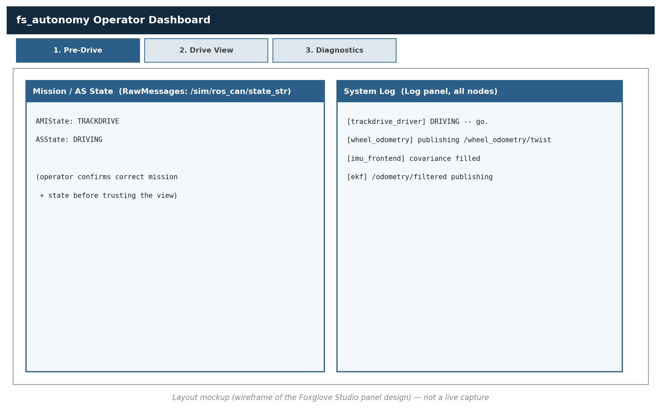
Figure 1. Screen 1 — Pre-Drive: confirm mission + AS state, watch node startup log before trusting the view.
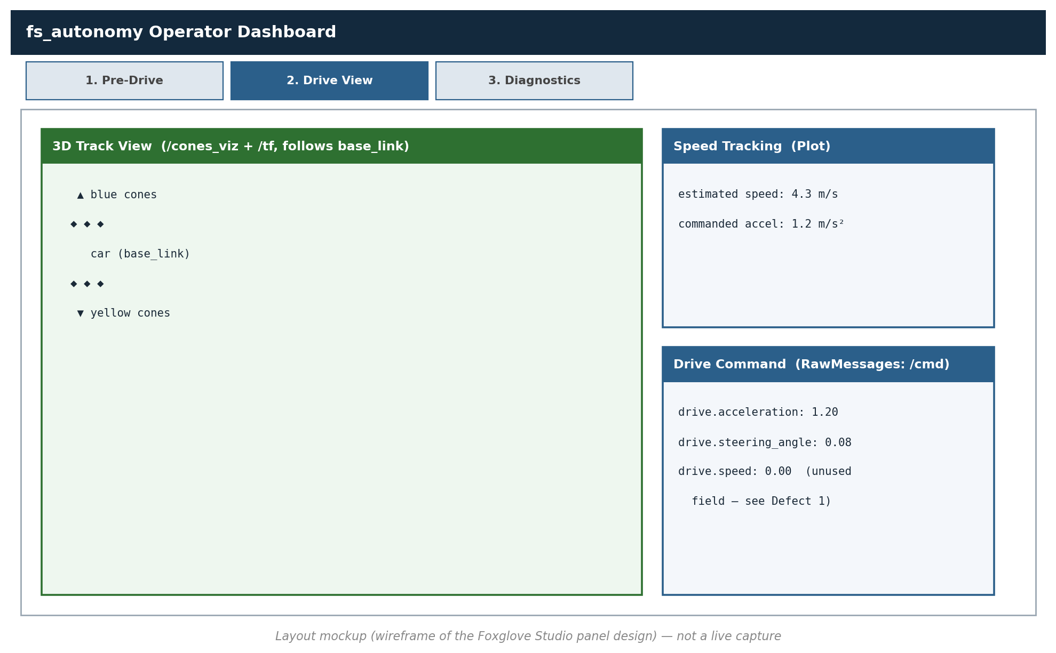
Figure 2. Screen 2 — Drive View: 3D cone/car view, live speed tracking, and the raw /cmd output — the same control loop traced in the integration submission.
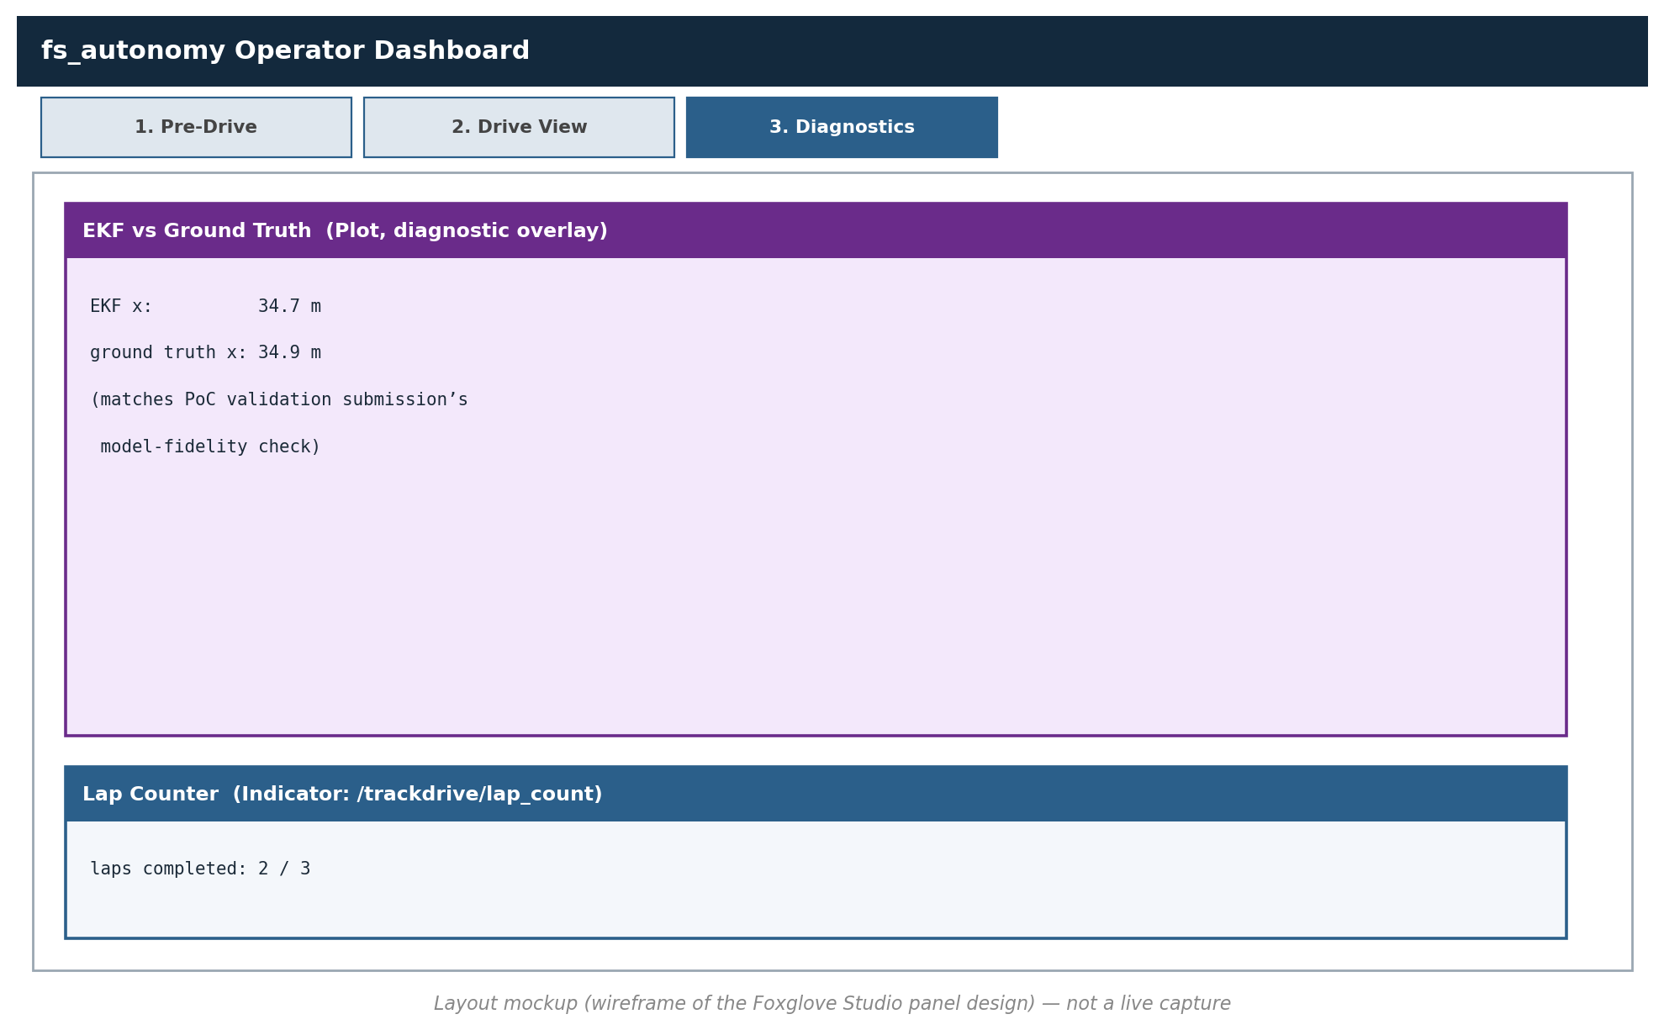
Figure 3. Screen 3 — Diagnostics: EKF vs ground-truth overlay and lap counter, for post-run review.
Navigation between the three is a single tab-click, by design: an operator at a live run should never need more than one click to get from “is it safe to drive” to “is it driving correctly” to “why did it do that”.

3. Design Explanation
Screen 1 exists because of a real incident class this project designs around. an operator must see AMIState/ASState before trusting anything else on screen — the mission-gating logic every controller runs (see the integration submission, Section 3.1) is exactly this same state, so the dashboard surfaces it first.
Screen 2's 3D view is driven by cone_viz.py, not a generic point cloud. it recolours and resizes markers per the project's own cone classification (classify(), same function used in trackdrive_driver.py), so what the operator sees matches what the controller is reasoning about — not a raw unlabeled scan.
The /cmd raw-message panel deliberately exposes drive.speed. to make the known simulator defect (drive.speed silently ignored, Defect 1 from the IEEE paper) visible on screen rather than hidden, so an operator isn't misled into thinking that field does anything.
Screen 3's EKF-vs-ground-truth plot is the same comparison as the PoC validation submission. reused here as a live/continuous view rather than a one-off offline measurement.

4. Frontend / Interface Source Files
File | Role
foxglove_layout.json | Editable design source for all three screens — panel types, topic bindings, tab navigation. Import via Foxglove Studio → Layout → Import from file.
cone_viz.py | Frontend data-adapter: converts raw simulator cone messages into the classified, coloured markers Screen 2 renders.

Excerpt of the Screen 2 / Screen 3 panel bindings from foxglove_layout.json:
"Plot!drive_speed": {
"paths": [
{ "value": "/odometry/filtered.twist.twist.linear.x", "label": "estimated speed" },
{ "value": "/cmd.drive.acceleration", "label": "commanded accel" }
],
"title": "Speed Tracking"
},
"Plot!diag_ekf_error": {
"paths": [
{ "value": "/odometry/filtered.pose.pose.position.x", "label": "EKF x" },
{ "value": "/odom.pose.pose.position.x", "label": "ground truth x" }
],
"title": "EKF vs Ground Truth (diagnostics)"
}

5. Hardware Section
Not applicable in the literal sense the task statement warns against — there is no PCB or FPGA in this project (hardware was dropped in favour of a sim-first platform; Jetson deployment remains future work). The equivalent real artifact for a software-only project — an editable interface design with a design explanation — is submitted above in place of it.

6. Individual Contribution
Rishi Satish: Defined the Pre-Drive screen's state/log panel bindings and the overall tab navigation structure in foxglove_layout.json.
Harshvardhan Singh: Built cone_viz.py (the classification-to-marker adapter powering Screen 2's 3D view) and the Drive View panel bindings.
Ayon Majumdar: Designed the Diagnostics screen (EKF-vs-ground-truth plot, lap counter) and produced the layout mockups in this document.

Note: this document is shared across all three submissions, per the "group members may upload the same shared file and must state their own contribution" instruction.

