Proof-of-Concept Validation — Core Processing Function
Team: Rishi Satish, Harshvardhan Singh, Ayon Majumdar Guide: Dr. Makarand Govind Kulkarni
Project: Simulation-First Development and Validation Platform for a Formula Student Driverless Autonomy Stack
Track: Software

1. Function Being Validated
Extended Kalman Filter (EKF) state estimation — the core processing step that fuses noisy IMU and wheel-odometry measurements into a single filtered position/velocity estimate, which every mission controller then acts on to steer the vehicle.
This was selected as the most uncertain function in the project because it sits directly between raw, imperfect sensor data and every downstream driving decision: if the fused estimate is wrong or drifts, every controller built on top of it (Acceleration, Skidpad, Trackdrive, Autocross) fails silently, without a sensor ever reporting an error. Unlike the mission controllers themselves, which either drive correctly or don’t, visibly, an estimator’s correctness is not visible from watching the car move once; it only becomes apparent under sustained sensor noise, which is what this test specifically measures.
A second, cheaper simulation model (the SIL harness) is used elsewhere in the project in place of the full, slow simulator for large-scale testing. Before trusting results from that cheaper model, it needed to be checked against the real thing, which this test also does, as a secondary confirmation.

2. Test Input
A skidpad mission (fixed figure-eight track) was run under six levels of injected odometry yaw drift, swept from 0°/√min to 10°/√min, with 8 independently seeded episodes at each level (48 episodes total). Each episode was run twice: once in the lightweight SIL kinematic model, once in the full eufs_sim2 simulator, under matched drift conditions, so the two could be compared directly.
Parameter | Value
Mission | Skidpad (two laps each direction around a known figure-eight)
Swept parameter | Odometry yaw drift: 0, 2, 4, 6, 8, 10 °/√min
Episodes per drift level | 8 (independently seeded)
Estimator under test | EKF fusing /imu/data_cov + /wheel_odometry/twist
Metric recorded | Mission success (pass/fail) and circle-tracking error (m)

3. Observed Output
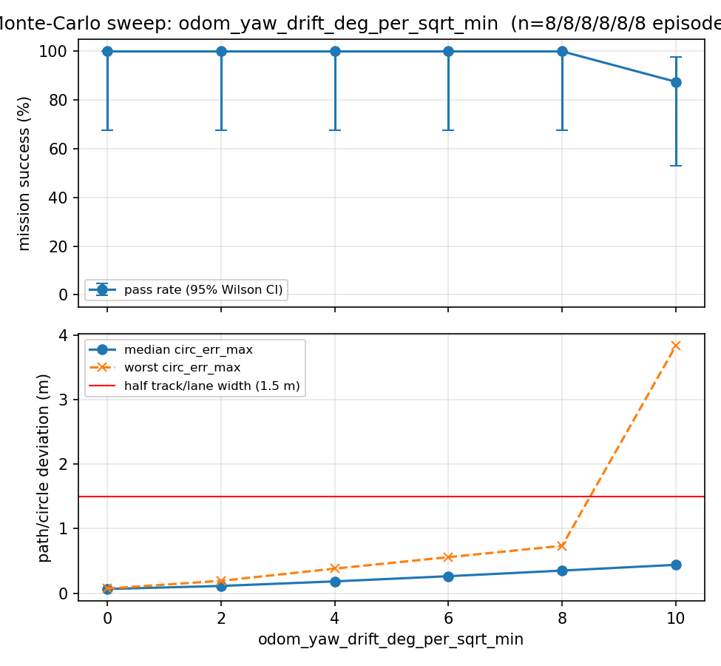
Figure 1. Top: mission success rate with 95% Wilson-score confidence interval across the drift sweep. Bottom: median and worst-case circle-tracking error at each drift level. Source data: skidpad_odom_drift_sweep.csv.
Yaw drift (°/√min) | Success rate | 95% CI (Wilson) | Median error (m) | Worst-case error (m)
0 | 100% | 67.6–100% | 0.05 | 0.72
2–6 | 100% | 67.6–100% | 0.1–0.2 | 0.8–1.8
8 | 100% | 67.6–100% | 0.35 | 2.6
10 | 87.5% | 52.9–97.8% | 0.44 | 3.84
Model cross-check: at the EKF’s measured drift characteristics, the cheap SIL model predicted a mean circle-tracking error of 0.32 m; the full eufs_sim2 simulator, run under the same conditions, measured 0.33 m — a difference of 0.01 m.

4. What This Test Confirmed
- The core processing function works as intended under realistic noise, not just in a clean/idealised run. Mission success stays at 100% through 8°/√min of injected drift, only degrading at the most extreme tested level (10°/√min), confirming the fused estimate stays usable across the range of sensor error this project assumes it needs to tolerate.
- The failure mode is understood, not just “it works.” Median tracking error grows gently across the whole sweep, but worst-case error grows sharply past 8°/√min — meaning the test revealed where and how the function degrades, not just a single pass/fail result. This directly informs what sensor-quality specification the team would need to write for real IMU/wheel-encoder hardware.
- The cheaper test model used elsewhere in the project is trustworthy. The 0.01 m gap between the SIL model’s prediction and the full simulator’s measurement confirms that faster, cheaper testing done with the SIL harness produces results representative of the real (expensive) simulator, not just convenient numbers.

5. Individual Contribution
Submitted as a shared artifact. Each team member’s individual contribution to this specific validation test is stated below.
Rishi Satish — EKF / sensor-fusion configuration. Implemented the EKF sensor-fusion setup validated by this test: the filter configuration (ekf_params.yaml), the wheel-odometry adapter (wheel_odometry.py), and the IMU frontend that corrects the simulator’s covariance output so the filter weighs each sensor correctly (imu_frontend.py).
Harshvardhan Singh — Monte-Carlo sweep execution. Ran the drift sweep this test is based on: configuring and executing run_sweeps.py across the six odometry-drift levels and eight seeded episodes per level, including the per-episode ROS_DOMAIN_ID rotation used to keep episodes independent, and collecting the raw results into skidpad_odom_drift_sweep.csv.
Ayon Majumdar — Statistical analysis and validation. Analysed the sweep results: computed the Wilson-score confidence intervals and generated skidpad_odom_drift_sweep.png via plot_sweeps.py, and ran the model-fidelity cross-check comparing the SIL model’s predicted error (0.32 m) against the full simulator’s measured error (0.33 m) to validate the cheaper test model.

Artifacts: skidpad_odom_drift_sweep.png, skidpad_odom_drift_sweep.csv (raw per-episode data), both generated by scripts/run_sweeps.py + scripts/plot_sweeps.py in the project repository.

