Deployment & Packaging Design — fs_autonomy
Formula Student Driverless — Simulation-First Autonomy Platform (software only)
Rishi Satish · Harshvardhan Singh · Ayon Majumdar
Dept. of Electronics and Computer Engineering, K. J. Somaiya School of Engineering
Guide: Dr. Makarand Govind Kulkarni

1. Packaging Approach
fs_autonomy is packaged as a Docker container built from docker/Dockerfile. The base image, ros:humble-ros-base, is multi-arch: the exact same Dockerfile builds an x86_64 image on the development VM and an arm64 image on an NVIDIA Jetson (JetPack 6, Ubuntu 22.04 L4T) without any change to the source — this is the same containment-architecture guarantee documented in the project's IEEE paper (the package has no build dependency on the simulator, only on message definitions, so the same artifact deploys unchanged to an embedded target).
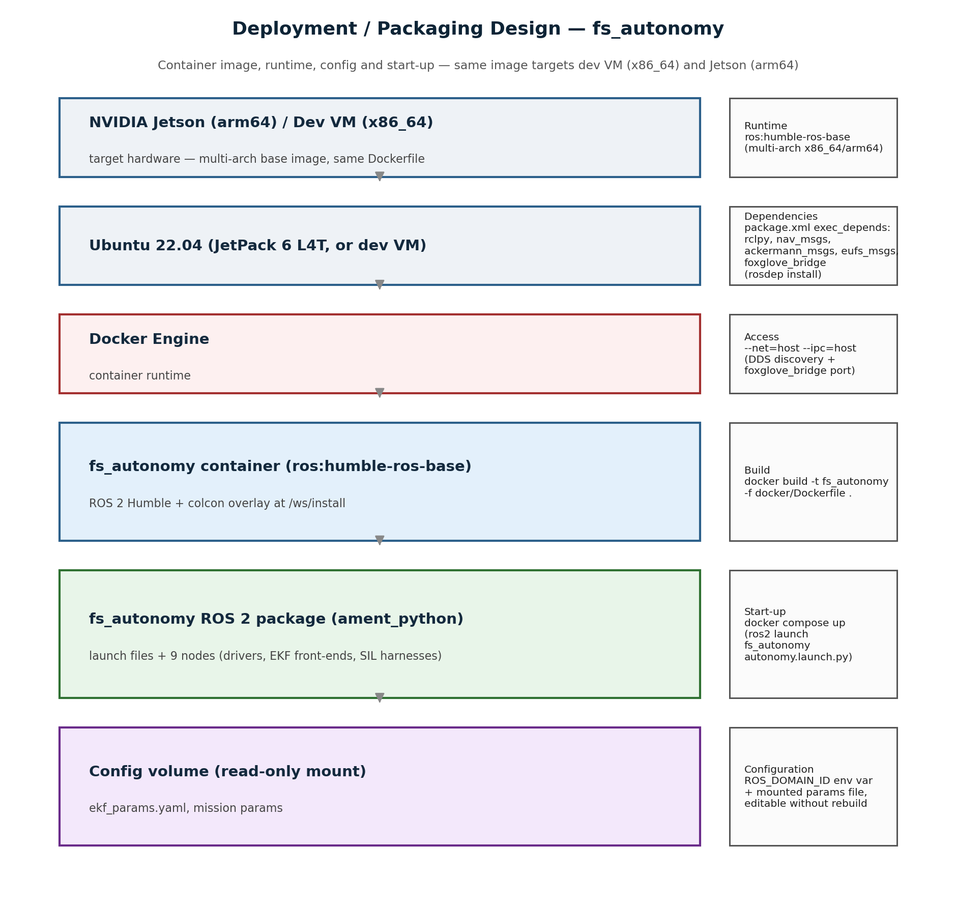
Figure 1. Deployment diagram — hardware → OS → container runtime → ROS 2 package, with runtime, dependencies, access and start-up annotated per layer.

2. Runtime
Base runtime image: ros:humble-ros-base (ROS 2 Humble on Ubuntu 22.04). The package itself builds with ament_python / colcon inside the image, producing an install overlay at /ws/install that is sourced automatically in place of the base ROS install (docker/Dockerfile, line 30).

3. Dependencies
Declared in src/fs_autonomy/package.xml and resolved at image-build time with rosdep install (Dockerfile line 25):
<exec_depend>rclpy</exec_depend>
<exec_depend>std_msgs</exec_depend>
<exec_depend>nav_msgs</exec_depend>
<exec_depend>ackermann_msgs</exec_depend>
<exec_depend>visualization_msgs</exec_depend>
<exec_depend>eufs_msgs</exec_depend>
<exec_depend>ros2launch</exec_depend>
<exec_depend>foxglove_bridge</exec_depend>
eufs_msgs (pure message definitions, no simulator code) is cloned directly into the image at build time — it is the only thing this package shares with eufs_sim2, by design.

4. Configuration
Runtime configuration is kept out of the image so it can be tuned on a deployed unit without a rebuild: docker-compose.yml mounts src/fs_autonomy/config (which holds ekf_params.yaml and mission parameters) as a read-only volume, and sets ROS_DOMAIN_ID via an environment variable to isolate this vehicle's ROS graph from any other DDS traffic on the same network.
environment:
- ROS_DOMAIN_ID=42
- RMW_IMPLEMENTATION=rmw_fastrtps_cpp
volumes:
- ../src/fs_autonomy/config:/ws/src/fs_autonomy/config:ro

5. Access
The container runs with --net=host --ipc=host (Dockerfile header comment; mirrored in docker-compose.yml's network_mode: host). Host networking is required for ROS 2's DDS discovery protocol (which uses dynamic multicast/UDP ports that don't map cleanly through normal Docker port publishing) and for foxglove_bridge, which must be reachable from the operator dashboard described in the prior UI design submission.

6. Start-Up Steps
# Build (once, or after a source change)
docker build -t fs_autonomy -f docker/Dockerfile .
# Run interactively
docker run --rm -it --net=host --ipc=host fs_autonomy \
ros2 launch fs_autonomy autonomy.launch.py
# Or, using the compose file (build + config volume + restart policy together)
docker compose -f docker/docker-compose.yml up --build
# Or, for an always-on deployed unit: enable the systemd unit so it starts on boot
sudo cp docker/fs_autonomy.service /etc/systemd/system/
sudo systemctl enable --now fs_autonomy

7. Editable Design Files Submitted
File | Role
docker/Dockerfile | Image definition: runtime base, dependency install, build. Pre-existing project file, used as-is.
docker/docker-compose.yml | Config + access + start-up: env vars, read-only config volume, host networking, restart policy. Written for this submission.
docker/fs_autonomy.service | Boot-time start-up for a permanently deployed unit (systemd unit wrapping docker compose up/down). Written for this submission.

A live container build was not run for this submission (no Docker daemon available on the current development VM); the Dockerfile and commands above are the project’s existing, previously-used packaging artifact, not new/untested instructions — docker/Dockerfile predates this submission.

8. Hardware Section
Not applicable in the literal sense the task statement warns against — there is no casing, PCB, or 3D-printed enclosure in this project (hardware was dropped in favour of a sim-first platform; see the IEEE report brief's Future Scope). The equivalent real artifact for a software-only project — a deployment/packaging design covering runtime, dependencies, configuration, access and start-up — is submitted above in its place.

9. Individual Contribution
Rishi Satish: Maintains the base Dockerfile (runtime image, dependency install, build) and verified the multi-arch build claim against package.xml's exec_depends.
Harshvardhan Singh: Wrote docker-compose.yml (configuration volume, environment variables, host-networking access) for this submission.
Ayon Majumdar: Wrote the systemd start-up unit (fs_autonomy.service) and the deployment diagram in this document.

Note: this document is shared across all three submissions, per the "group members may upload the same shared file and must state their own contribution" instruction.

