Integration & Demonstration — fs_autonomy
Formula Student Driverless — Simulation-First Autonomy Platform (software only)
Rishi Satish · Harshvardhan Singh · Ayon Majumdar
Dept. of Electronics and Computer Engineering, K. J. Somaiya School of Engineering
Guide: Dr. Makarand Govind Kulkarni

1. What Is Being Integrated
This submission connects the system's interface (the entry point that wires every node together, and the ROS 2 topics that cross the boundary to and from the simulator, which stands in for the real vehicle sensors/actuators) to the core logic (the Trackdrive mission controller's cone classification, gate-based lap counting, and closed-loop control). The demonstration shows one complete pass through the system: a raw sensor input enters at the interface, is validated and acted on by the core logic, updates internal state, and produces a validated output back across the interface — the full call chain, not an isolated unit.
No microcontroller or FPGA is used in this project (see Section 7 of this document and the prior submissions for context); the entire system is software, built on ROS 2 Humble and validated against the eufs_sim2 simulator in place of physical vehicle hardware.

2. Interface Diagram
The diagram below shows the external interface (simulator topics, left) wired through the system entry point into the integrated core logic (centre), with the EKF state-estimation path (right) feeding back into control. Orange boxes are ROS 2 topics crossing the interface boundary; blue boxes are the integrated software modules in this submission.
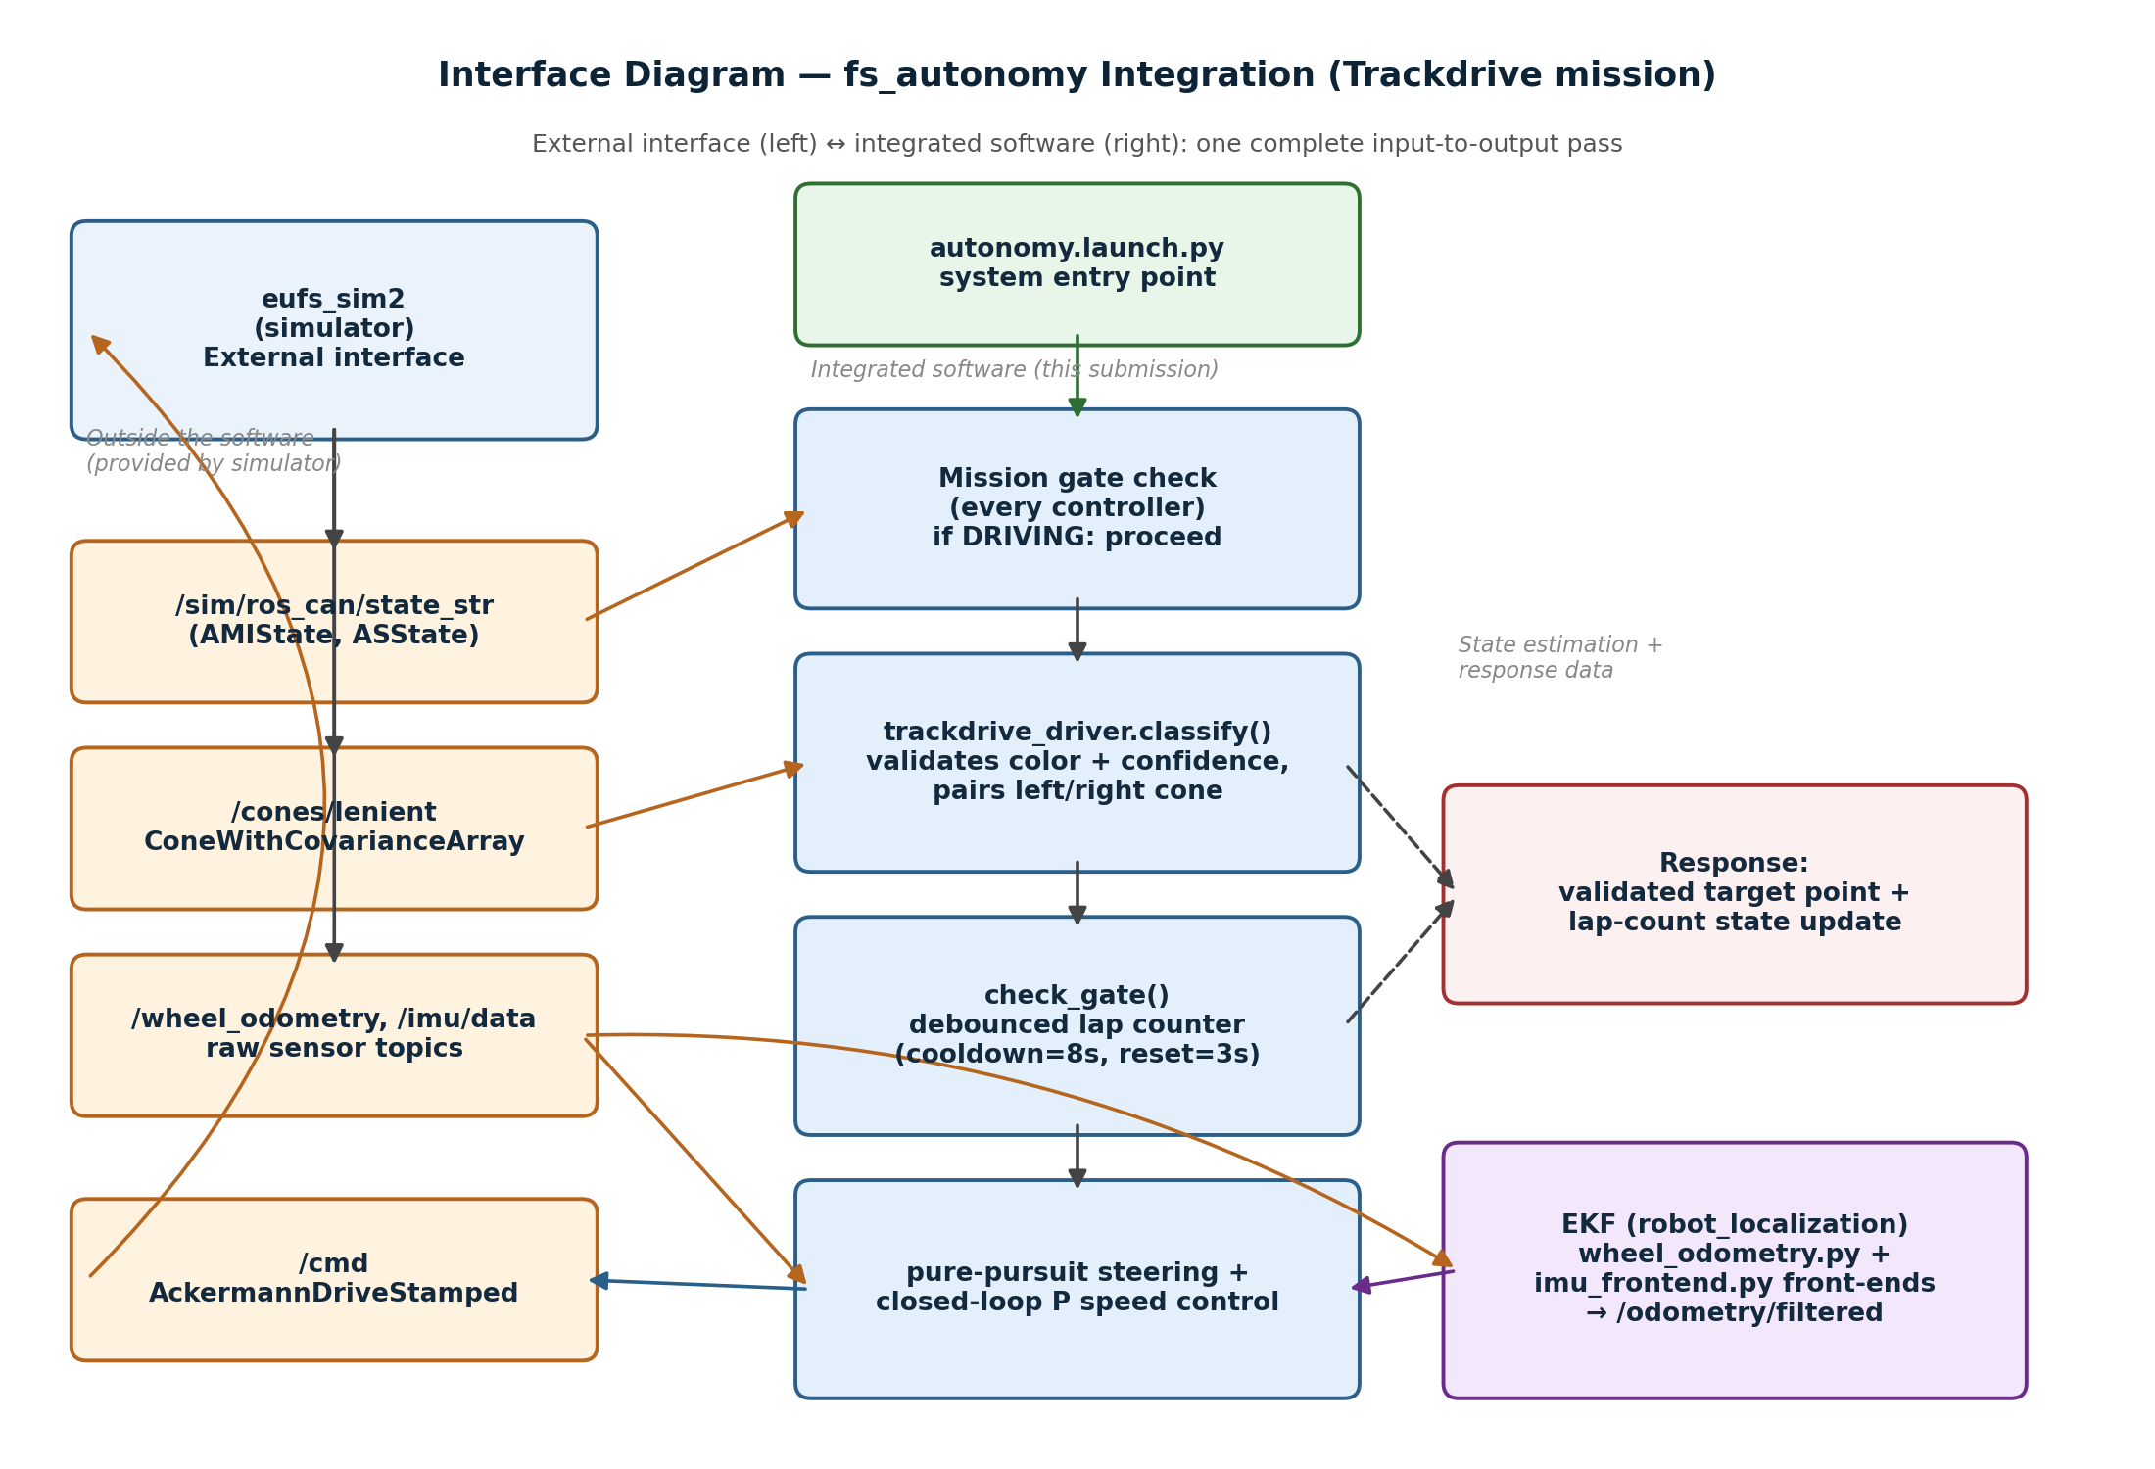
Figure 1. Interface diagram — one complete input-to-output pass through the integrated system (Trackdrive mission).

3. Integration Walkthrough — One Complete Operation
Traced below is a single end-to-end pass: a cone-detection message arriving from the simulator, through validation and core logic, to a published drive command. File: src/fs_autonomy/fs_autonomy/trackdrive_driver.py.

3.1 Call — sensor input crosses the interface
The simulator publishes a cone-detection array on /cones/lenient. The controller's subscriber callback on_cones() receives it (line 175):
def on_cones(self, msg):
self.cones_msg = msg
self.cones_rx_time = self.get_clock().now()
if self.driving and not self.finished:
self.check_gate(msg)
This call only proceeds if self.driving is True — set by on_state() (line 143), which gates on the vehicle's AMIState (correct mission selected) and ASState (DRIVING). This is the mission-gate check every controller performs before touching the vehicle.

3.2 Validation — classify() and check_gate()
check_gate() (line 181) validates each cone in the incoming message before using it: it classifies colour via classify(cone), rejects any cone behind the car or outside gate_range, and separates left/right gate cones by sign of y:
def check_gate(self, msg):
left_gate = right_gate = None
for cone in msg.cones:
if classify(cone) != "big_orange":
continue
x, y = cone.point.x, cone.point.y
r = math.hypot(x, y)
if x < 0.2 or r > self.gate_range:
continue
if y > 0.0:
left_gate = r if left_gate is None else min(left_gate, r)
else:
right_gate = r if right_gate is None else min(right_gate, r)
The gate is only counted as “seen” once both left_gate and right_gate resolve. This is the validation step: raw detections are filtered by colour, range, and heading before they are allowed to change any state.

3.3 Data change — debounced state update
A validated gate sighting updates internal state (self.laps, self.last_gate_time) only on a debounced rising edge — gated two ways, both wall-clock: gate_cooldown (8 s) prevents one physical gate crossing being double-counted, and gate_reset_time (3 s) prevents a single dropped detection frame from looking like the gate leaving and reappearing. This logic is documented directly in the function's docstring (lines 182–196) because it replaced an earlier distance-based counter that produced phantom laps under odometry drift.

3.4 Response — command crosses back over the interface
Once the controller has a validated target point (from the cone geometry) and current lap state, it computes a pure-pursuit steering angle and a closed-loop P-controlled speed target, and publishes an AckermannDriveStamped message on /cmd. The simulator consumes this on the next physics tick and the car's position/velocity update, which arrives back at on_odom() (line 168) and the EKF (wheel_odometry.py + imu_frontend.py → /odometry/filtered) on the next cycle — closing the loop.

4. Integrated Files Submitted
File | Role in the integration
autonomy.launch.py | System entry point — starts every node below together, wires topic remaps.
trackdrive_driver.py | Core logic demonstrated above: classify(), check_gate(), pure-pursuit control.
wheel_odometry.py | Interface adapter — converts raw wheel-speed topic into TwistWithCovarianceStamped for the EKF.
imu_frontend.py | Interface adapter — fills in covariance fields the simulator IMU topic omits, for the EKF.
accel_driver.py / skidpad_driver.py | Same gate-and-control pattern applied to the other two missions (for comparison).

All files are included in the accompanying source_files.zip (same files as the prior "main function" submission, resubmitted here as the integrated set for this task).

5. Demonstration Video
This task requires a short screen-recorded demonstration showing the integration running live — this is not something that can be produced from source alone and must be recorded on the machine running the simulator. Steps:
- Terminal 1: start the simulator — eufs sim run
- In the simulator GUI: select the Trackdrive mission, then move the RES slider to READY and press GO (ASState → DRIVING).
- Terminal 2: launch the integrated stack — ros2 launch fs_autonomy autonomy.launch.py
- Open rqt or Foxglove Studio and add: the simulator's 3D view (or camera feed), a plot of /odometry/filtered, and echo of /cmd — this is what makes the input→processing→output chain visible on screen.
- Record 30–90 seconds showing: the car starting to move after GO, at least one cone-gate pass (watch the terminal log line for the lap counter incrementing), and the car responding to a steering correction.
- Save as .mp4 and submit alongside this document and the source files.
A finished SIL (software-in-the-loop) run already exists as prior evidence of this same control loop (3/3 laps completed, 0.10 m max path deviation, 0 cones hit) — the live screen recording demonstrates the same integrated path with visible interface traffic, which the SIL log alone does not show.

6. Individual Contribution
Rishi Satish: Built and validated the system entry point (autonomy.launch.py) and the mission-gating logic shared by every controller (on_state(), the AMIState/ASState check shown in Section 3.1), and the Acceleration/Skidpad controllers used for cross-mission comparison in this integration.
Harshvardhan Singh: Implemented the perception-based core logic demonstrated in Sections 3.2–3.3 — cone classification and validation (classify(), check_gate()) and the pure-pursuit/closed-loop control response in Trackdrive.
Ayon Majumdar: Built the interface adapter modules that connect raw simulator sensor topics into the EKF (wheel_odometry.py, imu_frontend.py), and ran the integration test passes used to confirm the full loop (laps counted, command published, state updated) works end to end.

Note: this document and the source files are shared across all three submissions; each student records and submits their own demonstration video alongside it, per the "every student submits separately" requirement.

