POC — VRF RL Training

Charts
- State Machine
- 01 — Create VRF Scenario (Sequence)
- 02 — Create Red-Skies Scenario (Sequence)
- 03 — Training Mode Lockstep (Sequence)
- 04 — Inference Mode Async (Sequence)

State Machine
Source: state_machine.md
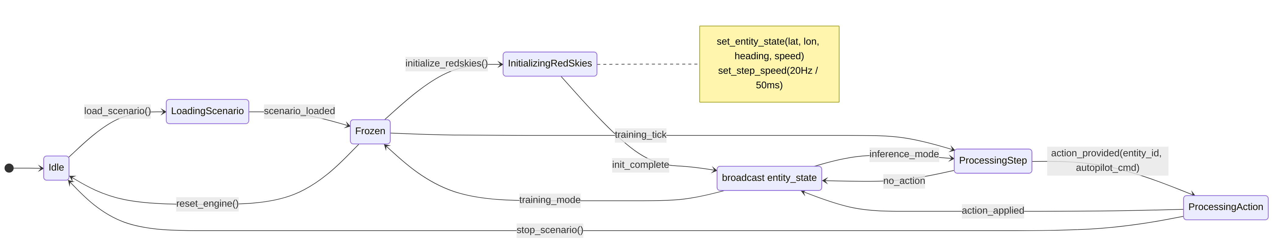

01 — Create VRF Scenario (Sequence)
Source: 01_create_vrf_scenario.sequence.md
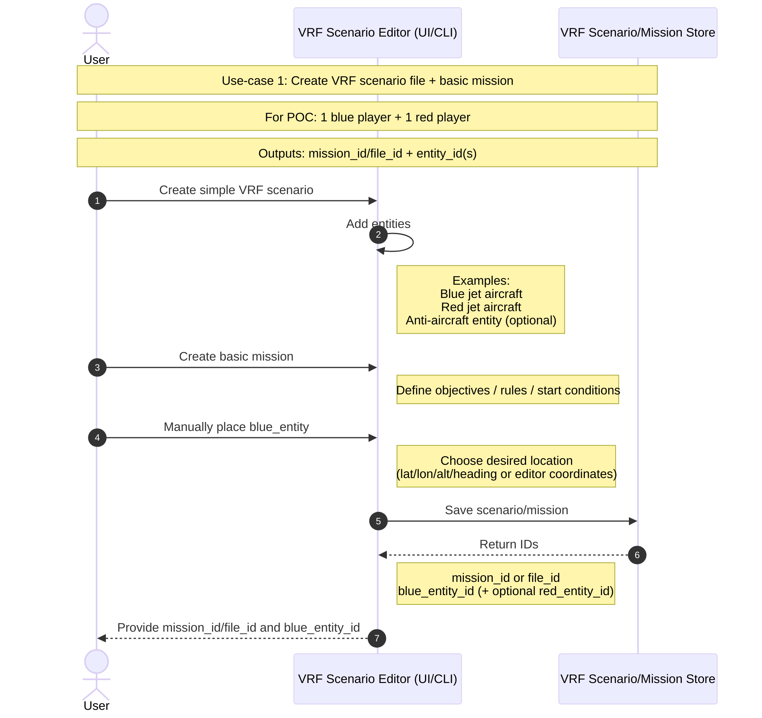

02 — Create Red-Skies Scenario (Sequence)
Source: 02_create_red_skies_scenario.sequence.md
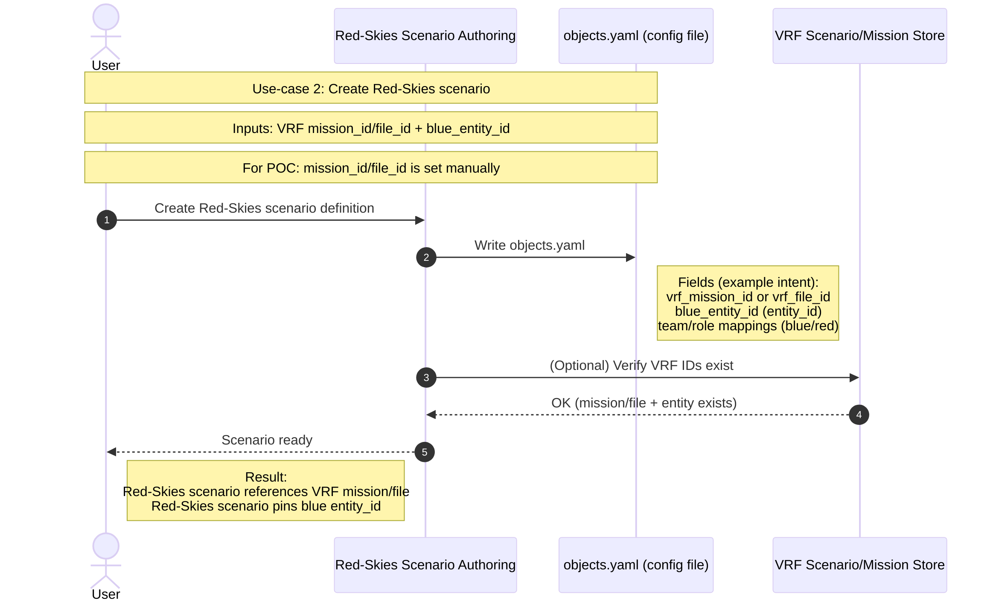

03 — Training Mode Lockstep (Sequence)
Source: 03_training_mode_lockstep.sequence.md
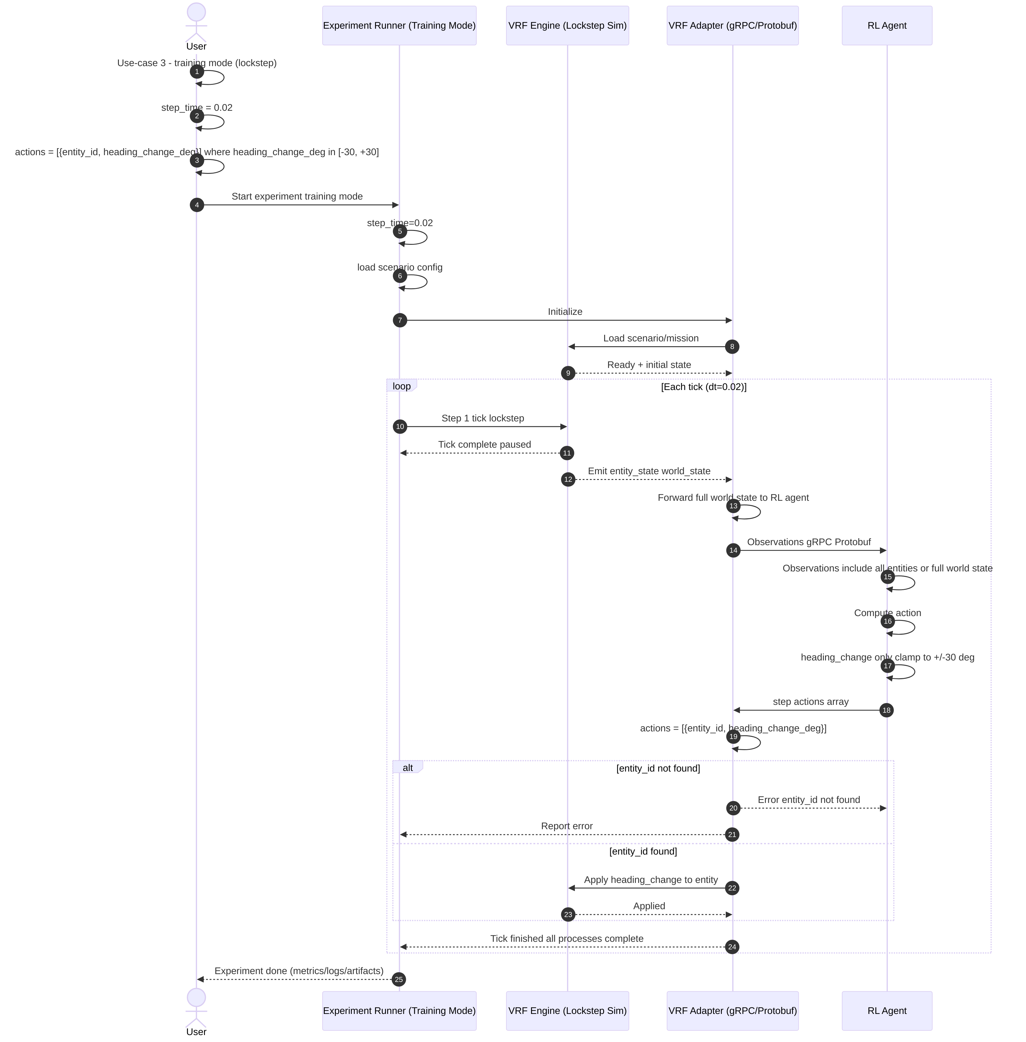

04 — Inference Mode Async (Sequence)
Source: 04_inference_mode_async.sequence.md
