GOD MADE
EVERYTHING!
The Seven Days of Creation
Genesis 1:1 – 2:3

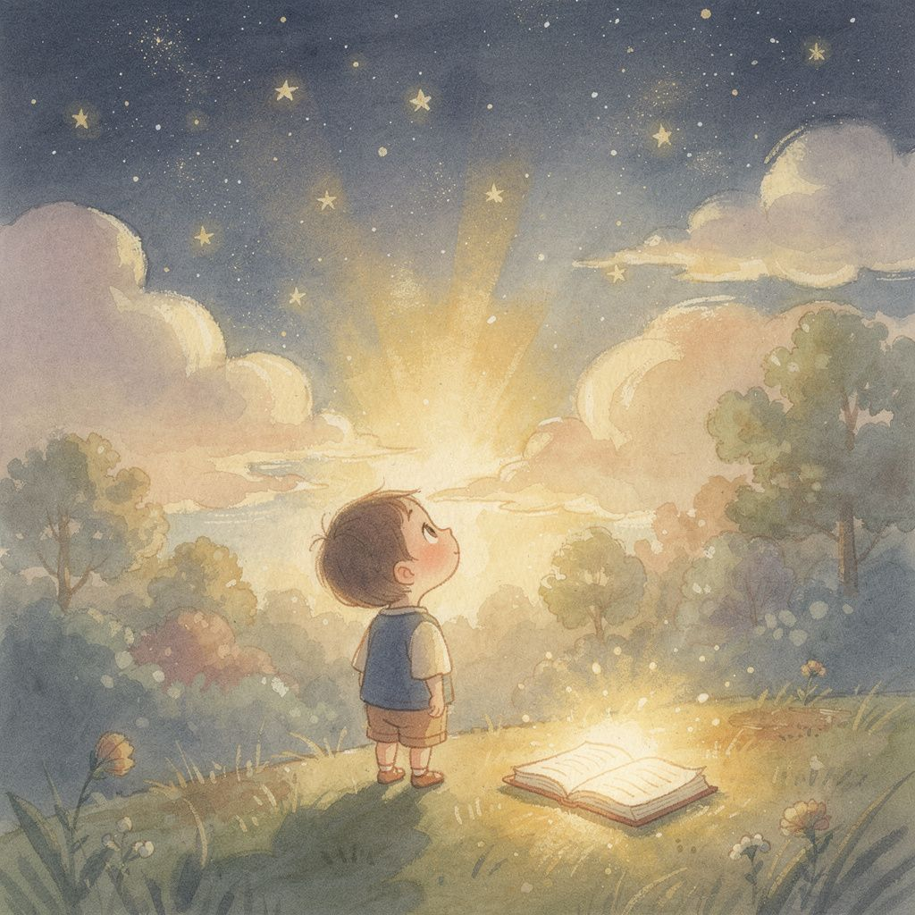
A Sprouts-Level Story for Ages 4–6
Story • Illustrations • Discussion Questions • Memory Verse • Worship Song

Page 1
Day One — Light!

📖 Read it in your Bible: Genesis 1:1–5
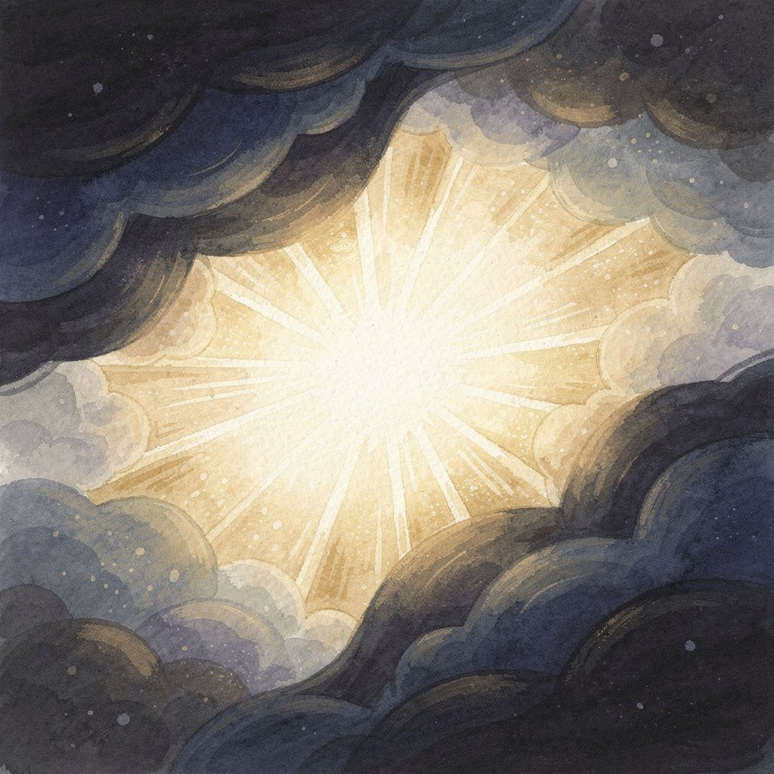
In the beginning, God made everything.
It was very dark. There was nothing at all.
Then God said, “Let there be light!” — and beautiful, bright light appeared!

Page 2
Day Two — Sky!

📖 Read it in your Bible: Genesis 1:6–8

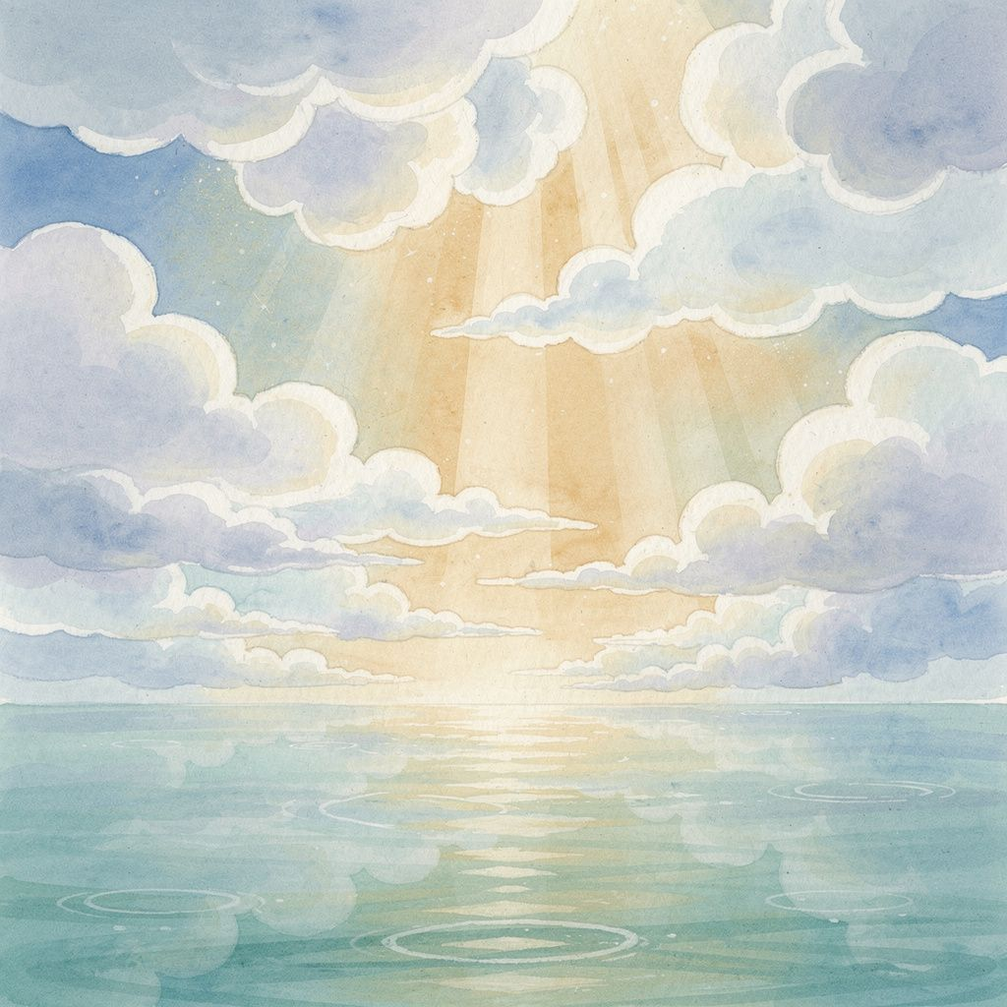
God looked at all the water. It was everywhere!
He said, “Let there be sky!”
God put water up high in fluffy clouds and left water down below — with a big, beautiful sky right in the middle.

Page 3
Day Three — Land and Plants!

📖 Read it in your Bible: Genesis 1:9–13

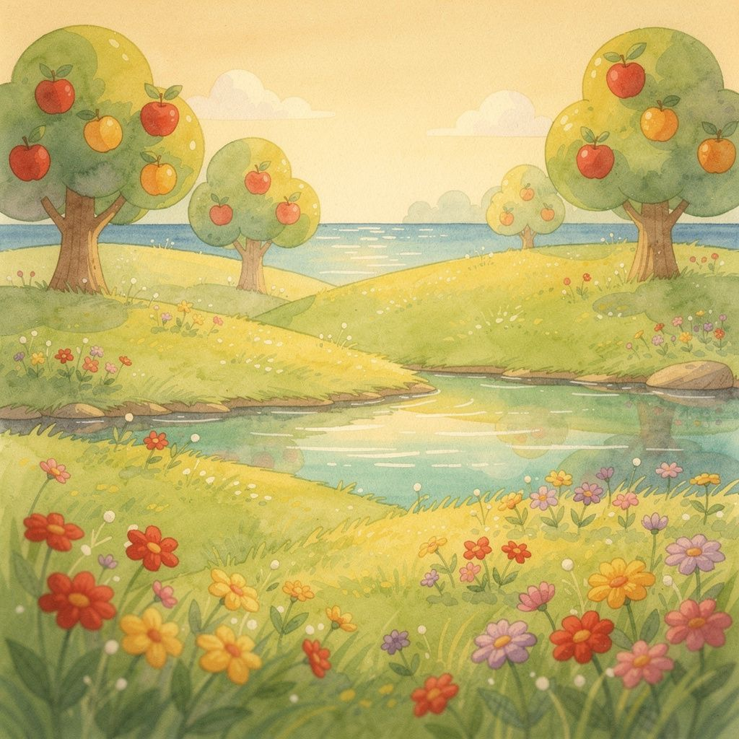
God told the water to move, and dry ground appeared!
Then He filled the land with soft green grass, tall trees, and flowers of every color.
Apples and berries and all kinds of fruit grew — it was beautiful!

Page 4
Day Four — Sun, Moon, and Stars!

📖 Read it in your Bible: Genesis 1:14–19

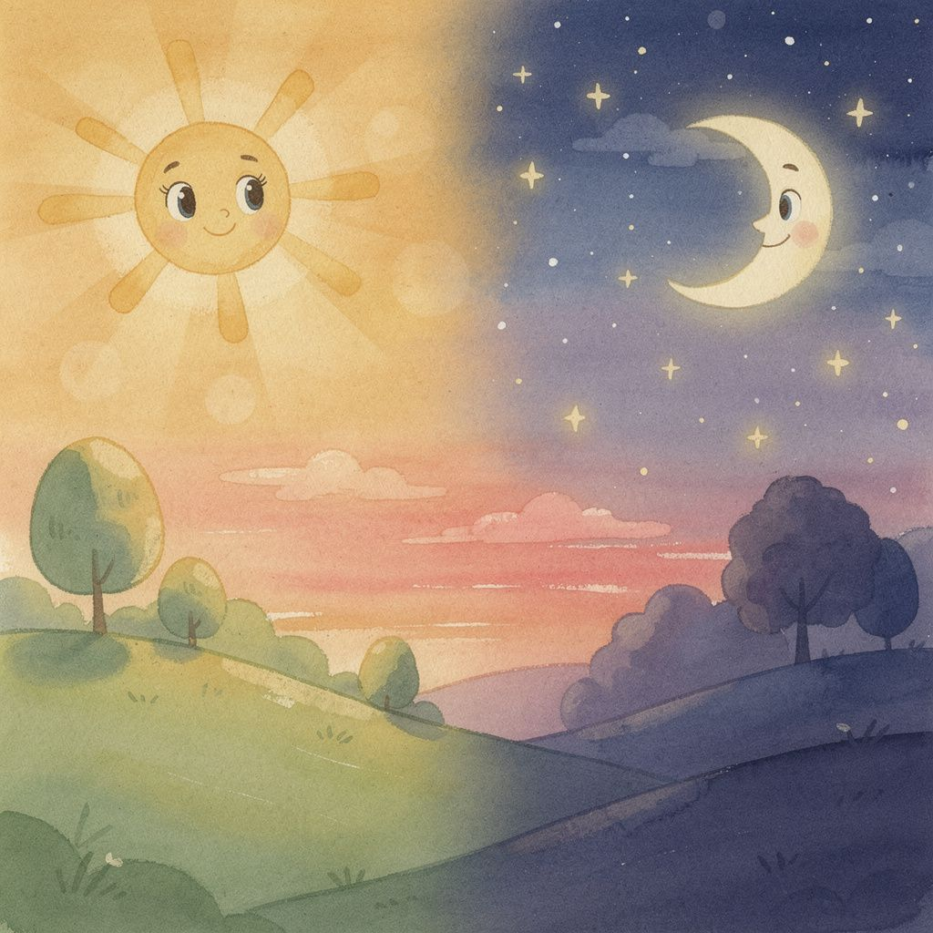
God put a big, warm sun in the sky to shine during the day.
He made a glowing moon for nighttime and scattered sparkling stars everywhere.
Now there were days and nights — and God said, “This is good!”

Page 5
Day Five — Fish and Birds!

📖 Read it in your Bible: Genesis 1:20–23

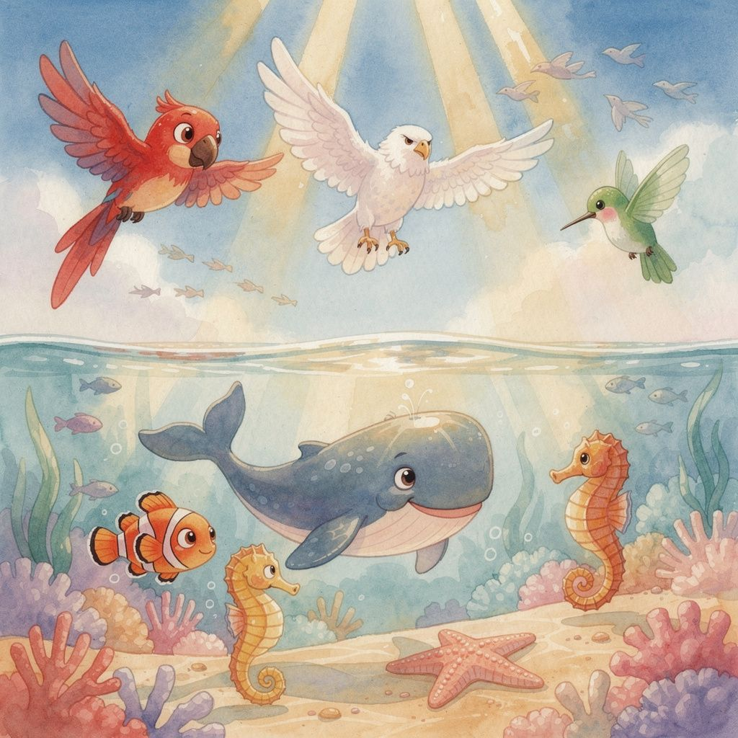
God filled the ocean with fish! Big whales, tiny clownfish, and wiggly seahorses.
Then He filled the sky with birds — soaring eagles, colorful parrots, and tiny hummingbirds.
God blessed them and said, “Have babies and fill the seas and skies!”

Page 6
Day Six — Animals and People!

📖 Read it in your Bible: Genesis 1:24–31

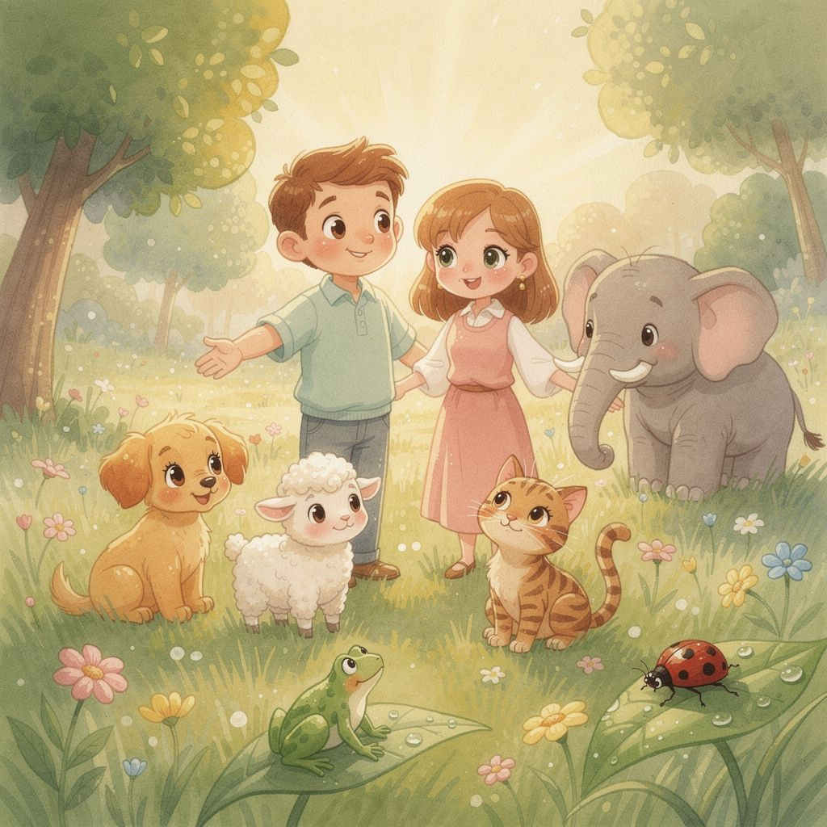
God made all the land animals — puppies, elephants, frogs, and ladybugs!
Then God did something extra special: He made people in His own image.
God looked at EVERYTHING and said, “This is very good!”

Page 7
Day Seven — God Rested!

📖 Read it in your Bible: Genesis 2:1–3

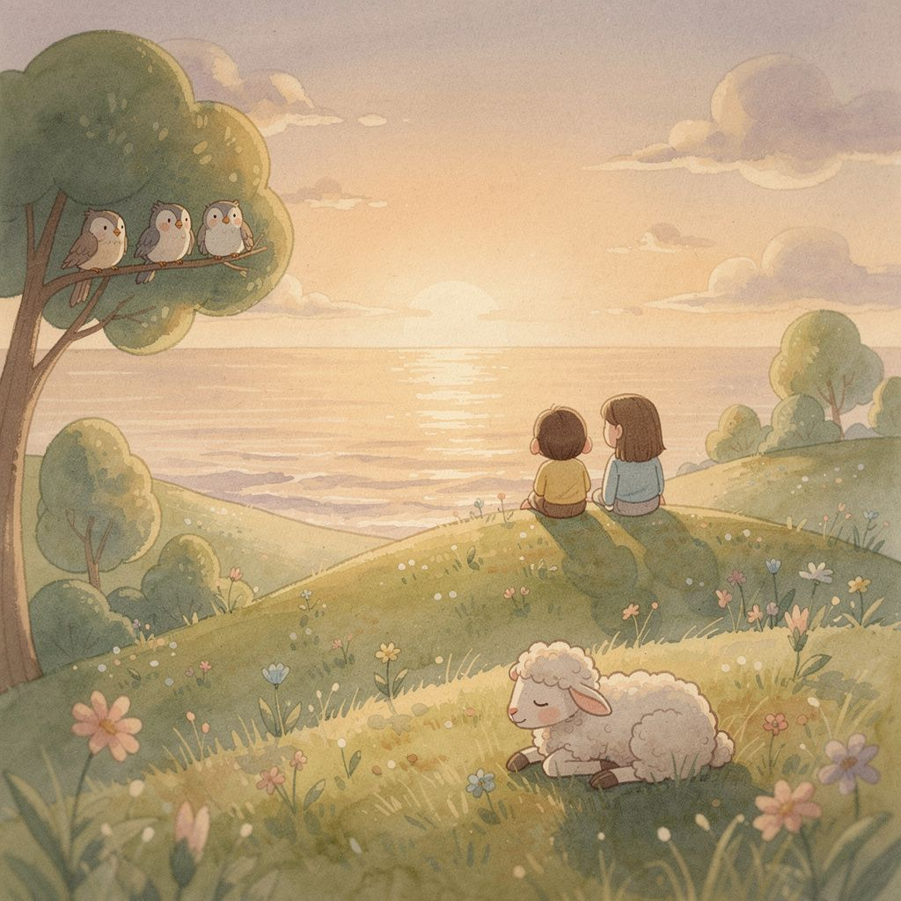
Everything was finished — light, sky, land, sun, moon, stars, fish, birds, animals, and people!
On the seventh day, God rested. He blessed this day and made it special.
It was a day to be still and enjoy everything He made.

Page 8
And God Saw That It Was Good.

📖 Read it in your Bible: Genesis 1:31

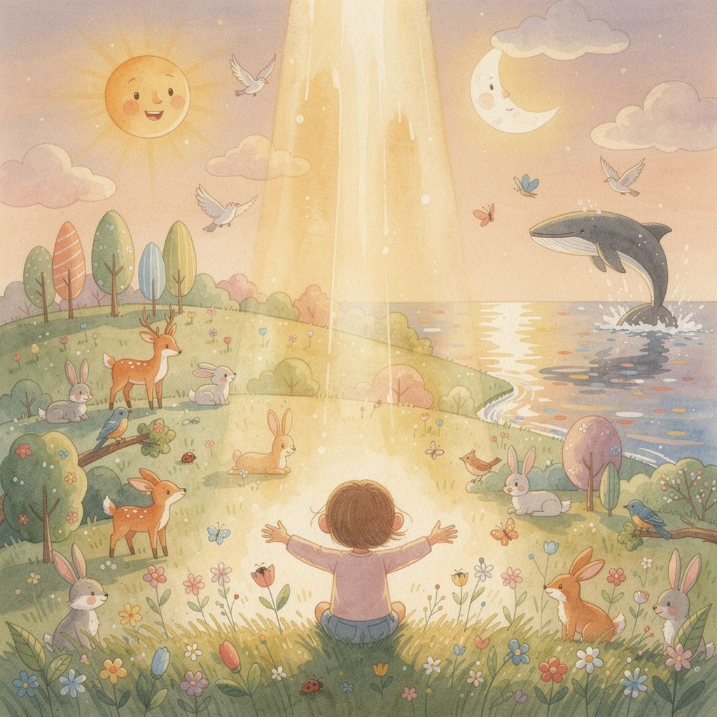
God made the light. God made the sky. God made the land, the sea, and every plant that grows.
God made the sun, the moon, and every star. God made the fish, the birds, and every animal.
God made you. And God said it was very, very good.

Discussion Questions
For parents, teachers, and small group leaders

[Comprehension]
1. What was the very first thing God made? (Light! Genesis 1:3)
[Comprehension]
2. On which day did God make the animals and people? (Day Six)
[Observation]
3. What did God say after He looked at everything He made? (“It was very good!”)
[Application]
4. God made you in His image — that means you are very special! How can you take care of the world God made?
[Reflection]
5. God rested on Day Seven. Why do you think rest is important? What do you like to do on rest days with your family?

Memory Verse

“In the beginning, God created the heavens and the earth.”
— Genesis 1:1 (ESV)

Tips for Learning:
‣ Have the child repeat the verse one phrase at a time after you.
‣ Use hand motions: point up for “heavens,” point down for “earth,” spread arms wide for “created.”
‣ Practice once a day for a week — by Day 7, they’ll have it!

