- Министерство образования и науки Российской Федерации
- Санкт-Петербургский Политехнический Университет Петра Великого
- —
Институт компьютерных наук и кибербезопасности

ЛАБОРАТОРНАЯ РАБОТА № 2

«Планирование процессов»

по дисциплине «Операционные системы»

Выполнил
студент гр. 5151001/40001 Волошкевич М.А.
<подпись>

Преподаватель Гавва Г.Д.
<подпись>

Санкт-Петербург
2025

1) Цель лабораторной работы
Изучение механизмов планирования процессов, разработка алгоритма приоритетного планирования и внедрение разработанного алгоритма в учебную операционную систему Pintos.
2) Описание решения
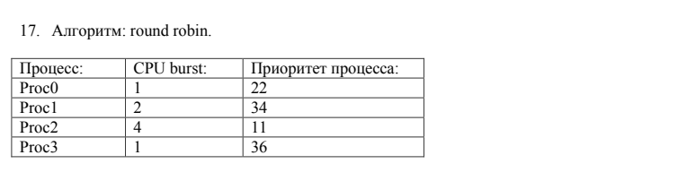
Изначально система планирования работает по алгоритму Round Robin с квантом времени 4 такта без учета приоритета.
Время | 1 | 2 | 3 | 4 | 5 | 6 | 7 | 8
Proc0 | и | - | - | - | - | - | - | -
Proc1 | г | и | и | - | - | - | - | -
Proc2 | г | г | г | и | и | и | и | -
Proc3 | г | г | г | г | г | г | г | и

Далее была проделана работа по оптимизизации алгоритма Round Robin. Теперь данный алгоритм работает с учетом приоритетов, чем выше приоритет, тем раньше будет выполняться процесс.

Время | 1 | 2 | 3 | 4 | 5 | 6 | 7 | 8
Proc0 | г | г | г | и | - | - | - | -
Proc1 | г | и | и | - | - | - | - | -
Proc2 | г | г | г | г | и | и | и | и
Proc3 | и | - | - | - | - | - | - | -

Далее была построена блок-схема реализованного алгоритма планирования:

Начало

Инициализация процесса

Присвоение приоритета
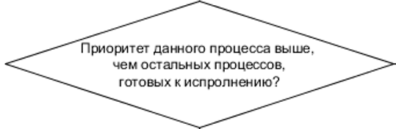
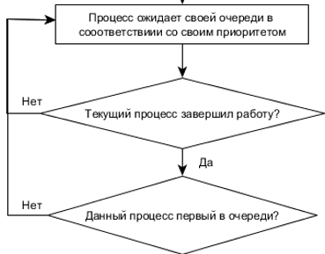
да да

Процесс исполняется

Конец

Далее была составлена таблица с функциями, участвующими в планировщике процессов.
Таблица 1 – Описание функций планировщика процессов
Функция | Описание | Какие функции вызывает
thread_create | Создает новый поток с заданным приоритетом и функцией | init_thread(), allocate_tid(), thread_unblock(), thread_yield()
thread_unblock | Деблокирует поток и добавляет его в очередь ready_list по приоритету | list_insert_ordered(), intr_disable(), intr_set_level()
thread_block | Блокирует текущий поток, вызывая schedule() для переключения контекста | schedule()
thread_yield | Переводит текущий поток в состояние READY и вызывает schedule() для переключения на другой поток | list_insert_ordered(), schedule(), intr_disable(), intr_set_level()
schedule | Основная функция диспетчеризации: выбирает следующий поток и вызывает switch_threads() | next_thread_to_run(), switch_threads(), thread_schedule_tail()
next_thread_to_run | Возвращает следующий поток для выполнения из ready_list | list_empty(), list_pop_front()
thread_schedule_tail | Завершает переключение контекста: обновляет статус нового потока, удаляет завершенные потоки | palloc_free_page() (если поток завершен)
thread_exit | Завершает выполнение текущего потока, удаляя его из all_list и вызывая schedule() | intr_disable(), schedule()
thread_tick | Увеличивает счетчик тактов и вызывает intr_yield_on_return(), если квант времени истек | intr_yield_on_return()
thread_set_priority | Устанавливает новый приоритет потока, проверяет необходимость переключения | refresh_priority(), thread_yield()

Далее был реализован новый алгоритм планирования потоков, основанный на приоритетном выборе задач и поддерживающий механизм передачи приоритета (priority donation).
Теперь потоки, ожидающие своей очереди, упорядочиваются по приоритету. В функциях thread_unblock() и thread_yield() добавление потока в список готовых (ready_list) выполняется через list_insert_ordered() с использованием компаратора thread_priority_less(). Благодаря этому планировщик всегда выбирает для выполнения поток с наивысшим приоритетом, а не просто последний добавленный.
В функции thread_create() после разблокировки нового потока вызывается thread_yield(), чтобы если вновь созданный поток имеет более высокий приоритет, он мог немедленно получить управление процессором.
Была реализована функция thread_priority_less(), служащая компаратором для сравнения приоритетов потоков. Аналогично, создана функция donation_priority_less() — она используется для сортировки списка донейшенов (donations) по приоритету.
Добавлена функция thread_set_priority(), которая изменяет базовый приоритет потока, пересчитывает его эффективный приоритет с учётом возможных донейшенов (thread_update_priority()), и при необходимости вызывает предвосхищение (thread_yield()), если в очереди готовых потоков находится поток с более высоким приоритетом.
Для поддержки механизма передачи приоритета были реализованы функции:
- thread_donate_priority() — выполняет донейт приоритета от потока-донора к потоку-получателю и при необходимости рекурсивно продолжает передачу вверх по цепочке блокировок;
- thread_remove_donations() — удаляет донейшены, связанные с конкретным замком, и пересчитывает эффективный приоритет потока;
- thread_update_priority() — вычисляет новый эффективный приоритет потока на основе его базового приоритета и активных донейшенов.
Также были внесены изменения в синхронизационные примитивы (synch.c):
- В функции sema_down() потоки, ожидающие на семафоре, добавляются в очередь ожидания с сортировкой по приоритету с помощью list_insert_ordered() и thread_priority_less().
- В sema_up() перед пробуждением потока список waiters пересортировывается по приоритету, чтобы разблокировался поток с наивысшим приоритетом. Если разбуженный поток приоритетнее текущего, вызывается thread_yield().
- В функции lock_acquire() добавлен вызов thread_donate_priority(), что обеспечивает передачу приоритета при ожидании блокировки.
- В lock_release() реализован вызов thread_remove_donations(), позволяющий корректно пересчитать приоритет после освобождения блокировки.

3) Тестирование
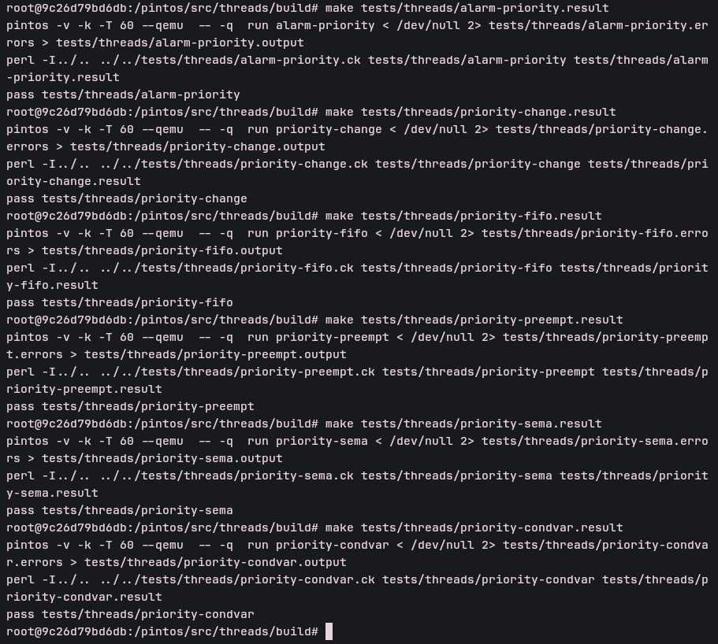
Рисунок 1 — Тестирование на наличие «тупиков» синхронизации.

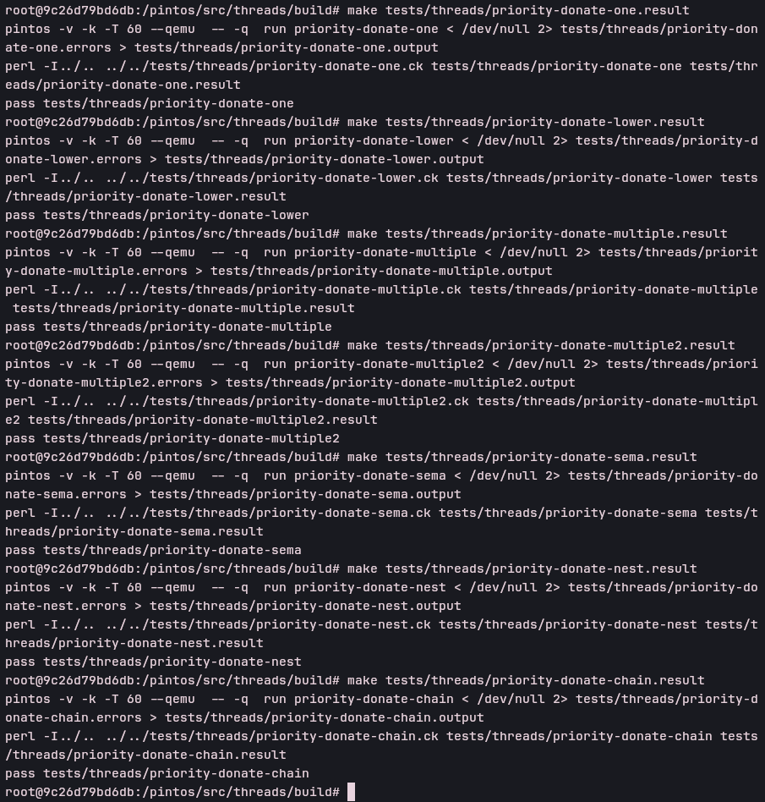
Рисунок 2 — Тестирование механизма разделения приоритета.

4) Выводы
В данной лабораторной работе были изучены механизмы планирования процессов, разработан алгоритм приоритетного планирования и внедрен разработанный алгоритм в учебную операционную систему Pintos.
Приложение А
“thread.c”
#include "threads/thread.h"
#include <debug.h>
#include <stddef.h>
#include <random.h>
#include <stdio.h>
#include <string.h>
#include "threads/flags.h"
#include "threads/interrupt.h"
#include "threads/intr-stubs.h"
#include "threads/palloc.h"
#include "threads/switch.h"
#include "threads/synch.h"
#include "threads/vaddr.h"
#ifdef USERPROG
#include "userprog/process.h"
#endif

/* Random value for struct thread's `magic' member.
Used to detect stack overflow. See the big comment at the top
of thread.h for details. */
#define THREAD_MAGIC 0xcd6abf4b

/* List of processes in THREAD_READY state, that is, processes
that are ready to run but not actually running. */
static struct list ready_list;

/* List of all processes. Processes are added to this list
when they are first scheduled and removed when they exit. */
static struct list all_list;

/* Idle thread. */
static struct thread *idle_thread;

/* Initial thread, the thread running init.c:main(). */
static struct thread *initial_thread;

/* Lock used by allocate_tid(). */
static struct lock tid_lock;

/* Stack frame for kernel_thread(). */
struct kernel_thread_frame
{
void *eip; /* Return address. */
thread_func *function; /* Function to call. */
void *aux; /* Auxiliary data for function. */
};

/* Statistics. */
static long long idle_ticks; /* # of timer ticks spent idle. */
static long long kernel_ticks; /* # of timer ticks in kernel threads. */
static long long user_ticks; /* # of timer ticks in user programs. */

/* Scheduling. */
#define TIME_SLICE 4 /* # of timer ticks to give each thread. */
static unsigned thread_ticks; /* # of timer ticks since last yield. */

/* If false (default), use round-robin scheduler.
If true, use multi-level feedback queue scheduler.
Controlled by kernel command-line option "-o mlfqs". */
bool thread_mlfqs;

static void kernel_thread (thread_func *, void *aux);

static void idle (void *aux UNUSED);
static struct thread *running_thread (void);
static struct thread *next_thread_to_run (void);
static void init_thread (struct thread *, const char *name, int priority);
static bool is_thread (struct thread *) UNUSED;
static void *alloc_frame (struct thread *, size_t size);
static void schedule (void);
void thread_schedule_tail (struct thread *prev);
static tid_t allocate_tid (void);

/* Initializes the threading system by transforming the code
that's currently running into a thread. This can't work in
general and it is possible in this case only because loader.S
was careful to put the bottom of the stack at a page boundary.

Also initializes the run queue and the tid lock.

After calling this function, be sure to initialize the page
allocator before trying to create any threads with
thread_create().

It is not safe to call thread_current() until this function
finishes. */
void
thread_init (void)
{
ASSERT (intr_get_level () == INTR_OFF);

lock_init (&tid_lock);
list_init (&ready_list);
list_init (&all_list);

/* Set up a thread structure for the running thread. */
initial_thread = running_thread ();
init_thread (initial_thread, "main", PRI_DEFAULT);
initial_thread->status = THREAD_RUNNING;
initial_thread->tid = allocate_tid ();
}

bool thread_priority_less (const struct list_elem *a_, const struct list_elem *b_, void *aux UNUSED)
{
// Получаем указатели на структуры thread из элементов списка
const struct thread *a = list_entry (a_, struct thread, elem);
const struct thread *b = list_entry (b_, struct thread, elem);

return a->priority > b->priority;
}

bool donation_priority_less (const struct list_elem *a_, const struct list_elem *b_, void *aux UNUSED)
{
// Получаем указатели на структуры thread из элементов списка
const struct thread *a = list_entry (a_, struct thread, donation_elem);
const struct thread *b = list_entry (b_, struct thread, donation_elem);

return a->priority > b->priority;
}

/* Starts preemptive thread scheduling by enabling interrupts.
Also creates the idle thread. */
void
thread_start (void)
{
/* Create the idle thread. */
struct semaphore idle_started;
sema_init (&idle_started, 0);
thread_create ("idle", PRI_MIN, idle, &idle_started);

/* Start preemptive thread scheduling. */
intr_enable ();

/* Wait for the idle thread to initialize idle_thread. */
sema_down (&idle_started);
}

/* Called by the timer interrupt handler at each timer tick.
Thus, this function runs in an external interrupt context. */
void
thread_tick (void)
{
struct thread *t = thread_current ();

/* Update statistics. */
if (t == idle_thread)
idle_ticks++;
#ifdef USERPROG
else if (t->pagedir != NULL)
user_ticks++;
#endif
else
kernel_ticks++;

/* Enforce preemption. */
if (++thread_ticks >= TIME_SLICE)
intr_yield_on_return ();
}

/* Prints thread statistics. */
void
thread_print_stats (void)
{
printf ("Thread: %lld idle ticks, %lld kernel ticks, %lld user ticks\n",
idle_ticks, kernel_ticks, user_ticks);
}

/* Creates a new kernel thread named NAME with the given initial
PRIORITY, which executes FUNCTION passing AUX as the argument,
and adds it to the ready queue. Returns the thread identifier
for the new thread, or TID_ERROR if creation fails.

If thread_start() has been called, then the new thread may be
scheduled before thread_create() returns. It could even exit
before thread_create() returns. Contrariwise, the original
thread may run for any amount of time before the new thread is
scheduled. Use a semaphore or some other form of
synchronization if you need to ensure ordering.

The code provided sets the new thread's `priority' member to
PRIORITY, but no actual priority scheduling is implemented.
Priority scheduling is the goal of Problem 1-3. */
tid_t
thread_create (const char *name, int priority,
thread_func *function, void *aux)
{
struct thread *t;
struct kernel_thread_frame *kf;
struct switch_entry_frame *ef;
struct switch_threads_frame *sf;
tid_t tid;
enum intr_level old_level;

ASSERT (function != NULL);

/* Allocate thread. */
t = palloc_get_page (PAL_ZERO);
if (t == NULL)
return TID_ERROR;

/* Initialize thread. */
init_thread (t, name, priority);
tid = t->tid = allocate_tid ();

/* Prepare thread for first run by initializing its stack.
Do this atomically so intermediate values for the 'stack'
member cannot be observed. */
old_level = intr_disable ();

/* Stack frame for kernel_thread(). */
kf = alloc_frame (t, sizeof *kf);
kf->eip = NULL;
kf->function = function;
kf->aux = aux;

/* Stack frame for switch_entry(). */
ef = alloc_frame (t, sizeof *ef);
ef->eip = (void (*) (void)) kernel_thread;

/* Stack frame for switch_threads(). */
sf = alloc_frame (t, sizeof *sf);
sf->eip = switch_entry;
sf->ebp = 0;

intr_set_level (old_level);

/* Add to run queue. */
thread_unblock (t);

if(t->priority > thread_current()->priority)
thread_yield();

return tid;
}

/* Puts the current thread to sleep. It will not be scheduled
again until awoken by thread_unblock().

This function must be called with interrupts turned off. It
is usually a better idea to use one of the synchronization
primitives in synch.h. */
void
thread_block (void)
{
ASSERT (!intr_context ());
ASSERT (intr_get_level () == INTR_OFF);

thread_current ()->status = THREAD_BLOCKED;
schedule ();
}

/* Transitions a blocked thread T to the ready-to-run state.
This is an error if T is not blocked. (Use thread_yield() to
make the running thread ready.)

This function does not preempt the running thread. This can
be important: if the caller had disabled interrupts itself,
it may expect that it can atomically unblock a thread and
update other data. */
void
thread_unblock (struct thread *t)
{
enum intr_level old_level;

ASSERT (is_thread (t));

old_level = intr_disable ();
ASSERT (t->status == THREAD_BLOCKED);
list_insert_ordered(&ready_list, &t->elem, thread_priority_less, NULL);
t->status = THREAD_READY;
intr_set_level (old_level);
}

/* Returns the name of the running thread. */
const char *
thread_name (void)
{
return thread_current ()->name;
}

/* Returns the running thread.
This is running_thread() plus a couple of sanity checks.
See the big comment at the top of thread.h for details. */
struct thread *
thread_current (void)
{
struct thread *t = running_thread ();

/* Make sure T is really a thread.
If either of these assertions fire, then your thread may
have overflowed its stack. Each thread has less than 4 kB
of stack, so a few big automatic arrays or moderate
recursion can cause stack overflow. */
ASSERT (is_thread (t));
ASSERT (t->status == THREAD_RUNNING);

return t;
}

/* Returns the running thread's tid. */
tid_t
thread_tid (void)
{
return thread_current ()->tid;
}

/* Deschedules the current thread and destroys it. Never
returns to the caller. */
void
thread_exit (void)
{
ASSERT (!intr_context ());

#ifdef USERPROG
process_exit ();
#endif

/* Remove thread from all threads list, set our status to dying,
and schedule another process. That process will destroy us
when it calls thread_schedule_tail(). */
intr_disable ();
list_remove (&thread_current()->allelem);
thread_current ()->status = THREAD_DYING;
schedule ();
NOT_REACHED ();
}

/* Yields the CPU. The current thread is not put to sleep and
may be scheduled again immediately at the scheduler's whim. */
void
thread_yield (void)
{
struct thread *cur = thread_current ();
enum intr_level old_level;

ASSERT (!intr_context ());

old_level = intr_disable ();
if (cur != idle_thread)
list_insert_ordered (&ready_list, &cur->elem, thread_priority_less, NULL);
cur->status = THREAD_READY;
schedule ();
intr_set_level (old_level);
}

/* Invoke function 'func' on all threads, passing along 'aux'.
This function must be called with interrupts off. */
void
thread_foreach (thread_action_func *func, void *aux)
{
struct list_elem *e;

ASSERT (intr_get_level () == INTR_OFF);

for (e = list_begin (&all_list); e != list_end (&all_list);
e = list_next (e))
{
struct thread *t = list_entry (e, struct thread, allelem);
func (t, aux);
}
}

/* Sets the current thread's priority to NEW_PRIORITY. */
void
thread_set_priority (int new_priority)
{
enum intr_level old_level = intr_disable ();
struct thread *cur = thread_current ();

/* Set base priority, then recompute effective priority with donations applied. */
cur->base_priority = new_priority;
thread_update_priority (cur);

/* If a higher-priority thread is ready, yield. */
if (!list_empty (&ready_list))
{
struct thread *front = list_entry (list_front (&ready_list),
struct thread, elem);
if (front->priority > cur->priority)
{
intr_set_level (old_level);
thread_yield ();
return;
}
}

intr_set_level (old_level);
}

/* Обновляет приоритет потока с учётом донейшнов */
void
thread_update_priority (struct thread *t)
{
int max = t->base_priority;
struct list_elem *e;

for (e = list_begin (&t->donations); e != list_end (&t->donations);
e = list_next (e))
{
struct thread *donor = list_entry (e, struct thread, donation_elem);
if (donor->priority > max)
max = donor->priority;
}

t->priority = max;
}

/* Добавляет донейшн текущему потоку */
void
thread_donate_priority (struct thread *donor, struct thread *receiver)
{
/* Если донор имеет меньший приоритет — не имеет смысла донейтить */
if (donor->priority <= receiver->priority)
return;

/* Добавляем донейшн (уникальный для каждого донора) */
bool already_donated = false;
struct list_elem *e;
for (e = list_begin (&receiver->donations);
e != list_end (&receiver->donations);
e = list_next (e))
{
struct thread *d = list_entry (e, struct thread, donation_elem);
if (d == donor)
{
already_donated = true;
break;
}
}

if (!already_donated)
list_insert_ordered (&receiver->donations, &donor->donation_elem,
donation_priority_less, NULL);

/* Пересортировать список, чтобы максимальный донор был первым */
list_sort (&receiver->donations, donation_priority_less, NULL);

/* Обновляем приоритет получателя */
thread_update_priority (receiver);

/* Рекурсивно продолжаем донейт вверх, если receiver ждёт другой lock */
if (receiver->waiting_lock != NULL && receiver->waiting_lock->holder != NULL)
thread_donate_priority (receiver, receiver->waiting_lock->holder);
}

/* Удаляет донейшны, связанные с данным замком */
void
thread_remove_donations (struct lock *lock)
{
struct thread *cur = thread_current ();
struct list_elem *e = list_begin (&cur->donations);

while (e != list_end (&cur->donations))
{
struct thread *donor = list_entry (e, struct thread, donation_elem);
if (donor->waiting_lock == lock)
{
e = list_remove (e); /* удаляет и возвращает следующий элемент */
donor->donated = false;
}
else
e = list_next (e);
}

/* После удаления пересчитать приоритет */
thread_update_priority (cur);
}

/* Returns the current thread's priority. */
int
thread_get_priority (void)
{
return thread_current ()->priority;
}

/* Sets the current thread's nice value to NICE. */
void
thread_set_nice (int nice UNUSED)
{
/* Not yet implemented. */
}

/* Returns the current thread's nice value. */
int
thread_get_nice (void)
{
/* Not yet implemented. */
return 0;
}

/* Returns 100 times the system load average. */
int
thread_get_load_avg (void)
{
/* Not yet implemented. */
return 0;
}

/* Returns 100 times the current thread's recent_cpu value. */
int
thread_get_recent_cpu (void)
{
/* Not yet implemented. */
return 0;
}

/* Idle thread. Executes when no other thread is ready to run.

The idle thread is initially put on the ready list by
thread_start(). It will be scheduled once initially, at which
point it initializes idle_thread, "up"s the semaphore passed
to it to enable thread_start() to continue, and immediately
blocks. After that, the idle thread never appears in the
ready list. It is returned by next_thread_to_run() as a
special case when the ready list is empty. */
static void
idle (void *idle_started_ UNUSED)
{
struct semaphore *idle_started = idle_started_;
idle_thread = thread_current ();
sema_up (idle_started);

for (;;)
{
/* Let someone else run. */
intr_disable ();
thread_block ();

/* Re-enable interrupts and wait for the next one.

The `sti' instruction disables interrupts until the
completion of the next instruction, so these two
instructions are executed atomically. This atomicity is
important; otherwise, an interrupt could be handled
between re-enabling interrupts and waiting for the next
one to occur, wasting as much as one clock tick worth of
time.

See [IA32-v2a] "HLT", [IA32-v2b] "STI", and [IA32-v3a]
7.11.1 "HLT Instruction". */
asm volatile ("sti; hlt" : : : "memory");
}
}

/* Function used as the basis for a kernel thread. */
static void
kernel_thread (thread_func *function, void *aux)
{
ASSERT (function != NULL);

intr_enable (); /* The scheduler runs with interrupts off. */
function (aux); /* Execute the thread function. */
thread_exit (); /* If function() returns, kill the thread. */
}

/* Returns the running thread. */
struct thread *
running_thread (void)
{
uint32_t *esp;

/* Copy the CPU's stack pointer into `esp', and then round that
down to the start of a page. Because `struct thread' is
always at the beginning of a page and the stack pointer is
somewhere in the middle, this locates the curent thread. */
asm ("mov %%esp, %0" : "=g" (esp));
return pg_round_down (esp);
}

/* Returns true if T appears to point to a valid thread. */
static bool
is_thread (struct thread *t)
{
return t != NULL && t->magic == THREAD_MAGIC;
}

/* Does basic initialization of T as a blocked thread named
NAME. */
static void
init_thread (struct thread *t, const char *name, int priority)
{
ASSERT (t != NULL);
ASSERT (PRI_MIN <= priority && priority <= PRI_MAX);
ASSERT (name != NULL);

memset (t, 0, sizeof *t);
t->status = THREAD_BLOCKED;
strlcpy (t->name, name, sizeof t->name);
t->stack = (uint8_t *) t + PGSIZE;
t->priority = priority;
t->base_priority = priority;
list_init(&t->donations);
t->waiting_lock = NULL;
t->donation_elem.prev = NULL;
t->donation_elem.next = NULL;
t->donated = false;
t->magic = THREAD_MAGIC;
list_push_back (&all_list, &t->allelem);
}

/* Allocates a SIZE-byte frame at the top of thread T's stack and
returns a pointer to the frame's base. */
static void *
alloc_frame (struct thread *t, size_t size)
{
/* Stack data is always allocated in word-size units. */
ASSERT (is_thread (t));
ASSERT (size % sizeof (uint32_t) == 0);

t->stack -= size;
return t->stack;
}

/* Chooses and returns the next thread to be scheduled. Should
return a thread from the run queue, unless the run queue is
empty. (If the running thread can continue running, then it
will be in the run queue.) If the run queue is empty, return
idle_thread. */
static struct thread *
next_thread_to_run (void)
{
if (list_empty (&ready_list))
return idle_thread;
else
return list_entry (list_pop_front (&ready_list), struct thread, elem);
}

/* Completes a thread switch by activating the new thread's page
tables, and, if the previous thread is dying, destroying it.

At this function's invocation, we just switched from thread
PREV, the new thread is already running, and interrupts are
still disabled. This function is normally invoked by
thread_schedule() as its final action before returning, but
the first time a thread is scheduled it is called by
switch_entry() (see switch.S).

It's not safe to call printf() until the thread switch is
complete. In practice that means that printf()s should be
added at the end of the function.

After this function and its caller returns, the thread switch
is complete. */
void
thread_schedule_tail (struct thread *prev)
{
struct thread *cur = running_thread ();

ASSERT (intr_get_level () == INTR_OFF);

/* Mark us as running. */
cur->status = THREAD_RUNNING;

/* Start new time slice. */
thread_ticks = 0;

#ifdef USERPROG
/* Activate the new address space. */
process_activate ();
#endif

/* If the thread we switched from is dying, destroy its struct
thread. This must happen late so that thread_exit() doesn't
pull out the rug under itself. (We don't free
initial_thread because its memory was not obtained via
palloc().) */
if (prev != NULL && prev->status == THREAD_DYING && prev != initial_thread)
{
ASSERT (prev != cur);
palloc_free_page (prev);
}
}

/* Schedules a new process. At entry, interrupts must be off and
the running process's state must have been changed from
running to some other state. This function finds another
thread to run and switches to it.

It's not safe to call printf() until thread_schedule_tail()
has completed. */
static void
schedule (void)
{
struct thread *cur = running_thread ();
struct thread *next = next_thread_to_run ();
struct thread *prev = NULL;

ASSERT (intr_get_level () == INTR_OFF);
ASSERT (cur->status != THREAD_RUNNING);
ASSERT (is_thread (next));

if (cur != next)
prev = switch_threads (cur, next);
thread_schedule_tail (prev);
}

/* Returns a tid to use for a new thread. */
static tid_t
allocate_tid (void)
{
static tid_t next_tid = 1;
tid_t tid;

lock_acquire (&tid_lock);
tid = next_tid++;
lock_release (&tid_lock);

return tid;
}

/* Offset of `stack' member within `struct thread'.
Used by switch.S, which can't figure it out on its own. */
uint32_t thread_stack_ofs = offsetof (struct thread, stack);

Приложение B
“thread.h”
#ifndef THREADS_THREAD_H
#define THREADS_THREAD_H

#include <debug.h>
#include <list.h>
#include <stdint.h>

/* States in a thread's life cycle. */
enum thread_status
{
THREAD_RUNNING, /* Running thread. */
THREAD_READY, /* Not running but ready to run. */
THREAD_BLOCKED, /* Waiting for an event to trigger. */
THREAD_DYING /* About to be destroyed. */
};

/* Thread identifier type.
You can redefine this to whatever type you like. */
typedef int tid_t;
#define TID_ERROR ((tid_t) -1) /* Error value for tid_t. */

/* Thread priorities. */
#define PRI_MIN 0 /* Lowest priority. */
#define PRI_DEFAULT 31 /* Default priority. */
#define PRI_MAX 63 /* Highest priority. */

/* A kernel thread or user process.

Each thread structure is stored in its own 4 kB page. The
thread structure itself sits at the very bottom of the page
(at offset 0). The rest of the page is reserved for the
thread's kernel stack, which grows downward from the top of
the page (at offset 4 kB). Here's an illustration:

4 kB +---------------------------------+
| kernel stack |
| | |
| | |
| V |
| grows downward |
| |
| |
| |
| |
| |
| |
| |
| |
+---------------------------------+
| magic |
| : |
| : |
| name |
| status |
0 kB +---------------------------------+

The upshot of this is twofold:

1. First, `struct thread' must not be allowed to grow too
big. If it does, then there will not be enough room for
the kernel stack. Our base `struct thread' is only a
few bytes in size. It probably should stay well under 1
kB.

2. Second, kernel stacks must not be allowed to grow too
large. If a stack overflows, it will corrupt the thread
state. Thus, kernel functions should not allocate large
structures or arrays as non-static local variables. Use
dynamic allocation with malloc() or palloc_get_page()
instead.

The first symptom of either of these problems will probably be
an assertion failure in thread_current(), which checks that
the `magic' member of the running thread's `struct thread' is
set to THREAD_MAGIC. Stack overflow will normally change this
value, triggering the assertion. */
/* The `elem' member has a dual purpose. It can be an element in
the run queue (thread.c), or it can be an element in a
semaphore wait list (synch.c). It can be used these two ways
only because they are mutually exclusive: only a thread in the
ready state is on the run queue, whereas only a thread in the
blocked state is on a semaphore wait list. */
struct thread
{
/* Owned by thread.c. */
tid_t tid; /* Thread identifier. */
enum thread_status status; /* Thread state. */
char name[16]; /* Name (for debugging purposes). */
uint8_t *stack; /* Saved stack pointer. */
int priority; /* Priority. */
int base_priority;
struct list donations;
struct lock *waiting_lock;
struct list_elem donation_elem;
bool donated;
struct list_elem allelem; /* List element for all threads list. */

/* Shared between thread.c and synch.c. */
struct list_elem elem; /* List element. */

#ifdef USERPROG
/* Owned by userprog/process.c. */
uint32_t *pagedir; /* Page directory. */
#endif

/* Owned by thread.c. */
unsigned magic; /* Detects stack overflow. */
};

/* If false (default), use round-robin scheduler.
If true, use multi-level feedback queue scheduler.
Controlled by kernel command-line option "-o mlfqs". */
extern bool thread_mlfqs;

bool thread_priority_less (const struct list_elem *a_, const struct list_elem *b_, void *aux UNUSED);

void thread_init (void);
void thread_start (void);

void thread_tick (void);
void thread_print_stats (void);

typedef void thread_func (void *aux);
tid_t thread_create (const char *name, int priority, thread_func *, void *);

void thread_block (void);
void thread_unblock (struct thread *);

struct thread *thread_current (void);
tid_t thread_tid (void);
const char *thread_name (void);

void thread_exit (void) NO_RETURN;
void thread_yield (void);

/* Performs some operation on thread t, given auxiliary data AUX. */
typedef void thread_action_func (struct thread *t, void *aux);
void thread_foreach (thread_action_func *, void *);

int thread_get_priority (void);
void thread_set_priority (int);
void thread_update_priority (struct thread *t);
void thread_donate_priority (struct thread *donor, struct thread *receiver);
void thread_remove_donations (struct lock *lock);

int thread_get_nice (void);
void thread_set_nice (int);
int thread_get_recent_cpu (void);
int thread_get_load_avg (void);

#endif /* threads/thread.h */

Приложение С
“synch.c”
#include "threads/synch.h"
#include <stdio.h>
#include <string.h>
#include "threads/interrupt.h"
#include "threads/thread.h"

/* Initializes semaphore SEMA to VALUE. A semaphore is a
nonnegative integer along with two atomic operators for
manipulating it:

- down or "P": wait for the value to become positive, then
decrement it.

- up or "V": increment the value (and wake up one waiting
thread, if any). */
void
sema_init (struct semaphore *sema, unsigned value)
{
ASSERT (sema != NULL);

sema->value = value;
list_init (&sema->waiters);
}

/* Down or "P" operation on a semaphore. Waits for SEMA's value
to become positive and then atomically decrements it.

This function may sleep, so it must not be called within an
interrupt handler. This function may be called with
interrupts disabled, but if it sleeps then the next scheduled
thread will probably turn interrupts back on. */
void
sema_down (struct semaphore *sema)
{
enum intr_level old_level;

ASSERT (sema != NULL);
ASSERT (!intr_context ());

old_level = intr_disable ();
while (sema->value == 0)
{
list_insert_ordered (&sema->waiters, &thread_current ()->elem, thread_priority_less, NULL);
thread_block ();
}
sema->value--;
intr_set_level (old_level);
}

/* Down or "P" operation on a semaphore, but only if the
semaphore is not already 0. Returns true if the semaphore is
decremented, false otherwise.

This function may be called from an interrupt handler. */
bool
sema_try_down (struct semaphore *sema)
{
enum intr_level old_level;
bool success;

ASSERT (sema != NULL);

old_level = intr_disable ();
if (sema->value > 0)
{
sema->value--;
success = true;
}
else
success = false;
intr_set_level (old_level);

return success;
}

/* Up or "V" operation on a semaphore. Increments SEMA's value
and wakes up one thread of those waiting for SEMA, if any.

This function may be called from an interrupt handler. */
void
sema_up (struct semaphore *sema)
{
enum intr_level old_level;

ASSERT (sema != NULL);

old_level = intr_disable ();
struct thread *t = NULL;

if (!list_empty (&sema->waiters))
{
list_sort(&sema->waiters, thread_priority_less, NULL);
t = list_entry (list_pop_front (&sema->waiters), struct thread, elem);
thread_unblock (t);
}
sema->value++;
intr_set_level (old_level);

if(t != NULL && t->priority > thread_current()->priority)
thread_yield();
}

static void sema_test_helper (void *sema_);

/* Self-test for semaphores that makes control "ping-pong"
between a pair of threads. Insert calls to printf() to see
what's going on. */
void
sema_self_test (void)
{
struct semaphore sema[2];
int i;

printf ("Testing semaphores...");
sema_init (&sema[0], 0);
sema_init (&sema[1], 0);
thread_create ("sema-test", PRI_DEFAULT, sema_test_helper, &sema);
for (i = 0; i < 10; i++)
{
sema_up (&sema[0]);
sema_down (&sema[1]);
}
printf ("done.\n");
}

/* Thread function used by sema_self_test(). */
static void
sema_test_helper (void *sema_)
{
struct semaphore *sema = sema_;
int i;

for (i = 0; i < 10; i++)
{
sema_down (&sema[0]);
sema_up (&sema[1]);
}
}

/* Initializes LOCK. A lock can be held by at most a single
thread at any given time. Our locks are not "recursive", that
is, it is an error for the thread currently holding a lock to
try to acquire that lock.

A lock is a specialization of a semaphore with an initial
value of 1. The difference between a lock and such a
semaphore is twofold. First, a semaphore can have a value
greater than 1, but a lock can only be owned by a single
thread at a time. Second, a semaphore does not have an owner,
meaning that one thread can "down" the semaphore and then
another one "up" it, but with a lock the same thread must both
acquire and release it. When these restrictions prove
onerous, it's a good sign that a semaphore should be used,
instead of a lock. */
void
lock_init (struct lock *lock)
{
ASSERT (lock != NULL);

lock->holder = NULL;
sema_init (&lock->semaphore, 1);
}

/* Acquires LOCK, sleeping until it becomes available if
necessary. The lock must not already be held by the current
thread.

This function may sleep, so it must not be called within an
interrupt handler. This function may be called with
interrupts disabled, but interrupts will be turned back on if
we need to sleep. */
void
lock_acquire (struct lock *lock)
{
ASSERT (lock != NULL);
ASSERT (!lock_held_by_current_thread (lock));

struct thread *cur = thread_current ();

if (lock->holder != NULL)
{
cur->waiting_lock = lock;

/* Донейт приоритет текущему владельцу */
thread_donate_priority (cur, lock->holder);
}

sema_down (&lock->semaphore);

cur->waiting_lock = NULL;
lock->holder = cur;
}

/* Tries to acquires LOCK and returns true if successful or false
on failure. The lock must not already be held by the current
thread.

This function will not sleep, so it may be called within an
interrupt handler. */
bool
lock_try_acquire (struct lock *lock)
{
bool success;

ASSERT (lock != NULL);
ASSERT (!lock_held_by_current_thread (lock));

success = sema_try_down (&lock->semaphore);
if (success)
lock->holder = thread_current ();
return success;
}

/* Releases LOCK, which must be owned by the current thread.

An interrupt handler cannot acquire a lock, so it does not
make sense to try to release a lock within an interrupt
handler. */
void
lock_release (struct lock *lock)
{
ASSERT (lock != NULL);
ASSERT (lock_held_by_current_thread (lock));

thread_remove_donations(lock);
lock->holder = NULL;
sema_up (&lock->semaphore);
}

/* Returns true if the current thread holds LOCK, false
otherwise. (Note that testing whether some other thread holds
a lock would be racy.) */
bool
lock_held_by_current_thread (const struct lock *lock)
{
ASSERT (lock != NULL);

return lock->holder == thread_current ();
}

/* One semaphore in a list. */
struct semaphore_elem
{
struct list_elem elem; /* List element. */
struct semaphore semaphore; /* This semaphore. */
int priority;
};

static bool
sema_elem_priority_less (const struct list_elem *a_, const struct list_elem *b_,
void *aux UNUSED)
{
const struct semaphore_elem *a = list_entry (a_, struct semaphore_elem, elem);
const struct semaphore_elem *b = list_entry (b_, struct semaphore_elem, elem);

return a->priority > b->priority;
}

/* Initializes condition variable COND. A condition variable
allows one piece of code to signal a condition and cooperating
code to receive the signal and act upon it. */
void
cond_init (struct condition *cond)
{
ASSERT (cond != NULL);

list_init (&cond->waiters);
}

/* Atomically releases LOCK and waits for COND to be signaled by
some other piece of code. After COND is signaled, LOCK is
reacquired before returning. LOCK must be held before calling
this function.

The monitor implemented by this function is "Mesa" style, not
"Hoare" style, that is, sending and receiving a signal are not
an atomic operation. Thus, typically the caller must recheck
the condition after the wait completes and, if necessary, wait
again.

A given condition variable is associated with only a single
lock, but one lock may be associated with any number of
condition variables. That is, there is a one-to-many mapping
from locks to condition variables.

This function may sleep, so it must not be called within an
interrupt handler. This function may be called with
interrupts disabled, but interrupts will be turned back on if
we need to sleep. */
void
cond_wait (struct condition *cond, struct lock *lock)
{
struct semaphore_elem waiter;

ASSERT (cond != NULL);
ASSERT (lock != NULL);
ASSERT (!intr_context ());
ASSERT (lock_held_by_current_thread (lock));

sema_init (&waiter.semaphore, 0);
waiter.priority = thread_current()->priority;
list_insert_ordered (&cond->waiters, &waiter.elem, sema_elem_priority_less, NULL);
lock_release (lock);
sema_down (&waiter.semaphore);
lock_acquire (lock);
}

/* If any threads are waiting on COND (protected by LOCK), then
this function signals one of them to wake up from its wait.
LOCK must be held before calling this function.

An interrupt handler cannot acquire a lock, so it does not
make sense to try to signal a condition variable within an
interrupt handler. */
void
cond_signal (struct condition *cond, struct lock *lock UNUSED)
{
ASSERT (cond != NULL);
ASSERT (lock != NULL);
ASSERT (!intr_context ());
ASSERT (lock_held_by_current_thread (lock));

if (!list_empty (&cond->waiters))
sema_up (&list_entry (list_pop_front (&cond->waiters),
struct semaphore_elem, elem)->semaphore);
}

/* Wakes up all threads, if any, waiting on COND (protected by
LOCK). LOCK must be held before calling this function.

An interrupt handler cannot acquire a lock, so it does not
make sense to try to signal a condition variable within an
interrupt handler. */
void
cond_broadcast (struct condition *cond, struct lock *lock)
{
ASSERT (cond != NULL);
ASSERT (lock != NULL);

while (!list_empty (&cond->waiters))
cond_signal (cond, lock);
}

Приложение D
“synch.h”
#ifndef THREADS_SYNCH_H
#define THREADS_SYNCH_H

#include <list.h>
#include <stdbool.h>

/* A counting semaphore. */
struct semaphore
{
unsigned value; /* Current value. */
struct list waiters; /* List of waiting threads. */
};

void sema_init (struct semaphore *, unsigned value);
void sema_down (struct semaphore *);
bool sema_try_down (struct semaphore *);
void sema_up (struct semaphore *);
void sema_self_test (void);

/* Lock. */
struct lock
{
struct thread *holder; /* Thread holding lock (for debugging). */
struct semaphore semaphore; /* Binary semaphore controlling access. */
};

void lock_init (struct lock *);
void lock_acquire (struct lock *);
bool lock_try_acquire (struct lock *);
void lock_release (struct lock *);
bool lock_held_by_current_thread (const struct lock *);

/* Condition variable. */
struct condition
{
struct list waiters; /* List of waiting threads. */
};

void cond_init (struct condition *);
void cond_wait (struct condition *, struct lock *);
void cond_signal (struct condition *, struct lock *);
void cond_broadcast (struct condition *, struct lock *);

/* Optimization barrier.

The compiler will not reorder operations across an
optimization barrier. See "Optimization Barriers" in the
reference guide for more information.*/
#define barrier() asm volatile ("" : : : "memory")

#endif /* threads/synch.h */

