Assignment 2 - Git & GitHub Fundamentals
Group Report
GitHub Collaboration & Automation
Unit Converter

Field | Details
Group Size | 2 members
Chosen Theme | Unit Converter
Full Names | Reda Alalach; Hajar Ouaghad
Student IDs | Reda Alalach: 200762  Hajar Ouaghad: 168053
GitHub Usernames | Reda Alalach: redaalch  Hajar Ouaghad: HJ-OGH
GitHub Repository URL | https://github.com/redaalch/unit-converter-team2
GitHub Pages URL | https://redaalch.github.io/unit-converter-team2/

28 October 2026

1. Project & Role Distribution
Our two-member group built a Python unit converter with two comparable feature areas. Reda handled temperature conversion between Celsius, Fahrenheit, and Kelvin. Hajar handled length conversion between meters, kilometers, and miles. Each member owned a separate feature branch and contributed testable program logic and unit tests.
Member | Feature | Additional work
Reda Alalach | Temperature conversion | Repository setup, CI workflow, main ruleset, and README conflict resolution.
Hajar Ouaghad | Length conversion | Static project page, final visible page update, and peer reviews.

2. Branches, Commits & Contributions
Reda recorded the temperature implementation and its tests in two separate commits. Hajar made two initial length-feature commits and then added a third commit to address review feedback. Feature development used branches and Pull Requests into main.
Member and branch | Meaningful feature commits
Reda  feature/temperature | 2f4c937: Add validated Celsius Fahrenheit and Kelvin conversions  28a0953: Test temperature conversions boundaries and invalid inputs
Hajar  feature/length-conversions | a129ecd: Add length conversion functions  6df4292: Add length conversion unit tests  f11ac27: Reject non-finite length values

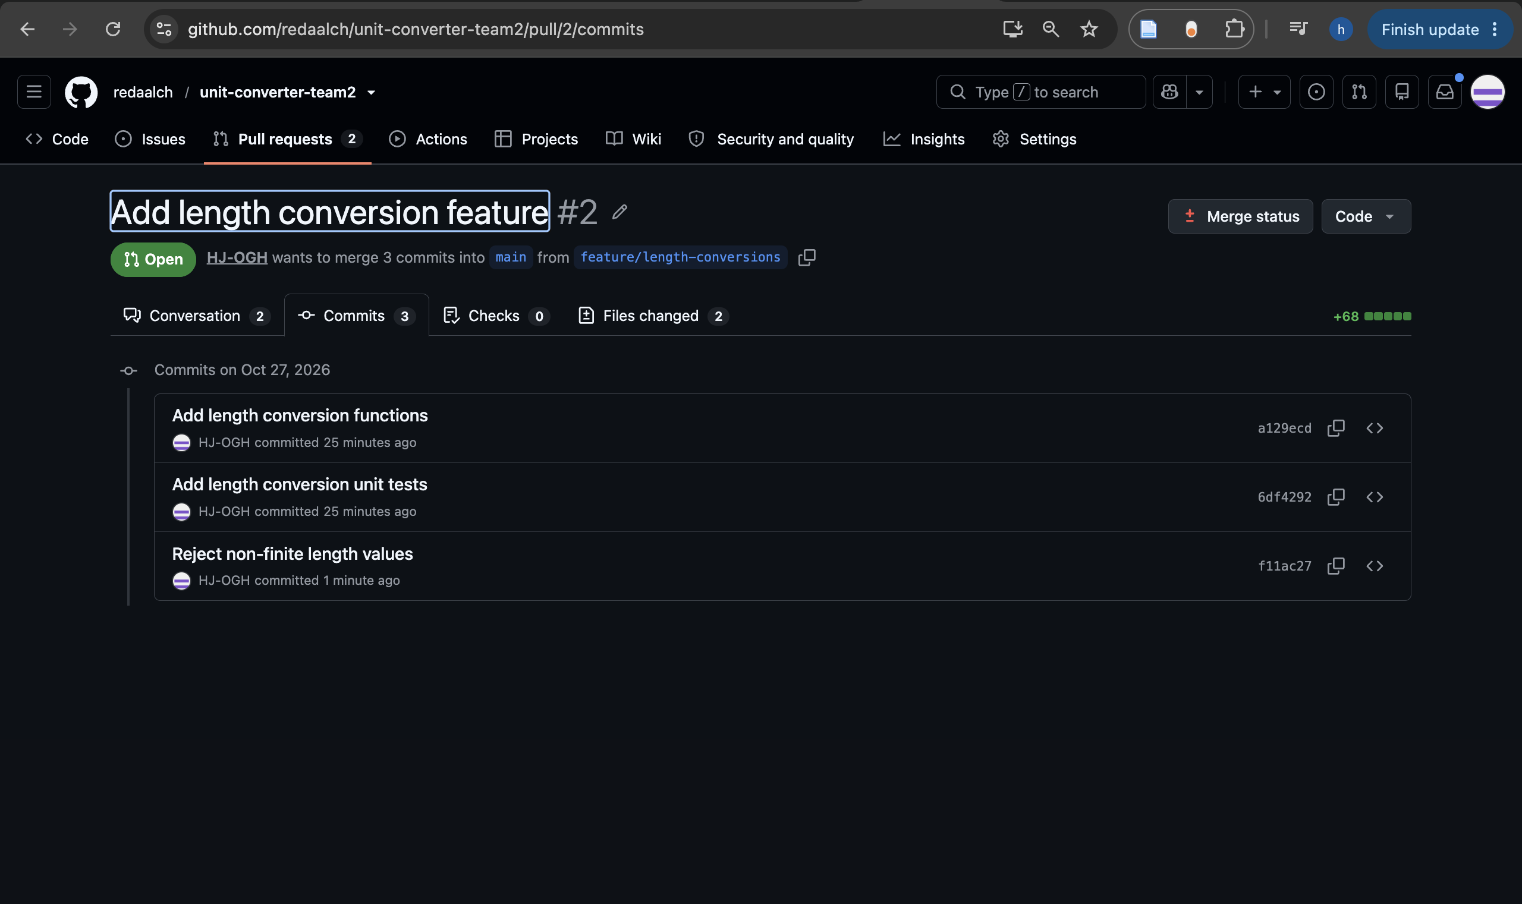
Figure 1. Hajar's length PR contains the implementation, tests, and review correction in three commits.

3. Pull Requests & Code Review
Reda authored temperature PR #1, which Hajar reviewed. Her line comment requested a regression test to verify that a temperature below absolute zero would still be rejected when the source and target units were identical. Hajar then approved the PR. The comment addressed validation order and the same-unit early return.
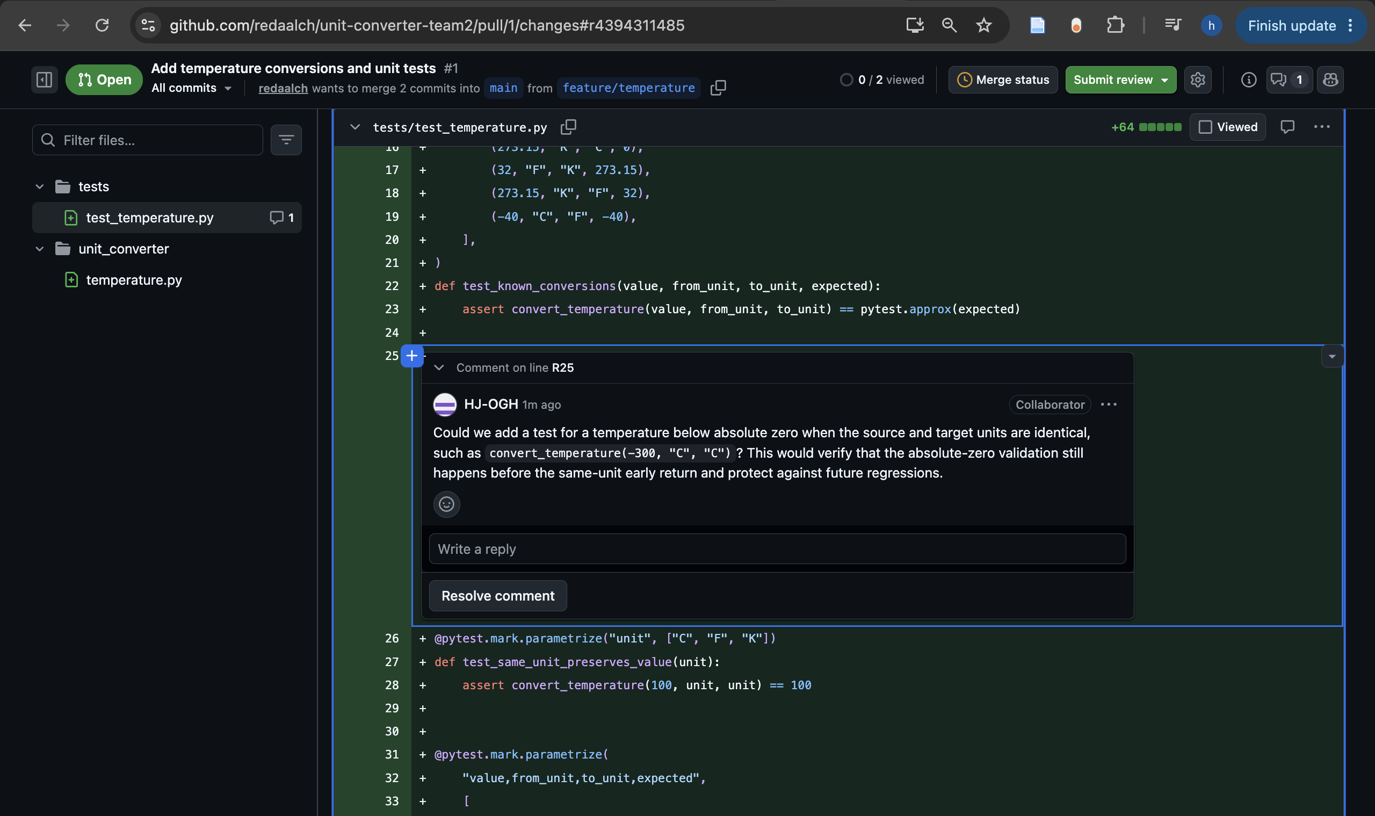
Figure 2. Hajar requests a regression test for absolute-zero validation with identical source and target units.
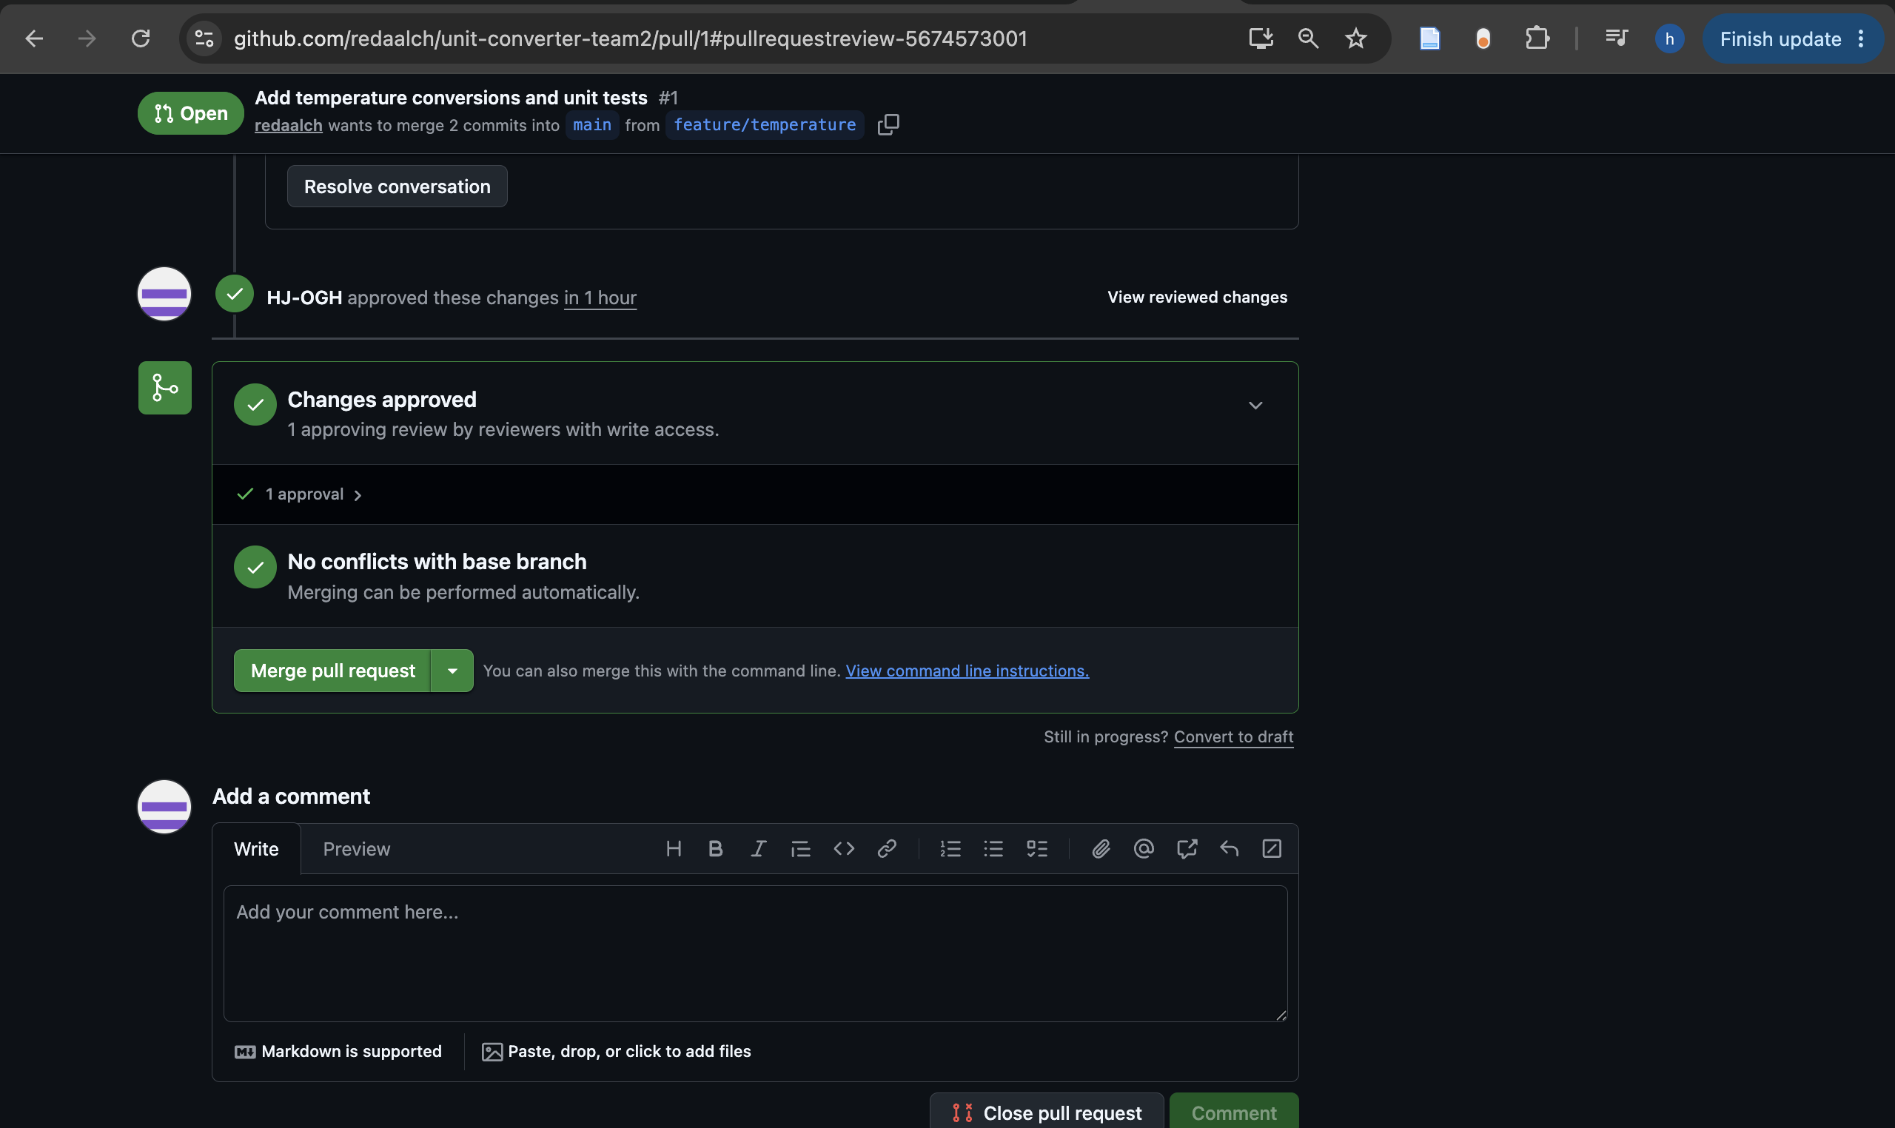
Figure 3. Hajar's submitted approval of the temperature PR before its merge.
Hajar authored length PR #2, which Reda reviewed. Reda submitted Request changes because NaN and positive infinity passed through the original negative-value check. Hajar added math.isfinite validation and tests for NaN and both infinities in commit f11ac27 on the same feature/length-conversions branch. Reda verified the correction, reran the tests, and approved the existing PR before it was merged.
Length PR #2: requested changes, correction, and approval

4. Merge Conflict
Both status branches began at main commit 2a4b4e9, where README.md contained "Project status: Development in progress." Hajar created conflict/length-status and changed the line to "Project status: Length conversion completed." Reda created conflict/temperature-status and changed the same line to "Project status: Temperature conversion completed."
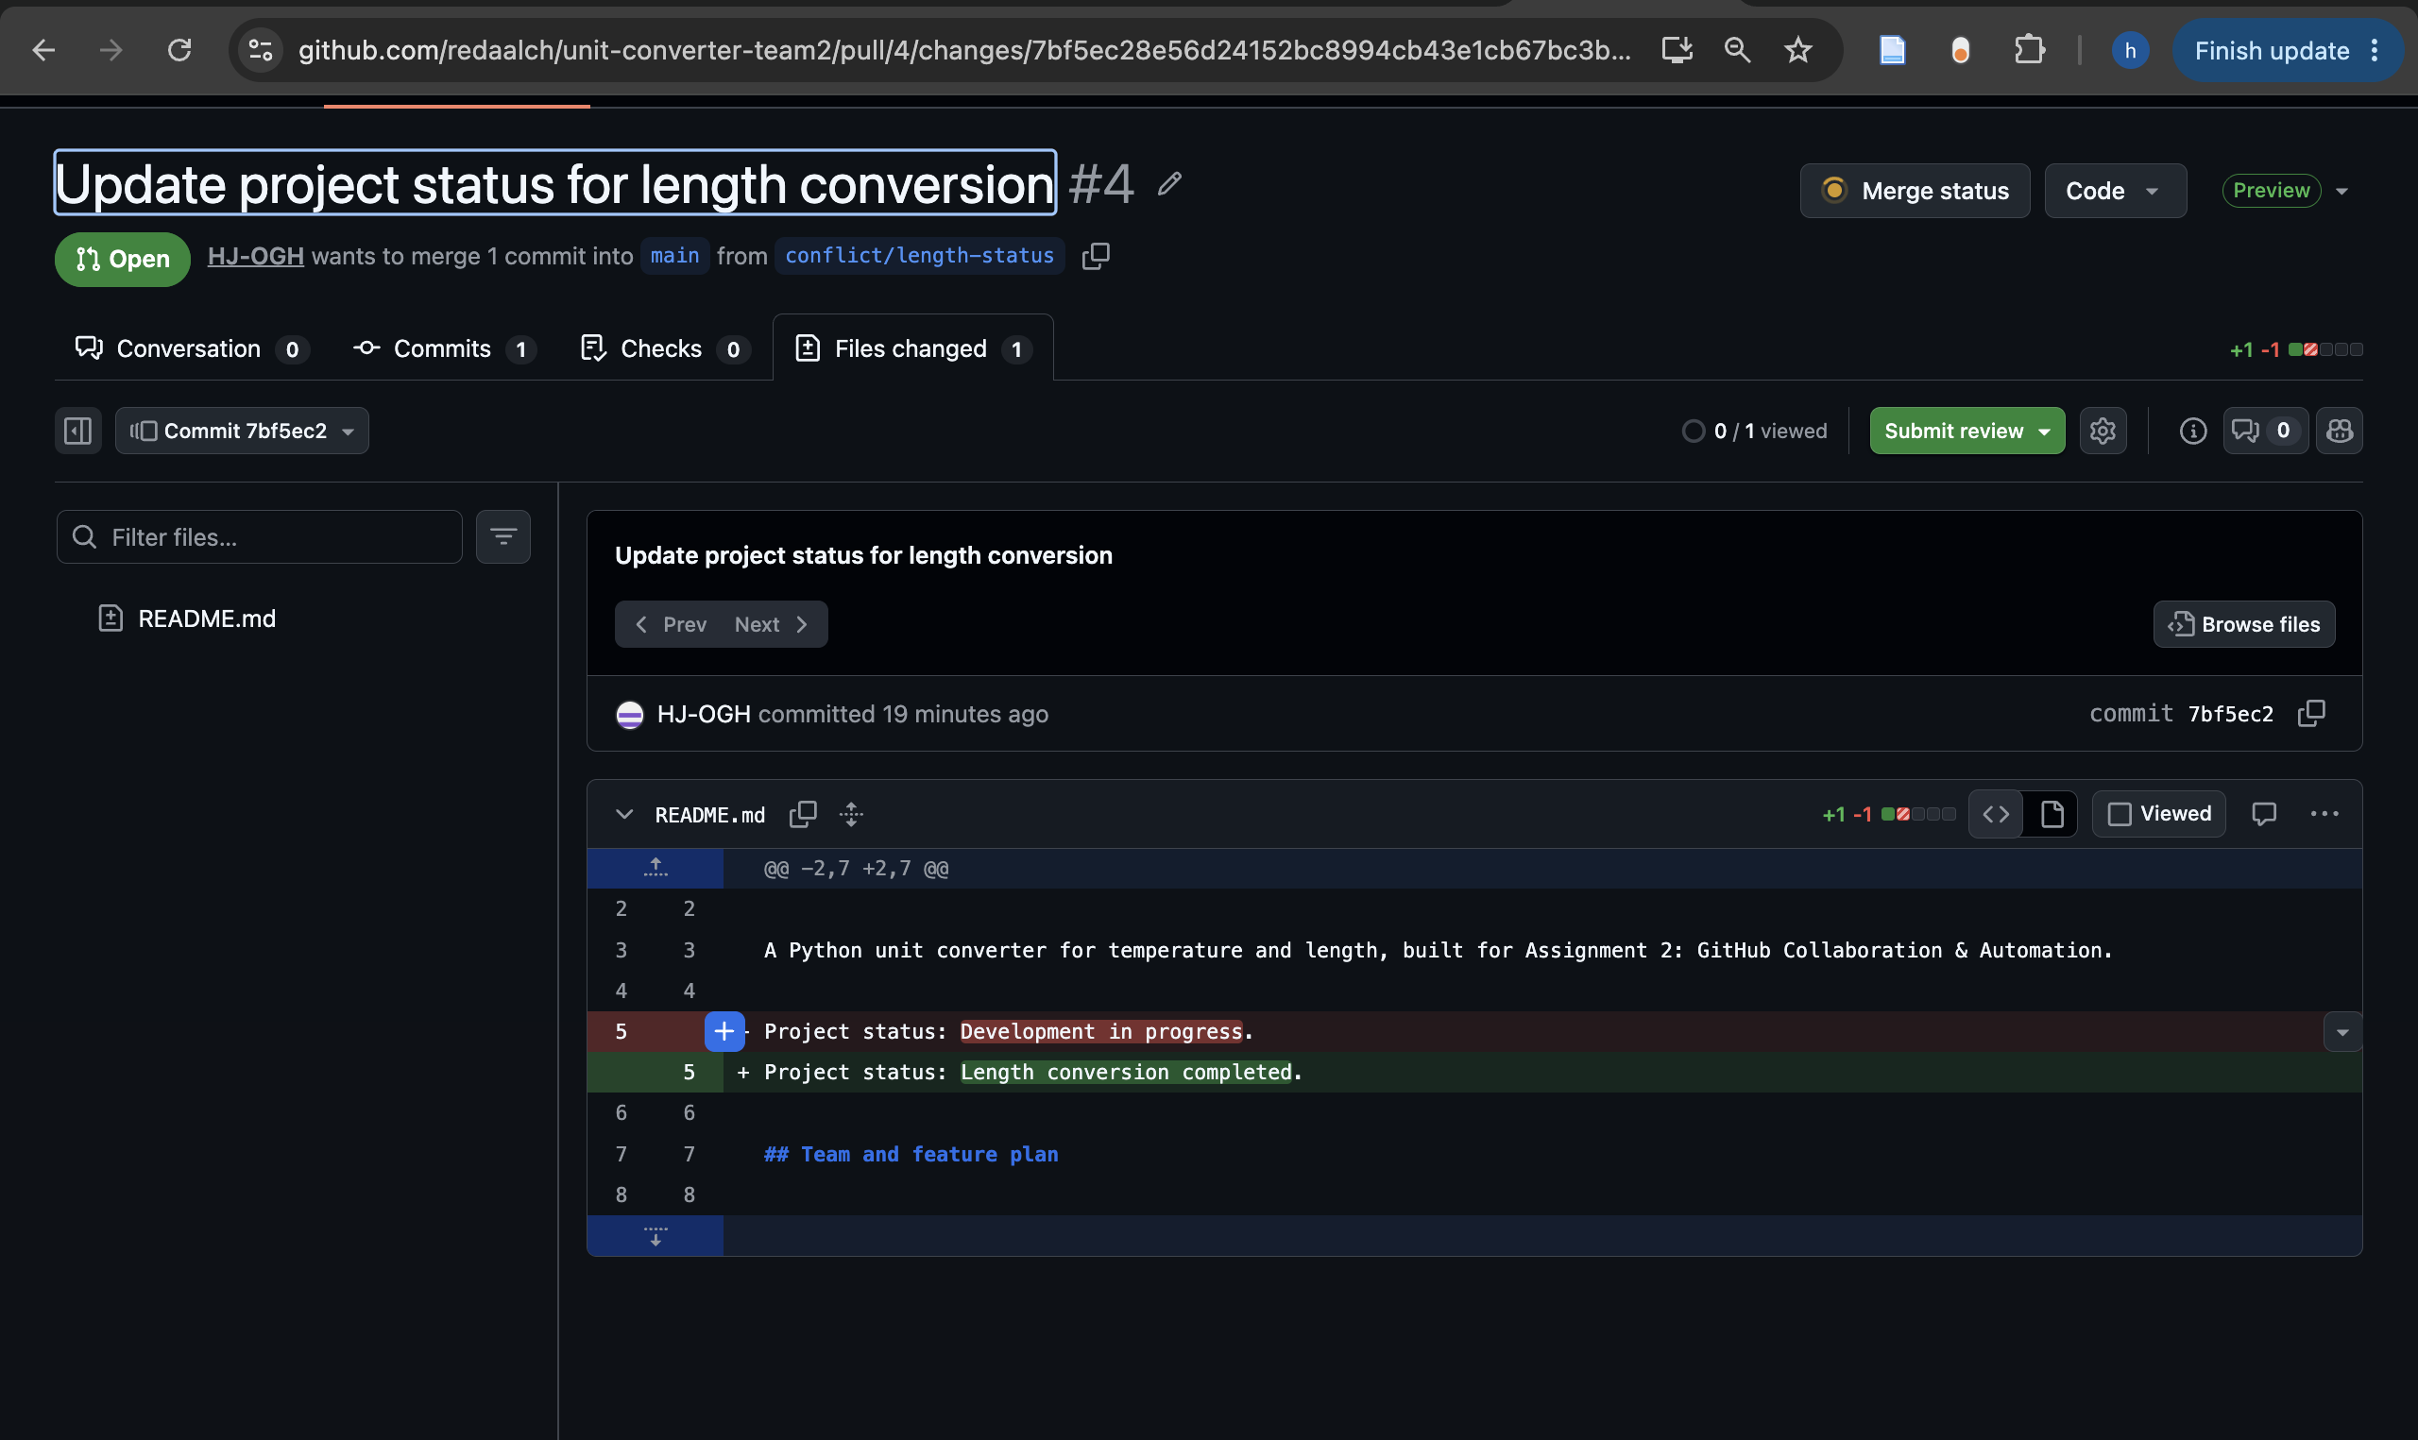
Figure 4. Hajar's first status PR changes the shared README line before it is merged into main.
Hajar's PR #4 was reviewed and merged first. On Reda's branch, git fetch origin followed by git merge origin/main produced a content conflict in README.md. Current/HEAD represented Reda's temperature status. Incoming/origin/main represented Hajar's length status already merged into main. The captured conflict contained:
<<<<<<< HEAD
Project status: Temperature conversion completed.
=======
Project status: Length conversion completed.
>>>>>>> origin/main
Reda combined both statements into one final line:
Project status: Temperature and length conversions completed.
The resolved file was staged, all tests passed, and merge commit 8e1e0a2 recorded the resolution with parents 0e426f7 and b49bdd2. Reda pushed it to the same PR #6. Hajar reviewed the combined status and removal of conflict markers, approved the PR, and the resolution was merged.
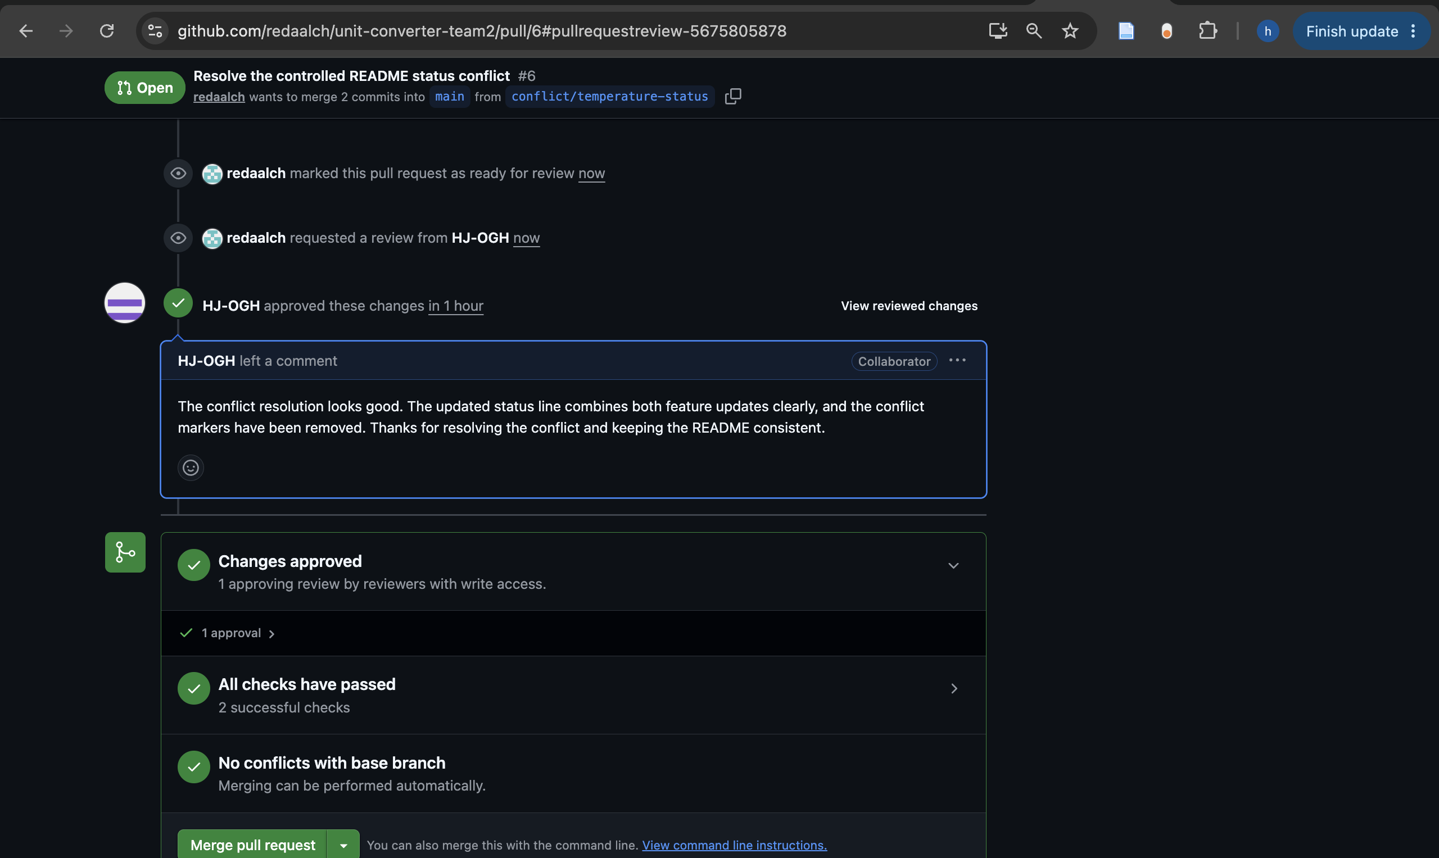
Figure 5. Hajar approves the resolved status PR; GitHub shows passing checks and no remaining merge conflict.

5. Unit Tests
The final suite contains 15 test functions that expand to 39 pytest cases through parameterization: 29 temperature cases and 10 length cases. Both members exceed the requirement of three meaningful tests for a two-member group. Tests use pytest.approx where floating-point conversion results need approximate comparison.
Category | Temperature example | Length example
Normal behavior | 0 C converts to approximately 32 F. | 1 mile converts to approximately 1609.344 meters.
Boundary or edge case | Absolute zero converts to 0 K; same-unit values are preserved. | Zero length converts to zero; same-unit values are preserved.
Invalid input or error | Below-absolute-zero values, invalid units, and non-finite input raise ValueError. | Negative length, invalid units, NaN, and infinity raise ValueError.

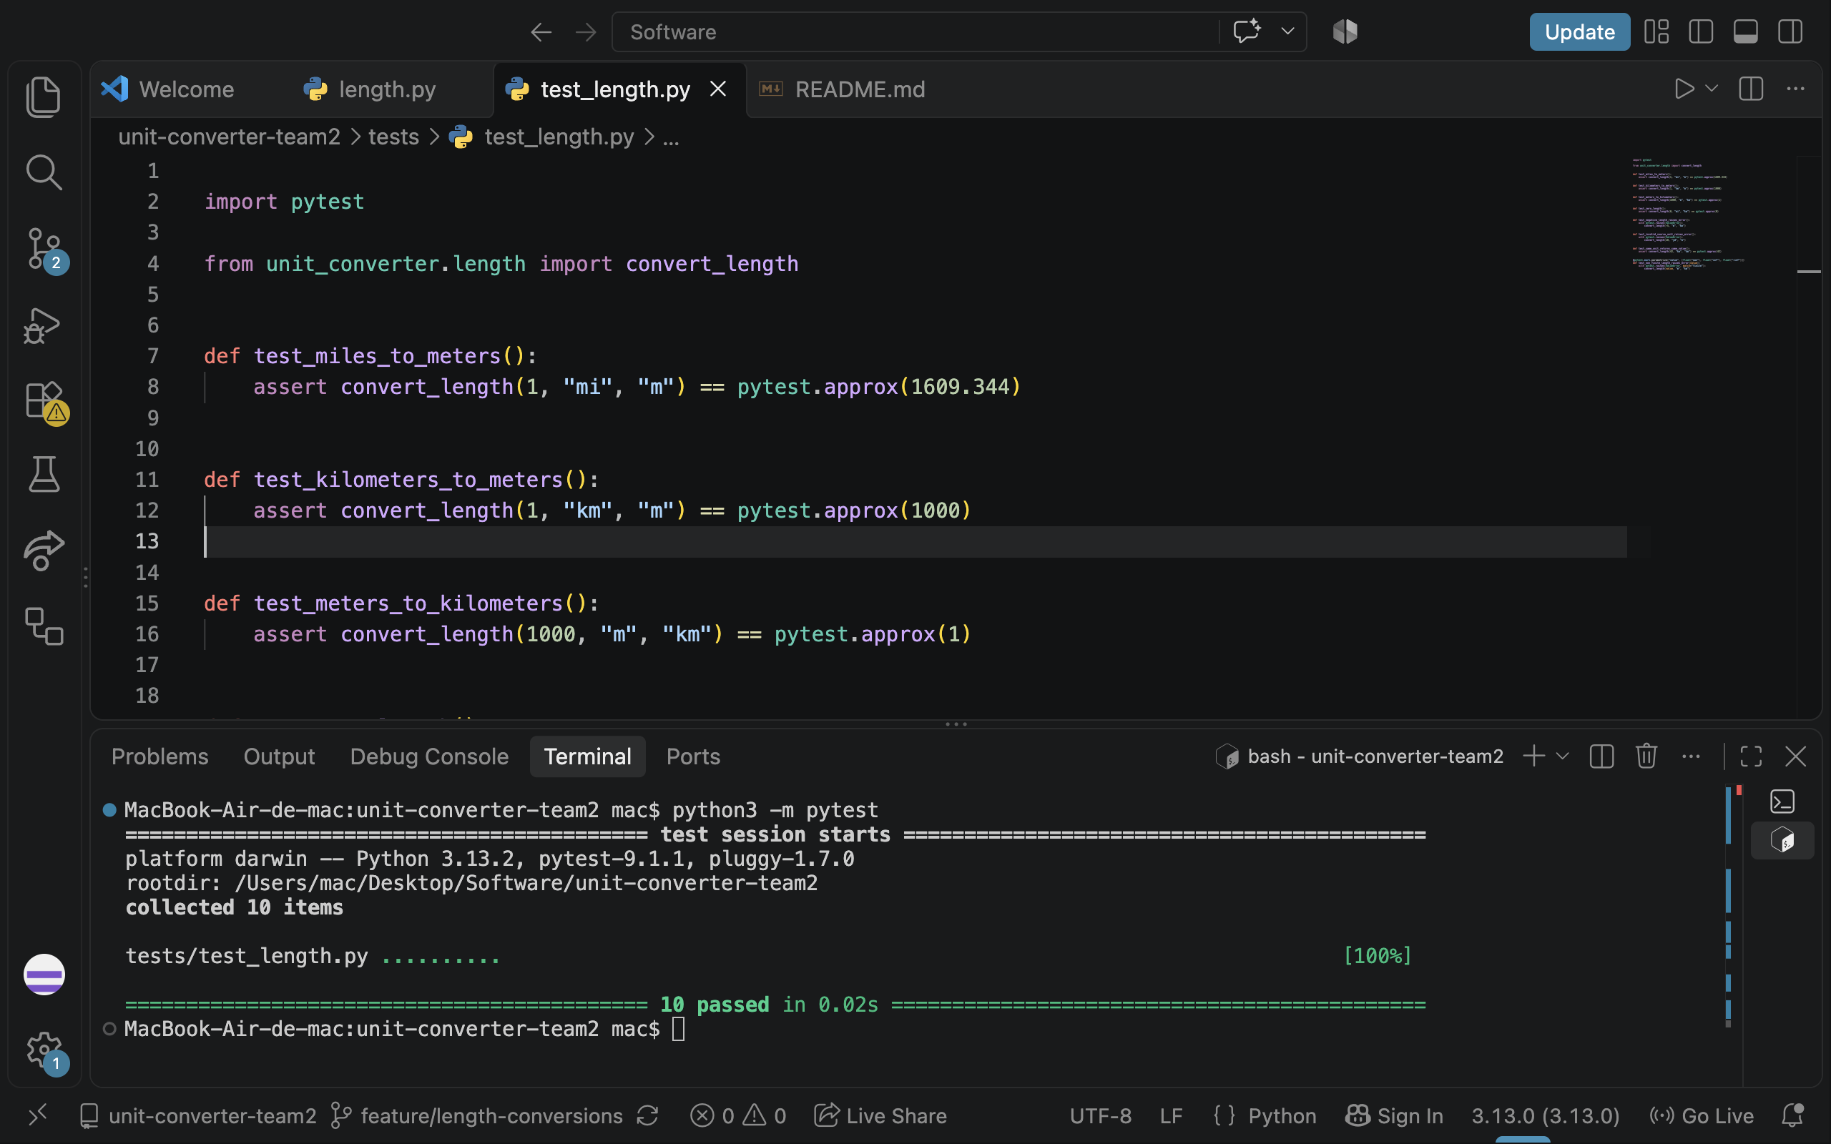
Figure 6. Hajar's local feature branch passes all 10 length cases; the terminal identifies Python 3.13.2.
The complete main suite was verified again at commit f70959a with python3 -m pytest -q: 39 passed. That verification used Python 3.10.12. GitHub Actions also passed the full suite using Python 3.12.15.

6. Continuous Integration
The Tests workflow is stored in .github/workflows/tests.yml and runs on push and pull_request events. Its Python tests job uses ubuntu-latest, prepares Python 3.12, installs requirements.txt, and runs python -m pytest -q. The workflow grants read-only access to repository contents and has a five-minute job timeout.
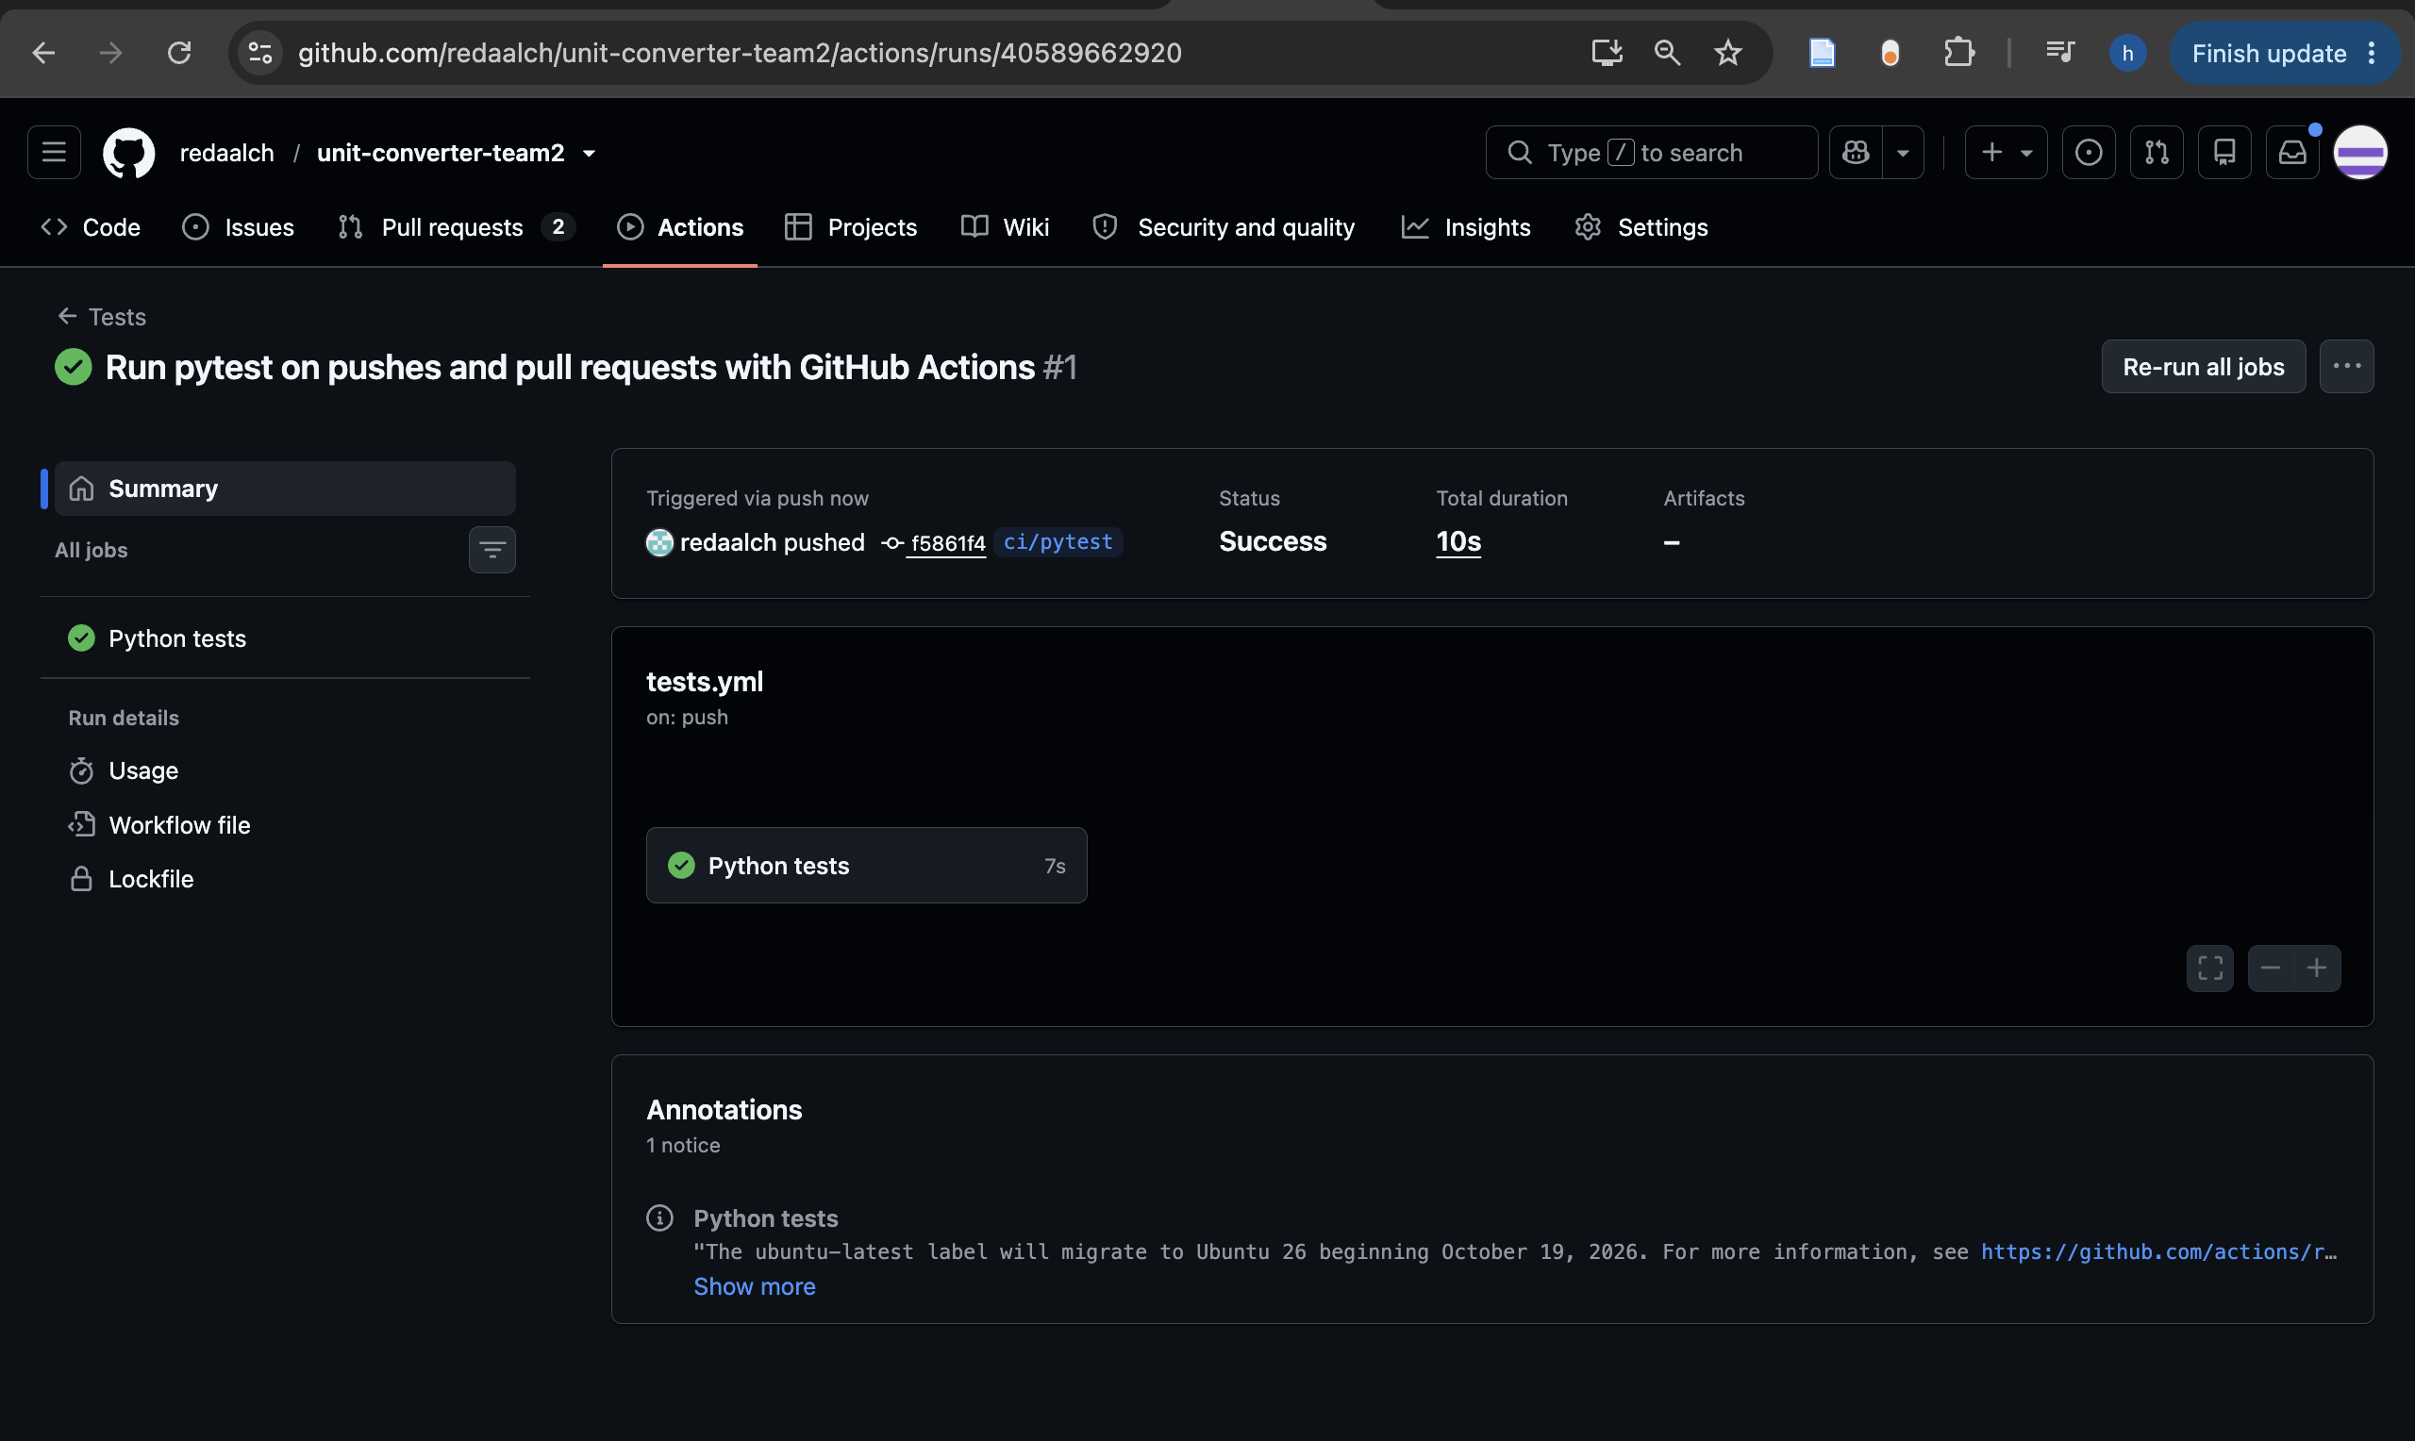
Figure 7. The initial push run succeeds at commit f5861f4. This screenshot was taken before the controlled failure.
After the initial successful run, Reda added a temporary test that called pytest.fail. The failed run reported one failed case and 39 passing application cases. The logs identified the controlled demo test and exit code 1. Reda inspected the output, removed the temporary file in commit e58a0fd on the same ci/pytest branch, and pushed the correction. The later push and PR runs passed all 39 cases. The final branch diff contained only the workflow file.
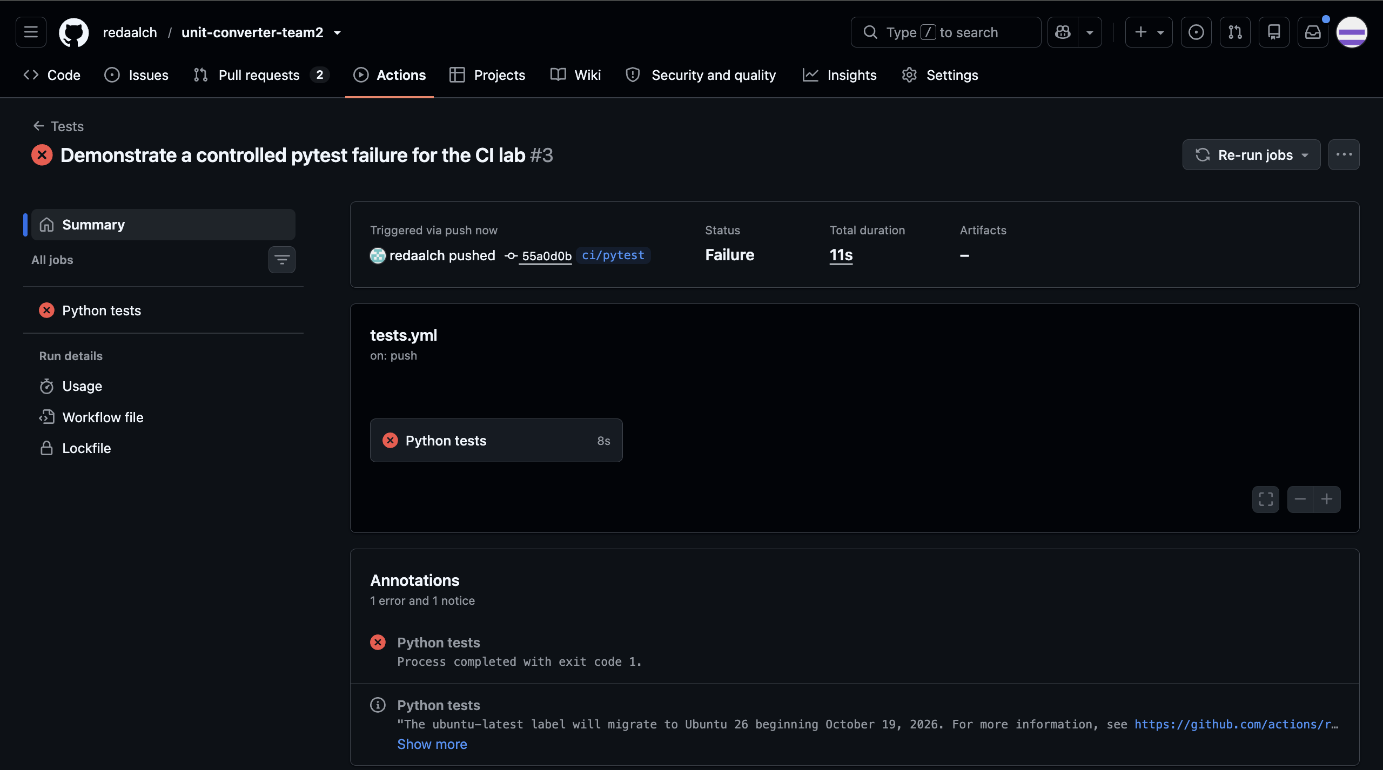
Figure 8. The controlled pytest failure at commit 55a0d0b causes the CI push run to fail.
Stage | Commit | Recorded result
Initial workflow | f5861f4 | Success; see Figure 7.
Controlled failing test | 55a0d0b | Failure; 1 failed and 39 passed.
Correction | e58a0fd | Success after removing the demo; 39 passed.

Failed PR run: 40589847428
Successful PR run after correction: 40589970912

7. Ruleset & Protected main
The active Protect main ruleset targets refs/heads/main. It requires a Pull Request and at least one approving review, blocks branch deletion and force pushes, and has an empty bypass list. New commits dismiss stale approvals. The Python tests status check from GitHub Actions must pass, and the branch must be tested with the latest main code before merging.
During the CI exercise, PR #3 was blocked while its checks failed and approval was missing. After the correction, the checks passed while the review requirement still prevented merging. Hajar's approval satisfied the remaining review requirement before the PR was merged. Figure 9 records the review request and required approval in the workflow PR.
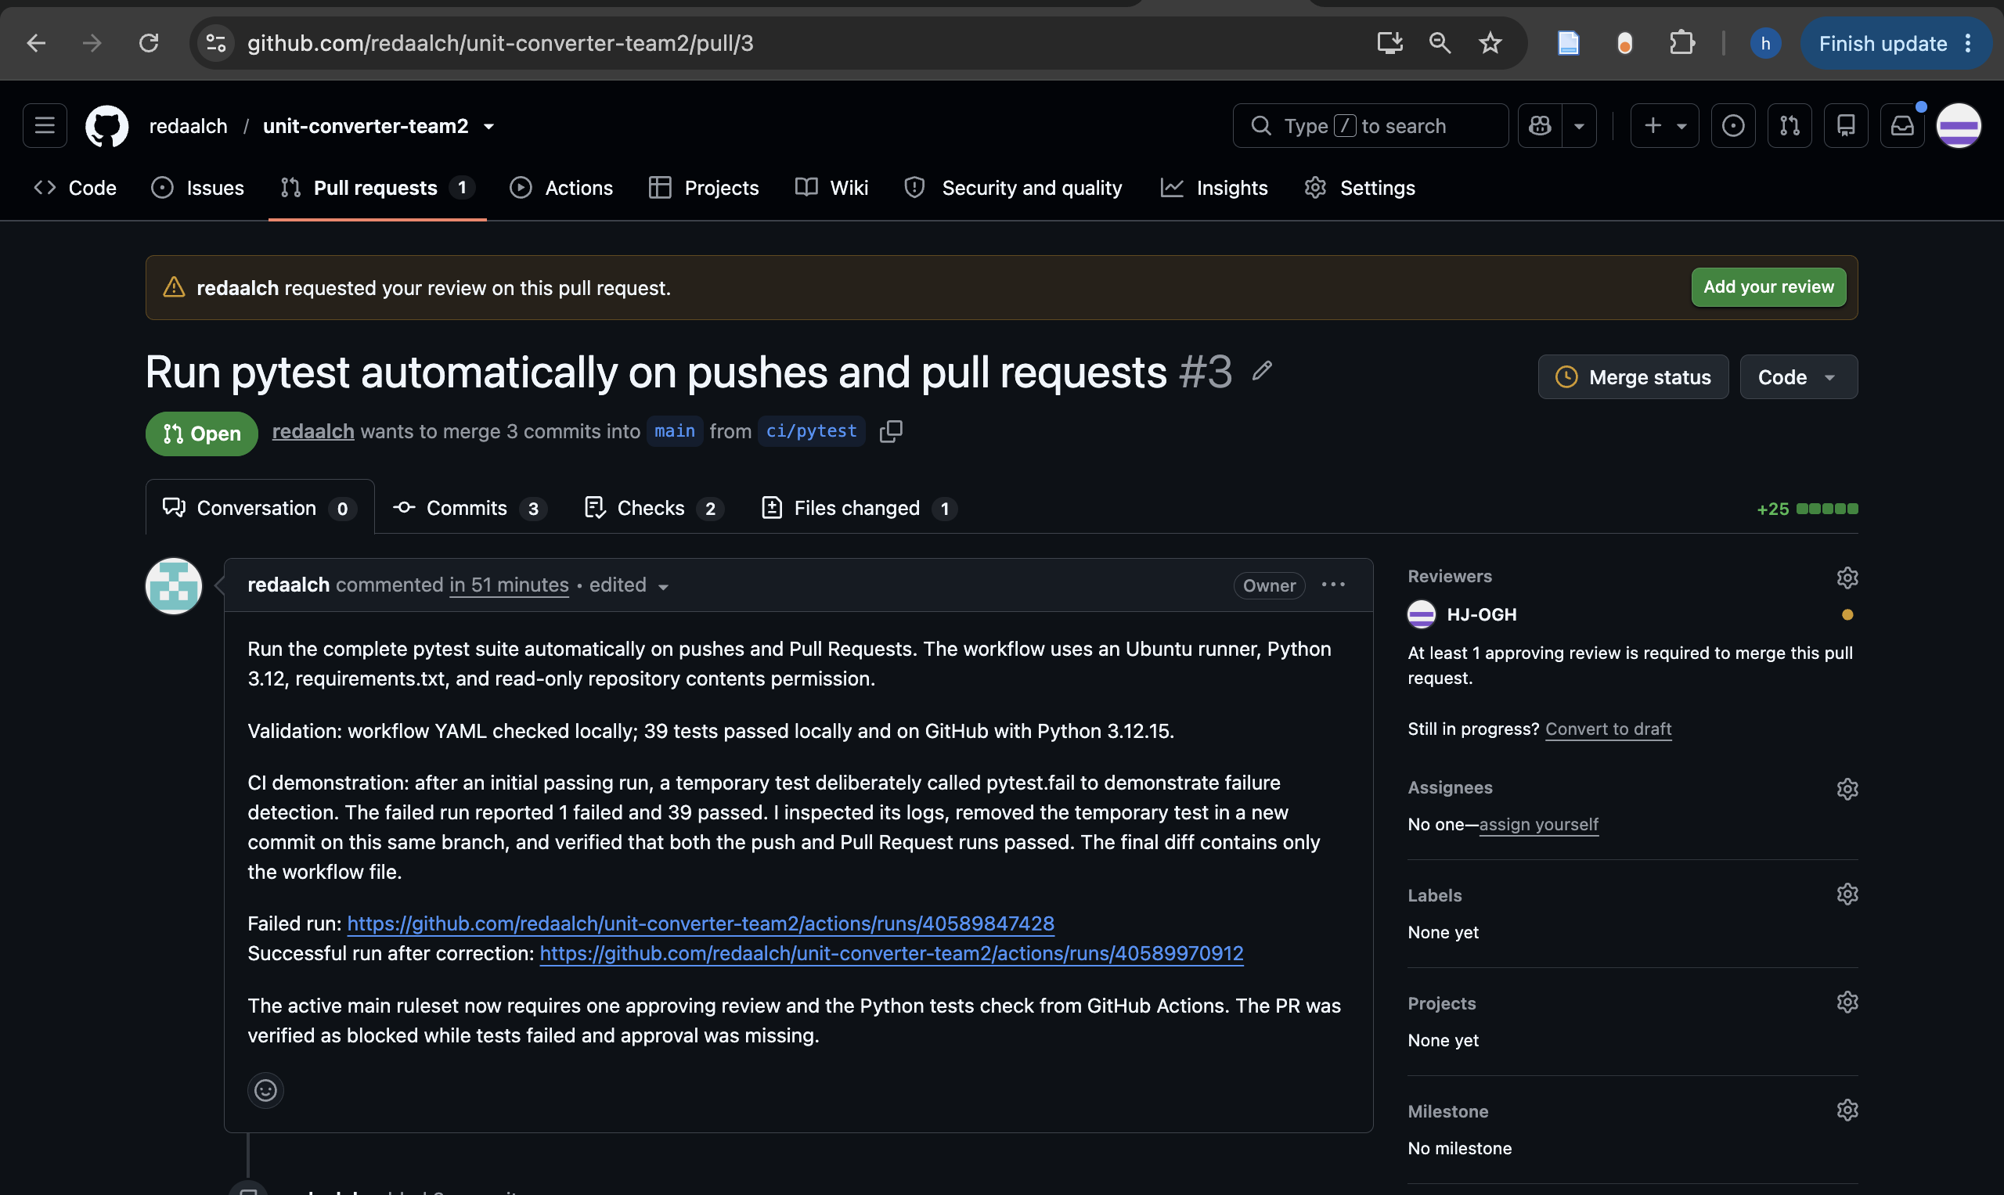
Figure 9. Workflow PR #3 shows the required approval; its description states the CI requirement.
Final Protect main ruleset

8. Continuous Deployment
GitHub Pages publishes the static project page from the main branch and /docs folder, using docs/index.html as its entry file. Hajar added the page through PR #5 on feature/project-pages. The page includes the project title and theme, both team members, a feature overview, and setup and test instructions.
Hajar then used feature/final-page-update and PR #7 to add a visible sentence about collaborative development, automated testing, and continuous integration. That change was committed as 97d7e8d and merged into main at f70959a. The Pages build for f70959a completed successfully, and the new sentence was verified on the live page with HTTP 200.
Live GitHub Pages project page
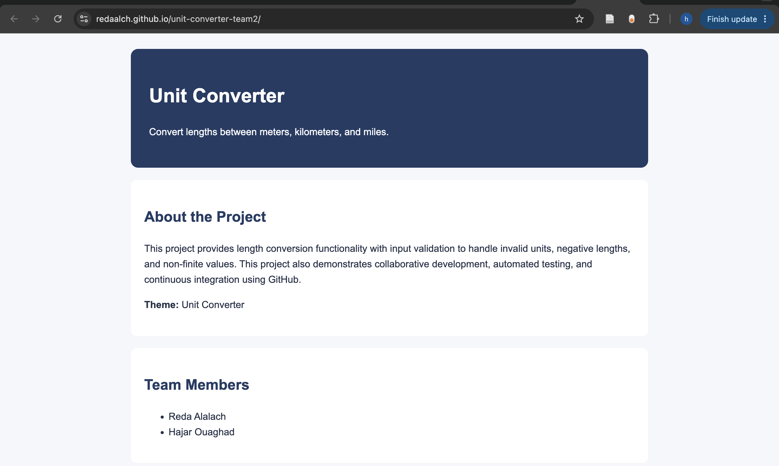
Figure 10. The published page shows both members and the description update introduced through PR #7.

9. Contribution Summary
Member | Branches and PRs | Feature and test contribution
Reda Alalach | Authored PRs #1, #3, #6.  Reviewed PRs #2, #4, #5, #7.  Branches: feature/temperature; ci/pytest; conflict/temperature-status. | Temperature converter; 7 test functions / 29 cases; CI and ruleset setup; README conflict resolution.
Hajar Ouaghad | Authored PRs #2, #4, #5, #7.  Reviewed PRs #1, #3, #6.  Branches: feature/length-conversions; conflict/length-status; feature/project-pages; feature/final-page-update. | Length converter; 8 test functions / 10 cases; finite-input correction; project page and final visible update.

10. Fair Use of AI
We used Codex for assignment planning, code and test drafts, CI configuration, review assistance, conflict-resolution guidance, and report preparation. Prompts asked for converter functions, meaningful pytest cases, input-validation checks, and workflow troubleshooting. Reda reused and checked an earlier AI-assisted temperature implementation. Hajar updated the length feature after review identified non-finite inputs. We checked the accepted work through local pytest runs, GitHub Actions logs, peer reviews, Git history, and the published page. Each member remains responsible for understanding the contribution under their account.

11. Sources & Reflection
[1] Course materials. Assignment 2 - Group D: GitHub Collaboration & Automation, including the report template.
[2] Course slides. Session 2: Collaboration & Automation, Group D.
[3] Project repository, Pull Requests #1 to #7, commits, and Actions history.
[4] GitHub Docs. REST API endpoints for rules.
[5] GitHub Docs. Creating a GitHub Pages site.
The hardest collaboration step was resolving the README conflict without losing either status update. Comparing the common starting commit with Current and Incoming helped us preserve both completed features. If a PR or workflow behaves unexpectedly, we would first check its base branch, required reviews, and Actions logs. We would then rerun pytest locally and verify the Pages publishing folder before changing code.

