Assignment 2 - Git & GitHub Fundamentals
Group Report
GitHub Collaboration & Automation
Unit Converter

Field | Details
Group Size | 2 members
Chosen Theme | Unit Converter
Full Names | Reda Alalach; Nour El Houda Garaoui
Student IDs | Reda Alalach: 200762  Nour El Houda Garaoui: 158151
GitHub Usernames | Reda Alalach: redaalch  Nour El Houda Garaoui: Nour-2101
GitHub Repository URL | https://github.com/redaalch/unit-converter
GitHub Pages URL | https://redaalch.github.io/unit-converter/

28 October 2026

1. Project & Role Distribution
Our group followed the two-member path and built a Python unit converter with two feature areas. Reda implemented temperature conversion between Celsius, Fahrenheit, and Kelvin. Nour implemented length conversion between meters, kilometers, and miles. Both members contributed program logic, unit tests, and peer reviews through separate branches and Pull Requests.
Member | Assigned feature | Additional work
Reda Alalach | Temperature conversion | Repository and CI setup, main ruleset, conflict resolution, and project page.
Nour El Houda Garaoui | Length conversion | Module filename correction, length-status PR merged first, and peer reviews.

2. Branches, Commits & Contributions
Reda used feature/temperature and recorded the converter and its tests in two meaningful commits. Nour used feature/length and committed the tests and converter separately. She then updated the same branch during review; commit 7d0d35b recorded the required lowercase filename correction.
Member and feature branch | Main feature commits
Reda: feature/temperature | 850c154: Implement validated C, F, and K conversions.  8d9a0fd: Test conversions, boundaries, and invalid inputs.
Nour: feature/length | e9790c8: Add length conversion tests.  97f0935: Implement length conversion.  7d0d35b: Fix the lowercase module filename.

3. Pull Requests & Code Review
Reda authored temperature PR #2. Nour left inline comments on the test file and converter function declaration, then approved it. Nour authored length PR #3. Reda commented on the lowercase import in tests/test_Length.py and submitted Request changes because the module was named unit_converter/Length.py. That mismatch prevented imports on a case-sensitive filesystem.
Nour corrected the filename to unit_converter/length.py in commit 7d0d35b and pushed it to the same feature/length branch. Reda verified that all six length tests passed and checked the combined 35-case suite before approving the existing PR. Peer review also covered the initial team-names PR #1, which Nour approved before it was merged.
Length PR #3: filename comment, requested changes, correction, and approval
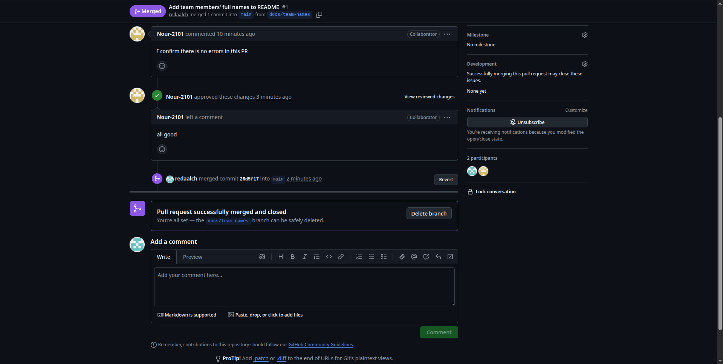
Figure 1. Nour approves the team-names PR #1; GitHub records its subsequent merge.

4. Merge Conflict
Both status branches began at main commit 6fcac07, where README.md contained "Project status: Development in progress." Reda created conflict/temperature-status and changed that line to "Project status: Temperature conversion completed." Nour created conflict/length- from the same version of main and changed it to "Project status: Length conversion completed."
Reda reviewed Nour's PR #6, and it was merged first. On Reda's branch, git fetch origin followed by git merge origin/main produced a real README content conflict. Current/HEAD contained Reda's temperature status; Incoming/origin/main contained Nour's length status already merged into main.
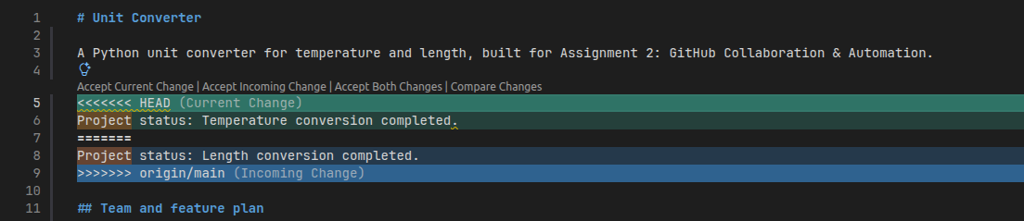
Figure 2. The shared README line conflicts: Current contains the temperature status and Incoming contains the length status.
Reda combined the two statements into one line and removed the conflict markers:
Project status: Temperature and length conversions completed.
The resolved README was staged and committed as merge commit eb77a34, with parents 1353c94 and 55f06ca. All 35 tests passed, and the resolution was pushed to the same PR #5. Nour approved the resolution, and PR #5 was merged into main as b12ba5c.
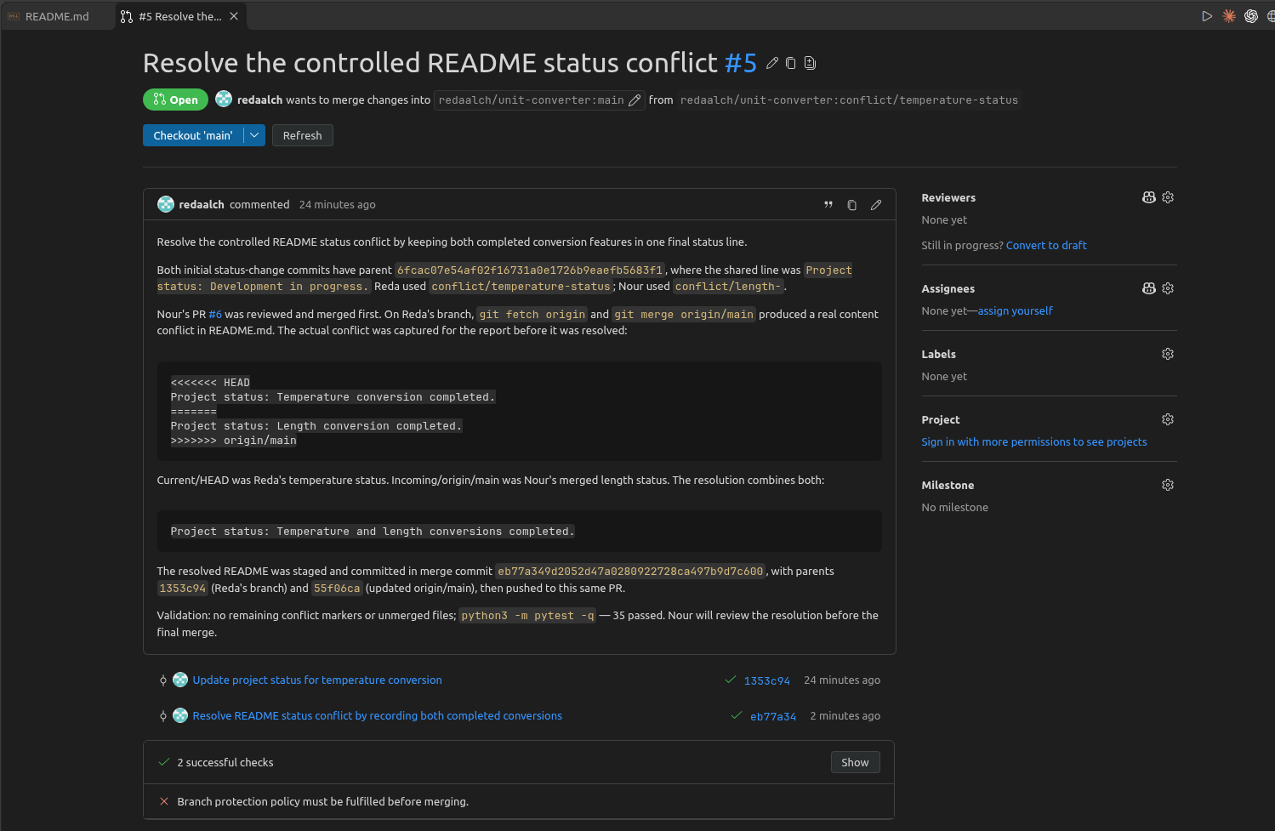
Figure 3. PR #5 shows the combined status and two successful checks before the required review.

5. Unit Tests
The final suite has 13 test functions that expand to 35 pytest cases: seven temperature functions produce 29 cases, and six length functions produce six cases. Both members exceed the requirement of three meaningful tests for their feature. pytest.approx handles floating-point comparisons.
Case category | Temperature example | Length example
Normal behavior | 0 C converts to approximately 32 F. | 1 mile converts to approximately 1609.344 meters.
Boundary or edge | Absolute zero converts to 0 K; same-unit values are preserved. | Zero meters converts to zero kilometers.
Invalid input or error | Below-absolute-zero temperatures, unsupported units, and non-finite input raise ValueError. | Negative lengths and unknown units raise ValueError.

The complete suite was rerun locally at main commit 95e5182 using Python 3.10.12. GitHub Actions also passed the suite with Python 3.12.15. The local result was:
$ python3 -m pytest -q
................................... [100%]
35 passed in 0.02s

6. Continuous Integration
The Tests workflow is stored in .github/workflows/tests.yml and runs on push and pull_request events. Its Python tests job uses an Ubuntu runner, prepares Python 3.12, installs requirements.txt, and runs python -m pytest -q. It grants read-only access to repository contents and has a five-minute job timeout.
Reda added the workflow on ci/pytest in commit 2265cff, together with a temporary test that deliberately called pytest.fail. The failed PR run reported one failed demo case and 35 passing application cases, then exited with code 1. The group inspected the failed output before correcting the branch.
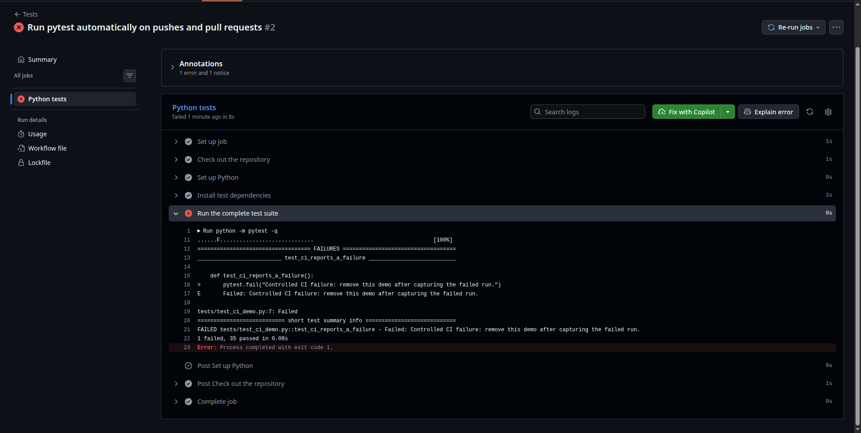
Figure 4. The controlled CI run fails at the pytest step; the output identifies the temporary failure demonstration.
Reda removed tests/test_ci_demo.py in commit eff77bf on the same ci/pytest branch. The corrected push and PR runs passed all 35 cases. The final PR diff contained only the workflow file. Nour approved PR #4 before its merge.
CI stage | Commit | Verified result
Controlled failure | 2265cff | 1 failed, 35 passed; exit code 1.
Correction | eff77bf | 35 passed; both push and PR checks succeeded.

Failed PR workflow run: 40604696099
Successful PR workflow run after correction: 40605031076
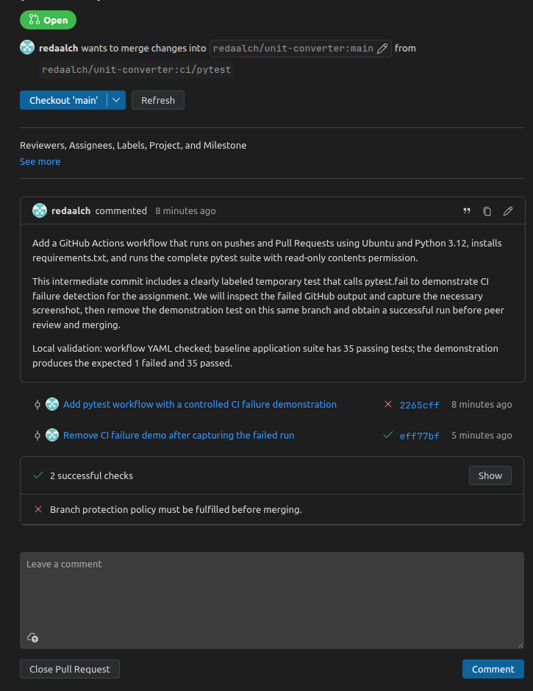
Figure 5. The corrected workflow PR #4 has two successful checks while branch protection still requires approval.

7. Ruleset & Protected main
The active Protect main ruleset targets refs/heads/main. The initial rules required a Pull Request and one approval and blocked deletion and force pushes. The team-names PR #1 demonstrated that branch protection prevented merging until Nour approved it.
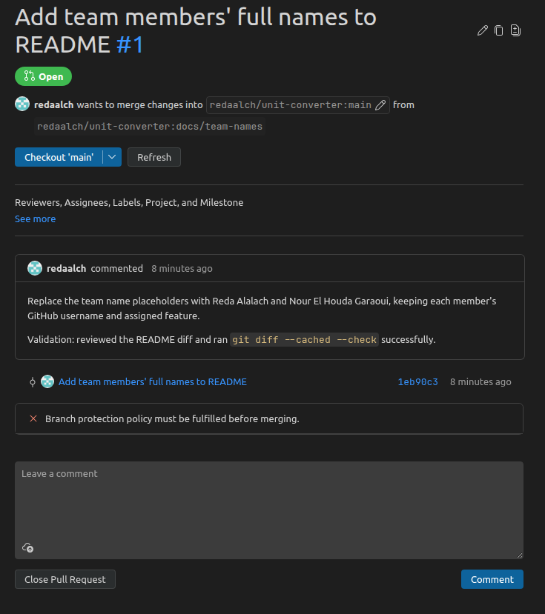
Figure 6. The initial team-names PR #1 is blocked by branch protection before its required approval.
After the workflow was working, the final ruleset also required the Python tests status check from GitHub Actions and strict checks against the latest main. New commits dismiss stale approvals, and the bypass list is empty. In PR #4, successful checks alone did not permit merging: Nour's approval was still required, as shown in Figure 5.
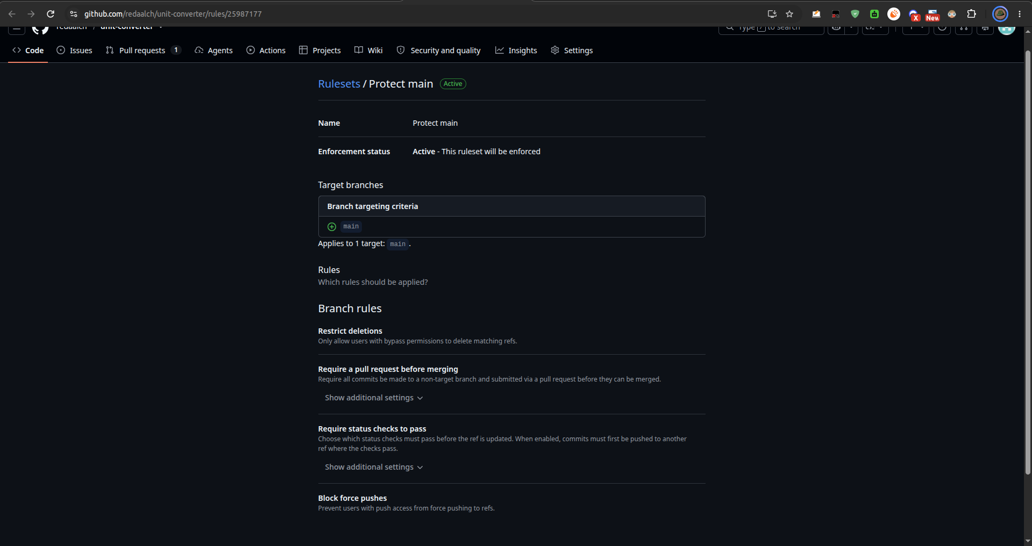
Figure 7. The updated main ruleset adds required status checks to the existing Pull Request protections.
Final Protect main ruleset

8. Continuous Deployment
GitHub Pages publishes from main and /docs, using docs/index.html as its entry file. Reda added the project page through PR #7, and Nour reviewed it. The page includes the title and theme, both members, temperature and length features, local setup, usage examples, and pytest instructions. README.md contains the live Pages URL.
For the final visible change, Reda created docs/final-page-update and added "Project status: Temperature and length conversions completed and tested." in commit 8f4b32c. Nour approved PR #8, which was merged as 95e5182. The automatic Pages deployment for that commit succeeded, and the new sentence was verified on the live page with HTTP 200.
Live GitHub Pages project page
Successful deployment of the final visible update
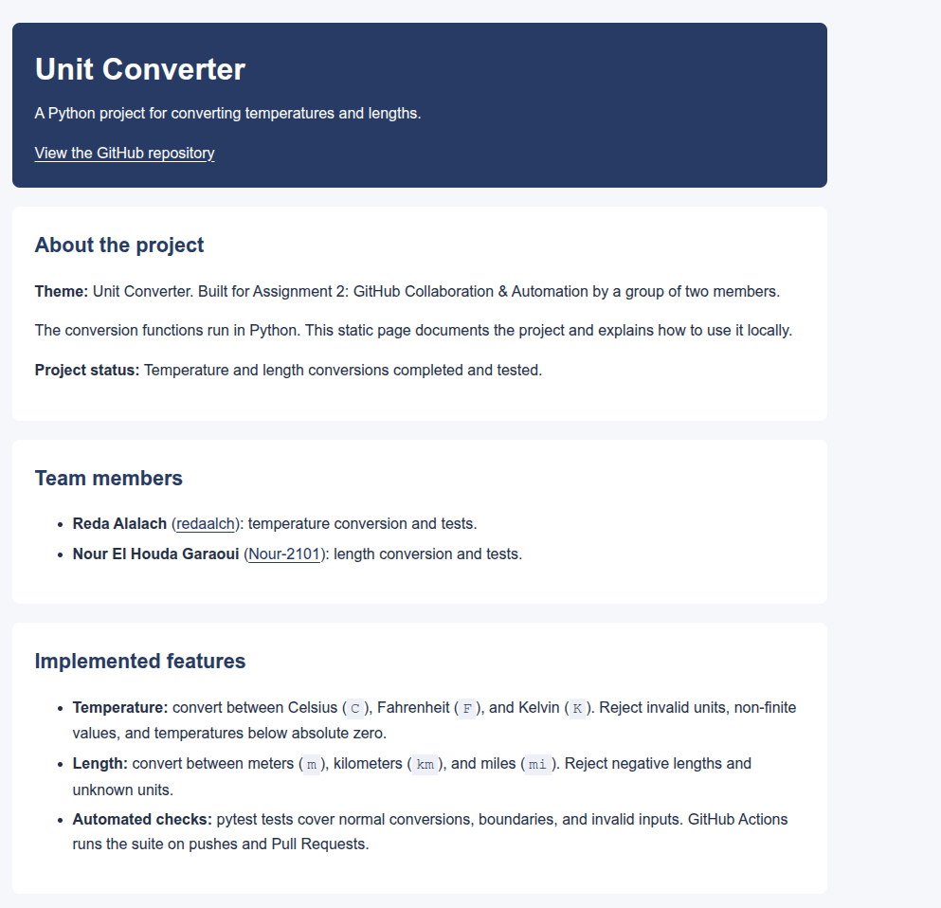
Figure 8. The live page displays the final status sentence, both group members, and both conversion features.

9. Contribution Summary
Member | Development branches and PRs | Feature and test contribution
Reda Alalach | Authored PRs #1, #2, #4, #5, #7, #8.  Reviewed PRs #3, #6.  Branches: docs/team-names; feature/temperature; ci/pytest; conflict/temperature-status; docs/project-page; docs/final-page-update. | Temperature converter; 7 test functions / 29 cases; repository and CI setup; ruleset; README resolution; project page and final update.
Nour El Houda Garaoui | Authored PRs #3, #6.  Reviewed PRs #1, #2, #4, #5, #7, #8.  Branches: feature/length; conflict/length-. | Length converter; 6 test functions / 6 cases; lowercase filename correction; length-status update merged first; peer reviews.

10. Fair Use of AI
Reda used Codex for assignment planning, temperature code and test drafts, CI configuration, review assistance, conflict-resolution guidance, project-page work, and report preparation. Prompts asked for converter functions, meaningful pytest cases, input validation, and GitHub workflow troubleshooting. We accepted the temperature and automation drafts after checking their behavior. Nour contributed the length converter and its tests and corrected its module filename after peer review. We verified the work through local pytest runs, Actions logs, peer reviews, Git history, and the published page. Each member remains responsible for understanding the contribution made under their account.

11. Sources & Reflection
[1] Course materials. Assignment 2 - Group D: GitHub Collaboration & Automation, including the report template.
[2] Course slides. Session 2: Collaboration & Automation, Group D.
[3] Project repository, Pull Requests #1 to #8, commits, and Actions history.
[4] GitHub Docs. REST API endpoints for rules.
[5] GitHub Docs. Creating a GitHub Pages site.
The hardest collaboration problem was detecting the case-sensitive length-module import before merging. Comparing the import with the actual filename helped us record the correct rename on the existing branch. If a test or workflow failed again, we would first check filenames and imports, then read the first failing test or CI step. For merge or deployment problems, we would check the branch base, required reviews and checks, and the Pages publishing source.

