Exam-2-answers
- 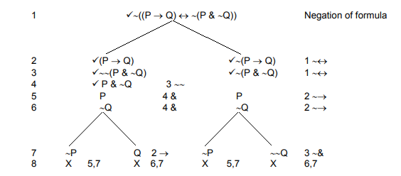
- 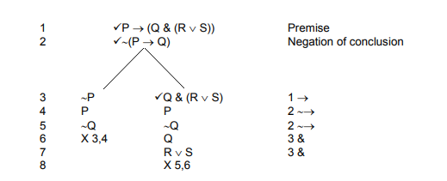
- 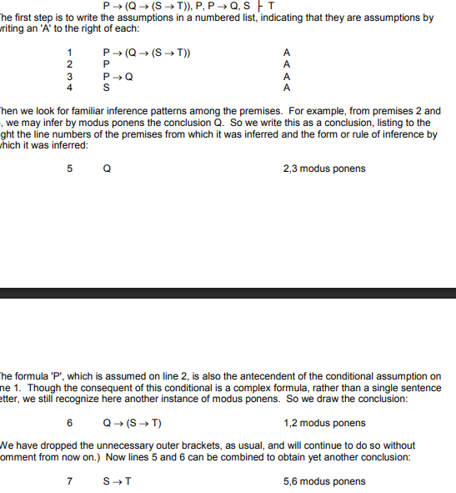
- 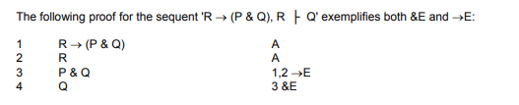
- 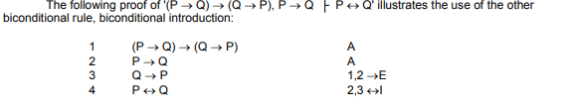
- 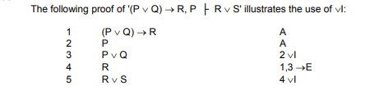
- 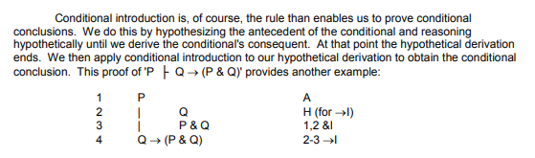
- 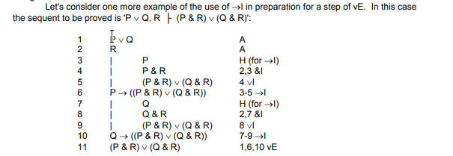
- 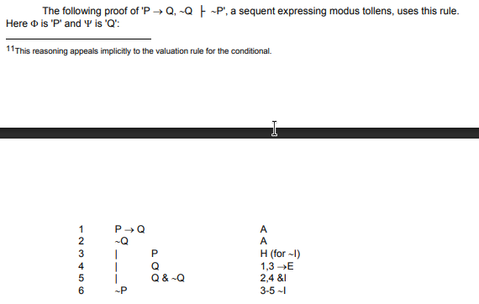
- 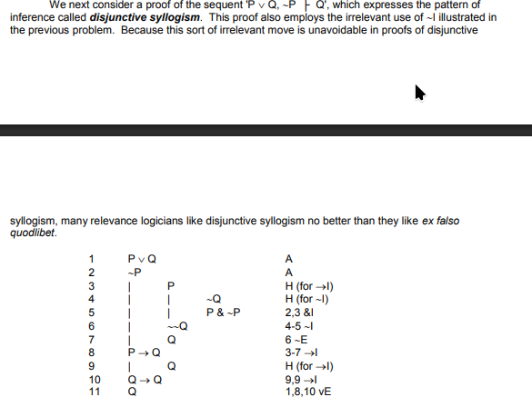
- 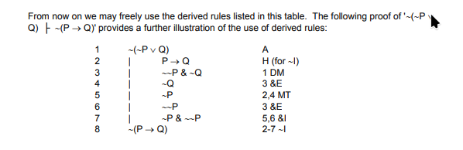
- 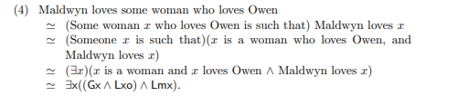
- Cindy is the richest doctor. Deb is a doctor. Therefore, unless Cindy is Deb, Cindy is richer than Deb.
- Dc & $∀$x((Dx & ~x=c) $→$ Rcx)
- Dd
$∴$
- ~c=d $→$ Rcd

