mCRM EWOC for PD1-TIM3

Francesca Michielin

Last compiled 2018-05-31 by kochr4 on rkaub00459.kau.roche.com

## R Markdown

This is an R Markdown document. Markdown is a simple formatting syntax for authoring HTML, PDF, and MS Word documents. For more details on using R Markdown see <http://rmarkdown.rstudio.com>.

THSI IS HOW TO INSERT BIBLIOGRAPHY (S. P et al. (2004); C, JJ, and LL. (2009); B, M, and T. (2008)).

When you click the **Knit** button a document will be generated that includes both content as well as the output of any embedded R code chunks within the document. You can embed an R code chunk like this:

summary(cars)

## speed dist   
## Min. : 4.0 Min. : 2.00   
## 1st Qu.:12.0 1st Qu.: 26.00   
## Median :15.0 Median : 36.00   
## Mean :15.4 Mean : 42.98   
## 3rd Qu.:19.0 3rd Qu.: 56.00   
## Max. :25.0 Max. :120.00

## Including Plots

You can also embed plots, for example:

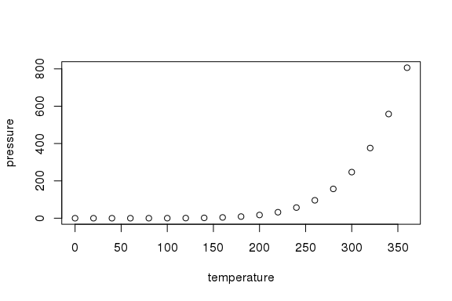

Note that the echo = FALSE parameter was added to the code chunk to prevent printing of the R code that generated the plot.

## Reference

B, Neuenschwander, Branson M, and Gsponer T. 2008. “Critical Aspects of the Bayesian Approach to Phase I Cancer Trials.” *Stat Med.* 27 (13): 2420 2439.

C, Le Tourneau, Lee JJ, and Siu LL. 2009. “Dose Escalation Methods in Phase I Cancer Clinical Trials.” *J Natl Cancer Inst.* 101: 708 720.

P, Schöffski, Riggert S, Fumoleau P, and et al. 2004. “Phase I Trial of Intravenous Aviscumine (rViscumin) in Patients with Solid Tumors: A Study of the European Organization for Research and Treatment of Cancer New Drug Development Group.” *Ann Oncol.* 15: 1816–24.