**Employee App Report**

**Name**: Yixuan Li

**Content**:

1 Introduction 2

1.1 Implementation Technique 2

1.1.1 MATLAB 2

1.1.2 App Designer 2

1.2 Application of Technology 2

2 Development Tool and Environment 2

2.1 Software Tools 2

2.2 Environment 2

3 System Analysis and Design 2

3.1 Requirements analysis 2

3.2 Use Case Diagram 2

3.3 Data Flow Analysis 2

3.4 Data Structure 3

3.4.1 Model 3

3.4.2 View 3

3.4.3 Controller 3

4 System Implementation 3

4.1 Function Implementation 3

4.2 Graphical User Interface 3

5 Testing 3

6 Summarization 3

6.1 Summarization 3

6.2 Prospect 3

6.3 Puzzles 3

# 1 Introduction

## 1.1 Implementation Technique

### 1.1.1 MATLAB

MATLAB combines a desktop environment tuned for iterative analysis and design processes with a programming language that expresses matrix and array mathematics directly.

* Professionally Built

MATLAB toolboxes are professionally developed, rigorously tested, and fully documented.

* With Interactive Apps

MATLAB apps let you see how different algorithms work with your data. Iterate until you’ve got the results you want, then automatically generate a MATLAB program to reproduce or automate your work.

### 1.1.2 App Designer

## 1.2 Application of Technology

# 2 Development Tool and Environment

## 2.1 Software Tools

## 2.2 Environment

# 3 System Analysis and Design

## 3.1 Requirements analysis

1. Code documentation
   * Good for maintaining and readability
2. Apply Model-View-Controller architecture
   * Lower the coupling. Modification does not affect the entire model
   * Faster development process. MVC supports rapid and parallel development.
   * In the MVC Model, you can create multiple views for a model. Code duplication is very limited in MVC because it separates data and business logic from the display. The code is easier to re-use and independently test
3. Input validation
4. clean and concise organization of code

## 3.2 Use Case Diagram

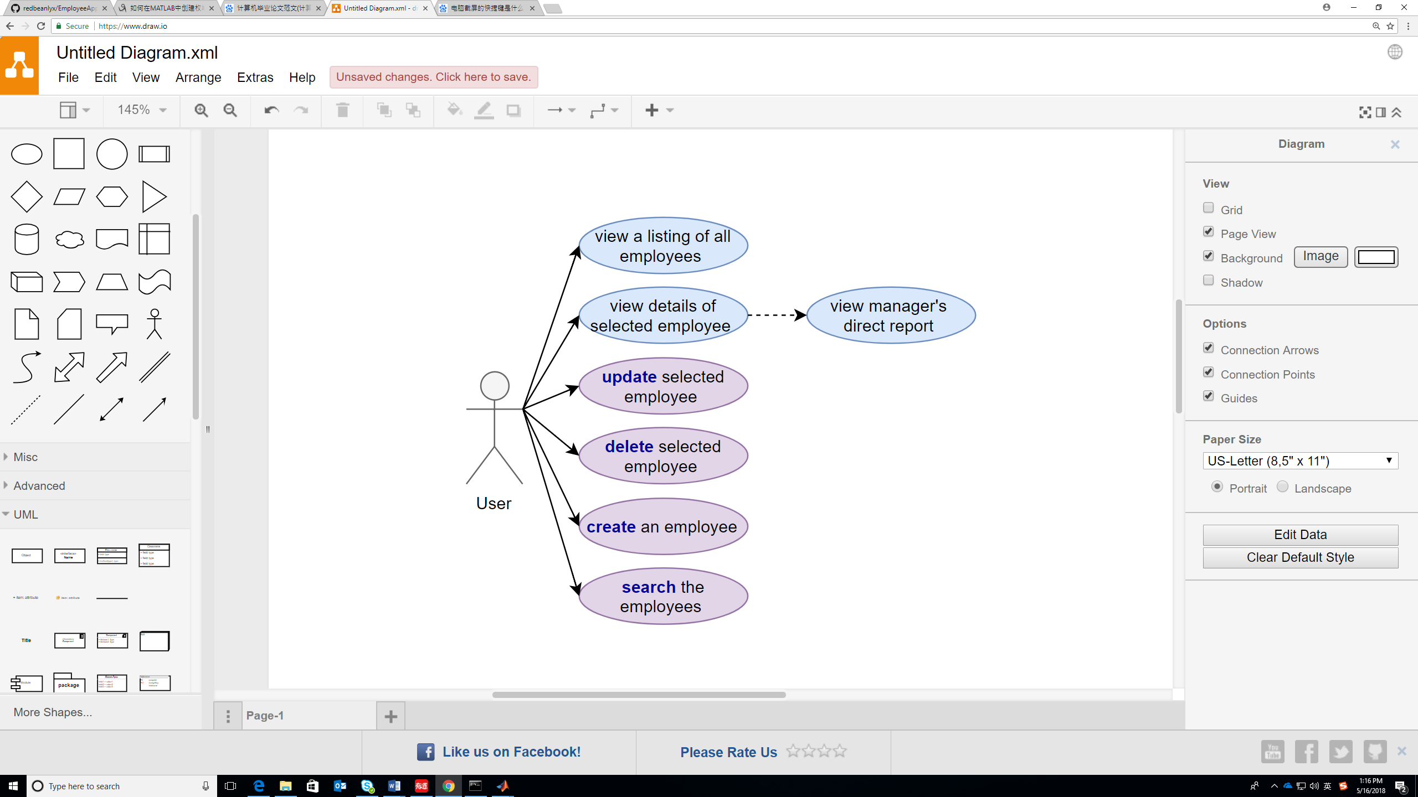

## 3.3 Data Flow Analysis

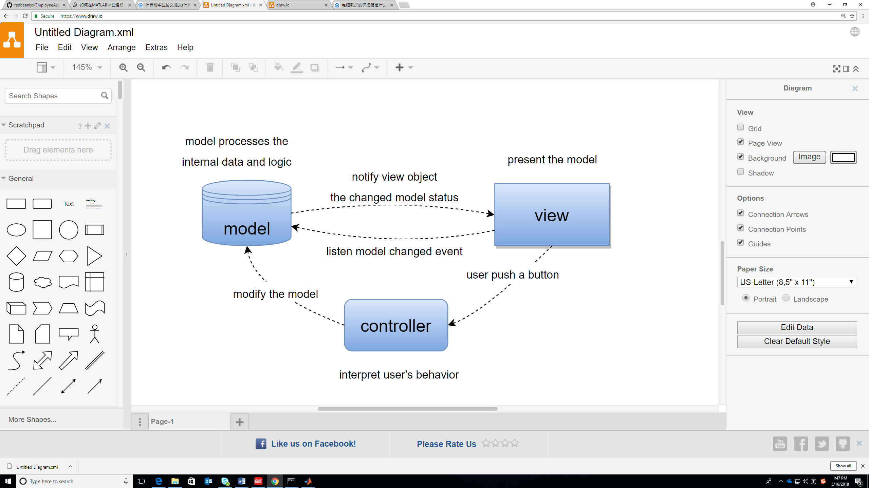

## 3.4 Data Structure

### 3.4.1 Model

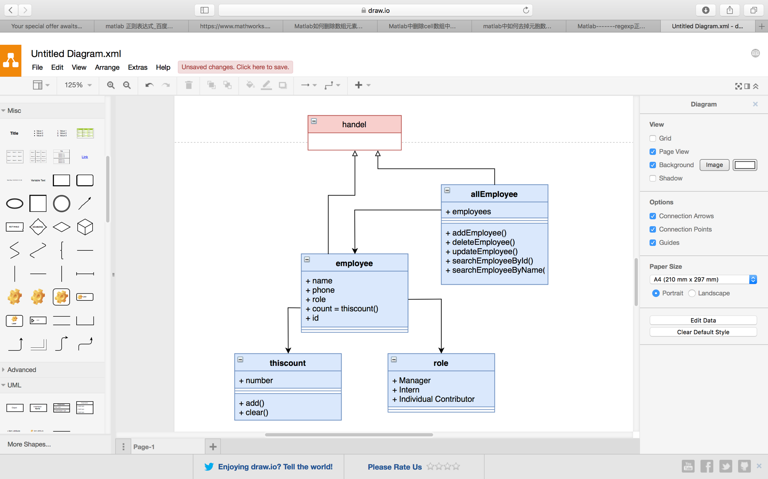

### 3.4.2 View

### 3.4.3 Controller

# 4 System Implementation

## 4.1 Function Implementation

## 4.2 Graphical User Interface

# 5 Testing

Everything looks great!

# 6 Summarization

## 6.1 Summarization

## 6.2 Prospect

* Connect to the database to persist the data
* Upload profile photo

## 6.3 Puzzles

* What is the naming convention in our team?
* Couldn’t modify the constructor in app designer
* Open *.m file in app designer
* Repeatedly open the same file in a lot of windows