Data Science Capstone Report

JMc May 2019

Pittsburgh vs. Manhattan and Toronto for Amenities

- Introduction / General Business Problem

General quality of life is a factor in recruiting and keeping talent for technology innovation operations. For example, Amazon recently went through a process to select a location for a secondary headquarters location from its original headquarters in Seattle. Selection of location on the east coast would have presumably added a diversity to the Amazon geographic base and provided a desired distribution of presence. Intuitively, large cities in the east would provide the best opportunity for Amazon to recruit a large base of the best and brightest to live and work. Large cities, however, have undeniably higher costs of living. It would be ideal for companies like Amazon to be able to locate in smaller cities that have adequate stock of University academic talent but may not have the amenities of the larger and more expensive cities. The question is, “Are there neighborhoods in smaller cities that have the quality of living profile (based on amenities) of the neighborhoods in the larger cities?” For the purposes of assessment, we will compare the amenity profiles of Toronto and New York with a smaller city such as Pittsburgh. The working hypothesis is that Toronto and New York have adequate food, drink, entertainment and Recreation to support a quality of life that is attractive. Do these amenities exist in Pittsburgh so that locating there would provide an attractive life/work location at a lower cost? We will use Foursquare location data from all three cities to analyze neighborhood data to assess the amenity profiles. This report is useful to any companies checking out locations (in this case Pittsburgh) to locate in when attracting talent has an element of cost and quality of life tradeoff.

- Data Sources and Use

I used the analysis of New York and Toronto previously performed in week 3 of the course as reference artifacts [1]. I performed a similar analysis of Pittsburgh. I gathered information about Pittsburgh from a Wikipedia site that lists the neighborhoods of Pittsburgh [2]. I used the location/position coordinates listed on the pages referenced. Where geo data available about the neighborhood was unavailable or suspect on the neighborhood Wikipedia page, I used the Google Maps Geocoder RESTful API [3] to resolve any missing or questionable data. Ultimately, wrangled the Pittsburgh neighborhood and Geocoding data into a .csv file that was used as the basis for querying Foursquare [4] venue data about Pittsburgh. I performed a neighborhood classification analysis of Pittsburgh similar to what was done in course week 3 (classification of similarity through clustering by unsupervised machine learning) for Manhattan and Toronto. Armed with three individual analyses of the three cities, I performed an analysis of all three cities as a whole to see how Pittsburgh stacks up to the larger cities from a similarity of amenities perspective.

- Methodology

The methodology used to do the analysis was based on using geocoding data for Manhattan, Toronto and Pittsburgh. With good long/lat reference data for neighborhoods in the cities, and further long/lat reference data associated with the amenity venues in each neighborhood, neighborhoods can be classified by their similarity to each other. The methodology used in this study was:
- Take the well-known neighborhoods in each city as identified by public reference sites such as Wikipedia
- Get good reference long/lat data for each neighborhood by whatever means available
- Search for venues by amenity in each neighborhood
- Run the neighborhood amenity data through an unsupervised clustering algorithm to classify the neighborhoods for similarity based on the amenity venues
- Interpret the classification

Some observations and choices were made in the execution of the methodology that had some effect on the analysis. The choices of the tools and their configurations were made to attempt to create as granular and technically precise outcome as possible.

  - Use of the geo tools

As noted, geo coding tools were central to the analysis. Some of the long/lat data was readily available on web or download sites. In order to verify locations of neighborhoods, two checks were done to verify correctness. The Google Geocoder API [3] was used to double check the coordinates listed/provide by other sources, and the neighborhoods were mapped on Folium maps to get a level of visual inspection.

    - Google[3]

The Google geocoder RESTful API was used to verify addresses. Google now requires a key to use this service but the quality of the information and the ease and availability of the API makes this the best source of data in a geocoder API. Here is an example of the query and output. (The geometry location longitude and latitude show the central point of the neighborhood.)

EXAMPLE QUERY

https://maps.googleapis.com/maps/api/geocode/json?address=Squirrel+Hill,+Pittsburgh,+PA&key=*********************

EXAMPLE RESPONSE

{
"results" : [
{
"address_components" : [
{
"long_name" : "Squirrel Hill North",
"short_name" : "Squirrel Hill North",
"types" : [ "neighborhood", "political" ]
},
{
"long_name" : "Pittsburgh",
"short_name" : "Pittsburgh",
"types" : [ "locality", "political" ]
},
{
"long_name" : "Allegheny County",
"short_name" : "Allegheny County",
"types" : [ "administrative_area_level_2", "political" ]
},
{
"long_name" : "Pennsylvania",
"short_name" : "PA",
"types" : [ "administrative_area_level_1", "political" ]
},
{
"long_name" : "United States",
"short_name" : "US",
"types" : [ "country", "political" ]
}
],
"formatted_address" : "Squirrel Hill North, Pittsburgh, PA, USA",
"geometry" : {
"bounds" : {
"northeast" : {
"lat" : 40.4528989,
"lng" : -79.91156819999999
},
"southwest" : {
"lat" : 40.437569,
"lng" : -79.94887299999999
}
},
"location" : {
"lat" : 40.4455627,
"lng" : -79.9276651
},
"location_type" : "APPROXIMATE",
"viewport" : {
"northeast" : {
"lat" : 40.4528989,
"lng" : -79.91156819999999
},

"southwest" : {
"lat" : 40.437569,
"lng" : -79.94887299999999
}
}
},
"place_id" : "ChIJad-T0wTyNIgRhqJwxBxMbmA",
"types" : [ "neighborhood", "political" ]
}
],
"status" : "OK"
}

    - Mapping tools

Additionally the Nominatim geocoding service [5] was accessed by the geopy client [6] to plot neighborhoods onto a Folium[7] map as a visual check and illustration of neighborhood location. This was done for all three cities. After classification by the machine learning algorithm the neighborhood locations were color coded dots overlaid using this mapping methodology.

  - Use of the Foursquare API[4]

The analysis performed used the Foursquare regular endpoint for venues/explore. An authenticated RESTful GET request in the example form of:

url ='https://api.foursquare.com/v2/venues/explore?&client_id=******&client_secret=*************&v=20180605&ll=40.438072,-79.922972&radius=500&limit=100'

results = requests.get(url).json()

information is parsed out of the json form of results.

One of the choices made during the analysis was the radius of the venues/explore query. Since the size of the neighborhoods are not uniform, there is no right or wrong selection of radius. If radius is selected to be too small, some venues in a neighborhood may be missed. If radius is selected to be too large, venues in adjacent neighborhoods may be double counted in two neighborhoods. For the purposes of this analysis we used 500 meters as the radius value.

  - K-Means Clustering

K-means clustering[8] was used as the unsupervised machine learning method in this analysis. Through the clustering done in this analysis, we attempted to partition the neighborhoods in the three cities (by the venue amenities in each neighborhood). The partitioning through k-means attempts to classify/associate each neighborhood with the nearest (most similar) mean neighborhood, serving as a prototype of the cluster. The arbitrary choice for the value of K proved to be an important choice for this analysis. . We experimented with the value of K as 5, but we found that there were enough outlier neighborhoods that most of the mainstream neighborhoods all belonged to the same cluster. With the large number of neighborhoods involved in the combined list of neighborhoods, it was more feasible to use a larger number. We chose to make the value of K relatively large so we could get some granularity of classification. We chose K=15. With K=15, we got a much better distribution in the clusters. Ran several times and got similar but not exact results. K-means places the initial seeds (cluster centers) randomly. So each run will have a different initial set of seed locations, and as such (slightly) different outcomes. We show a sample run in our results section of this result. We are confident that the majority of groupings are consistent with each run even though the cluster numbers might change for a handful of neighborhoods that were close calls between two adjacent clusters.

The Jupyter Notebook for the analysis is located on Github[9]. Please use nbviewer[10] to view the project notebook to see the maps presented.

- Results

After completing the analysis presented in the notebook[9], it has become evident that some of the Pittsburgh neighborhoods are outliers and some are very comparable to neighborhoods in Toronto and New York. For reference, we have included maps at figures 1, 2 and 3 that represent color coded similarities between neighborhoods where similarities exist
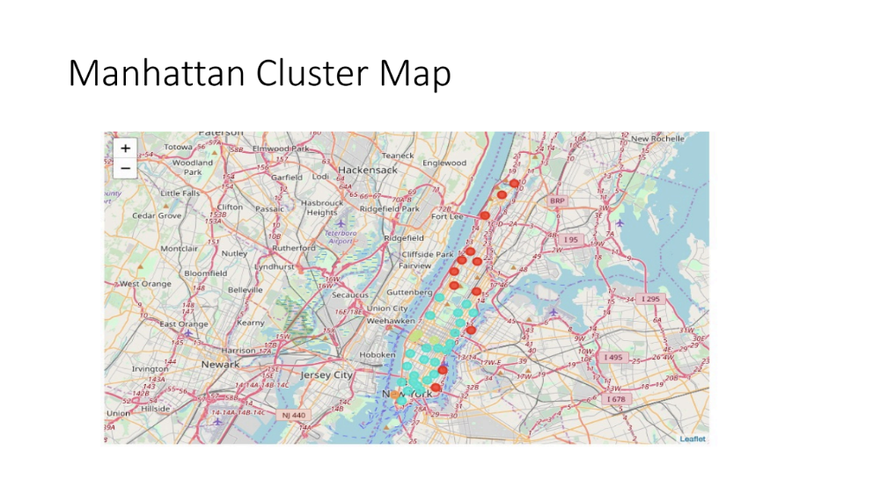
Figure 1. Manhattan Cluster map
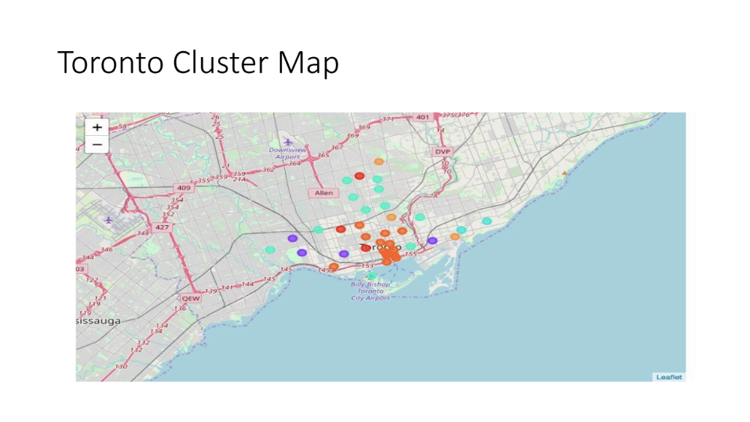
Figure 2 Toronto Cluster Map
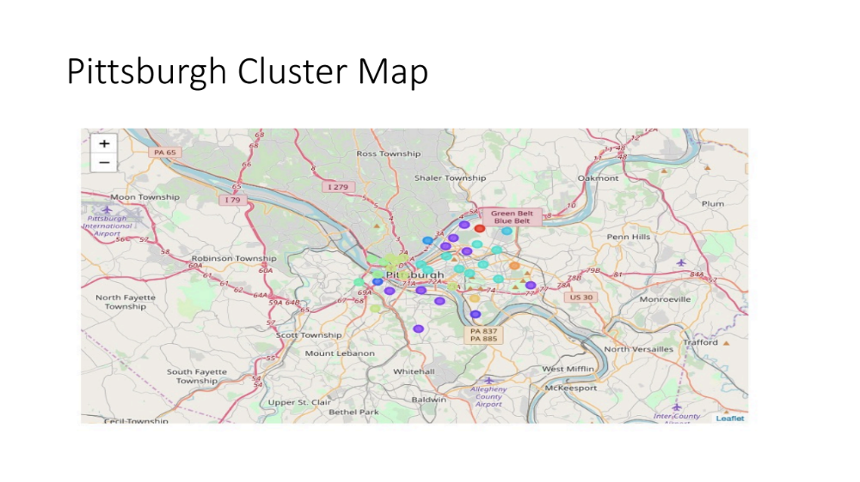
Figure 3 Pittsburgh Cluster Map

  - Similar neighborhoods

. We start with some of the neighborhoods that have shown similarity. In the run of the K-Means algorithm we analyze, four clusters, in particular are interesting. Cluster 3 shows a similarity between some Pittsburgh neighborhoods and Toronto neighborhoods. See Figure 4.

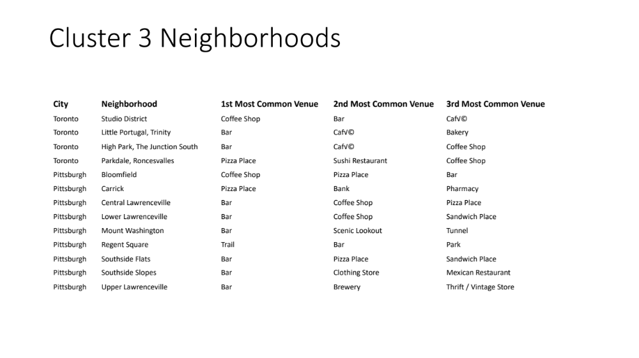

Figure 4. Cluster 3 Neighborhoods

Cluster eight shows a good deal of similarity between some of Manhattan’s attractive neighborhoods, Toronto’s Beaches neighborhoods and most of Pittsburgh’s most venue rich neighborhoods. This is an attractive cluster from a venue amenity perspective. See figure 5.

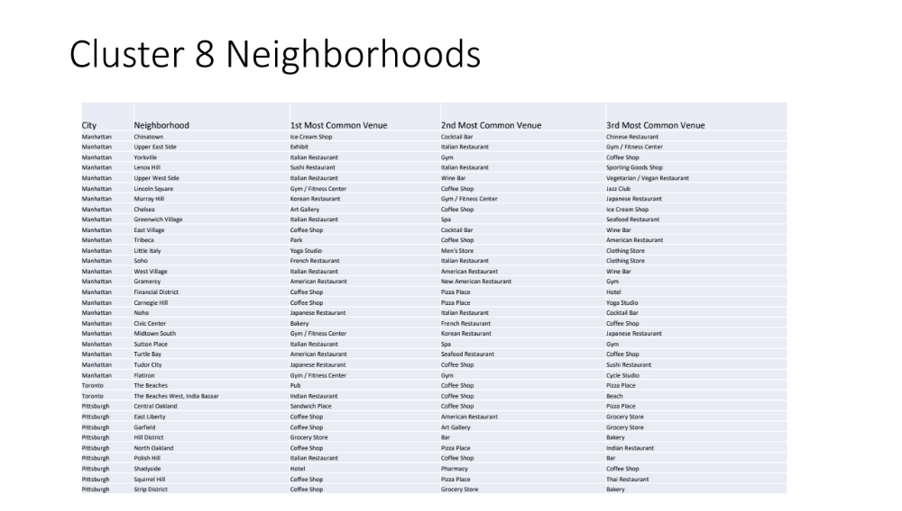
Figure 5. Cluster 8 Neighborhoods

Cluster twelve shows a similarity between some more of Manhattan’s attractive neighborhoods and some up and coming Pittsburgh venue rich neighborhoods. See figure 6.

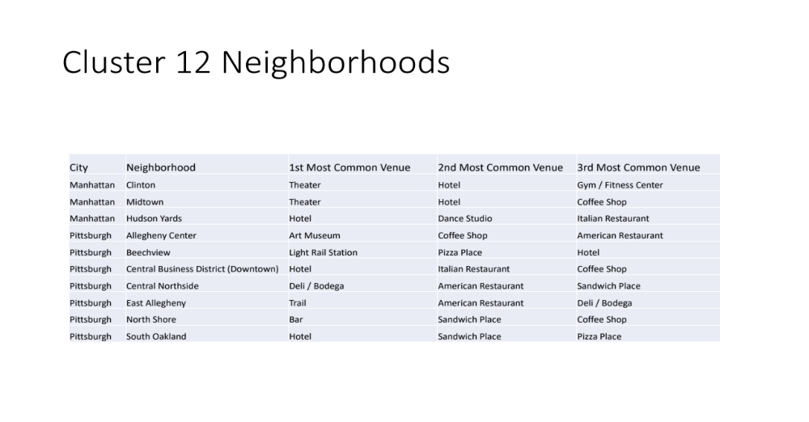
Figure 6. Cluster 12 Neighborhoods

Cluster fourteen shows similarity between Battery Park in Manhattan, a few Toronto neighborhoods and the Point Breeze section of Pittsburgh (a very nice place). See figure 7.

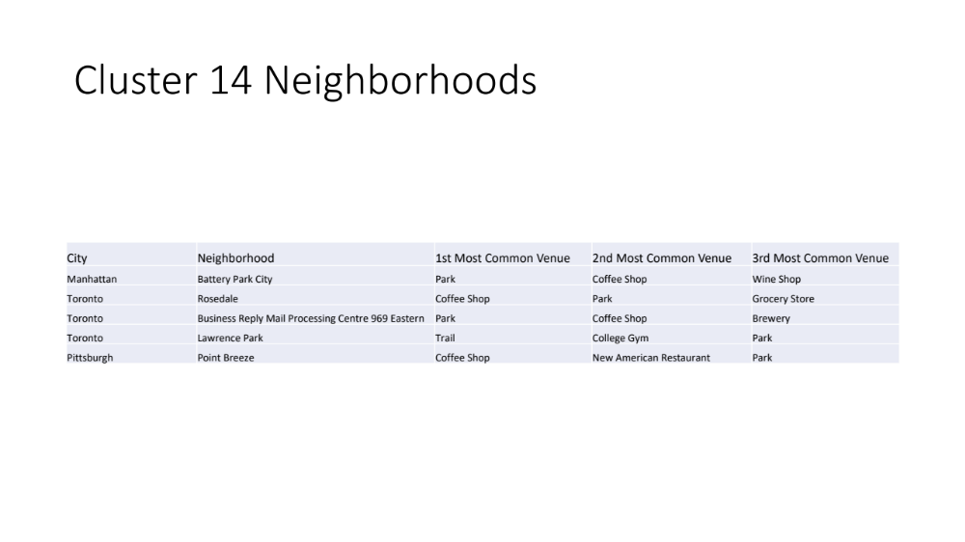
Figure 7. Cluster 14 Neighborhoods

  - Outliers

The analysis of the rest of the clusters did not demonstrate neighborhood similarity between Pittsburgh and the other two cities. They were:

- Cluster 0 was exclusively Toronto so it had nothing to do with Pittsburgh.
- Cluster 1 was mostly Manhattan (1 Toronto Neighborhood) so it had nothing to do with Pittsburgh
- Cluster 2 was (an outlier) the Stanton Heights section of Pittsburgh only. This is
- Cluster 4 was (an outlier) the Hazelwood section of Pittsburgh
- Cluster 5 was (an outlier) the Duquesne Heights section of Pittsburgh
- Cluster 6 was (an outlier) the Troy Hill section of Pittsburgh
- Cluster 7 was (an outlier) the Highland Park section of Pittsburgh
- Cluster 9 was exclusively Toronto
- Cluster 10 was (an outlier) the West End section of Pittsburgh
- Cluster 11 was all Pittsburgh (Allegheny West, Southshore and Manchester) and closely located to major Stadium and River Confluence.
- Cluster 13 was (an outlier) the Greenfield section of Pittsburgh

The Stanton Heights, Hazelwood, Troy Hill, Highland Park and Greenfield are outliers possibly because they are less socioeconomically developed. Because of the size of New York and Toronto (we just analyzed Manhattan and the Central areas of Toronto), the less socioeconomically developed neighborhoods got pushed beyond the geographic scope in those cities but did not in the smaller Pittsburgh. Clusters 5 and 11 are outliers because they have some relationship to the unique terrain of Pittsburgh (the riverfront and the view of the confluence of three winding rivers that do not exist in Toronto or New York).

Ultimately the following Pittsburgh neighborhoods show a great level of similarity to corresponding neighborhoods in New York and Toronto:

Point Breeze, Allegheny Center, Beechview, Downtown, Central Northside, East Allegheny, North Shore, South, Central and North Oakland, Bloomfield, Lower, Central and Upper Lawrenceville, Mount Washington, Regent Square, South Side Flats and Slopes, East Liberty, shadyside, Squirrel and Strip District.

- Discussion

Our analysis indicates that certain neighborhoods in Pittsburgh have a great deal of similarity with attractive amenity neighborhoods in Toronto and Manhattan, and some do not. Largely the neighborhoods in clusters 3, 8, 12 and 14 show significant similarity. During the analysis, some imperfection in methodology and tool use were noted. Largely, these notes provide a better and deeper understanding of how to use and interpret the precision of the analysis. The factors and issues noted provide more completeness to the study, and so follow on analysis that (was outside of the scope of this analysis but) will increase the completeness of the full picture of quality of amenities in these neighborhoods.

  - Issues Complicating Comparison

Some issues and differences between the cities and how they lay over the land make the comparisons between the cities require deeper understanding than can be had with the Foursquare venue explorer alone.

    - Neighborhood Boundaries

The neighborhoods in all cities analyzed are really informal in their boundaries. The geo data retrieved from the Google geocoder API attempts to identify some boundary conditions for each boundary but the data necessary to use the Foursquare APIs is the center point for each neighborhood (which Google also provides). The use of the Foursquare API uses a radius for the venue explorer which provides a circular footprint for each exploration. Ultimately, the neighborhoods are not circular. It would be better if the API allowed the exploration to be done with a set of edge coordinates. From a practical sense, though, residents freely use amenities in a circular radius more than they would care about formal neighborhood boundaries.

    - Issues of Density

The analysis showed that the 500M radius of exploration was big enough for Manhattan but struggled to cover some of the less dense neighborhoods in Pittsburgh and even in Toronto. Manhattan has a much denser concentration of people that consequently correlates to a much denser concentration of everything including venues. This presents itself also in smaller physical footprints of neighborhoods. With smaller cities (and western cities), neighborhoods are bigger. We used 1000M in our analysis for Foursquare radius because the 500M search caused amenities to be missed. The 1000M analysis caused some overlap and double counting of amenities in adjacent neighborhoods, however. Would the analysis have been ‘apples to apples’ if we used a different radius in different cities? From a practical sense, though, residents freely use amenities in a circular radius that the inhabited density dictates more than they would care about formal neighborhood boundaries.

    - Mobility

Related to density of population, it is intuitive to believe that the population use of amenities is really constrained by how efficient their mobility is to use the amenity. While not studied in this analysis, factors of logistics and transportation response time are the factors that dictate use of an amenity. For example, all cities allow walking to amenity venues. However, how practical (cost, time) is it to use public transit (bus, subway, etc.) or get an Uber or Taxi or drive, etc. Clearly, Manhattan is the least mobile of the cities (even though we did not measure this) so mobility factors also do not allow an exact ‘apples to apples’ comparison.

    - Unique Business Categories

Foursquare tracks a very large number of discrete venue categories, but many amenities are describable by a finite discrete set. This makes our analysis a good approximation and is probably good enough from a practical perspective.

  - Attractive Neighborhoods are a matter of taste

With the large number of categories covered in our analysis, there emerges a large set of permutations/combinations of amenities that may or may not be individually important to a person relying on the analysis. The attractiveness of combinations is largely a matter of individual need and taste. Consequently, with the limitations of classification possible with a reasonably small value of K (in K-means clustering), This again makes the classification a good approximation and is probably good enough from a practical perspective.

  - Follow-on or adjacent study

This study would be greatly enhanced in value if, along with the amenity similarity clustering we provide, we could add some costs data about living in these neighborhoods (what is the cost for lodging, other expenses as a feature in a cluster calculation). Also, it would be helpful if we could quantify a mobility factor based on transit times to travel 1000M, 2000M, 10000M away. This would help normalize what the unit of practical mobility is and further define the equivalent search radius for each city. This would help us provide a good value comparison for these neighborhoods as well.

- Conclusion

Pittsburgh has some good Neighborhoods and stands up well against New York and Toronto for its inventory of neighborhoods with good amenities. The Neighborhoods itemized in clusters 3, 8, 12 and 14 of the analysis run using K-Means clustering are illustrative of the outcome of the analysis.

Ultimately the following Pittsburgh neighborhoods show a great level of similarity to corresponding neighborhoods in New York and Toronto:

Point Breeze, Allegheny Center, Beechview, Downtown, Central Northside, East Allegheny, North Shore, South, Central and North Oakland, Bloomfield, Lower, Central and Upper Lawrenceville, Mount Washington, Regent Square, South Side Flats and Slopes, East Liberty, shadyside, Squirrel and Strip District.

References

- Coursera Data Science Capstone, Week 3
https://www.coursera.org/learn/applied-data-science-capstone/home/week/3

- List of Pittsburgh Neighborhoods
https://en.wikipedia.org/wiki/List_of_Pittsburgh_neighborhoods

- Google Geocoder API
https://developers.google.com/maps/documentation/geocoding/start

- Foursquare
https://developer.foursquare.com/

- Nominatim
https://nominatim.openstreetmap.org/

- Geopy
https://pypi.org/project/geopy/

- Folium
https://python-visualization.github.io/folium/

- K-Means Clustering
https://en.wikipedia.org/wiki/K-means_clustering

- Project Jupyter Notebook
https://github.com/JMcRedstone/Coursera_Capstone/blob/master/NYTORPITT.ipynb

- nbview
https://nbviewer.jupyter.org/

