AVP LIMB HITBOX SYSTEM
How animated model cubes extend the normal mob hitbox — without replacing collision
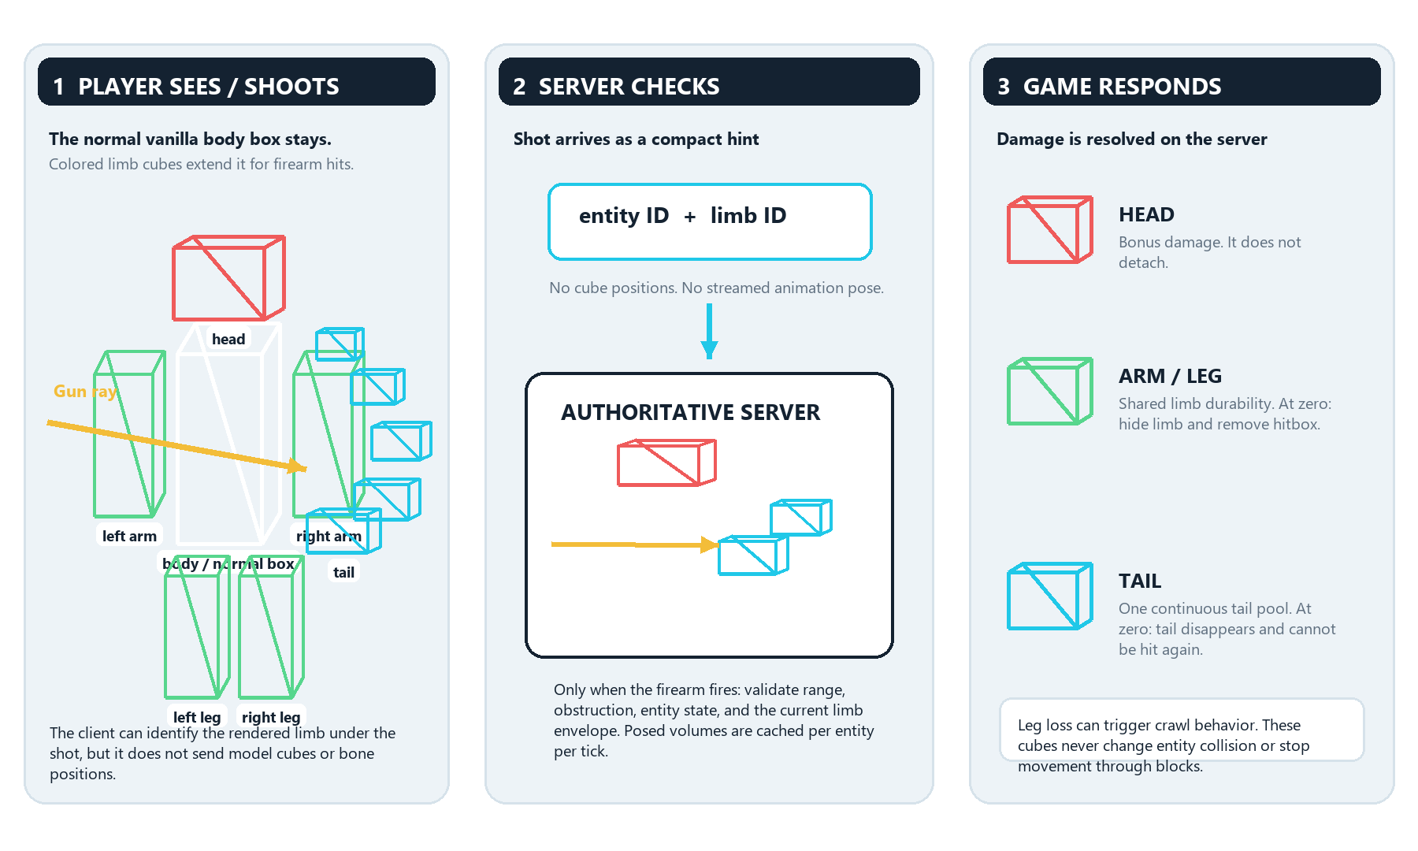
WHEN IT RUNS | On a firearm shot only Client rendering and server idle mobs do not receive continuous limb work.
CURRENT SCOPE | AVP xenomorphs Praetorian, Drone, Warrior, Runner, Queen and other configured AVP mobs. Vanilla firearm limb support is not active.
KEY: white = normal body hitbox • green = arms/legs • cyan = tail • red = head • yellow = shot ray

