Extended-Abstract Template (Times New Roman 14 PT, Bold)

J. Smith¹, M. Zhang*,², and A. Müller#,¹,c)
¹School of Aerospace Engineering and Applied Mechanics, Tongji University, Shanghai, China
²Institute of Applied Mechanics, TU Darmstadt, Darmstadt, Germany

*Corresponding author: xxx@yyy.zzz
# Presenter: aaa@bbb.ccc

Authors should submit an extended-abstract written in English, including supporting figures, within one A4 page with one-inch margins. Times New Roman 12 pt should be used. Please follow font types, styles and sizes as in this template. A figure caption should be inserted below the figure. Authors are reminded to ensure the resolution of figures to be high enough. Please try to modify this template to form your submission.
For submission, please log in to our online submission system and complete the registration form for our records.
For technical support and inquiries, please contact Prof. Zhao (19531@tongji.edu.cn). Please submit your extended-abstract through the online system on or before the due date.

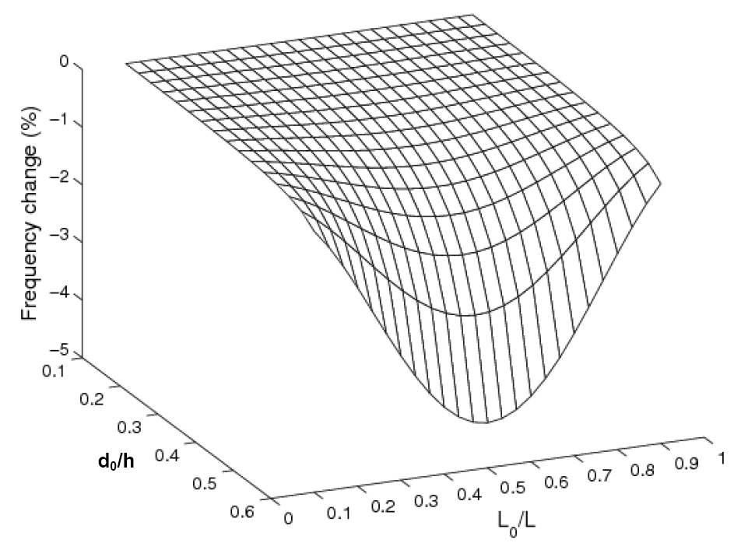
Figure 1. Smart material deformation analysis.

Acknowledgements
The authors wish to thank …. (in Times New Roman 12 pt). This section is optional.

References
Haldar, A. and S. Mahadevan (2000), Probability, Reliability and Statistical Methods in Engineering Design, Wiley, New York.
Kareem, A., C.C. Hsieh, and M.A. Tognarelli (1998), “Frequency-domain analysis of offshore platform in non-Gaussian seas,” ASCE Journal of Engineering Mechanics, 124(6), 668–683.

