A homogenization-based multiscale framework for Li-ion batteries: interplay between stack pressure, porosity evolution and cell performance
Zhongli Ge¹, Ying Zhao*,¹)
¹School of Aerospace Engineering and Applied Mechanics, Tongji University, Shanghai, China

*Corresponding author: 19531@tongji.edu.cn
# Presenter: zlge@tongji.edu.cn

Composite electrodes play a pivotal role in determining the overall performance and longevity of lithium-ion batteries (LIBs). Due to the inherent complex microstructure (including heterogeneous components distribution and porous networks), and the evolution of volumetric changes arising from chemical-induced eigenstrains, accurately tracking the evolution of porosity and effective mechanical properties remains a great challenge. In this study, we propose a novel multi-scale micromechanics framework to investigate battery performances considering the evolution of effective electro-chemo-mechanical properties and porosity in composite electrodes. Analytical expressions for effective properties and porosity evolution are derived and validated against experimental data and finite element (FE) simulations, demonstrating excellent agreement. Validation confirms the self-consistent method's superiority over the Mori-Tanaka approach for estimating effective properties of battery electrodes, which are densely packed with active materials. Key findings reveal that the effective Young’s modulus is governed by competitive mechanisms between active material phase transformations and microstructural reconfiguration. Porosity evolution exhibits strong dependence on initial particle volume fraction, mechanical constraints, and C-rate. Models neglecting parameter evolution incur approximately $19\%$ Mises stress errors and significant discharge curve divergence beyond $50\%$ capacity. This establishes the framework as an effective analytical tool for investigating electrochemical-mechanical performance of Lithium ion batteries.

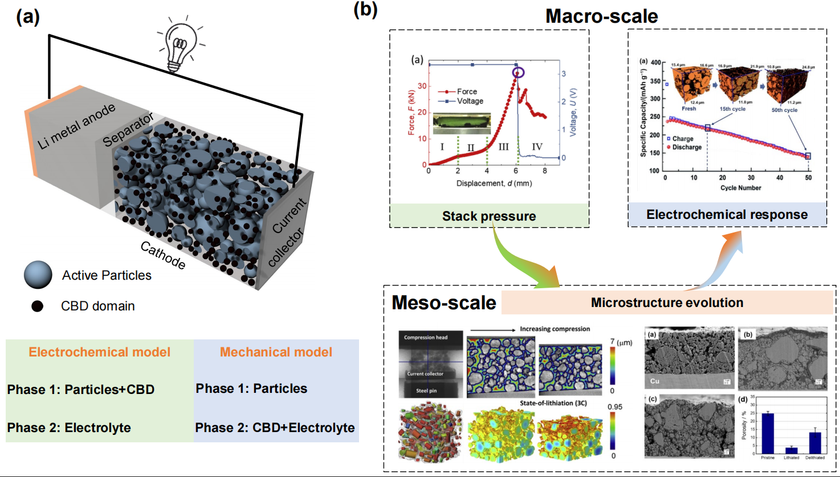
Figure 1. An illustration of the half-cell model of the lithium-ion battery.

Acknowledgements
This work is supported by the National Natural Science Foundation of China (Project No. 12472175).

References
L. Wang, A detailed computational model for cylindrical lithium-ion batteries under mechanical loading from cell deformation to short-circuit onset, Journal of Power Sources (2019).
S. Wu, Y. Chen, w. Luan, H. Chen, L. Huo, M. Wang, S.-t. Tu, A review of multiscale mechanical failuresin lithium-ion batteries: Implications for performance, lifetime and safety, Electrochemical Energy Reviews7(1)(2024)35.
X. Lu, S. R. Daemi, A. Bertei, M. D. Kok, K. B. O'Regan, L. Rasha, J. Park, G. Hinds, E. Kendrick, D. J.Brett, P. R. Shearing, Microstructural evolution of battery electrodes during calendering, Joule 4 (12) (2020)2746-2768.
D.-H. Yoon. . Marinaro, P. Axmann, . Wohlfahrt-Mehrens, Study of the binder infuence on expan-sion/contraction behavior of silicon alloy negative electrodes for lithium-ion batteries, Journal of The Electrochemical Society 167(16)(2020)160537.

